Assignment 3: Our IT Project

**Program name:** Introduction to Information of Technology

**Program code:** COSC2083

**Name of lecturer/teacher:** Nguyen Minh Long/ Nguyen Ngoc Thanh

**Due data:** 20/9/2020

**Students:**

BUI HOANG – S3818202

LUU VI QUAN – S3871124

KIM HYUNMIN – S3868517

**Assessment declaration**

1. I have not impersonated, or allowed myself to be impersonated by any person for the purposes of this assessment.
2. This assessment is my/our original work and no part of it has been copied from any other source except where due acknowledgement is made.
3. No part of this assessment has been written for me/us by any other person except where such collaboration has been authorised by the lecturer/teacher concerned.
4. I have correctly acknowledged the re-use of any of my own previously submitted work within this submission.
5. I give permission for my assessment response to be reproduced, communicated compared and archived for the purposes of detecting plagiarism.
6. I give permission for a copy of my assessment to be retained by the university for review and comparison, including review by external examiners.

#### I understand that:

* Plagiarism is the presentation of the work, idea or creation of another person as though it is your own. It is a form of cheating and is a very serious academic offence that may lead to exclusion from the University. Plagiarised material can be drawn from, and presented in, written, graphic and visual form, including electronic data and oral presentations. Plagiarism occurs when the origin of the material used is not appropriately cited.
* Plagiarism includes the act of assisting or allowing another person to plagiarise or to copy my work.

#### I agree and acknowledge that:

1. I have read and understood the Declaration and Statement of Authorship above.

2. I accept that use of my RMIT account to electronically submit this assessment constitutes my agreement to the Declaration and Statement of Authorship

3. If I do not agree to the Declaration and Statement of Authorship in this context, the assessment outcome is not valid for assessment purposes and cannot be included in my aggregate score for this course.

LINK FOR OUR GITHUB RESPOSITORY:

https://github.com/uhnmji8899/Assignment-3-Our-IT-Project

LINK FIR OUR URL:

https://htmlpreview.github.io/?https://github.com/uhnmji8899/Assignment-3-Our-IT-Project/blob/master/Index.html

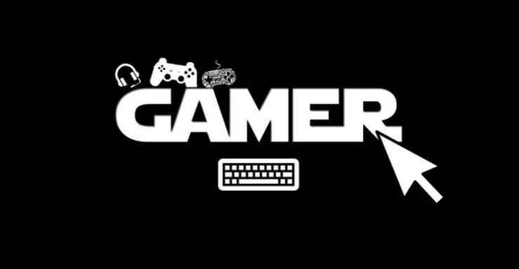

# Assignment 3: Our IT Project

## HOME

### WELCOME YO THE WEBSITE OF THE GAMING BRO

This is the website of Assignment 3: Our IT Project of THE GAMING BROs. We were formed and enjoyed working together from Assignment 2 and we glad to introduce our new project: VR Game.

As the name of the group, we all love video games and we spend most time of day to play video games. In this assignment, we all agreed to choose Games as a project topic.

### TEAM PROCESSES

We had a bad run from the start in assignment 2 because we unknown others and we had bad communication but in the last weeks of the deadline, we worked hard, done all the tasks of the assignment, and finished it on time. Move on this assignment with the same members, we can expect a better result while we have a group work experience from the last task.

The parts we will include in this assignment:

* Roles and responsibilities for the project.
* Persuasion meeting
* Testing and risks
* Professionalism

**TEAM PROFILE**

**Hoang- Student ID: S3818202**



Hello everyone! My full name is Bui Hoang, I’m 22 years old and I’m from Hanoi. Right now, I study a Bachelor of Information of Technology at RMIT Vietnam but before that, I was a student of Hanoi University of Science. I enjoy playing video games and playing soccer with my friends in my free time. I had my first PC when I was 5, so I have approached the computer from a very early. Then, instead of hanging out to the street, I spent all day playing videos game and exploring my PC. For me, that time in part build my IT interests. Before I go to RMIT, I don’t have any experience in IT major but I believe that I will have a good knowledge of IT ecosystems and able to use all common program languages.

**Hyun Min Kim - Student ID: S3868517**

Hello, my name is Hyun Min kim. I'm 22 years old and I'm from south Korea. I live in Korea for 21 years and I decided to move Vietnam because my father is working here. I'm interested in listing to music, especially K-pop. And I regually work out for fun and health. The reason why I chose this course is the importance of IT has been rising and I thought this will be helpful for my future career. I'm really not familiar with this area because I studied about liberal arts until the end of highschool in Korea.

**Luu Vi Quan - Student ID: S3871124**

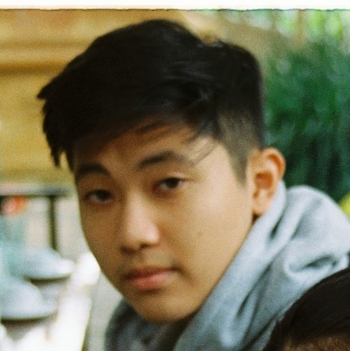

Hi everyone, my full name is Luu Vi Quan, I’m from Hanoi, and I’m currently studying Bachelor of Digital Marketing at RMIT Saigon. I can speak two languages, Vietnamese and English. In my spare time, I enjoy hanging out with my friends and play soccer as my hobby. The reason that I'm mainly interested in IT is its ability to bring everyone closer together by connecting with people all around the world. In terms of IT experience, I currently don’t have any experience, but I’m eager to learn and expand my knowledge in the IT industry.

**CAREER PLANS**

**Hoang : Database Administrator**

After 2 assignments before, my career won’t change at all. My ideal job is still a Database Administrator and to gain that goal, I have to complete my study in RMIT to have a Bachelor’s Degree and try to join in technology competitions as much as I can. Different from 2 career plans of my teammates, I have to give my attention to database knowledge, programming languages, and their tools. The most common element in our group that we have to work in a group as a part of required in the technology industry. For those reasons, the experiences I got from assignments like this are really important for us.

**HyunMin : Senior iOS & Android Developer**

**Quan: Digital Marketing Manager**

Relating to the two previous assignments, I’m still following my path of becoming a Digital Marketing Manager. Once I acquire my bachelor degree in the Digital Marketing major, I will be able to apply for internships as well as beginner jobs that will help to build my CV resume. Although my major mostly revolve around business and marketing courses, I still need more experience in the IT industry to achieve my dream job ultimately and the career of becoming a Digital Marketing Manager. Conversely, my teammates Hoang and Hyunmin are more experienced in IT as they are currently taking programming courses and is in the process of completing their IT bachelor. However, what we do have in common is our teamwork skills and the ability to cooperate in harmony. Therefore by completing these group assignments, it would help us massively to achieve our dream career in the future.

**AIMS AND PROGRESS**

**AIMS AND GOALS**



**AIMS**

Telling an amazing story by a combination of Virtual Reality technology with an action game.

To make an action game that people enjoyed by bringing gamers to a fantastic world so they can start their own amazing journey.

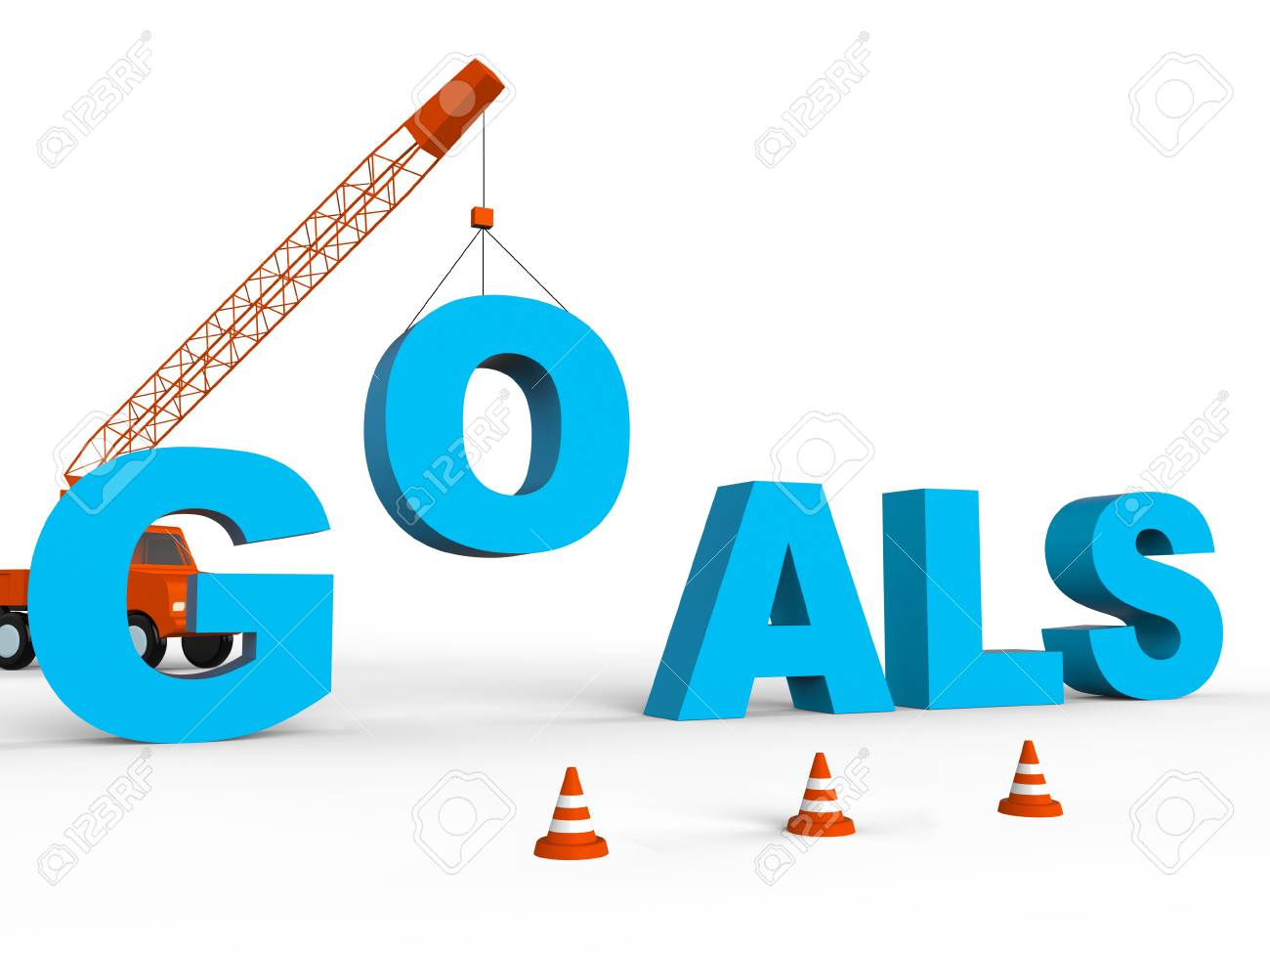

**GOAL**

Our first goal is to successfully make a VR action game that has 500.000 players buy this game.

Successful contracting with famous video game publishers company in Vietnam.

Becoming one of the most prominent new games in the Vietnam gaming market and even in the Sea gaming market.

**PLANS AND PROGRESS**

**What our project does?**

Our project is making a VR action video game.

**How we will do it ?**

Our group will use the Unity Editor or the Unreal Engine 4 to make the game.

**Steps we will take**

The first step we take is to design the game concept: story, characters, boss, gameplay, context, and animations.

Next, we will plan about what work we have to and make a schedule for all of the scope tasks and manage the deadline for their tasks.

In the next step, we will distribute all the tasks for each member of the group as a planned schedule.

**Developing of Featrures**

Instead of playing game in single-player mode, people can coop with their friends to playing our game together.

**Ourcomes of Project**

The VR Game we make will help players have a good relaxing time enjoying our game and sent them to the magical world with an interesting story.

**Time Frame**

https://rmiteduau-my.sharepoint.com/:x:/r/personal/s3818202_rmit_edu_vn/_layouts/15/Doc.aspx?sourcedoc=%7BE3905F7F-A495-47D8-8545-61E0A9B364CB%7D&file=S%E1%BB%95%2011.xlsx&action=editnew&mobileredirect=true&wdTpl=TM10000105&wdlcid=1066&wdNewAndOpenCt=1600173993117&ct=1600173993117&wdPreviousSession=b21aff4a-4bf5-4f69-8841-a2cb335200dc&wdOrigin=OFFICECOM-WEB.TEMPLATES.TEMPLATES&cid=3669e5f1-66fd-4a99-801f-0ad9f00d416a

[Time Frame of the Project](https://rmiteduau-my.sharepoint.com/:x:/r/personal/s3818202_rmit_edu_vn/_layouts/15/Doc.aspx?sourcedoc=%7BE3905F7F-A495-47D8-8545-61E0A9B364CB%7D&file=S%E1%BB%95%2011.xlsx&action=editnew&mobileredirect=true&wdTpl=TM10000105&wdlcid=1066&wdNewAndOpenCt=1600173993117&ct=1600173993117&wdPreviousSession=b21aff4a-4bf5-4f69-8841-a2cb335200dc&wdOrigin=OFFICECOM-WEB.TEMPLATES.TEMPLATES)

**SCORE AND LIMITS**

**Score**

Determining the score of our project is very significant for the group. Making a long interesting story and a huge wonderful world for the game is good but we have to complete the game project within the limited time and lacking of members from the start, so we have to focus on develop in a few maps and characters.

**Limits**

Time is one of the most limit factors for this project while we just have 16 weeks to complete all the parts of this project.

The second factor is group members, our group was formed for the first time with 4 members but one student was left from the start of the assignment 2 so we have to work as a team-3-members during 2 assignments. Because of lacking people, all members have to work harder for the assignment and have more tasks to do.

**PROJECT**

**PROJECT DECRIPTION**

**What does it do ?**

Our project will be focusing on the concept of VR gaming. So what is VR in the first place? VR stands for virtual reality and refers to the creation of technology that allows users to engage in an artificial and fictional world. Virtual reality is used for many different purposes, such as gaming, entertainment, and even education. However, for our project, we will go deeper into the art of virtual reality gaming. Based on the concept of a 3D dimensional world, VR gaming gives the players a realistic and mesmerizing experience of an action game. The players can choose their preferred platform to encounter the new definition of gaming. VR gaming comes in different forms, where users can play on their PCs or laptops, gaming consoles such as PS4 and Xbox, and their smartphones. Moreover, for VR gaming to work, players must possess a majority of devices and accessories such as VR headsets and Goggles, along with controllers and gloves. By putting these devices on, the player won’t be able to differentiate between the real world and the virtual world when their senses have now converted and linked with the 3D world so that they can have the most realistic gaming experience ever.

**What it likely to impact ?**

With the development of technology rising rapidly day by day, the concept of gaming is expanded with the lights of virtual reality. VR positive has influenced the gaming industry heavily and changed the way it operates. First of all, with developing VR into video games, it creates more job opportunities for the game developers as there’s a new area to focus and research on. As a result, it would mean no redundancy of current workers and along with more games designer and developer being recruited into the company to exploit the VR software further. Second of all, with virtual reality trending in the gaming industry, it attracts brands and businesses to invest and identify new gaps and opportunities. An example of this scenario would be Mountain Dews sponsoring famous streamers when they play games using virtual reality technology. Furthermore, by installing VR into the gameplay of new action games, it opens up a new spin for gamers to take on as VR injects its own unique plot and storyline of the game, hence allowing gamers to immerse themselves in the virtual world fully. An example of popular games introducing VR into its gameplay is League of Legends, releasing their new patch that includes a 360-degree view VR arena mode.

**How will this affect you?**

As for myself, I had a recent experience with VR gaming when I take part in an action game, firing different kinds of weapons through holding a controller and wearing a VR headset. The experience was one of a kind and very surreal as I felt like I’m in my world, walking through a storyline of my own and controlling the progression of the game as it goes.

**PROJECT IDEA**

**Story**

Our action game storyline revolves around the main protagonist and his companions’ journey fighting for their lives to escape from a multiverse and abandoned world. Going back to the beginning of the story, the main protagonist and a bunch of his friends were exploring on an archaeology tour in Greece where the tour guide shows the crew around the historical sites. The main protagonist receives a thick book from the tour guide, which contains all the information about those historical sites and images depicted from that period.

For some reason, the tour guide was summoned by the tour manager and had to leave the crew for a few seconds. As the team were left standing in the middle of nowhere, they had no other options but to open the guide book and search for the directions back to the path that they initially entered the site in the first place. The main protagonist slowly opened the book and flicked through the book to find the map that will lead their way back. However, as soon as the main protagonist gets to the map page, a shiny golden flare burst through the book and head directly up to the sky. Everyone in the crew was taken by the golden flare and sucked into the legendary, cursed book, in which the team lands upon an abandoned world full of never seen before objects.

The crew realised they were stuck in the book and this unrealistic experience is some sort of a game where the only way out was to advance through the map, defeating any challenges and obstacles that might stand in their way. The main protagonist soon figured out that each player has a total of 3 lives. If that person happens to run out 3 lives, they are eternally dead, both in that world and the outside world. The map consists of 4 stages, where each stage provides a life-threatening experience as the team have to conquer different types of mystic creatures as they move along the map. Each character is given a list of strengths and weaknesses, along with various weapons to help them advance through each stage. Ultimately, the character’s decision and actions shall shape the way the game ends where it could end drastically or in a happy ending where all member stays alive and well as they return to their real world.

**Gameplay**

The game will bring you to the magical world with giants, elves, goblins, orcs, dragons, etc. All the amazing creatures that just appeared in books such as Lord of the Rings and Eragon will be in this game.

This game will focus on melee, ranged, and magic combat that fully utilizes a unique and realistic physics-driven interaction and combat system.

Immerse yourself in deep environmental interactions, puzzle-polving, world exploration, and visceral combat.

Built exclusively for VR, collisions are dictated by fine hitboxes, objects have weight and follow the laws of physics, creatures have full body physics and presence, and blades can be used to penetrate soft materials or deflect magic.

Players also can build their own fighting method by the skills table in 3 different ways: Warrior, Mage, and Stealing.

**OVERVIEW**

**Topic**

Our project is based on the development of VR gaming, where game developers and designers will be collaborating together to create a masterpiece VR product. We aim to provide the players with the highest and the most realistic gaming experience ever where they just have to purchase a few of VR devices and accessories and enjoy the ultimate experience. This notion will also help the players to engage with others socially as they can form new friends online and change the gaming community concept to a place full of positivity and love.

One of the primary purposes of our project is to save the environment where we encourage our users a specific type of devices and consoles that won’t take up much electricity, which helps reduce the C02 levels released from electricity and up onto the atmosphere along with preventing climate change ultimately.

**Motivation**

All our group members love to play video games so as a reason, we all agreed that our project will be a video game. Moreover, the demand for people to entertain in their own houses is more and more increase nowadays, especially at this time. Because of the corona outbreak, people have to spend almost all their time at their house so games are a good way to entertain.

We chose our project will be a Virtual Reality game because of the reasons below:

The new age of Virtual Reality has started with its application in many major and especially in Gaming. Many famous games with millions of player can be proof for the success of Virtual Reality Gaming (VR Gaming):

https://www.youtube.com/watch?v=lKr94gsbkzY

Top 15 PC VR Games in 2020

And even some games have developed new VR versions of their game:

https://www.youtube.com/watch?v=XuS6tsA_yfA

A video of Minecraft in VR version

https://www.youtube.com/watch?v=fcLl-DZGLZ8

A video of The Resident Evil 7 in VR version

The Movie also can help us see the future of VR Gaming:

https://www.youtube.com/watch?v=cSp1dM2Vj48

A Official Trailer of READY PLAYER ONE

Secondly, we all agree that the perfect way to tell a story for people is that make them join to that story. And VR Gaming is a good way to help the player completely become a character in a story.

https://www.youtube.com/watch?v=bv7I8nMV914

We can see how people enter to their characters mind while playing VR Games

For all the reasons that we gave above, we chose VR Game as our Project in Assignment 3.

**Landscape**

We believe that Half–Life : Alyx has some similar points with our project.

https://www.youtube.com/watch?v=O2W0N3uKXmo

Half-Life: Alyx Announcement Trailer

There are many VR games in the gaming market currently and it is a big competitive market. Half-Life: Alyx is one of the most prominent VR games which have interesting gameplay and amazing story. But the difference between other games are their gameplay and the game’s story, our group believe that we have an interesting game’s story and gameplay that can attract players. Moreover, our game project adds the coop function that helps players can play with their friends and explore the game together. Furthermore, Our project want to develop in both console version and PC version.

**TECHNOLOGIES AND TESTING**

**TOOLS AND TECHNOLOGIES**

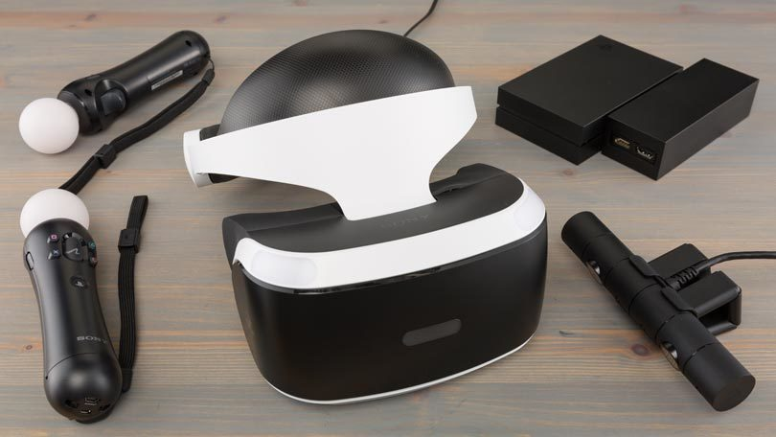

**Hardware**

In a VR world, VR Headset (eg. Oculus Quest, Sony Playstation VR) is a critical item for players to play VR games. This equipment plays as a role like a key to connect people from the real world to VR

**Software**

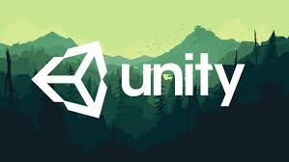 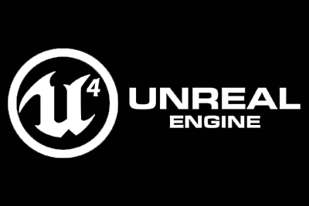

Unity 3D Pro( Version 2020.1.5) or Unreal Engine 4(Version 4.25) is our first choice of software tools for this project. Both of them are the most popular engines for game developers and they also have good support for VR games.

Currently, all members of our group don’t have any practical experience and core technology knowledge in writing VR software or VR game, so we need to spend a lot of time learning tools, technologies, and programing language to develop our game.

**TESTING**

The first testing way we use that we need to play our game. By checking the game ourselves, we can check the gameplay, graphic of our game, and if the game is run fluently as we expected. Each of us will give feedback for the game and discuss it together. Then, we can find out bugs in the game and quickly fix it.

Secondly, to complete the game we also have to receive ideas and comments from other players. At that point, we will spend the demo version of our game on the official website so people can download and play it for free. We will also send our game to forums and communities on social networks such as Facebook and Twitter. The discussions in their places can help us improve our game. Then, the more testers, the better. The feedback we received from people will help us fix bugs and mistakes that we didn’t note.

Furthermore, we can introduce our game to people by joining in game festivals. Customers can play our game in VR places in game festivals and review the game for us.

**PROGRESS**

**GITHUB REPOSITORY LINK**

<https://github.com/uhnmji8899/Assignment-3-Our-IT-Project/tree/master>

**GROUP PROCESSES AND COMMUNICATIONS**

Throughout the project, our group’s communications were used 2 platforms:



**Facebook Messenger**

Facebook is a common social network in Vietnam and we all have a Facebook account. As a result, we use Facebook Messenger as a good platform to communicate about daily talks.

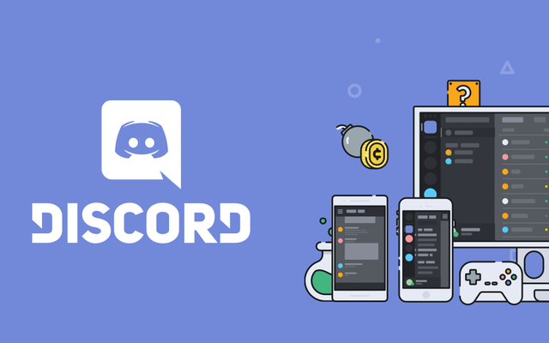

**Discord**

A convenient online platform that helps us to make our own server to host a communicate by video call and posting our work in that server at home. We also can stream our laptop screen in this platform to show the task’s project problems without meetings so that is very convenient for the group discussion. Moreover, we can able to play video games together to break the walls and really be comfortable with one another here, which allows for more effective communication.



**Meetings**

Even though we have a platform for the group’s communications, we still believe that meetings are really important for the project. All our big discussion and our tasks distribution are in meetings. We all feed that the work will be more productive and quickly while working face to face.

**SKILLS AND JOBS**

**Video Game Designer ( Quan, Hoang)**

Video Game Designer is one of the most important parts of this game. The designers are responsible for the games' storylines and plots, user interfaces, in-game objectives, maps, scenarios, the degree of difficulty, and character development. Video game designers are expected to use computer software to input computer scripting. For those reasons, they must have the critical thinking, creativity, storytelling ability, programming knowledge, and knowledge of multimedia development software.

**Video Game Developer (Hoang, Hyunmin)**

Video game developers, also known as video game programmers, write code for games. They take the Video Game Designer’s ideas, drawings and rules, and turn them into a playable game with visuals and sound through writing code. Key skills required for these jobs: creativity, wide-ranging knowledge of gaming trends, a strong analytical frame of mind, and proficiency in programming languages, such as C# and C++.

**Video Game Tester( Quan, Hyunmin)**

Providing quality assurance for the game project. They make sure all game functions correctly, identify problems and bugs and report their finding to Video Game Developers and Video Game Designers. For those reasons, a Video Game Tester has to be a gamer and love video games, carefully, self-motivated, and willing to take ownership of their work.

**Audio Engineer ( Hyunmin)**

Be who creates soundtracks for video games. They are responsible for all the sound in a videogame: voice characters, sound effects, background music. Skills required: Problem Solving, Critical Thinking, Manual Dexterity, and Monitoring.

**Writer (Quan)**

Creating the stories upon the game and write dialogue for the characters. Skills required: Writing skills, creativity, and critical thinking.

**General Skills required for all jobs in the gaming industry:** A passion for video games, Ability to work as part of a team, adaptability, time management.

**GROUP REFLECTION AND FEEDBACK**



**Hoang**

**Feedback**

I glad that we could finish this assignment in time and completed all the parts of it. Quan showed that he is a good teammate who shared tasks and a good writer. Hyunmin is a member who can complete all tasks he is distributed.

**Reflection**

This is the 2nd-assignment that I have a chance to work as a group and this is also the last assignment of this course. This assignment help I have a lot of experience in group work:

I have become more active with other people. From the first time of the course, I was an introvert and I was rarely to start a conversation with strangers in class. By forming in a group, I have to work with people I don’t know so that helps my communication skills improve a lot.

Furthermore, I found that my leader skills gain a huge range after this task. I can distribute tasks for team members equally, I become the one who organized the meetings for the group, and I have a responsibility for the group’s tasks.

Overall, the assignment helps me have a critical knowledged of team working. I believe that this experience will help me work more effecitvely in the next tasks.

**Quan**

Moving to our final assignment of the course, our group, The Gaming Bros did a great job of communicating with each other as well as trusting each other with individual tasks. Everyone in the group managed to carry out tasks successfully as well as influencing positivity to the working environment in the group. In this particular assignment, our communication skills were on the top when each of us cooperated flawlessly and did an excellent job at dividing tasks equally and wisely. However, one thing that could be improved is our meeting frequency, and what I mean about this is because of our tight deadlines and different schedules, all of us couldn’t meet up as much as we would like to. This obstacle prevents us from producing a masterpiece assignment.

Although we did become friends at the beginning of the course, the one surprising thing that I’ve come across is our mutual love of gaming where all of us likes to play video games in our spare time. Furthermore, by working in groups, I have learnt that time management and communication skills are the two most crucial skills when performing a group assignment.

Overall, since this is our last assignment working together, I’m very pleased and happy with the progress that we have shown in each project and the improvements that each of us has made.

**HyunMin**