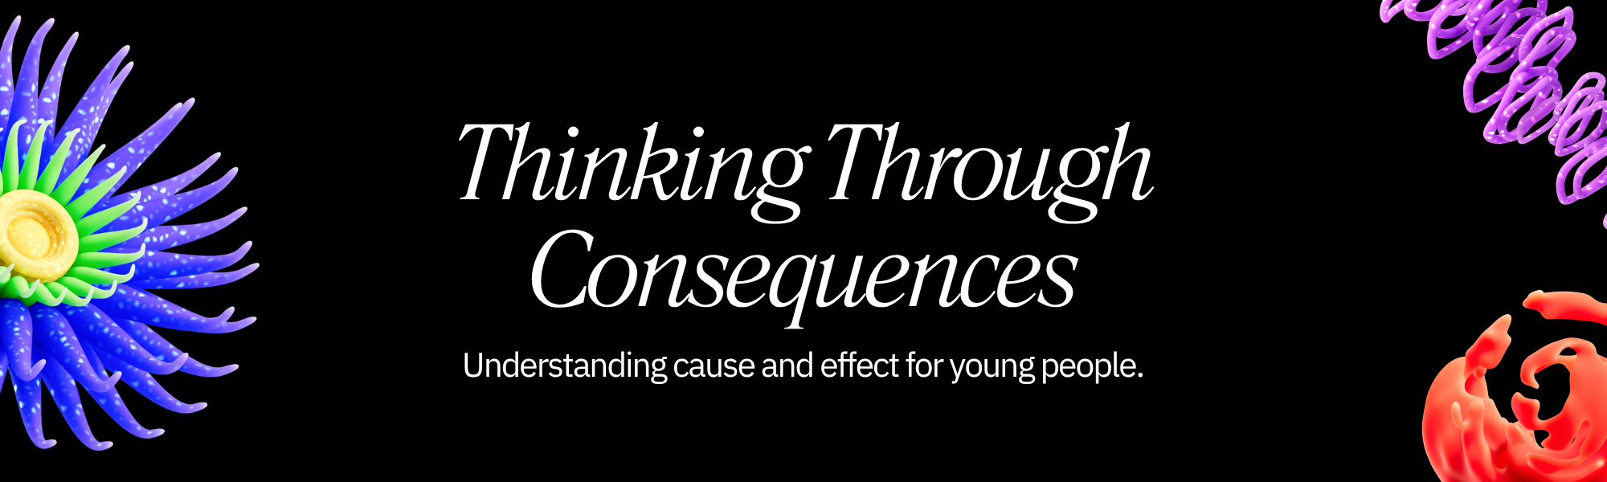
What Does It Mean to Think Through Consequences?
Making choices is a part of everyday life, from deciding what to wear to choosing your friends. Sometimes, the choices are easy, and other times, they can be tough. Thinking through consequences means stopping for a moment to consider what might happen after you make a decision. It's like being a detective for your own future!
Why is this important?
- Avoiding Trouble: Understanding potential negative outcomes can help you steer clear of difficult situations, like getting grounded, failing a test, or hurting someone's feelings.
- Making Better Decisions: When you think about the good things that might happen, you're more likely to choose paths that lead to success and happiness.
- Becoming Independent: Learning to weigh options and predict outcomes is a key skill for becoming a responsible and independent young adult.
- Building Stronger Relationships: Considering how your actions affect others helps you be a more thoughtful and considerate friend, sibling, and family member.
The "What If?" Game
One of the best ways to practice thinking through consequences is to play the "What If?" game. For any decision, big or small, ask yourself:
- What if I do this? What are the possible good things that could happen? What are the possible bad things that could happen?
- What if I don't do this? What are the possible good things that could happen? What are the possible bad things that could happen?
Let's try an example:
Decision: Your friend asks you to skip school to go to the store.
- What if I go to the store?
  - Good: It might be fun, I could get something I want, I'll be with my friend.
  - Bad: I could get caught and suspended, I'll miss important lessons, my parents will be angry, I might get a bad grade.
- What if I don't go to the store?
  - Good: I'll be in class and learn, I won't get in trouble, my parents will be happy, I'll be on track for good grades.
  - Bad: My friend might be mad at me, I might feel left out, I won't get to go shopping.
When you look at it like this, going to school seems like the better choice, even if it means missing out on fun that day. You're choosing a better long-term outcome!
Your Turn: Practice Activity
Choose one of the scenarios below or think of your own. Grab a piece of paper or your phone and play the "What If?" game. Write down the possible good and bad consequences for both actions.  Scenarios:  - Your best friend wants you to share their vape/e-cigarette.  - What if you say yes?  - What if you say no?  - You're tempted to download a game that costs money without asking your parents/guardian.  - What if you download it?  - What if you don't download it?  - You see someone being bullied online, and you know who it is.  - What if you report it?  - What if you don't report it?  - You have a big project due tomorrow but want to stay up late playing video games.  - What if you play games all night?  - What if you focus on your project? | After you've thought about the consequences:  - Which choice leads to the best outcome for you and others?  - What's one thing you learned from this exercise?  - How can you use this "What If?" game in your daily life?  Remember: Thinking through consequences doesn't mean you can never have fun or take risks. It means making sure the risks you take are worth it and that you're aware of what might happen. This skill will help you navigate challenges and build a future you're proud of!

