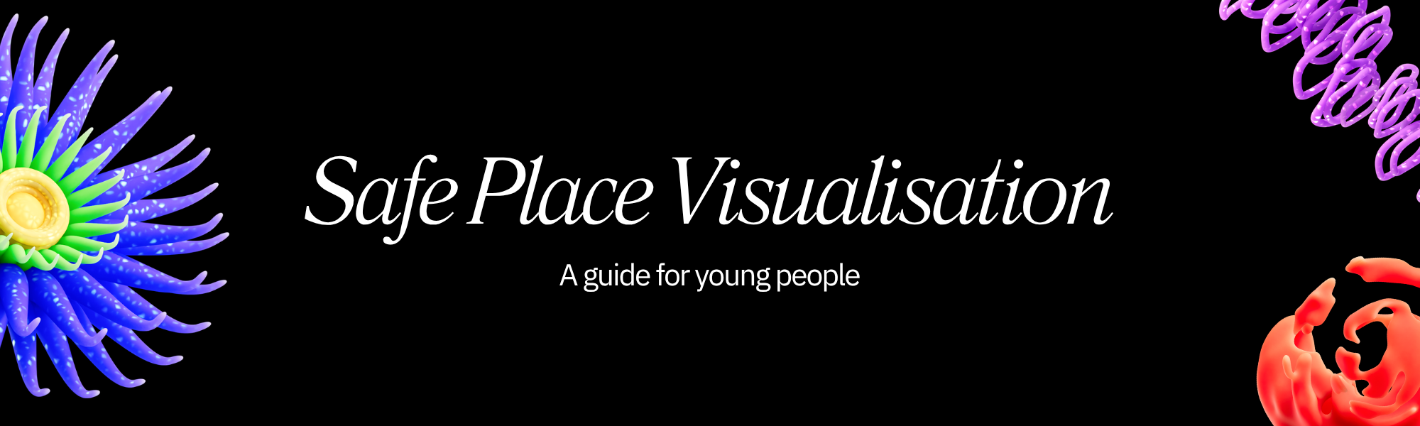
What is a Safe Place Visualisation?
A safe place visualisation is a technique used to help you feel calm and relaxed. It involves imagining a place where you feel completely safe, happy, and peaceful. This place can be real or imaginary, and it's totally unique to you!
Think of it like a secret hideaway in your mind where you can go whenever you feel stressed, worried, or just need a break from everything. It's a place where you are in control, and nothing bad can happen.
This technique is super helpful for managing feelings of anxiety, overwhelm, or when you're having a tough time. It's a tool you can use anywhere, anytime, to help bring you back to a feeling of calm.
Why Use a Safe Place?
✨ Reduces Stress and Anxiety: When you focus on your safe place, your mind shifts away from worries, helping to lower stress hormones.  ✨ Promotes Relaxation: The act of visualising a peaceful place can trigger your body's relaxation response.  ✨ Boosts Feelings of Control: In your safe place, you are in charge, which can be empowering when other things feel out of control. | ✨ Improves Mood: Focusing on positive and happy memories or imaginary scenes can lift your spirits.  ✨ Helps with Sleep: Using a safe place visualisation before bed can quiet a busy mind, making it easier to fall asleep.  ✨ A Personal Retreat: It's your own private sanctuary, available whenever you need a moment of peace.
Creating Your Safe Place: An Activity
Let's create your very own safe place! Find a quiet spot where you won't be disturbed for about 5-10 minutes.
Step 1: Get Comfortable
- Sit or lie down in a way that feels relaxed and comfortable.
- Gently close your eyes, or soften your gaze if closing them feels difficult.
- Take a few slow, deep breaths. Breathe in through your nose and out through your mouth. Feel your body start to relax with each breath.
Step 2: Choose Your Place
- Imagine a place where you feel completely safe and happy. This could be:
  - A cosy room in your house
  - A beautiful beach
  - A magical forest
  - A field of flowers
  - Even a place from a favourite book or movie!
Step 3: Engage Your Senses
- Now, let's bring your safe place to life using all your senses:
  - What do you SEE? Look around. What colours are there? What objects can you see? Are there any people or animals?
  - What do you HEAR? Listen carefully. Is there gentle music? The sound of waves? Birds chirping? A soft breeze?
  - What do you SMELL? Are there pleasant scents? Like flowers, the sea, fresh rain, or maybe your favourite food?
  - What do you FEEL? What is the temperature like? Is there a soft surface beneath you? Can you feel a gentle breeze or warmth from the sun?
  - What do you TASTE? Is there a sweet treat or a refreshing drink available?
Step 4: Feel the Safety
- As you experience your safe place with all your senses, notice how calm and relaxed you feel.
- Remind yourself that this is your special place, and you can return here whenever you need to.
Step 5: Returning
- When you're ready, slowly bring your awareness back to the room you are in.
- Take another deep breath, wiggle your fingers and toes, and gently open your eyes.
Remember: Keep practicing your safe place visualisation regularly, especially when you feel overwhelmed or stressed. You can even draw or write about your safe place to make it even more real for you. If you find it difficult to create a safe place on your own, don't hesitate to talk to a trusted adult, such as a parent, teacher, or school counsellor, who can help you.

