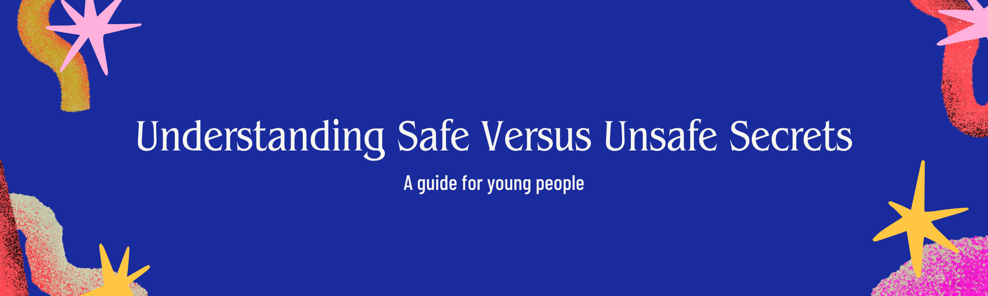
What is a Secret?
A secret is information that is kept hidden from others. Everyone has secrets, and that's okay! Secrets can be fun and personal, like a surprise birthday party you're planning, or a special diary entry. However, not all secrets are healthy or safe. It's important to know the difference.
Safe Secrets
Safe secrets are those that:
- Don't cause harm: They don't hurt you or anyone else, now or in the future.
- Are about positive or neutral things: Like a surprise gift, a personal goal, or a private thought.
- Make you feel good or neutral: They don't make you feel worried, scared, ashamed, or guilty.
- Are generally shared with one or a few trusted people: If you choose to share them.
Examples of safe secrets:
- Planning a surprise for a friend or family member.
- A personal dream or aspiration.
- A private journal entry.
- A funny inside joke with a friend.
- A crush you haven't told anyone about yet.
Unsafe Secrets
Unsafe secrets are those that:
- Cause harm or put you in danger: They involve abuse, neglect, illegal activities, or anything that could hurt you physically or emotionally.
- Make you feel bad: They often lead to feelings of fear, shame, guilt, confusion, or anxiety.
- Are about something wrong or illegal: This includes things like bullying, stealing, self-harm, or someone else being hurt.
- Are kept because someone is pressuring you or threatening you: If someone tells you to keep a secret and you feel scared if you don't, it's likely an unsafe secret.
- Involve someone else's inappropriate behavior: If someone is telling you secrets that are too adult or that make you uncomfortable, it's an unsafe secret.
Examples of unsafe secrets:
- Someone touching you inappropriately.
- Being asked to keep quiet about someone being hurt or in danger.
- Knowing about bullying that is happening.
- Someone forcing you to do something you don't want to do.
- Seeing or hearing about illegal activities.
- Being threatened if you tell anyone.
If you have an unsafe secret, it is NOT your fault, and you DO NOT have to keep it.
What to Do with Unsafe Secrets
The most important thing to remember is that you are not alone, and you deserve to be safe. If you are holding onto an unsafe secret, please talk to a trusted adult. This could be:
- A parent or guardian
- A teacher
- A school counselor
- Another family member you trust
- A doctor
- A helpline or crisis line (like Childline or Kids Help Phone - numbers can be found online or by asking a trusted adult).
Talking about an unsafe secret is the first step to getting help and feeling safe again. The adult you talk to is there to support you and help you figure out the best way to handle the situation.
Activity: Secret Sort!
Let's test your understanding! Read the following scenarios and decide if each one sounds like a safe secret or an unsafe secret. Think about how the secret makes the person feel and if it involves harm or danger.
Scenarios:
- Scenario: You are planning a surprise birthday party for your best friend and you don't want them to find out.
  - Safe Secret / Unsafe Secret
- Scenario: Someone at school is telling you they sometimes get hit by their parents when they misbehave, and they made you promise not to tell anyone.
  - Safe Secret / Unsafe Secret
- Scenario: You wrote a poem that is very personal about your feelings, and you're keeping it in a locked diary.
  - Safe Secret / Unsafe Secret
- Scenario: A classmate asks you to help them cheat on a test, and they say they'll tell everyone you're a snitch if you don't.
  - Safe Secret / Unsafe Secret
- Scenario: You found a wallet with money inside and you're deciding whether to turn it in or keep it.
  - Safe Secret / Unsafe Secret
- Scenario: Your older sibling is showing you how to vape and telling you not to tell your parents because they'll take it away.
  - Safe Secret / Unsafe Secret
Answers:
- Safe Secret: This is a fun surprise that brings joy.
- Unsafe Secret: This involves potential harm and needs to be reported to a trusted adult.
- Safe Secret: This is personal and doesn't cause harm.
- Unsafe Secret: This involves pressure, dishonesty, and potential negative social consequences.
- Unsafe Secret: Keeping something that isn't yours is wrong and can lead to trouble. It's best to turn it in.
- Unsafe Secret: This involves risky behavior (vaping) and potential harm, and it's being hidden from responsible adults.
Remember, if you ever feel unsure about a secret, it's always best to talk to a trusted adult. Your safety and well-being are the most important things! You are not alone, and help is available!

