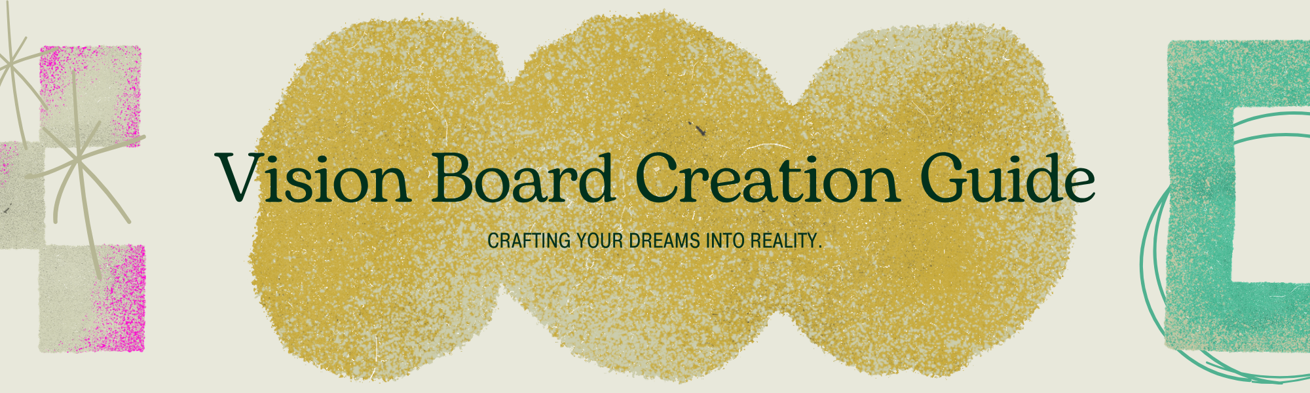
What is a Vision Board?
A vision board is a visual representation of your goals, dreams, and aspirations. It's a collage of images, words, and affirmations that inspire you and keep your desires top of mind. Think of it as a roadmap to your future, a tangible reminder of what you want to achieve and experience in your life. By creating a vision board, you tap into the power of visualisation, a technique that has been used for centuries to help individuals manifest their desires.
Why Create a Vision Board?
Vision boards are more than just pretty pictures; they are powerful tools for personal growth and goal achievement. Here's why you should consider creating one:
- Clarifies Your Goals: The process of creating a vision board forces you to think deeply about what you truly want in different areas of your life; career, relationships, health, personal development and more. This clarity is the first step towards achieving anything.
- Keeps You Motivated: Your vision board serves as a constant visual reminder of your aspirations. When you see it daily, it reinforces your motivation and helps you stay focused, especially during challenging times.
- Harnesses the Law of Attraction: Many believe that by focusing on what you want with strong emotion and belief, you attract those things into your life. A vision board amplifies this focus and intention.
- Enhances Creativity: Designing your vision board is a creative process that allows you to express yourself and connect with your inner desires on a deeper level.
- Provides a Sense of Hope and Optimism: Seeing your dreams visualised can instill a powerful sense of hope and optimism, making your goals feel more attainable.
How to Create Your Vision Board
Step 1: Gather Your Materials  - A Board: This can be a corkboard, poster board, foam board, or even a blank canvas.  - Images: Cut out pictures from magazines, print them from online sources, or use your own photographs.  - Words and Quotes: Find inspiring words, phrases, and affirmations that resonate with you.  - Art Supplies: Markers, pens, stickers, glue, scissors, etc.  - Optional: Small objects, trinkets, or symbols that represent your goals.  Step 2: Reflect and Visualize  Take some quiet time to reflect on what you want to achieve. Ask yourself:  - What are my biggest dreams?  - What do I want my life to look like in one year? Five years? Ten years?  - What experiences do I want to have?  - What kind of person do I want to become?  Try to visualise yourself already living these dreams | Step 3: Curate Your Content  As you find images and words, set them aside if they evoke a strong positive feeling or directly represent a goal. Don't overthink it; trust your intuition.  Step 4: Assemble Your Board  Arrange your chosen images and words on your board. Play with different layouts until it feels visually appealing and inspiring to you. Once you're happy with the arrangement, glue or pin everything down.  Step 5: Place and Engage  Display your vision board in a place where you will see it every single day: your bedroom, bathroom, or even your main living area. Make it a habit to look at it, feel the emotions associated with your goals, and remind yourself of your vision.
Your Vision Board Activity
Now it's your turn to create! Dedicate some time this week to build your vision board. Follow the steps above, and most importantly, have fun with the process. Let your imagination and desires guide you. Remember, your vision board is a personal tool, so make it unique to you. Happy creating!

