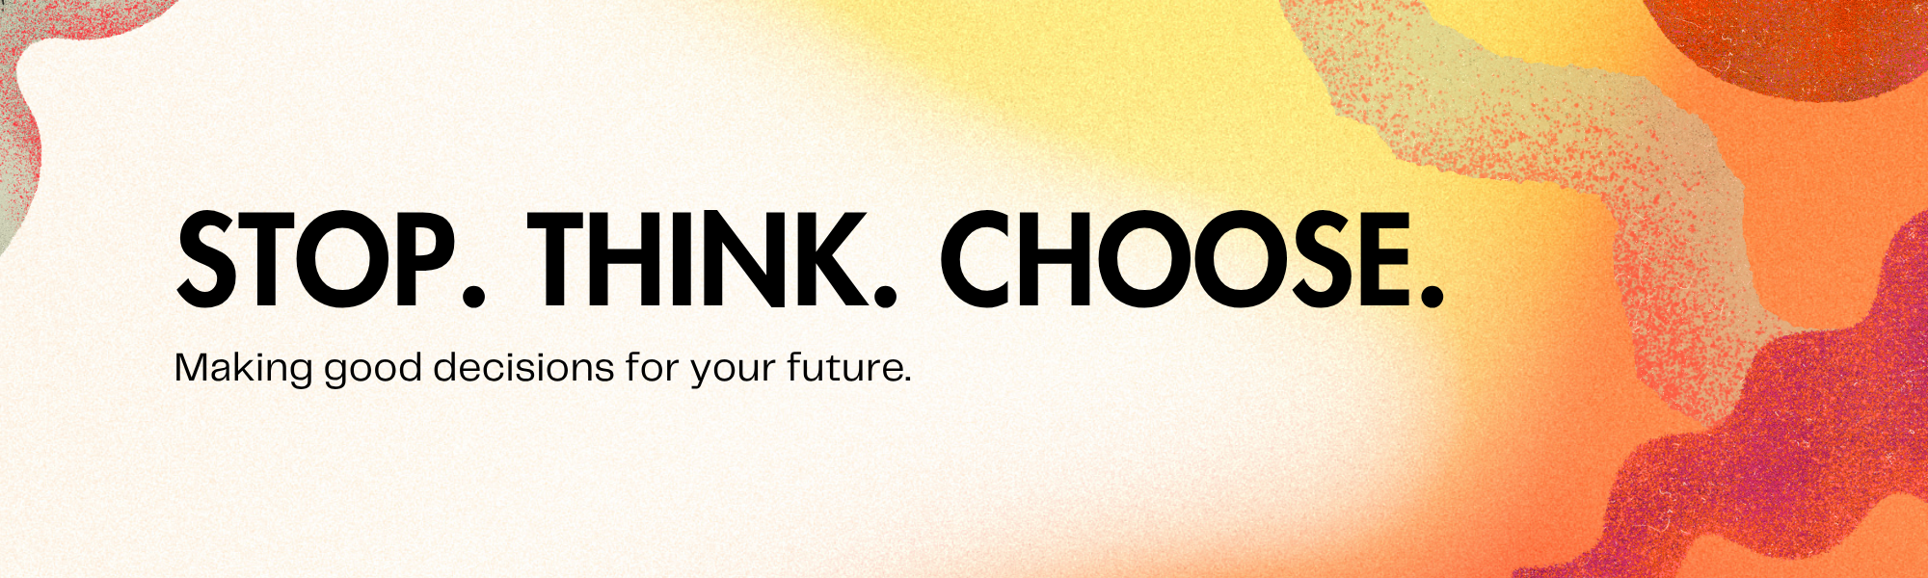
What is it?
The "Stop. Think. Choose." strategy is a simple yet powerful tool to help you navigate tricky situations and make decisions that are good for you. It's like having a superhero power for your brain that helps you pause before you react, figure out what's going on, and then pick the best path forward.
Think of it like this:
- Stop: When you feel a strong emotion like anger, frustration, or even excitement that makes you want to act super fast, your first step is to STOP. This means taking a moment to breathe and not rush into anything.
- Think: Once you've stopped, it's time to THINK. Ask yourself questions like:
  - What's happening right now?
  - How am I feeling?
  - What do I want to happen?
  - What are the possible ways I could react?
  - What might happen if I choose each option?
- Choose: After you've stopped and thought, you can CHOOSE. This is where you pick the action that you think will lead to the best outcome for yourself and others. It might be speaking up, walking away, asking for help, or trying something new.
This strategy is super useful for all sorts of things, from dealing with friends and family to handling schoolwork and making choices about your free time. It helps you feel more in control and less likely to do something you might regret later.
Why is "Stop. Think. Choose." Important for You?
As a young person, you're growing and learning so much every day! Your brain is still developing, especially the part that helps you think before you act. This makes it extra important to practice skills that help you:
- Manage your emotions: Sometimes feelings can be really big and overwhelming. "Stop. Think. Choose." gives you a way to handle these feelings without letting them take over.
- Solve problems: You'll face all sorts of challenges, big and small. This strategy helps you break down problems and find solutions.
- Build better relationships: By thinking before you speak or act, you're more likely to say and do things that make your friendships and family relationships stronger.
- Stay safe: Sometimes impulsive decisions can lead to risky situations. "Stop. Think. Choose." helps you make safer choices.
- Feel more confident: When you make good decisions, you feel better about yourself and more capable of handling whatever comes your way.
Activity: Put "Stop. Think. Choose." into Action!
Let's try a practice scenario. Read the situation below and then use the "Stop. Think. Choose." steps to figure out what you would do.
Scenario:
You're hanging out with your friends, and one of them starts teasing another friend about their new haircut. The friend being teased looks upset, but your other friends are laughing along. You feel a bit uncomfortable.
Your Turn:
- STOP: What do you do first?
  - Example: Take a deep breath and remind yourself not to jump in immediately.
- THINK: What questions can you ask yourself?
  - Example: How is the friend being teased feeling? Is this really funny to everyone? What could happen if I say something? What could happen if I don't?
- CHOOSE: What is your best choice of action? What would you say or do?
  - Example: I could say, "Hey, I don't think that's very nice." or "Let's change the subject." or I could go stand by the friend who looks upset.
Now, think about another situation you might face and walk through the "Stop. Think. Choose." steps yourself!
Remember, practicing "Stop. Think. Choose." will make it easier and more natural over time. It's a skill that will help you throughout your life!

