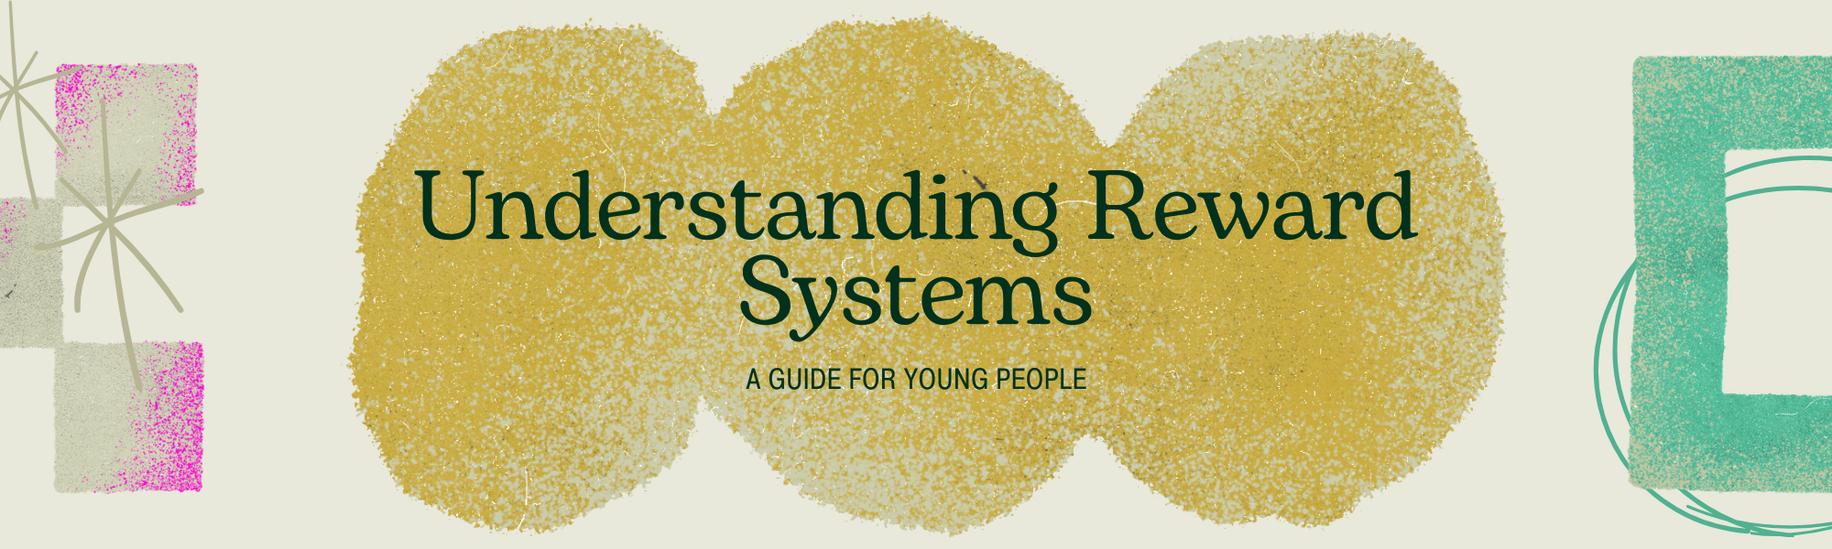
What's the Big Deal About Rewards?
Imagine you're playing your favorite video game. What keeps you going? It's usually the thought of leveling up, getting cool new gear, or beating that tough boss, right? That's a reward system in action!
In simple terms, a reward system is anything that makes you feel good when you accomplish something. It's like your brain's way of saying, "Awesome job! Let's do that again!"
These rewards can be:
- Tangible: Things you can touch, like a sticker, a piece of candy, or a new toy.
- Intangible: Things you can't touch, like praise from a friend, a feeling of pride, or getting to choose what to watch on TV.
- Internal: Feelings you get from within, like satisfaction, accomplishment, or happiness.
- External: Rewards that come from outside yourself, like points, treats, or privileges.
Our brains are wired to seek out rewards. It's a natural part of how we learn and grow. When we get a reward, our brain releases chemicals like dopamine, which makes us feel happy and motivated. This makes us more likely to repeat the behavior that led to the reward.
Why Reward Systems Matter for You
Reward systems aren't just for little kids or pets! They can be super helpful for young people like you in many ways:
- Boosting Motivation: Feeling stuck on homework or a chore? A small reward can give you the push you need to get started and finish.
- Building Good Habits: Want to read more, practice an instrument, or drink more water? Setting up a reward for hitting your daily or weekly goals can make it easier to stick with it.
- Celebrating Achievements: Big or small, every accomplishment deserves a cheer! Rewards help you recognize and appreciate your hard work.
- Making Tasks Fun: Let's be honest, some things can be a bit boring. A reward system can add an element of excitement and turn a tedious task into something you look forward to.
- Developing Self-Control: Learning to work towards a future reward teaches you patience and self-discipline, which are super important skills for life.
Creating Your Own Awesome Reward System
Your Mission: Design Your Dream Reward System!
Step 1: Pick Your Goal!
What is something you want to achieve or a habit you want to build? Be specific!
- Examples: Finish all my homework by 7 PM every night, practice guitar for 30 minutes daily, help out with a chore without being asked, read one chapter of a book each day.
Your Goal: _____________________________________________________________
Step 2: Brainstorm Your Rewards!
Think about things you really like. Mix tangible and intangible rewards. What would make you feel happy and motivated?
- Examples: Extra screen time, choosing dinner one night, a small treat, a new sticker, a compliment from a family member, listening to your favorite music, a fun outing with friends, a new game or app.
Your Awesome Rewards:
Step 3: Set Up the Rules!
How will you earn your rewards? Be clear about what you need to do.
- Small Reward (for small steps/daily tasks): For example, if you complete X, you get reward Y.
  - Example: If I finish my math homework, I get 30 extra minutes of phone time.
- My Small Reward Rule: ___________________________________________________
- Big Reward (for bigger goals/consistency over a week): For example, if you achieve Z for a whole week, you get reward A.
  - Example: If I practice football for 30 minutes every day for a week, I can choose a new movie to watch.
- My Big Reward Rule: ____________________________________________________
Step 4: Track Your Progress!
How will you keep track of what you've done? You could use a chart, a sticker book, or a simple note on your phone.
My Tracking Method: _____________________________________________________
Step 5: Make it Happen & Have Fun!
Start using your reward system! Remember, the goal is to make progress and feel good about it. If something isn't working, don't be afraid to tweak your rules or rewards. It's your system!
Bonus Tip: Sometimes, the best reward is the feeling of accomplishment itself. Notice how good it feels when you achieve your goals!
Let’s Reflect!
Think about the reward system you just designed. What makes it exciting for you? What challenges might you face, and how can you overcome them? Remember, building good habits and achieving goals is a journey, and reward systems are fantastic tools to help you along the way!

