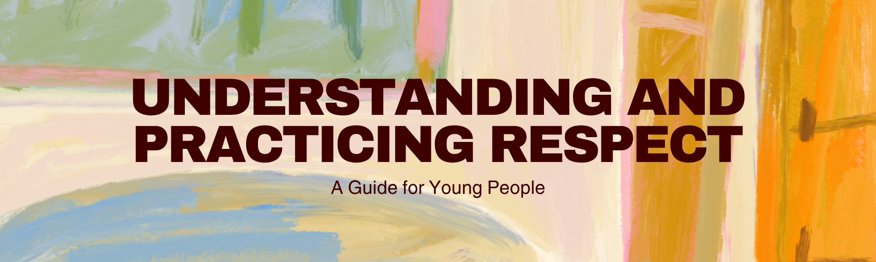
What is Respect?
Respect is a fundamental concept that underpins healthy relationships and a positive society. At its core, respect means showing consideration and admiration for others. It's about valuing people for who they are, even if they are different from you. This includes recognizing their feelings, rights, and opinions. When you show respect, you are acknowledging their inherent worth as human beings.
Respect isn't just about being polite, though politeness is a part of it. It's about a deeper understanding and appreciation of individuality. This means respecting:
- Differences: People come from diverse backgrounds, have different beliefs, and may look or act differently. Respect means accepting and valuing these differences.
- Boundaries: Everyone has personal boundaries. Respecting these means not pushing or crossing lines that make others uncomfortable.
- Feelings: Being mindful of how your words and actions might affect others emotionally.
- Opinions: Even if you disagree with someone, respecting their right to have their own opinion is important.
- Property: Taking care of things that belong to others and asking permission before using them.
Practicing respect creates a positive environment where everyone feels safe, valued, and heard. It reduces conflict and builds stronger, more trusting relationships.
Why is Respect Important?
When you show respect, you:  - Build Trust: People are more likely to trust and open up to those who treat them with consideration.  - Prevent Conflict: Many arguments and disagreements stem from a lack of respect. Showing it can de-escalate tense situations.  - Foster Stronger Relationships: Whether with friends, family, or teachers, mutual respect creates bonds that last.  - Promote Inclusivity: A respectful environment welcomes everyone, making them feel like they belong.  - Develop Empathy: Understanding and respecting others' perspectives helps you develop empathy, the ability to understand and share the feelings of another. | However, a lack of respect can lead to:  - Misunderstandings: When people don't feel heard or valued, communication breaks down.  - Bullying and Harassment: Disrespect can manifest as aggression, exclusion, or hurtful behavior.  - Damaged Relationships: Repeated disrespect erodes trust and can lead to broken friendships and family rifts.  - Negative Environments: Schools and communities where respect is lacking can feel unsafe and unwelcoming.  Learning to give and receive respect is a vital life skill that will benefit you throughout your life.
How to Practice Respect
Practicing respect involves conscious effort in your daily interactions. Here are some practical ways to show respect:
- Listen Actively: When someone is speaking, give them your full attention. Try to understand their point of view without interrupting. Nodding and making eye contact shows you're engaged.
- Speak Kindly and Thoughtfully: Choose your words carefully. Avoid gossip, insults, or harsh criticism. Even when you disagree, express your thoughts calmly and constructively.
- Be Punctual: Respecting others' time by arriving on time for appointments, classes, or meetings shows you value their schedule.
- Ask for Permission: Before borrowing something or entering someone's personal space (like their room), always ask first.
- Respect Personal Space: Be aware of how close you stand to others and avoid touching people without their consent.
- Acknowledge Everyone: Make an effort to greet people, even if you don't know them well. A simple "hello" can make a difference.
- Be Honest: Honesty is a form of respect. It shows you value the relationship and the other person enough to be truthful.
- Apologize When Necessary: If you make a mistake or hurt someone's feelings, a sincere apology is a sign of respect for their feelings and the relationship.
- Respect Authority and Rules: Follow the rules set by parents, teachers, and community guidelines. This shows respect for the structures that help keep things organized and safe.
Activity: Respect Scenarios
Let's put your understanding of respect into practice! Read the following scenarios and think about how you would respond respectfully. Discuss your answers with a friend, family member, or group.
Scenario 1:
Your friend is wearing an outfit you don't like and asks for your opinion. How can you be honest without being hurtful?
Scenario 2:
You're in a group project at school, and one member isn't contributing much. How can you address this respectfully?
Scenario 3:
Someone cuts in front of you in the lunch line. What's a respectful way to handle this?
Scenario 4:
You overhear classmates making fun of another student's accent. What can you do?
Scenario 5:
You accidentally break a borrowed item belonging to a friend. What's the most respectful course of action?
Think about:
- What are the feelings of the people involved?
- What is the most respectful way to communicate in each situation?
- What are the potential consequences of different responses?
Respect is a powerful tool for building positive connections and a harmonious environment. By actively practicing respect in all your interactions, you contribute to a better world for yourself and everyone around you. Remember, respect is a two-way street, when you give it, you are more likely to receive it in return.

