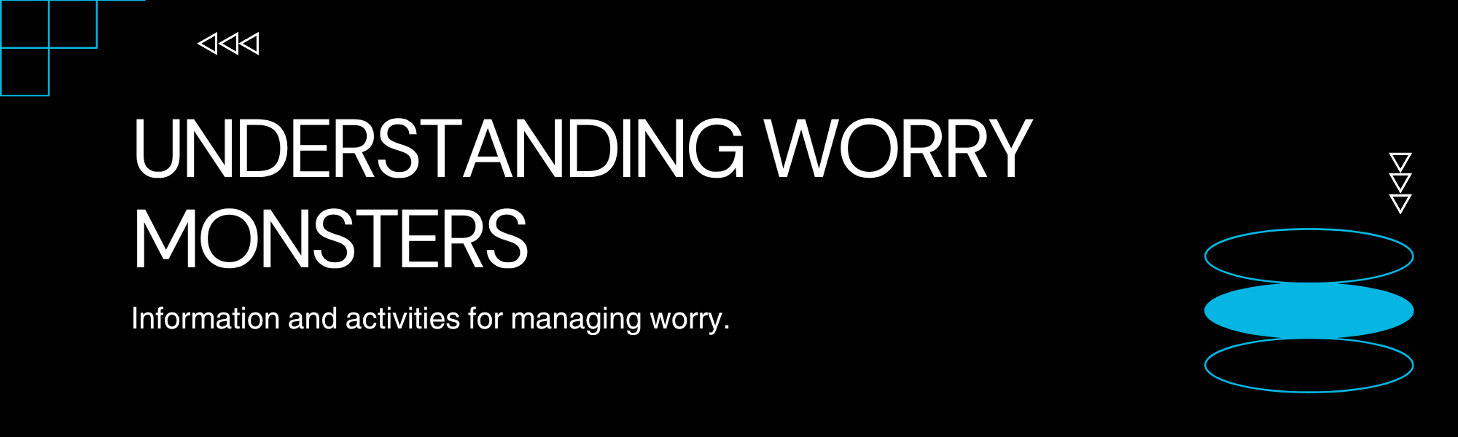
What is a Worry Monster?
A worry monster is a metaphorical creature that represents your worries and anxieties. It's an imaginative way to visualise and externalise those nagging thoughts and feelings that can sometimes feel overwhelming. Just like a real monster, a worry monster can seem big and scary, but by understanding it, we can learn to manage it effectively.
Think of your worry monster as a companion that feeds on your concerns. The more you focus on your worries, the bigger and stronger your worry monster becomes. However, the good news is that you have the power to shrink your worry monster by addressing your worries and developing coping strategies.
Why Do We Have Worry Monsters?
Everyone experiences worries. They are a natural part of life and can sometimes serve as a signal that something needs attention. However, when worries become excessive or persistent, they can start to interfere with our daily lives, our happiness, and our ability to function.
These persistent worries can be fueled by many things, including:
- Uncertainty: Not knowing what will happen can trigger anxiety.
- Past Experiences: Negative events can make us fear similar outcomes.
- Perfectionism: The pressure to be perfect can lead to constant worry about mistakes.
- Overthinking: Ruminating on problems without finding solutions.
Recognizing when your worry monster is getting too big is the first step to taming it.
How to Tame Your Worry Monster
Here are some effective strategies to help you manage and shrink your worry monster:  - Acknowledge Your Worries: Don't try to ignore your worries. Instead, acknowledge them and write them down. This can help you see them more clearly and objectively.  - Challenge Your Worries: Ask yourself: Is this worry realistic? What's the worst that could happen? How likely is that to happen? Often, challenging your worries can reduce their power.  - Problem-Solve: If a worry is about a solvable problem, break it down into smaller steps and create a plan to address it.  - Practice Mindfulness: Focus on the present moment. Engage your senses to ground yourself and reduce anxious thoughts about the past or future.  - Healthy Lifestyle: Ensure you're getting enough sleep, eating nutritious food, and engaging in physical activity. These all contribute to better mental well-being. | Here's an activity to help you visualise and interact with your worry monster:  Create Your Worry Monster Jar  You will need:  - A clean jar or container  - Paper and pens/pencils  Instructions:  - Decorate Your Jar: Make your jar a safe and special place. You can paint it, cover it with decorative paper, or simply leave it as is.  - Write Down Your Worries: On small pieces of paper, write down each worry you have. Be specific! For example, instead of 'school,' write 'worrying about my math test.'  - Feed Your Monster: Fold up the pieces of paper and place them inside your worry monster jar. Imagine you are feeding your worries to the jar, so they are contained and not swirling around in your head.  - Visit Your Jar: When you feel overwhelmed with worry, you can look at your jar. You don't have to take the worries out, but knowing they are contained can be comforting. You can also choose to take one out and try to problem-solve it, or simply acknowledge that it's there but you are choosing to focus on something else.  - Empty Your Jar (Optional): Periodically, you might choose to take out the worries and review them. Some you might have solved, some might seem less important now, and some might still need attention. Dispose of the papers in a way that feels right for you (e.g., shredding, burning safely, or just throwing them away).
Summary
Worry monsters are a helpful tool for understanding and managing our anxieties. By acknowledging, challenging, and actively working through our worries, we can reduce their power and improve our overall well-being. The "Worry Monster Jar" activity provides a tangible way to externalise worries and practice coping strategies, helping you feel more in control of your anxious thoughts.

