PRESERVE.
SET DECIMAL DOT.

GET DATA /TYPE=TXT
/FILE="\\andrew.ad.cmu.edu\users\users14\uhq\Desktop\VisualLab\csv\colorContextCuration.csv"
/ENCODING='UTF8'
/DELIMITERS=","
/QUALIFIER='"'
/ARRANGEMENT=DELIMITED
/FIRSTCASE=2
/DATATYPEMIN PERCENTAGE=95.0
/VARIABLES=
Subject AUTO
contextandcolorshort AUTO
nocontextandcolorshort AUTO
contextandnocolorshort AUTO
nocontextandnocolorshort AUTO
contextandcolorlong AUTO
nocontextandcolorlong AUTO
contextandnocolorlong AUTO
nocontextandnocolorlong AUTO
/MAP.
RESTORE.
CACHE.
EXECUTE.

Data written to the working file.
9 variables and 15 cases written.
Variable: Subject Type: Number Format : F4
Variable: contextandcolorshort Type: Number Format : F1
Variable: nocontextandcolorshort Type: Number Format : F1
Variable: contextandnocolorshort Type: Number Format : F1
Variable: nocontextandnocolorshort Type: Number Format : F1
Variable: contextandcolorlong Type: Number Format : F1
Variable: nocontextandcolorlong Type: Number Format : F1
Variable: contextandnocolorlong Type: Number Format : F1
Variable: nocontextandnocolorlong Type: Number Format : F1

DATASET NAME DataSet1 WINDOW=FRONT.
GLM nocontextandnocolorshort nocontextandnocolorlong nocontextandcolorshort nocontextandcolorlong
contextandnocolorshort contextandnocolorlong contextandcolorshort contextandcolorlong
/WSFACTOR=color 2 Polynomial context 2 Polynomial duration 2 Polynomial
/MEASURE=numImagesRecalled
/METHOD=SSTYPE(3)
/PLOT=PROFILE(color context duration color*context context*duration color*duration
color*context*duration)
/EMMEANS=TABLES(color) COMPARE ADJ(BONFERRONI)
/EMMEANS=TABLES(context) COMPARE ADJ(BONFERRONI)
/EMMEANS=TABLES(duration) COMPARE ADJ(BONFERRONI)
/EMMEANS=TABLES(color*context)
/EMMEANS=TABLES(color*duration)
/EMMEANS=TABLES(context*duration)
/EMMEANS=TABLES(color*context*duration)
/PRINT=DESCRIPTIVE ETASQ OPOWER
/CRITERIA=ALPHA(.05)
/WSDESIGN=color context duration color*context color*duration context*duration
color*context*duration.

General Linear Model

[DataSet1]

Within-Subjects Factors
Measure: numImagesRecalled
color | context | duration | Dependent Variable
1 | 1 | 1 | nocontextandnocolorshort
1 | 1 | 2 | nocontextandnocolorlong
1 | 2 | 1 | nocontextandcolorshort
1 | 2 | 2 | nocontextandcolorlong
2 | 1 | 1 | contextandnocolorshort
2 | 1 | 2 | contextandnocolorlong
2 | 2 | 1 | contextandcolorshort
2 | 2 | 2 | contextandcolorlong

Descriptive Statistics
 | Mean | Std. Deviation | N
nocontextandnocolorshort | 1.73 | 1.100 | 15
nocontextandnocolorlong | 2.13 | 1.125 | 15
nocontextandcolorshort | 1.67 | 1.047 | 15
nocontextandcolorlong | 2.60 | 1.352 | 15
contextandnocolorshort | 1.67 | 1.113 | 15
contextandnocolorlong | 2.33 | 1.047 | 15
contextandcolorshort | 1.67 | 1.047 | 15
contextandcolorlong | 2.13 | .915 | 15

Multivariate Testsª
Effect |  | Value | F | Hypothesis df | Error df | Sig.
color | Pillai's Trace | .015 | .210^{b} | 1.000 | 14.000 | .654
color | Wilks' Lambda | .985 | .210^{b} | 1.000 | 14.000 | .654
color | Hotelling's Trace | .015 | .210^{b} | 1.000 | 14.000 | .654
color | Roy's Largest Root | .015 | .210^{b} | 1.000 | 14.000 | .654
context | Pillai's Trace | .003 | .042^{b} | 1.000 | 14.000 | .841
context | Wilks' Lambda | .997 | .042^{b} | 1.000 | 14.000 | .841
context | Hotelling's Trace | .003 | .042^{b} | 1.000 | 14.000 | .841
context | Roy's Largest Root | .003 | .042^{b} | 1.000 | 14.000 | .841
duration | Pillai's Trace | .504 | 14.239^{b} | 1.000 | 14.000 | .002
duration | Wilks' Lambda | .496 | 14.239^{b} | 1.000 | 14.000 | .002
duration | Hotelling's Trace | 1.017 | 14.239^{b} | 1.000 | 14.000 | .002
duration | Roy's Largest Root | 1.017 | 14.239^{b} | 1.000 | 14.000 | .002
color * context | Pillai's Trace | .030 | .431^{b} | 1.000 | 14.000 | .522
color * context | Wilks' Lambda | .970 | .431^{b} | 1.000 | 14.000 | .522
color * context | Hotelling's Trace | .031 | .431^{b} | 1.000 | 14.000 | .522
color * context | Roy's Largest Root | .031 | .431^{b} | 1.000 | 14.000 | .522
color * duration | Pillai's Trace | .003 | .040^{b} | 1.000 | 14.000 | .844
color * duration | Wilks' Lambda | .997 | .040^{b} | 1.000 | 14.000 | .844
color * duration | Hotelling's Trace | .003 | .040^{b} | 1.000 | 14.000 | .844
color * duration | Roy's Largest Root | .003 | .040^{b} | 1.000 | 14.000 | .844
context * duration | Pillai's Trace | .023 | .327^{b} | 1.000 | 14.000 | .576
context * duration | Wilks' Lambda | .977 | .327^{b} | 1.000 | 14.000 | .576
context * duration | Hotelling's Trace | .023 | .327^{b} | 1.000 | 14.000 | .576
context * duration | Roy's Largest Root | .023 | .327^{b} | 1.000 | 14.000 | .576
color * context * duration | Pillai's Trace | .117 | 1.853^{b} | 1.000 | 14.000 | .195
color * context * duration | Wilks' Lambda | .883 | 1.853^{b} | 1.000 | 14.000 | .195
color * context * duration | Hotelling's Trace | .132 | 1.853^{b} | 1.000 | 14.000 | .195
color * context * duration | Roy's Largest Root | .132 | 1.853^{b} | 1.000 | 14.000 | .195

Multivariate Testsª
Effect |  | Partial Eta Squared | Noncent. Parameter | Observed Power^{c}
color | Pillai's Trace | .015 | .210 | .071
color | Wilks' Lambda | .015 | .210 | .071
color | Hotelling's Trace | .015 | .210 | .071
color | Roy's Largest Root | .015 | .210 | .071
context | Pillai's Trace | .003 | .042 | .054
context | Wilks' Lambda | .003 | .042 | .054
context | Hotelling's Trace | .003 | .042 | .054
context | Roy's Largest Root | .003 | .042 | .054
duration | Pillai's Trace | .504 | 14.239 | .939
duration | Wilks' Lambda | .504 | 14.239 | .939
duration | Hotelling's Trace | .504 | 14.239 | .939
duration | Roy's Largest Root | .504 | 14.239 | .939
color * context | Pillai's Trace | .030 | .431 | .094
color * context | Wilks' Lambda | .030 | .431 | .094
color * context | Hotelling's Trace | .030 | .431 | .094
color * context | Roy's Largest Root | .030 | .431 | .094
color * duration | Pillai's Trace | .003 | .040 | .054
color * duration | Wilks' Lambda | .003 | .040 | .054
color * duration | Hotelling's Trace | .003 | .040 | .054
color * duration | Roy's Largest Root | .003 | .040 | .054
context * duration | Pillai's Trace | .023 | .327 | .083
context * duration | Wilks' Lambda | .023 | .327 | .083
context * duration | Hotelling's Trace | .023 | .327 | .083
context * duration | Roy's Largest Root | .023 | .327 | .083
color * context * duration | Pillai's Trace | .117 | 1.853 | .245
color * context * duration | Wilks' Lambda | .117 | 1.853 | .245
color * context * duration | Hotelling's Trace | .117 | 1.853 | .245
color * context * duration | Roy's Largest Root | .117 | 1.853 | .245

a. Design: Intercept
Within Subjects Design: color + context + duration + color * context + color * duration + context * duration + color * context * duration
b. Exact statistic
c. Computed using alpha = .05

Mauchly's Test of Sphericityª
Measure: numImagesRecalled
Within Subjects Effect | Mauchly's W | Approx. Chi-Square | df | Sig. | Epsilon^{b}
 |  |  |  |  | Greenhouse-Geisser
color | 1.000 | .000 | 0 | . | 1.000
context | 1.000 | .000 | 0 | . | 1.000
duration | 1.000 | .000 | 0 | . | 1.000
color * context | 1.000 | .000 | 0 | . | 1.000
color * duration | 1.000 | .000 | 0 | . | 1.000
context * duration | 1.000 | .000 | 0 | . | 1.000
color * context * duration | 1.000 | .000 | 0 | . | 1.000

Mauchly's Test of Sphericityª
Measure: numImagesRecalled
Within Subjects Effect | Epsilon
Within Subjects Effect | Huynh-Feldt | Lower-bound
color | 1.000 | 1.000
context | 1.000 | 1.000
duration | 1.000 | 1.000
color * context | 1.000 | 1.000
color * duration | 1.000 | 1.000
context * duration | 1.000 | 1.000
color * context * duration | 1.000 | 1.000

Tests the null hypothesis that the error covariance matrix of the orthonormalized transformed dependent variables is proportional to an identity matrix.ª
a. Design: Intercept
Within Subjects Design: color + context + duration + color * context + color * duration + context * duration + color * context * duration
b. May be used to adjust the degrees of freedom for the averaged tests of significance. Corrected tests are displayed in the Tests of Within-Subjects Effects table.

Tests of Within-Subjects Effects
Measure: numImagesRecalled
Source |  | Type III Sum of Squares | df | Mean Square | F | Sig. | Partial Eta Squared | Noncent. Parameter | Observed Powerª
color | Sphericity Assumed | .208 | 1 | .208 | .210 | .654 | .015 | .210 | .071
color | Greenhouse-Geisser | .208 | 1.000 | .208 | .210 | .654 | .015 | .210 | .071
color | Huynh-Feldt | .208 | 1.000 | .208 | .210 | .654 | .015 | .210 | .071
color | Lower-bound | .208 | 1.000 | .208 | .210 | .654 | .015 | .210 | .071
Error(color) | Sphericity Assumed | 13.917 | 14 | .994
Error(color) | Greenhouse-Geisser | 13.917 | 14.000 | .994
Error(color) | Huynh-Feldt | 13.917 | 14.000 | .994
Error(color) | Lower-bound | 13.917 | 14.000 | .994
context | Sphericity Assumed | .075 | 1 | .075 | .042 | .841 | .003 | .042 | .054
context | Greenhouse-Geisser | .075 | 1.000 | .075 | .042 | .841 | .003 | .042 | .054
context | Huynh-Feldt | .075 | 1.000 | .075 | .042 | .841 | .003 | .042 | .054
context | Lower-bound | .075 | 1.000 | .075 | .042 | .841 | .003 | .042 | .054
Error(context) | Sphericity Assumed | 25.050 | 14 | 1.789
Error(context) | Greenhouse-Geisser | 25.050 | 14.000 | 1.789
Error(context) | Huynh-Feldt | 25.050 | 14.000 | 1.789
Error(context) | Lower-bound | 25.050 | 14.000 | 1.789
duration | Sphericity Assumed | 11.408 | 1 | 11.408 | 14.239 | .002 | .504 | 14.239 | .939
duration | Greenhouse-Geisser | 11.408 | 1.000 | 11.408 | 14.239 | .002 | .504 | 14.239 | .939
duration | Huynh-Feldt | 11.408 | 1.000 | 11.408 | 14.239 | .002 | .504 | 14.239 | .939
duration | Lower-bound | 11.408 | 1.000 | 11.408 | 14.239 | .002 | .504 | 14.239 | .939
Error(duration) | Sphericity Assumed | 11.217 | 14 | .801
Error(duration) | Greenhouse-Geisser | 11.217 | 14.000 | .801
Error(duration) | Huynh-Feldt | 11.217 | 14.000 | .801
Error(duration) | Lower-bound | 11.217 | 14.000 | .801
color * context | Sphericity Assumed | .675 | 1 | .675 | .431 | .522 | .030 | .431 | .094
color * context | Greenhouse-Geisser | .675 | 1.000 | .675 | .431 | .522 | .030 | .431 | .094
color * context | Huynh-Feldt | .675 | 1.000 | .675 | .431 | .522 | .030 | .431 | .094
color * context | Lower-bound | .675 | 1.000 | .675 | .431 | .522 | .030 | .431 | .094
Error(color*context) | Sphericity Assumed | 21.950 | 14 | 1.568
Error(color*context) | Greenhouse-Geisser | 21.950 | 14.000 | 1.568
Error(color*context) | Huynh-Feldt | 21.950 | 14.000 | 1.568
Error(color*context) | Lower-bound | 21.950 | 14.000 | 1.568
color * duration | Sphericity Assumed | .075 | 1 | .075 | .040 | .844 | .003 | .040 | .054
color * duration | Greenhouse-Geisser | .075 | 1.000 | .075 | .040 | .844 | .003 | .040 | .054
color * duration | Huynh-Feldt | .075 | 1.000 | .075 | .040 | .844 | .003 | .040 | .054
color * duration | Lower-bound | .075 | 1.000 | .075 | .040 | .844 | .003 | .040 | .054
Error(color*duration) | Sphericity Assumed | 26.050 | 14 | 1.861
Error(color*duration) | Greenhouse-Geisser | 26.050 | 14.000 | 1.861
Error(color*duration) | Huynh-Feldt | 26.050 | 14.000 | 1.861
Error(color*duration) | Lower-bound | 26.050 | 14.000 | 1.861
context * duration | Sphericity Assumed | .208 | 1 | .208 | .327 | .576 | .023 | .327 | .083
context * duration | Greenhouse-Geisser | .208 | 1.000 | .208 | .327 | .576 | .023 | .327 | .083
context * duration | Huynh-Feldt | .208 | 1.000 | .208 | .327 | .576 | .023 | .327 | .083
context * duration | Lower-bound | .208 | 1.000 | .208 | .327 | .576 | .023 | .327 | .083
Error(context*duration) | Sphericity Assumed | 8.917 | 14 | .637
Error(context*duration) | Greenhouse-Geisser | 8.917 | 14.000 | .637
Error(context*duration) | Huynh-Feldt | 8.917 | 14.000 | .637
Error(context*duration) | Lower-bound | 8.917 | 14.000 | .637
color * context * duration | Sphericity Assumed | 1.008 | 1 | 1.008 | 1.853 | .195 | .117 | 1.853 | .245
color * context * duration | Greenhouse-Geisser | 1.008 | 1.000 | 1.008 | 1.853 | .195 | .117 | 1.853 | .245
color * context * duration | Huynh-Feldt | 1.008 | 1.000 | 1.008 | 1.853 | .195 | .117 | 1.853 | .245
color * context * duration | Lower-bound | 1.008 | 1.000 | 1.008 | 1.853 | .195 | .117 | 1.853 | .245
Error(color*context*duration) | Sphericity Assumed | 7.617 | 14 | .544
Error(color*context*duration) | Greenhouse-Geisser | 7.617 | 14.000 | .544
Error(color*context*duration) | Huynh-Feldt | 7.617 | 14.000 | .544
Error(color*context*duration) | Lower-bound | 7.617 | 14.000 | .544

a. Computed using alpha = .05

Tests of Within-Subjects Contrasts
Measure: numImagesRecalled
Source | color | context | duration | Type III Sum of Squares | df | Mean Square
color | Linear |  |  | .208 | 1 | .208
Error(color) | Linear |  |  | 13.917 | 14 | .994
context |  | Linear |  | .075 | 1 | .075
Error(context) |  | Linear |  | 25.050 | 14 | 1.789
duration |  |  | Linear | 11.408 | 1 | 11.408
Error(duration) |  |  | Linear | 11.217 | 14 | .801
color * context | Linear | Linear |  | .675 | 1 | .675
Error(color*context) | Linear | Linear |  | 21.950 | 14 | 1.568
color * duration | Linear |  | Linear | .075 | 1 | .075
Error(color*duration) | Linear |  | Linear | 26.050 | 14 | 1.861
context * duration |  | Linear | Linear | .208 | 1 | .208
Error(context*duration) |  | Linear | Linear | 8.917 | 14 | .637
color * context * duration | Linear | Linear | Linear | 1.008 | 1 | 1.008
Error(color*context*duration) | Linear | Linear | Linear | 7.617 | 14 | .544

Tests of Within-Subjects Contrasts
Measure: numImagesRecalled
Source | color | context | duration | F | Sig. | Partial Eta Squared
color | Linear |  |  | .210 | .654 | .015
Error(color) | Linear
context |  | Linear |  | .042 | .841 | .003
Error(context) |  | Linear
duration |  |  | Linear | 14.239 | .002 | .504
Error(duration) |  |  | Linear
color * context | Linear | Linear |  | .431 | .522 | .030
Error(color*context) | Linear | Linear
color * duration | Linear |  | Linear | .040 | .844 | .003
Error(color*duration) | Linear |  | Linear
context * duration |  | Linear | Linear | .327 | .576 | .023
Error(context*duration) |  | Linear | Linear
color * context * duration | Linear | Linear | Linear | 1.853 | .195 | .117
Error(color*context*duration) | Linear | Linear | Linear

Tests of Within-Subjects Contrasts
Measure: numImagesRecalled
Source | color | context | duration | Noncent. Parameter | Observed Powerª
color | Linear |  |  | .210 | .071
Error(color) | Linear
context |  | Linear |  | .042 | .054
Error(context) |  | Linear
duration |  |  | Linear | 14.239 | .939
Error(duration) |  |  | Linear
color * context | Linear | Linear |  | .431 | .094
Error(color*context) | Linear | Linear
color * duration | Linear |  | Linear | .040 | .054
Error(color*duration) | Linear |  | Linear
context * duration |  | Linear | Linear | .327 | .083
Error(context*duration) |  | Linear | Linear
color * context * duration | Linear | Linear | Linear | 1.853 | .245
Error(color*context*duration) | Linear | Linear | Linear

a. Computed using alpha = .05

Tests of Between-Subjects Effects
Measure: numImagesRecalled
Transformed Variable: Average
Source | Type III Sum of Squares | df | Mean Square | F | Sig. | Partial Eta Squared
Intercept | 476.008 | 1 | 476.008 | 323.239 | .000 | .958
Error | 20.617 | 14 | 1.473

Tests of Between-Subjects Effects
Measure: numImagesRecalled
Transformed Variable: Average
Source | Noncent. Parameter | Observed Powerª
Intercept | 323.239 | 1.000
Error

a. Computed using alpha = .05

Estimated Marginal Means

1. color

Estimates
Measure: numImagesRecalled
color | Mean | Std. Error | 95% Confidence Interval
color | Mean | Std. Error | Lower Bound | Upper Bound
1 | 2.033 | .133 | 1.747 | 2.319
2 | 1.950 | .153 | 1.622 | 2.278

Pairwise Comparisons
Measure: numImagesRecalled
(I) color | (J) color | Mean Difference (I-J) | Std. Error | Sig.ª | 95% Confidence Interval for Differenceª
 |  |  |  |  | Lower Bound | Upper Bound
1 | 2 | .083 | .182 | .654 | -.307 | .474
2 | 1 | -.083 | .182 | .654 | -.474 | .307

Based on estimated marginal means
a. Adjustment for multiple comparisons: Bonferroni.

Multivariate Tests
 | Value | F | Hypothesis df | Error df | Sig. | Partial Eta Squared
Pillai's trace | .015 | .210ª | 1.000 | 14.000 | .654 | .015
Wilks' lambda | .985 | .210ª | 1.000 | 14.000 | .654 | .015
Hotelling's trace | .015 | .210ª | 1.000 | 14.000 | .654 | .015
Roy's largest root | .015 | .210ª | 1.000 | 14.000 | .654 | .015

Multivariate Tests
 | Noncent. Parameter | Observed Power^{b}
Pillai's trace | .210 | .071
Wilks' lambda | .210 | .071
Hotelling's trace | .210 | .071
Roy's largest root | .210 | .071

Each F tests the multivariate effect of color. These tests are based on the linearly independent pairwise comparisons among the estimated marginal means.
a. Exact statistic
b. Computed using alpha = .05

2. context

Estimates
Measure: numImagesRecalled
context | Mean | Std. Error | 95% Confidence Interval
context | Mean | Std. Error | Lower Bound | Upper Bound
1 | 1.967 | .174 | 1.593 | 2.340
2 | 2.017 | .155 | 1.684 | 2.350

Pairwise Comparisons
Measure: numImagesRecalled
(I) context | (J) context | Mean Difference (I-J) | Std. Error | Sig.ª | 95% Confidence Interval for Differenceª
 |  |  |  |  | Lower Bound | Upper Bound
1 | 2 | -.050 | .244 | .841 | -.574 | .474
2 | 1 | .050 | .244 | .841 | -.474 | .574

Based on estimated marginal means
a. Adjustment for multiple comparisons: Bonferroni.

Multivariate Tests
 | Value | F | Hypothesis df | Error df | Sig. | Partial Eta Squared
Pillai's trace | .003 | .042ª | 1.000 | 14.000 | .841 | .003
Wilks' lambda | .997 | .042ª | 1.000 | 14.000 | .841 | .003
Hotelling's trace | .003 | .042ª | 1.000 | 14.000 | .841 | .003
Roy's largest root | .003 | .042ª | 1.000 | 14.000 | .841 | .003

Multivariate Tests
 | Noncent. Parameter | Observed Power^{b}
Pillai's trace | .042 | .054
Wilks' lambda | .042 | .054
Hotelling's trace | .042 | .054
Roy's largest root | .042 | .054

Each F tests the multivariate effect of context. These tests are based on the linearly independent pairwise comparisons among the estimated marginal means.
a. Exact statistic
b. Computed using alpha = .05

3. duration

Estimates
Measure: numImagesRecalled
duration | Mean | Std. Error | 95% Confidence Interval
duration | Mean | Std. Error | Lower Bound | Upper Bound
1 | 1.683 | .143 | 1.376 | 1.991
2 | 2.300 | .132 | 2.017 | 2.583

Pairwise Comparisons
Measure: numImagesRecalled
(I) duration | (J) duration | Mean Difference (I-J) | Std. Error | Sig.^{b} | 95% Confidence Interval for Difference^{b}
 |  |  |  |  | Lower Bound | Upper Bound
1 | 2 | -.617* | .163 | .002 | -.967 | -.266
2 | 1 | .617* | .163 | .002 | .266 | .967

Based on estimated marginal means
*. The mean difference is significant at the .05 level.
b. Adjustment for multiple comparisons: Bonferroni.

Multivariate Tests
 | Value | F | Hypothesis df | Error df | Sig. | Partial Eta Squared
Pillai's trace | .504 | 14.239ª | 1.000 | 14.000 | .002 | .504
Wilks' lambda | .496 | 14.239ª | 1.000 | 14.000 | .002 | .504
Hotelling's trace | 1.017 | 14.239ª | 1.000 | 14.000 | .002 | .504
Roy's largest root | 1.017 | 14.239ª | 1.000 | 14.000 | .002 | .504

Multivariate Tests
 | Noncent. Parameter | Observed Power^{b}
Pillai's trace | 14.239 | .939
Wilks' lambda | 14.239 | .939
Hotelling's trace | 14.239 | .939
Roy's largest root | 14.239 | .939

Each F tests the multivariate effect of duration. These tests are based on the linearly independent pairwise comparisons among the estimated marginal means.
a. Exact statistic
b. Computed using alpha = .05

4. color * context
Measure: numImagesRecalled
color | context | Mean | Std. Error | 95% Confidence Interval
 |  |  |  | Lower Bound | Upper Bound
1 | 1 | 1.933 | .194 | 1.516 | 2.350
1 | 2 | 2.133 | .226 | 1.648 | 2.618
2 | 1 | 2.000 | .244 | 1.477 | 2.523
2 | 2 | 1.900 | .214 | 1.441 | 2.359

5. color * duration
Measure: numImagesRecalled
color | duration | Mean | Std. Error | 95% Confidence Interval
 |  |  |  | Lower Bound | Upper Bound
1 | 1 | 1.700 | .206 | 1.258 | 2.142
1 | 2 | 2.367 | .231 | 1.871 | 2.863
2 | 1 | 1.667 | .199 | 1.239 | 2.094
2 | 2 | 2.233 | .188 | 1.830 | 2.637

6. context * duration
Measure: numImagesRecalled
context | duration | Mean | Std. Error | 95% Confidence Interval
 |  |  |  | Lower Bound | Upper Bound
1 | 1 | 1.700 | .206 | 1.258 | 2.142
1 | 2 | 2.233 | .212 | 1.779 | 2.688
2 | 1 | 1.667 | .174 | 1.294 | 2.039
2 | 2 | 2.367 | .198 | 1.942 | 2.791

7. color * context * duration
Measure: numImagesRecalled
color | context | duration | Mean | Std. Error | 95% Confidence Interval
 |  |  |  |  | Lower Bound | Upper Bound
1 | 1 | 1 | 1.733 | .284 | 1.124 | 2.342
1 | 1 | 2 | 2.133 | .291 | 1.510 | 2.757
1 | 2 | 1 | 1.667 | .270 | 1.087 | 2.246
1 | 2 | 2 | 2.600 | .349 | 1.851 | 3.349
2 | 1 | 1 | 1.667 | .287 | 1.050 | 2.283
2 | 1 | 2 | 2.333 | .270 | 1.754 | 2.913
2 | 2 | 1 | 1.667 | .270 | 1.087 | 2.246
2 | 2 | 2 | 2.133 | .236 | 1.626 | 2.640

Profile Plots

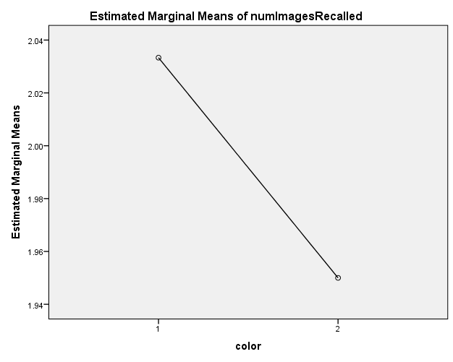

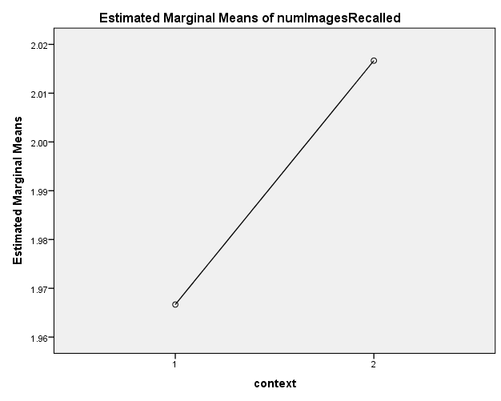

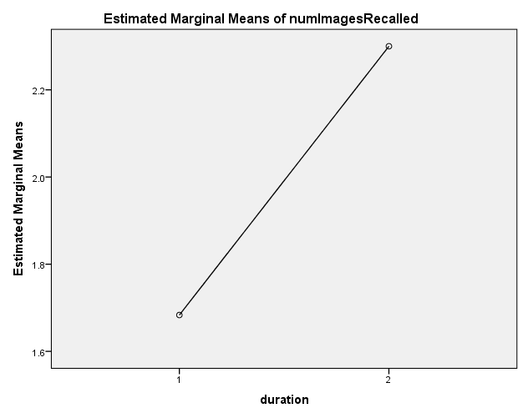

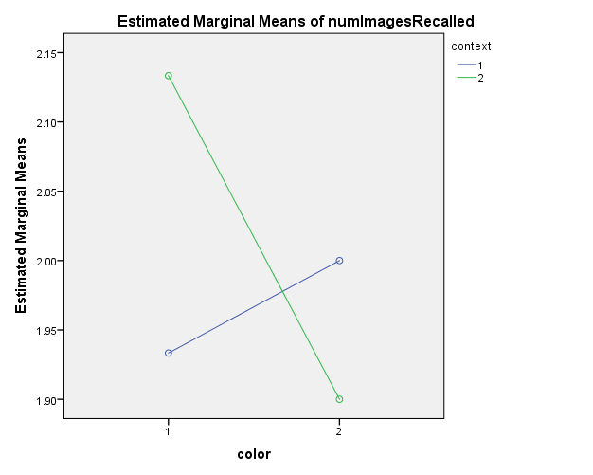

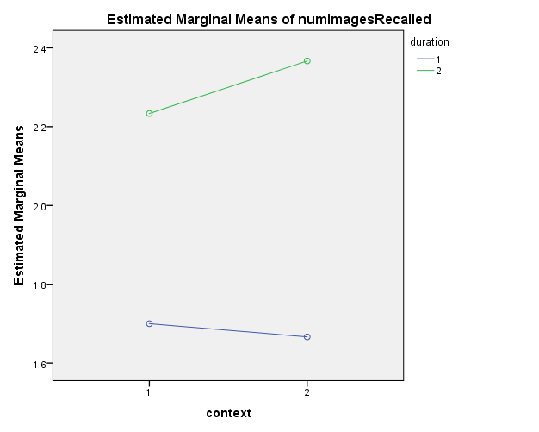

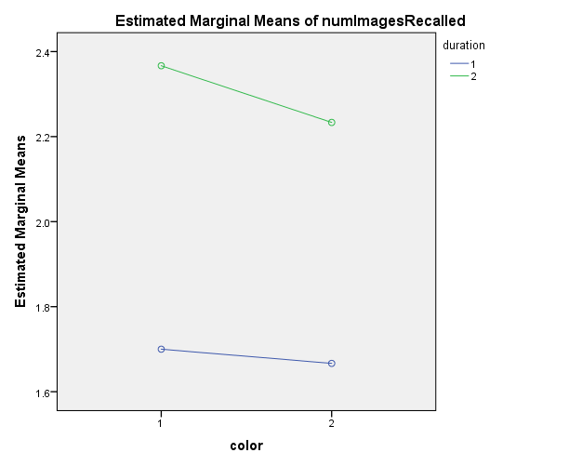

color * context * duration

