PRESERVE.
SET DECIMAL DOT.

GET DATA /TYPE=TXT
/FILE="\\andrew.ad.cmu.edu\users\users14\uhq\Desktop\VisualLab\csv\colorContextCuration.csv"
/ENCODING='UTF8'
/DELIMITERS=","
/QUALIFIER='"'
/ARRANGEMENT=DELIMITED
/FIRSTCASE=2
/DATATYPEMIN PERCENTAGE=95.0
/VARIABLES=
Subject AUTO
contextandcolorshort AUTO
nocontextandcolorshort AUTO
contextandnocolorshort AUTO
nocontextandnocolorshort AUTO
contextandcolorlong AUTO
nocontextandcolorlong AUTO
contextandnocolorlong AUTO
nocontextandnocolorlong AUTO
/MAP.
RESTORE.
CACHE.
EXECUTE.

Data written to the working file.
9 variables and 15 cases written.
Variable: Subject Type: Number Format : F4
Variable: contextandcolorshort Type: Number Format : F1
Variable: nocontextandcolorshort Type: Number Format : F1
Variable: contextandnocolorshort Type: Number Format : F1
Variable: nocontextandnocolorshort Type: Number Format : F1
Variable: contextandcolorlong Type: Number Format : F1
Variable: nocontextandcolorlong Type: Number Format : F1
Variable: contextandnocolorlong Type: Number Format : F1
Variable: nocontextandnocolorlong Type: Number Format : F1

DATASET NAME DataSet1 WINDOW=FRONT.
GLM nocontextandnocolorshort nocontextandnocolorlong nocontextandcolorshort nocontextandcolorlong
contextandnocolorshort contextandnocolorlong contextandcolorshort contextandcolorlong
/WSFACTOR=color 2 Polynomial context 2 Polynomial duration 2 Polynomial
/MEASURE=numImagesRecalled
/METHOD=SSTYPE(3)
/PLOT=PROFILE(color context duration color*context context*duration color*duration
color*context*duration)
/EMMEANS=TABLES(color) COMPARE ADJ(BONFERRONI)
/EMMEANS=TABLES(context) COMPARE ADJ(BONFERRONI)
/EMMEANS=TABLES(duration) COMPARE ADJ(BONFERRONI)
/EMMEANS=TABLES(color*context)
/EMMEANS=TABLES(color*duration)
/EMMEANS=TABLES(context*duration)
/EMMEANS=TABLES(color*context*duration)
/PRINT=DESCRIPTIVE ETASQ OPOWER
/CRITERIA=ALPHA(.05)
/WSDESIGN=color context duration color*context color*duration context*duration
color*context*duration.

General Linear Model

[DataSet1]

Within-Subjects Factors
Measure: numImagesRecalled
color | context | duration | Dependent Variable
1 | 1 | 1 | nocontextandnocolorshort
1 | 1 | 2 | nocontextandnocolorlong
1 | 2 | 1 | nocontextandcolorshort
1 | 2 | 2 | nocontextandcolorlong
2 | 1 | 1 | contextandnocolorshort
2 | 1 | 2 | contextandnocolorlong
2 | 2 | 1 | contextandcolorshort
2 | 2 | 2 | contextandcolorlong

Descriptive Statistics
 | Mean | Std. Deviation | N
nocontextandnocolorshort | 1.73 | 1.100 | 15
nocontextandnocolorlong | 2.13 | 1.125 | 15
nocontextandcolorshort | 1.67 | 1.047 | 15
nocontextandcolorlong | 2.60 | 1.352 | 15
contextandnocolorshort | 1.67 | 1.113 | 15
contextandnocolorlong | 2.33 | 1.047 | 15
contextandcolorshort | 1.67 | 1.047 | 15
contextandcolorlong | 2.13 | .915 | 15

Multivariate Testsª
Effect |  | Value | F | Hypothesis df | Error df | Sig.
color | Pillai's Trace | .015 | .210^{b} | 1.000 | 14.000 | .654
color | Wilks' Lambda | .985 | .210^{b} | 1.000 | 14.000 | .654
color | Hotelling's Trace | .015 | .210^{b} | 1.000 | 14.000 | .654
color | Roy's Largest Root | .015 | .210^{b} | 1.000 | 14.000 | .654
context | Pillai's Trace | .003 | .042^{b} | 1.000 | 14.000 | .841
context | Wilks' Lambda | .997 | .042^{b} | 1.000 | 14.000 | .841
context | Hotelling's Trace | .003 | .042^{b} | 1.000 | 14.000 | .841
context | Roy's Largest Root | .003 | .042^{b} | 1.000 | 14.000 | .841
duration | Pillai's Trace | .504 | 14.239^{b} | 1.000 | 14.000 | .002
duration | Wilks' Lambda | .496 | 14.239^{b} | 1.000 | 14.000 | .002
duration | Hotelling's Trace | 1.017 | 14.239^{b} | 1.000 | 14.000 | .002
duration | Roy's Largest Root | 1.017 | 14.239^{b} | 1.000 | 14.000 | .002
color * context | Pillai's Trace | .030 | .431^{b} | 1.000 | 14.000 | .522
color * context | Wilks' Lambda | .970 | .431^{b} | 1.000 | 14.000 | .522
color * context | Hotelling's Trace | .031 | .431^{b} | 1.000 | 14.000 | .522
color * context | Roy's Largest Root | .031 | .431^{b} | 1.000 | 14.000 | .522
color * duration | Pillai's Trace | .003 | .040^{b} | 1.000 | 14.000 | .844
color * duration | Wilks' Lambda | .997 | .040^{b} | 1.000 | 14.000 | .844
color * duration | Hotelling's Trace | .003 | .040^{b} | 1.000 | 14.000 | .844
color * duration | Roy's Largest Root | .003 | .040^{b} | 1.000 | 14.000 | .844
context * duration | Pillai's Trace | .023 | .327^{b} | 1.000 | 14.000 | .576
context * duration | Wilks' Lambda | .977 | .327^{b} | 1.000 | 14.000 | .576
context * duration | Hotelling's Trace | .023 | .327^{b} | 1.000 | 14.000 | .576
context * duration | Roy's Largest Root | .023 | .327^{b} | 1.000 | 14.000 | .576
color * context * duration | Pillai's Trace | .117 | 1.853^{b} | 1.000 | 14.000 | .195
color * context * duration | Wilks' Lambda | .883 | 1.853^{b} | 1.000 | 14.000 | .195
color * context * duration | Hotelling's Trace | .132 | 1.853^{b} | 1.000 | 14.000 | .195
color * context * duration | Roy's Largest Root | .132 | 1.853^{b} | 1.000 | 14.000 | .195

Multivariate Testsª
Effect |  | Partial Eta Squared | Noncent. Parameter | Observed Power^{c}
color | Pillai's Trace | .015 | .210 | .071
color | Wilks' Lambda | .015 | .210 | .071
color | Hotelling's Trace | .015 | .210 | .071
color | Roy's Largest Root | .015 | .210 | .071
context | Pillai's Trace | .003 | .042 | .054
context | Wilks' Lambda | .003 | .042 | .054
context | Hotelling's Trace | .003 | .042 | .054
context | Roy's Largest Root | .003 | .042 | .054
duration | Pillai's Trace | .504 | 14.239 | .939
duration | Wilks' Lambda | .504 | 14.239 | .939
duration | Hotelling's Trace | .504 | 14.239 | .939
duration | Roy's Largest Root | .504 | 14.239 | .939
color * context | Pillai's Trace | .030 | .431 | .094
color * context | Wilks' Lambda | .030 | .431 | .094
color * context | Hotelling's Trace | .030 | .431 | .094
color * context | Roy's Largest Root | .030 | .431 | .094
color * duration | Pillai's Trace | .003 | .040 | .054
color * duration | Wilks' Lambda | .003 | .040 | .054
color * duration | Hotelling's Trace | .003 | .040 | .054
color * duration | Roy's Largest Root | .003 | .040 | .054
context * duration | Pillai's Trace | .023 | .327 | .083
context * duration | Wilks' Lambda | .023 | .327 | .083
context * duration | Hotelling's Trace | .023 | .327 | .083
context * duration | Roy's Largest Root | .023 | .327 | .083
color * context * duration | Pillai's Trace | .117 | 1.853 | .245
color * context * duration | Wilks' Lambda | .117 | 1.853 | .245
color * context * duration | Hotelling's Trace | .117 | 1.853 | .245
color * context * duration | Roy's Largest Root | .117 | 1.853 | .245

a. Design: Intercept
Within Subjects Design: color + context + duration + color * context + color * duration + context * duration + color * context * duration
b. Exact statistic
c. Computed using alpha = .05

Mauchly's Test of Sphericityª
Measure: numImagesRecalled
Within Subjects Effect | Mauchly's W | Approx. Chi-Square | df | Sig. | Epsilon^{b}
 |  |  |  |  | Greenhouse-Geisser
color | 1.000 | .000 | 0 | . | 1.000
context | 1.000 | .000 | 0 | . | 1.000
duration | 1.000 | .000 | 0 | . | 1.000
color * context | 1.000 | .000 | 0 | . | 1.000
color * duration | 1.000 | .000 | 0 | . | 1.000
context * duration | 1.000 | .000 | 0 | . | 1.000
color * context * duration | 1.000 | .000 | 0 | . | 1.000

Mauchly's Test of Sphericityª
Measure: numImagesRecalled
Within Subjects Effect | Epsilon
Within Subjects Effect | Huynh-Feldt | Lower-bound
color | 1.000 | 1.000
context | 1.000 | 1.000
duration | 1.000 | 1.000
color * context | 1.000 | 1.000
color * duration | 1.000 | 1.000
context * duration | 1.000 | 1.000
color * context * duration | 1.000 | 1.000

Tests the null hypothesis that the error covariance matrix of the orthonormalized transformed dependent variables is proportional to an identity matrix.ª
a. Design: Intercept
Within Subjects Design: color + context + duration + color * context + color * duration + context * duration + color * context * duration
b. May be used to adjust the degrees of freedom for the averaged tests of significance. Corrected tests are displayed in the Tests of Within-Subjects Effects table.

Tests of Within-Subjects Effects
Measure: numImagesRecalled
Source |  | Type III Sum of Squares | df | Mean Square | F | Sig. | Partial Eta Squared | Noncent. Parameter | Observed Powerª
color | Sphericity Assumed | .208 | 1 | .208 | .210 | .654 | .015 | .210 | .071
color | Greenhouse-Geisser | .208 | 1.000 | .208 | .210 | .654 | .015 | .210 | .071
color | Huynh-Feldt | .208 | 1.000 | .208 | .210 | .654 | .015 | .210 | .071
color | Lower-bound | .208 | 1.000 | .208 | .210 | .654 | .015 | .210 | .071
Error(color) | Sphericity Assumed | 13.917 | 14 | .994
Error(color) | Greenhouse-Geisser | 13.917 | 14.000 | .994
Error(color) | Huynh-Feldt | 13.917 | 14.000 | .994
Error(color) | Lower-bound | 13.917 | 14.000 | .994
context | Sphericity Assumed | .075 | 1 | .075 | .042 | .841 | .003 | .042 | .054
context | Greenhouse-Geisser | .075 | 1.000 | .075 | .042 | .841 | .003 | .042 | .054
context | Huynh-Feldt | .075 | 1.000 | .075 | .042 | .841 | .003 | .042 | .054
context | Lower-bound | .075 | 1.000 | .075 | .042 | .841 | .003 | .042 | .054
Error(context) | Sphericity Assumed | 25.050 | 14 | 1.789
Error(context) | Greenhouse-Geisser | 25.050 | 14.000 | 1.789
Error(context) | Huynh-Feldt | 25.050 | 14.000 | 1.789
Error(context) | Lower-bound | 25.050 | 14.000 | 1.789
duration | Sphericity Assumed | 11.408 | 1 | 11.408 | 14.239 | .002 | .504 | 14.239 | .939
duration | Greenhouse-Geisser | 11.408 | 1.000 | 11.408 | 14.239 | .002 | .504 | 14.239 | .939
duration | Huynh-Feldt | 11.408 | 1.000 | 11.408 | 14.239 | .002 | .504 | 14.239 | .939
duration | Lower-bound | 11.408 | 1.000 | 11.408 | 14.239 | .002 | .504 | 14.239 | .939
Error(duration) | Sphericity Assumed | 11.217 | 14 | .801
Error(duration) | Greenhouse-Geisser | 11.217 | 14.000 | .801
Error(duration) | Huynh-Feldt | 11.217 | 14.000 | .801
Error(duration) | Lower-bound | 11.217 | 14.000 | .801
color * context | Sphericity Assumed | .675 | 1 | .675 | .431 | .522 | .030 | .431 | .094
color * context | Greenhouse-Geisser | .675 | 1.000 | .675 | .431 | .522 | .030 | .431 | .094
color * context | Huynh-Feldt | .675 | 1.000 | .675 | .431 | .522 | .030 | .431 | .094
color * context | Lower-bound | .675 | 1.000 | .675 | .431 | .522 | .030 | .431 | .094
Error(color*context) | Sphericity Assumed | 21.950 | 14 | 1.568
Error(color*context) | Greenhouse-Geisser | 21.950 | 14.000 | 1.568
Error(color*context) | Huynh-Feldt | 21.950 | 14.000 | 1.568
Error(color*context) | Lower-bound | 21.950 | 14.000 | 1.568
color * duration | Sphericity Assumed | .075 | 1 | .075 | .040 | .844 | .003 | .040 | .054
color * duration | Greenhouse-Geisser | .075 | 1.000 | .075 | .040 | .844 | .003 | .040 | .054
color * duration | Huynh-Feldt | .075 | 1.000 | .075 | .040 | .844 | .003 | .040 | .054
color * duration | Lower-bound | .075 | 1.000 | .075 | .040 | .844 | .003 | .040 | .054
Error(color*duration) | Sphericity Assumed | 26.050 | 14 | 1.861
Error(color*duration) | Greenhouse-Geisser | 26.050 | 14.000 | 1.861
Error(color*duration) | Huynh-Feldt | 26.050 | 14.000 | 1.861
Error(color*duration) | Lower-bound | 26.050 | 14.000 | 1.861
context * duration | Sphericity Assumed | .208 | 1 | .208 | .327 | .576 | .023 | .327 | .083
context * duration | Greenhouse-Geisser | .208 | 1.000 | .208 | .327 | .576 | .023 | .327 | .083
context * duration | Huynh-Feldt | .208 | 1.000 | .208 | .327 | .576 | .023 | .327 | .083
context * duration | Lower-bound | .208 | 1.000 | .208 | .327 | .576 | .023 | .327 | .083
Error(context*duration) | Sphericity Assumed | 8.917 | 14 | .637
Error(context*duration) | Greenhouse-Geisser | 8.917 | 14.000 | .637
Error(context*duration) | Huynh-Feldt | 8.917 | 14.000 | .637
Error(context*duration) | Lower-bound | 8.917 | 14.000 | .637
color * context * duration | Sphericity Assumed | 1.008 | 1 | 1.008 | 1.853 | .195 | .117 | 1.853 | .245
color * context * duration | Greenhouse-Geisser | 1.008 | 1.000 | 1.008 | 1.853 | .195 | .117 | 1.853 | .245
color * context * duration | Huynh-Feldt | 1.008 | 1.000 | 1.008 | 1.853 | .195 | .117 | 1.853 | .245
color * context * duration | Lower-bound | 1.008 | 1.000 | 1.008 | 1.853 | .195 | .117 | 1.853 | .245
Error(color*context*duration) | Sphericity Assumed | 7.617 | 14 | .544
Error(color*context*duration) | Greenhouse-Geisser | 7.617 | 14.000 | .544
Error(color*context*duration) | Huynh-Feldt | 7.617 | 14.000 | .544
Error(color*context*duration) | Lower-bound | 7.617 | 14.000 | .544

a. Computed using alpha = .05

Tests of Within-Subjects Contrasts
Measure: numImagesRecalled
Source | color | context | duration | Type III Sum of Squares | df | Mean Square
color | Linear |  |  | .208 | 1 | .208
Error(color) | Linear |  |  | 13.917 | 14 | .994
context |  | Linear |  | .075 | 1 | .075
Error(context) |  | Linear |  | 25.050 | 14 | 1.789
duration |  |  | Linear | 11.408 | 1 | 11.408
Error(duration) |  |  | Linear | 11.217 | 14 | .801
color * context | Linear | Linear |  | .675 | 1 | .675
Error(color*context) | Linear | Linear |  | 21.950 | 14 | 1.568
color * duration | Linear |  | Linear | .075 | 1 | .075
Error(color*duration) | Linear |  | Linear | 26.050 | 14 | 1.861
context * duration |  | Linear | Linear | .208 | 1 | .208
Error(context*duration) |  | Linear | Linear | 8.917 | 14 | .637
color * context * duration | Linear | Linear | Linear | 1.008 | 1 | 1.008
Error(color*context*duration) | Linear | Linear | Linear | 7.617 | 14 | .544

Tests of Within-Subjects Contrasts
Measure: numImagesRecalled
Source | color | context | duration | F | Sig. | Partial Eta Squared
color | Linear |  |  | .210 | .654 | .015
Error(color) | Linear
context |  | Linear |  | .042 | .841 | .003
Error(context) |  | Linear
duration |  |  | Linear | 14.239 | .002 | .504
Error(duration) |  |  | Linear
color * context | Linear | Linear |  | .431 | .522 | .030
Error(color*context) | Linear | Linear
color * duration | Linear |  | Linear | .040 | .844 | .003
Error(color*duration) | Linear |  | Linear
context * duration |  | Linear | Linear | .327 | .576 | .023
Error(context*duration) |  | Linear | Linear
color * context * duration | Linear | Linear | Linear | 1.853 | .195 | .117
Error(color*context*duration) | Linear | Linear | Linear

Tests of Within-Subjects Contrasts
Measure: numImagesRecalled
Source | color | context | duration | Noncent. Parameter | Observed Powerª
color | Linear |  |  | .210 | .071
Error(color) | Linear
context |  | Linear |  | .042 | .054
Error(context) |  | Linear
duration |  |  | Linear | 14.239 | .939
Error(duration) |  |  | Linear
color * context | Linear | Linear |  | .431 | .094
Error(color*context) | Linear | Linear
color * duration | Linear |  | Linear | .040 | .054
Error(color*duration) | Linear |  | Linear
context * duration |  | Linear | Linear | .327 | .083
Error(context*duration) |  | Linear | Linear
color * context * duration | Linear | Linear | Linear | 1.853 | .245
Error(color*context*duration) | Linear | Linear | Linear

a. Computed using alpha = .05

Tests of Between-Subjects Effects
Measure: numImagesRecalled
Transformed Variable: Average
Source | Type III Sum of Squares | df | Mean Square | F | Sig. | Partial Eta Squared
Intercept | 476.008 | 1 | 476.008 | 323.239 | .000 | .958
Error | 20.617 | 14 | 1.473

Tests of Between-Subjects Effects
Measure: numImagesRecalled
Transformed Variable: Average
Source | Noncent. Parameter | Observed Powerª
Intercept | 323.239 | 1.000
Error

a. Computed using alpha = .05

Estimated Marginal Means

1. color

Estimates
Measure: numImagesRecalled
color | Mean | Std. Error | 95% Confidence Interval
color | Mean | Std. Error | Lower Bound | Upper Bound
1 | 2.033 | .133 | 1.747 | 2.319
2 | 1.950 | .153 | 1.622 | 2.278

Pairwise Comparisons
Measure: numImagesRecalled
(I) color | (J) color | Mean Difference (I-J) | Std. Error | Sig.ª | 95% Confidence Interval for Differenceª
 |  |  |  |  | Lower Bound | Upper Bound
1 | 2 | .083 | .182 | .654 | -.307 | .474
2 | 1 | -.083 | .182 | .654 | -.474 | .307

Based on estimated marginal means
a. Adjustment for multiple comparisons: Bonferroni.

Multivariate Tests
 | Value | F | Hypothesis df | Error df | Sig. | Partial Eta Squared
Pillai's trace | .015 | .210ª | 1.000 | 14.000 | .654 | .015
Wilks' lambda | .985 | .210ª | 1.000 | 14.000 | .654 | .015
Hotelling's trace | .015 | .210ª | 1.000 | 14.000 | .654 | .015
Roy's largest root | .015 | .210ª | 1.000 | 14.000 | .654 | .015

Multivariate Tests
 | Noncent. Parameter | Observed Power^{b}
Pillai's trace | .210 | .071
Wilks' lambda | .210 | .071
Hotelling's trace | .210 | .071
Roy's largest root | .210 | .071

Each F tests the multivariate effect of color. These tests are based on the linearly independent pairwise comparisons among the estimated marginal means.
a. Exact statistic
b. Computed using alpha = .05

2. context

Estimates
Measure: numImagesRecalled
context | Mean | Std. Error | 95% Confidence Interval
context | Mean | Std. Error | Lower Bound | Upper Bound
1 | 1.967 | .174 | 1.593 | 2.340
2 | 2.017 | .155 | 1.684 | 2.350

Pairwise Comparisons
Measure: numImagesRecalled
(I) context | (J) context | Mean Difference (I-J) | Std. Error | Sig.ª | 95% Confidence Interval for Differenceª
 |  |  |  |  | Lower Bound | Upper Bound
1 | 2 | -.050 | .244 | .841 | -.574 | .474
2 | 1 | .050 | .244 | .841 | -.474 | .574

Based on estimated marginal means
a. Adjustment for multiple comparisons: Bonferroni.

Multivariate Tests
 | Value | F | Hypothesis df | Error df | Sig. | Partial Eta Squared
Pillai's trace | .003 | .042ª | 1.000 | 14.000 | .841 | .003
Wilks' lambda | .997 | .042ª | 1.000 | 14.000 | .841 | .003
Hotelling's trace | .003 | .042ª | 1.000 | 14.000 | .841 | .003
Roy's largest root | .003 | .042ª | 1.000 | 14.000 | .841 | .003

Multivariate Tests
 | Noncent. Parameter | Observed Power^{b}
Pillai's trace | .042 | .054
Wilks' lambda | .042 | .054
Hotelling's trace | .042 | .054
Roy's largest root | .042 | .054

Each F tests the multivariate effect of context. These tests are based on the linearly independent pairwise comparisons among the estimated marginal means.
a. Exact statistic
b. Computed using alpha = .05

3. duration

Estimates
Measure: numImagesRecalled
duration | Mean | Std. Error | 95% Confidence Interval
duration | Mean | Std. Error | Lower Bound | Upper Bound
1 | 1.683 | .143 | 1.376 | 1.991
2 | 2.300 | .132 | 2.017 | 2.583

Pairwise Comparisons
Measure: numImagesRecalled
(I) duration | (J) duration | Mean Difference (I-J) | Std. Error | Sig.^{b} | 95% Confidence Interval for Difference^{b}
 |  |  |  |  | Lower Bound | Upper Bound
1 | 2 | -.617* | .163 | .002 | -.967 | -.266
2 | 1 | .617* | .163 | .002 | .266 | .967

Based on estimated marginal means
*. The mean difference is significant at the .05 level.
b. Adjustment for multiple comparisons: Bonferroni.

Multivariate Tests
 | Value | F | Hypothesis df | Error df | Sig. | Partial Eta Squared
Pillai's trace | .504 | 14.239ª | 1.000 | 14.000 | .002 | .504
Wilks' lambda | .496 | 14.239ª | 1.000 | 14.000 | .002 | .504
Hotelling's trace | 1.017 | 14.239ª | 1.000 | 14.000 | .002 | .504
Roy's largest root | 1.017 | 14.239ª | 1.000 | 14.000 | .002 | .504

Multivariate Tests
 | Noncent. Parameter | Observed Power^{b}
Pillai's trace | 14.239 | .939
Wilks' lambda | 14.239 | .939
Hotelling's trace | 14.239 | .939
Roy's largest root | 14.239 | .939

Each F tests the multivariate effect of duration. These tests are based on the linearly independent pairwise comparisons among the estimated marginal means.
a. Exact statistic
b. Computed using alpha = .05

4. color * context
Measure: numImagesRecalled
color | context | Mean | Std. Error | 95% Confidence Interval
 |  |  |  | Lower Bound | Upper Bound
1 | 1 | 1.933 | .194 | 1.516 | 2.350
1 | 2 | 2.133 | .226 | 1.648 | 2.618
2 | 1 | 2.000 | .244 | 1.477 | 2.523
2 | 2 | 1.900 | .214 | 1.441 | 2.359

5. color * duration
Measure: numImagesRecalled
color | duration | Mean | Std. Error | 95% Confidence Interval
 |  |  |  | Lower Bound | Upper Bound
1 | 1 | 1.700 | .206 | 1.258 | 2.142
1 | 2 | 2.367 | .231 | 1.871 | 2.863
2 | 1 | 1.667 | .199 | 1.239 | 2.094
2 | 2 | 2.233 | .188 | 1.830 | 2.637

6. context * duration
Measure: numImagesRecalled
context | duration | Mean | Std. Error | 95% Confidence Interval
 |  |  |  | Lower Bound | Upper Bound
1 | 1 | 1.700 | .206 | 1.258 | 2.142
1 | 2 | 2.233 | .212 | 1.779 | 2.688
2 | 1 | 1.667 | .174 | 1.294 | 2.039
2 | 2 | 2.367 | .198 | 1.942 | 2.791

7. color * context * duration
Measure: numImagesRecalled
color | context | duration | Mean | Std. Error | 95% Confidence Interval
 |  |  |  |  | Lower Bound | Upper Bound
1 | 1 | 1 | 1.733 | .284 | 1.124 | 2.342
1 | 1 | 2 | 2.133 | .291 | 1.510 | 2.757
1 | 2 | 1 | 1.667 | .270 | 1.087 | 2.246
1 | 2 | 2 | 2.600 | .349 | 1.851 | 3.349
2 | 1 | 1 | 1.667 | .287 | 1.050 | 2.283
2 | 1 | 2 | 2.333 | .270 | 1.754 | 2.913
2 | 2 | 1 | 1.667 | .270 | 1.087 | 2.246
2 | 2 | 2 | 2.133 | .236 | 1.626 | 2.640

Profile Plots

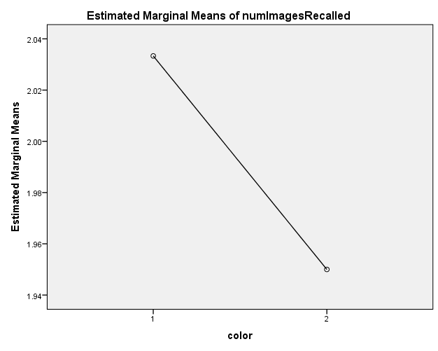

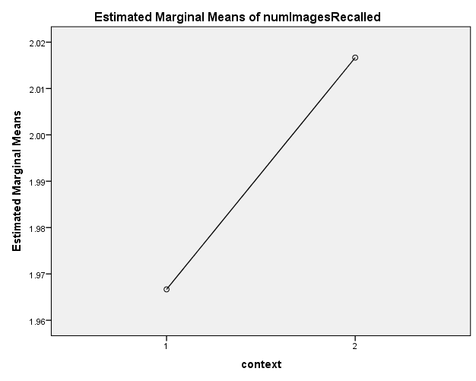

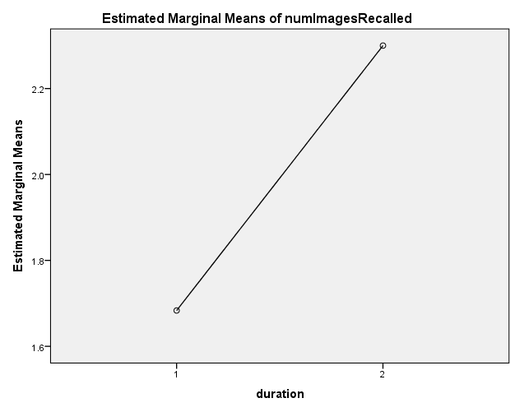

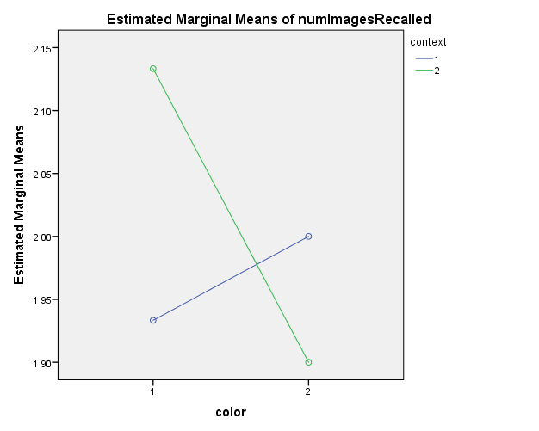

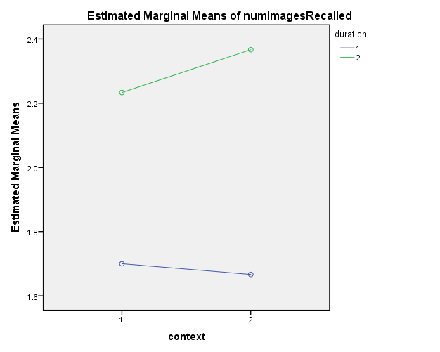

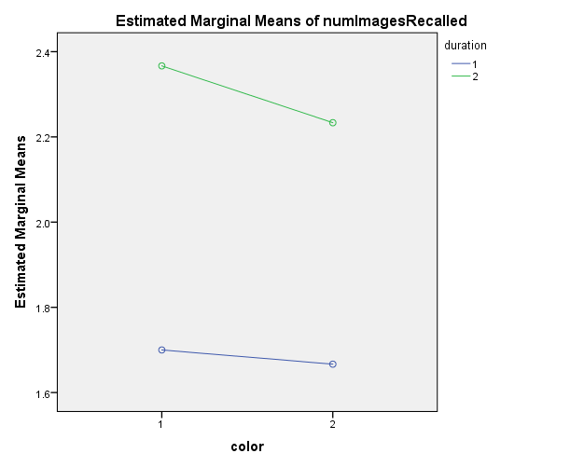

color * context * duration

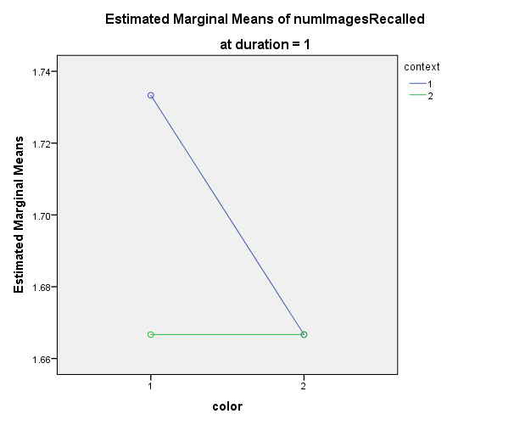

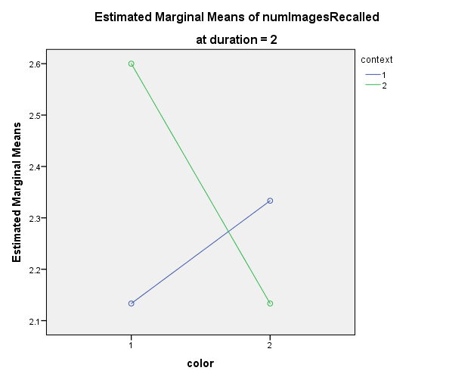

PRESERVE.
SET DECIMAL DOT.

GET DATA /TYPE=TXT
/FILE="\\andrew.ad.cmu.edu\users\users14\uhq\Desktop\VisualLab\csv\image.csv"
/ENCODING='UTF8'
/DELIMITERS=","
/QUALIFIER='"'
/ARRANGEMENT=DELIMITED
/FIRSTCASE=2
/DATATYPEMIN PERCENTAGE=95.0
/VARIABLES=
Subject AUTO
noimage AUTO
image AUTO
/MAP.
RESTORE.
CACHE.
EXECUTE.

Data written to the working file.
3 variables and 15 cases written.
Variable: Subject Type: Number Format : F4
Variable: noimage Type: Number Format : F2
Variable: image Type: Number Format : F2

DATASET NAME DataSet2 WINDOW=FRONT.
GLM noimage image
/WSFACTOR=img 2 Polynomial
/MEASURE=numImagesRecalled
/METHOD=SSTYPE(3)
/SAVE=SEPRED SRESID
/PLOT=PROFILE(img)
/EMMEANS=TABLES(img) COMPARE ADJ(BONFERRONI)
/PRINT=DESCRIPTIVE ETASQ
/CRITERIA=ALPHA(.05)
/WSDESIGN=img.

General Linear Model

[DataSet2]

Within-Subjects Factors
Measure: numImagesRecalled
img | Dependent Variable
1 | noimage
2 | image

Descriptive Statistics
 | Mean | Std. Deviation | N
noimage | 13.07 | 3.369 | 15
image | 17.07 | 3.918 | 15

Multivariate Testsª
Effect |  | Value | F | Hypothesis df | Error df | Sig.
img | Pillai's Trace | .476 | 12.727^{b} | 1.000 | 14.000 | .003
img | Wilks' Lambda | .524 | 12.727^{b} | 1.000 | 14.000 | .003
img | Hotelling's Trace | .909 | 12.727^{b} | 1.000 | 14.000 | .003
img | Roy's Largest Root | .909 | 12.727^{b} | 1.000 | 14.000 | .003

Multivariate Testsª
Effect |  | Partial Eta Squared
img | Pillai's Trace | .476
img | Wilks' Lambda | .476
img | Hotelling's Trace | .476
img | Roy's Largest Root | .476

a. Design: Intercept
Within Subjects Design: img
b. Exact statistic

Mauchly's Test of Sphericityª
Measure: numImagesRecalled
Within Subjects Effect | Mauchly's W | Approx. Chi-Square | df | Sig. | Epsilon^{b}
 |  |  |  |  | Greenhouse-Geisser
img | 1.000 | .000 | 0 | . | 1.000

Mauchly's Test of Sphericityª
Measure: numImagesRecalled
Within Subjects Effect | Epsilon
Within Subjects Effect | Huynh-Feldt | Lower-bound
img | 1.000 | 1.000

Tests the null hypothesis that the error covariance matrix of the orthonormalized transformed dependent variables is proportional to an identity matrix.ª
a. Design: Intercept
Within Subjects Design: img
b. May be used to adjust the degrees of freedom for the averaged tests of significance. Corrected tests are displayed in the Tests of Within-Subjects Effects table.

Tests of Within-Subjects Effects
Measure: numImagesRecalled
Source |  | Type III Sum of Squares | df | Mean Square | F | Sig.
img | Sphericity Assumed | 120.000 | 1 | 120.000 | 12.727 | .003
img | Greenhouse-Geisser | 120.000 | 1.000 | 120.000 | 12.727 | .003
img | Huynh-Feldt | 120.000 | 1.000 | 120.000 | 12.727 | .003
img | Lower-bound | 120.000 | 1.000 | 120.000 | 12.727 | .003
Error(img) | Sphericity Assumed | 132.000 | 14 | 9.429
Error(img) | Greenhouse-Geisser | 132.000 | 14.000 | 9.429
Error(img) | Huynh-Feldt | 132.000 | 14.000 | 9.429
Error(img) | Lower-bound | 132.000 | 14.000 | 9.429

Tests of Within-Subjects Effects
Measure: numImagesRecalled
Source |  | Partial Eta Squared
img | Sphericity Assumed | .476
img | Greenhouse-Geisser | .476
img | Huynh-Feldt | .476
img | Lower-bound | .476
Error(img) | Sphericity Assumed
Error(img) | Greenhouse-Geisser
Error(img) | Huynh-Feldt
Error(img) | Lower-bound

Tests of Within-Subjects Contrasts
Measure: numImagesRecalled
Source | img | Type III Sum of Squares | df | Mean Square | F | Sig. | Partial Eta Squared
img | Linear | 120.000 | 1 | 120.000 | 12.727 | .003 | .476
Error(img) | Linear | 132.000 | 14 | 9.429

Tests of Between-Subjects Effects
Measure: numImagesRecalled
Transformed Variable: Average
Source | Type III Sum of Squares | df | Mean Square | F | Sig. | Partial Eta Squared
Intercept | 6810.133 | 1 | 6810.133 | 394.192 | .000 | .966
Error | 241.867 | 14 | 17.276

Estimated Marginal Means

img

Estimates
Measure: numImagesRecalled
img | Mean | Std. Error | 95% Confidence Interval
img | Mean | Std. Error | Lower Bound | Upper Bound
1 | 13.067 | .870 | 11.201 | 14.933
2 | 17.067 | 1.012 | 14.897 | 19.236

Pairwise Comparisons
Measure: numImagesRecalled
(I) img | (J) img | Mean Difference (I-J) | Std. Error | Sig.^{b} | 95% Confidence Interval for Difference^{b}
 |  |  |  |  | Lower Bound | Upper Bound
1 | 2 | -4.000* | 1.121 | .003 | -6.405 | -1.595
2 | 1 | 4.000* | 1.121 | .003 | 1.595 | 6.405

Based on estimated marginal means
*. The mean difference is significant at the .05 level.
b. Adjustment for multiple comparisons: Bonferroni.

Multivariate Tests
 | Value | F | Hypothesis df | Error df | Sig. | Partial Eta Squared
Pillai's trace | .476 | 12.727ª | 1.000 | 14.000 | .003 | .476
Wilks' lambda | .524 | 12.727ª | 1.000 | 14.000 | .003 | .476
Hotelling's trace | .909 | 12.727ª | 1.000 | 14.000 | .003 | .476
Roy's largest root | .909 | 12.727ª | 1.000 | 14.000 | .003 | .476

Each F tests the multivariate effect of img. These tests are based on the linearly independent pairwise comparisons among the estimated marginal means.
a. Exact statistic

Profile Plots

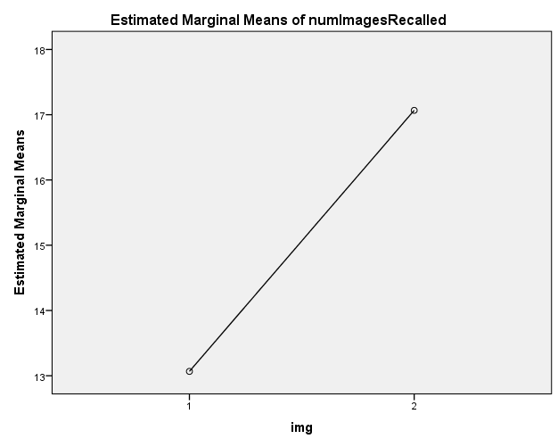

PRESERVE.
SET DECIMAL DOT.

GET DATA /TYPE=TXT
/FILE="\\andrew.ad.cmu.edu\users\users14\uhq\Desktop\VisualLab\csv\colorxcontext.csv"
/ENCODING='UTF8'
/DELIMITERS=","
/QUALIFIER='"'
/ARRANGEMENT=DELIMITED
/FIRSTCASE=2
/DATATYPEMIN PERCENTAGE=95.0
/VARIABLES=
Subject AUTO
colorcontext AUTO
colornocontext AUTO
nocolorcontext AUTO
nocolornocontext AUTO
/MAP.
RESTORE.
CACHE.
EXECUTE.

Data written to the working file.
5 variables and 15 cases written.
Variable: Subject Type: Number Format : F4
Variable: colorcontext Type: Number Format : F1
Variable: colornocontext Type: Number Format : F1
Variable: nocolorcontext Type: Number Format : F1
Variable: nocolornocontext Type: Number Format : F1

DATASET NAME DataSet3 WINDOW=FRONT.
GLM nocolornocontext nocolorcontext colornocontext colorcontext
/WSFACTOR=color 2 Polynomial context 2 Polynomial
/MEASURE=numImagesRecalled
/METHOD=SSTYPE(3)
/SAVE=SEPRED SRESID
/PLOT=PROFILE(color*context)
/EMMEANS=TABLES(color) COMPARE ADJ(BONFERRONI)
/EMMEANS=TABLES(context) COMPARE ADJ(BONFERRONI)
/EMMEANS=TABLES(color*context)
/PRINT=DESCRIPTIVE ETASQ
/CRITERIA=ALPHA(.05)
/WSDESIGN=color context color*context.

General Linear Model

[DataSet3]

Within-Subjects Factors
Measure: numImagesRecalled
color | context | Dependent Variable
1 | 1 | nocolornocontext
1 | 2 | nocolorcontext
2 | 1 | colornocontext
2 | 2 | colorcontext

Descriptive Statistics
 | Mean | Std. Deviation | N
nocolornocontext | 3.87 | 1.506 | 15
nocolorcontext | 4.00 | 1.890 | 15
colornocontext | 4.27 | 1.751 | 15
colorcontext | 3.80 | 1.656 | 15

Multivariate Testsª
Effect |  | Value | F | Hypothesis df | Error df | Sig.
color | Pillai's Trace | .003 | .042^{b} | 1.000 | 14.000 | .841
color | Wilks' Lambda | .997 | .042^{b} | 1.000 | 14.000 | .841
color | Hotelling's Trace | .003 | .042^{b} | 1.000 | 14.000 | .841
color | Roy's Largest Root | .003 | .042^{b} | 1.000 | 14.000 | .841
context | Pillai's Trace | .015 | .210^{b} | 1.000 | 14.000 | .654
context | Wilks' Lambda | .985 | .210^{b} | 1.000 | 14.000 | .654
context | Hotelling's Trace | .015 | .210^{b} | 1.000 | 14.000 | .654
context | Roy's Largest Root | .015 | .210^{b} | 1.000 | 14.000 | .654
color * context | Pillai's Trace | .030 | .431^{b} | 1.000 | 14.000 | .522
color * context | Wilks' Lambda | .970 | .431^{b} | 1.000 | 14.000 | .522
color * context | Hotelling's Trace | .031 | .431^{b} | 1.000 | 14.000 | .522
color * context | Roy's Largest Root | .031 | .431^{b} | 1.000 | 14.000 | .522

Multivariate Testsª
Effect |  | Partial Eta Squared
color | Pillai's Trace | .003
color | Wilks' Lambda | .003
color | Hotelling's Trace | .003
color | Roy's Largest Root | .003
context | Pillai's Trace | .015
context | Wilks' Lambda | .015
context | Hotelling's Trace | .015
context | Roy's Largest Root | .015
color * context | Pillai's Trace | .030
color * context | Wilks' Lambda | .030
color * context | Hotelling's Trace | .030
color * context | Roy's Largest Root | .030

a. Design: Intercept
Within Subjects Design: color + context + color * context
b. Exact statistic

Mauchly's Test of Sphericityª
Measure: numImagesRecalled
Within Subjects Effect | Mauchly's W | Approx. Chi-Square | df | Sig. | Epsilon^{b}
 |  |  |  |  | Greenhouse-Geisser
color | 1.000 | .000 | 0 | . | 1.000
context | 1.000 | .000 | 0 | . | 1.000
color * context | 1.000 | .000 | 0 | . | 1.000

Mauchly's Test of Sphericityª
Measure: numImagesRecalled
Within Subjects Effect | Epsilon
Within Subjects Effect | Huynh-Feldt | Lower-bound
color | 1.000 | 1.000
context | 1.000 | 1.000
color * context | 1.000 | 1.000

Tests the null hypothesis that the error covariance matrix of the orthonormalized transformed dependent variables is proportional to an identity matrix.ª
a. Design: Intercept
Within Subjects Design: color + context + color * context
b. May be used to adjust the degrees of freedom for the averaged tests of significance. Corrected tests are displayed in the Tests of Within-Subjects Effects table.

Tests of Within-Subjects Effects
Measure: numImagesRecalled
Source |  | Type III Sum of Squares | df | Mean Square | F
color | Sphericity Assumed | .150 | 1 | .150 | .042
color | Greenhouse-Geisser | .150 | 1.000 | .150 | .042
color | Huynh-Feldt | .150 | 1.000 | .150 | .042
color | Lower-bound | .150 | 1.000 | .150 | .042
Error(color) | Sphericity Assumed | 50.100 | 14 | 3.579
Error(color) | Greenhouse-Geisser | 50.100 | 14.000 | 3.579
Error(color) | Huynh-Feldt | 50.100 | 14.000 | 3.579
Error(color) | Lower-bound | 50.100 | 14.000 | 3.579
context | Sphericity Assumed | .417 | 1 | .417 | .210
context | Greenhouse-Geisser | .417 | 1.000 | .417 | .210
context | Huynh-Feldt | .417 | 1.000 | .417 | .210
context | Lower-bound | .417 | 1.000 | .417 | .210
Error(context) | Sphericity Assumed | 27.833 | 14 | 1.988
Error(context) | Greenhouse-Geisser | 27.833 | 14.000 | 1.988
Error(context) | Huynh-Feldt | 27.833 | 14.000 | 1.988
Error(context) | Lower-bound | 27.833 | 14.000 | 1.988
color * context | Sphericity Assumed | 1.350 | 1 | 1.350 | .431
color * context | Greenhouse-Geisser | 1.350 | 1.000 | 1.350 | .431
color * context | Huynh-Feldt | 1.350 | 1.000 | 1.350 | .431
color * context | Lower-bound | 1.350 | 1.000 | 1.350 | .431
Error(color*context) | Sphericity Assumed | 43.900 | 14 | 3.136
Error(color*context) | Greenhouse-Geisser | 43.900 | 14.000 | 3.136
Error(color*context) | Huynh-Feldt | 43.900 | 14.000 | 3.136
Error(color*context) | Lower-bound | 43.900 | 14.000 | 3.136

Tests of Within-Subjects Effects
Measure: numImagesRecalled
Source |  | Sig. | Partial Eta Squared
color | Sphericity Assumed | .841 | .003
color | Greenhouse-Geisser | .841 | .003
color | Huynh-Feldt | .841 | .003
color | Lower-bound | .841 | .003
Error(color) | Sphericity Assumed
Error(color) | Greenhouse-Geisser
Error(color) | Huynh-Feldt
Error(color) | Lower-bound
context | Sphericity Assumed | .654 | .015
context | Greenhouse-Geisser | .654 | .015
context | Huynh-Feldt | .654 | .015
context | Lower-bound | .654 | .015
Error(context) | Sphericity Assumed
Error(context) | Greenhouse-Geisser
Error(context) | Huynh-Feldt
Error(context) | Lower-bound
color * context | Sphericity Assumed | .522 | .030
color * context | Greenhouse-Geisser | .522 | .030
color * context | Huynh-Feldt | .522 | .030
color * context | Lower-bound | .522 | .030
Error(color*context) | Sphericity Assumed
Error(color*context) | Greenhouse-Geisser
Error(color*context) | Huynh-Feldt
Error(color*context) | Lower-bound

Tests of Within-Subjects Contrasts
Measure: numImagesRecalled
Source | color | context | Type III Sum of Squares | df | Mean Square | F
color | Linear |  | .150 | 1 | .150 | .042
Error(color) | Linear |  | 50.100 | 14 | 3.579
context |  | Linear | .417 | 1 | .417 | .210
Error(context) |  | Linear | 27.833 | 14 | 1.988
color * context | Linear | Linear | 1.350 | 1 | 1.350 | .431
Error(color*context) | Linear | Linear | 43.900 | 14 | 3.136

Tests of Within-Subjects Contrasts
Measure: numImagesRecalled
Source | color | context | Sig. | Partial Eta Squared
color | Linear |  | .841 | .003
Error(color) | Linear
context |  | Linear | .654 | .015
Error(context) |  | Linear
color * context | Linear | Linear | .522 | .030
Error(color*context) | Linear | Linear

Tests of Between-Subjects Effects
Measure: numImagesRecalled
Transformed Variable: Average
Source | Type III Sum of Squares | df | Mean Square | F | Sig. | Partial Eta Squared
Intercept | 952.017 | 1 | 952.017 | 323.239 | .000 | .958
Error | 41.233 | 14 | 2.945

Estimated Marginal Means

1. color

Estimates
Measure: numImagesRecalled
color | Mean | Std. Error | 95% Confidence Interval
color | Mean | Std. Error | Lower Bound | Upper Bound
1 | 3.933 | .348 | 3.187 | 4.680
2 | 4.033 | .310 | 3.368 | 4.699

Pairwise Comparisons
Measure: numImagesRecalled
(I) color | (J) color | Mean Difference (I-J) | Std. Error | Sig.ª | 95% Confidence Interval for Differenceª
 |  |  |  |  | Lower Bound | Upper Bound
1 | 2 | -.100 | .488 | .841 | -1.148 | .948
2 | 1 | .100 | .488 | .841 | -.948 | 1.148

Based on estimated marginal means
a. Adjustment for multiple comparisons: Bonferroni.

Multivariate Tests
 | Value | F | Hypothesis df | Error df | Sig. | Partial Eta Squared
Pillai's trace | .003 | .042ª | 1.000 | 14.000 | .841 | .003
Wilks' lambda | .997 | .042ª | 1.000 | 14.000 | .841 | .003
Hotelling's trace | .003 | .042ª | 1.000 | 14.000 | .841 | .003
Roy's largest root | .003 | .042ª | 1.000 | 14.000 | .841 | .003

Each F tests the multivariate effect of color. These tests are based on the linearly independent pairwise comparisons among the estimated marginal means.
a. Exact statistic

2. context

Estimates
Measure: numImagesRecalled
context | Mean | Std. Error | 95% Confidence Interval
context | Mean | Std. Error | Lower Bound | Upper Bound
1 | 4.067 | .267 | 3.495 | 4.639
2 | 3.900 | .306 | 3.245 | 4.555

Pairwise Comparisons
Measure: numImagesRecalled
(I) context | (J) context | Mean Difference (I-J) | Std. Error | Sig.ª | 95% Confidence Interval for Differenceª
 |  |  |  |  | Lower Bound | Upper Bound
1 | 2 | .167 | .364 | .654 | -.614 | .947
2 | 1 | -.167 | .364 | .654 | -.947 | .614

Based on estimated marginal means
a. Adjustment for multiple comparisons: Bonferroni.

Multivariate Tests
 | Value | F | Hypothesis df | Error df | Sig. | Partial Eta Squared
Pillai's trace | .015 | .210ª | 1.000 | 14.000 | .654 | .015
Wilks' lambda | .985 | .210ª | 1.000 | 14.000 | .654 | .015
Hotelling's trace | .015 | .210ª | 1.000 | 14.000 | .654 | .015
Roy's largest root | .015 | .210ª | 1.000 | 14.000 | .654 | .015

Each F tests the multivariate effect of context. These tests are based on the linearly independent pairwise comparisons among the estimated marginal means.
a. Exact statistic

3. color * context
Measure: numImagesRecalled
color | context | Mean | Std. Error | 95% Confidence Interval
 |  |  |  | Lower Bound | Upper Bound
1 | 1 | 3.867 | .389 | 3.033 | 4.700
1 | 2 | 4.000 | .488 | 2.953 | 5.047
2 | 1 | 4.267 | .452 | 3.297 | 5.236
2 | 2 | 3.800 | .428 | 2.883 | 4.717

Profile Plots

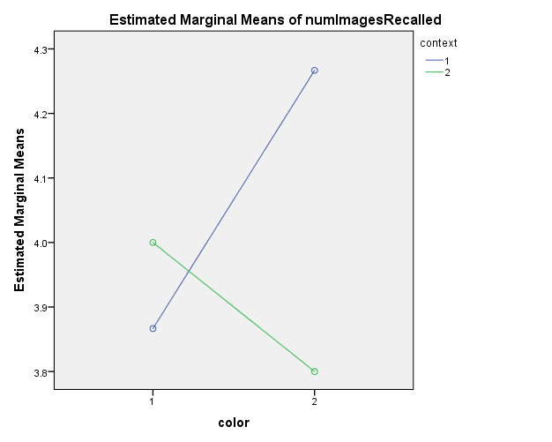

PRESERVE.
SET DECIMAL DOT.

GET DATA /TYPE=TXT
/FILE="\\andrew.ad.cmu.edu\users\users14\uhq\Desktop\VisualLab\csv\duration.csv"
/ENCODING='UTF8'
/DELIMITERS=","
/QUALIFIER='"'
/ARRANGEMENT=DELIMITED
/FIRSTCASE=2
/DATATYPEMIN PERCENTAGE=95.0
/VARIABLES=
Subject AUTO
short AUTO
long AUTO
/MAP.
RESTORE.
CACHE.
EXECUTE.

Data written to the working file.
3 variables and 15 cases written.
Variable: Subject Type: Number Format : F4
Variable: short Type: Number Format : F2
Variable: long Type: Number Format : F2

DATASET NAME DataSet4 WINDOW=FRONT.
GLM short long
/WSFACTOR=duration 2 Polynomial
/MEASURE=numImagesRecalled
/METHOD=SSTYPE(3)
/SAVE=SEPRED SRESID
/PLOT=PROFILE(duration)
/EMMEANS=TABLES(duration) COMPARE ADJ(BONFERRONI)
/PRINT=DESCRIPTIVE ETASQ
/CRITERIA=ALPHA(.05)
/WSDESIGN=duration.

General Linear Model

[DataSet4]

Within-Subjects Factors
Measure: numImagesRecalled
duration | Dependent Variable
1 | short
2 | long

Descriptive Statistics
 | Mean | Std. Deviation | N
short | 14.20 | 4.161 | 15
long | 15.93 | 3.432 | 15

Multivariate Testsª
Effect |  | Value | F | Hypothesis df | Error df | Sig.
duration | Pillai's Trace | .120 | 1.907^{b} | 1.000 | 14.000 | .189
duration | Wilks' Lambda | .880 | 1.907^{b} | 1.000 | 14.000 | .189
duration | Hotelling's Trace | .136 | 1.907^{b} | 1.000 | 14.000 | .189
duration | Roy's Largest Root | .136 | 1.907^{b} | 1.000 | 14.000 | .189

Multivariate Testsª
Effect |  | Partial Eta Squared
duration | Pillai's Trace | .120
duration | Wilks' Lambda | .120
duration | Hotelling's Trace | .120
duration | Roy's Largest Root | .120

a. Design: Intercept
Within Subjects Design: duration
b. Exact statistic

Mauchly's Test of Sphericityª
Measure: numImagesRecalled
Within Subjects Effect | Mauchly's W | Approx. Chi-Square | df | Sig. | Epsilon^{b}
 |  |  |  |  | Greenhouse-Geisser
duration | 1.000 | .000 | 0 | . | 1.000

Mauchly's Test of Sphericityª
Measure: numImagesRecalled
Within Subjects Effect | Epsilon
Within Subjects Effect | Huynh-Feldt | Lower-bound
duration | 1.000 | 1.000

Tests the null hypothesis that the error covariance matrix of the orthonormalized transformed dependent variables is proportional to an identity matrix.ª
a. Design: Intercept
Within Subjects Design: duration
b. May be used to adjust the degrees of freedom for the averaged tests of significance. Corrected tests are displayed in the Tests of Within-Subjects Effects table.

Tests of Within-Subjects Effects
Measure: numImagesRecalled
Source |  | Type III Sum of Squares | df | Mean Square | F
duration | Sphericity Assumed | 22.533 | 1 | 22.533 | 1.907
duration | Greenhouse-Geisser | 22.533 | 1.000 | 22.533 | 1.907
duration | Huynh-Feldt | 22.533 | 1.000 | 22.533 | 1.907
duration | Lower-bound | 22.533 | 1.000 | 22.533 | 1.907
Error(duration) | Sphericity Assumed | 165.467 | 14 | 11.819
Error(duration) | Greenhouse-Geisser | 165.467 | 14.000 | 11.819
Error(duration) | Huynh-Feldt | 165.467 | 14.000 | 11.819
Error(duration) | Lower-bound | 165.467 | 14.000 | 11.819

Tests of Within-Subjects Effects
Measure: numImagesRecalled
Source |  | Sig. | Partial Eta Squared
duration | Sphericity Assumed | .189 | .120
duration | Greenhouse-Geisser | .189 | .120
duration | Huynh-Feldt | .189 | .120
duration | Lower-bound | .189 | .120
Error(duration) | Sphericity Assumed
Error(duration) | Greenhouse-Geisser
Error(duration) | Huynh-Feldt
Error(duration) | Lower-bound

Tests of Within-Subjects Contrasts
Measure: numImagesRecalled
Source | duration | Type III Sum of Squares | df | Mean Square | F | Sig.
duration | Linear | 22.533 | 1 | 22.533 | 1.907 | .189
Error(duration) | Linear | 165.467 | 14 | 11.819

Tests of Within-Subjects Contrasts
Measure: numImagesRecalled
Source | duration | Partial Eta Squared
duration | Linear | .120
Error(duration) | Linear

Tests of Between-Subjects Effects
Measure: numImagesRecalled
Transformed Variable: Average
Source | Type III Sum of Squares | df | Mean Square | F | Sig. | Partial Eta Squared
Intercept | 6810.133 | 1 | 6810.133 | 394.192 | .000 | .966
Error | 241.867 | 14 | 17.276

Estimated Marginal Means

duration

Estimates
Measure: numImagesRecalled
duration | Mean | Std. Error | 95% Confidence Interval
duration | Mean | Std. Error | Lower Bound | Upper Bound
1 | 14.200 | 1.074 | 11.896 | 16.504
2 | 15.933 | .886 | 14.033 | 17.834

Pairwise Comparisons
Measure: numImagesRecalled
(I) duration | (J) duration | Mean Difference (I-J) | Std. Error | Sig.ª | 95% Confidence Interval for Differenceª
 |  |  |  |  | Lower Bound | Upper Bound
1 | 2 | -1.733 | 1.255 | .189 | -4.426 | .959
2 | 1 | 1.733 | 1.255 | .189 | -.959 | 4.426

Based on estimated marginal means
a. Adjustment for multiple comparisons: Bonferroni.

Multivariate Tests
 | Value | F | Hypothesis df | Error df | Sig. | Partial Eta Squared
Pillai's trace | .120 | 1.907ª | 1.000 | 14.000 | .189 | .120
Wilks' lambda | .880 | 1.907ª | 1.000 | 14.000 | .189 | .120
Hotelling's trace | .136 | 1.907ª | 1.000 | 14.000 | .189 | .120
Roy's largest root | .136 | 1.907ª | 1.000 | 14.000 | .189 | .120

Each F tests the multivariate effect of duration. These tests are based on the linearly independent pairwise comparisons among the estimated marginal means.
a. Exact statistic

Profile Plots

