Your AI Has a Page Limit: Building the Environment That Leads to Success
From Prompt Engineering to Context Engineering to Conversation Management

If you've spent any time using AI tools over the past couple of years, you've almost certainly encountered the idea of "prompt engineering": the skill of phrasing your requests to get better results. It's a real and useful skill. But if you've been following the conversation recently, you may have noticed a new term taking its place: context engineering. In mid-2025, the term gained traction after Shopify CEO Tobi Lütke and former OpenAI researcher Andrej Karpathy both endorsed it publicly. Anthropic's own engineering team published a detailed guide in September 2025 calling it the "natural progression" of prompt engineering.
To understand what changed and why it matters, it helps to step back and understand what's actually happening when you interact with an AI model. The concept is more intuitive than it sounds, especially if you've ever had to fit a compelling narrative into a sponsor's page limit.

The Context Window: The AI's Page Limit
Every AI model has what's called a context window. Think of it as the model's working memory: the total amount of information it can hold and process at any given moment. Everything the AI "knows" during your interaction has to fit inside this window. When the window is full, older information starts getting pushed out or compressed. The model doesn't have a filing cabinet it can reach into. If something isn't in the context window right now, it effectively doesn't exist.
If you've ever written an NSF project description, you already understand the core constraint. You have 15 pages. Everything that matters, your intellectual merit, your broader impacts, your methodology, your preliminary data, has to fit. You can't attach an appendix with "everything the reviewer might want to know." You have to make choices about what earns its space. The context window works the same way.
That limited space gets filled with three kinds of information, and understanding how they compete for room is the key to getting better results from AI.
First: instructions. This is the set of rules and guidance that tells the model how to behave. Think of it as the FOA requirements: the solicitation tells you what the sponsor wants, what format to use, what to include and exclude. In AI terms, this includes the system prompt (written by the tool's developers), any custom instructions you've set (like "I work at a public research university" or "Our F&A rate is 56%"), behavioral rules, and examples of desired output. This portion defines what the model should do and how it should do it.
Second: relevant information. This is the knowledge the model needs to do its job well for your specific task. Think of it as the supporting documents you'd assemble for a proposal: the institutional data, the PI's CV, the rate agreements, the letters of support. In AI terms, it might include documents you've uploaded (a funding opportunity announcement, a budget template), data retrieved from a database, institutional policies, or summaries of earlier conversations. This portion gives the model what it needs to know.
Third: the conversation itself. Your current message, the model's response, your follow-up, its next response, and so on. Think of it as the back-and-forth with a program officer: each exchange adds valuable clarification, but the longer it goes, the harder it is to keep track of everything that's been said. As the conversation grows, this portion of the window expands, potentially crowding out the instructions and information that were there at the start. This is why AI tools sometimes seem to "forget" earlier context in a long conversation: the working memory is finite, and the dialogue has consumed the space.
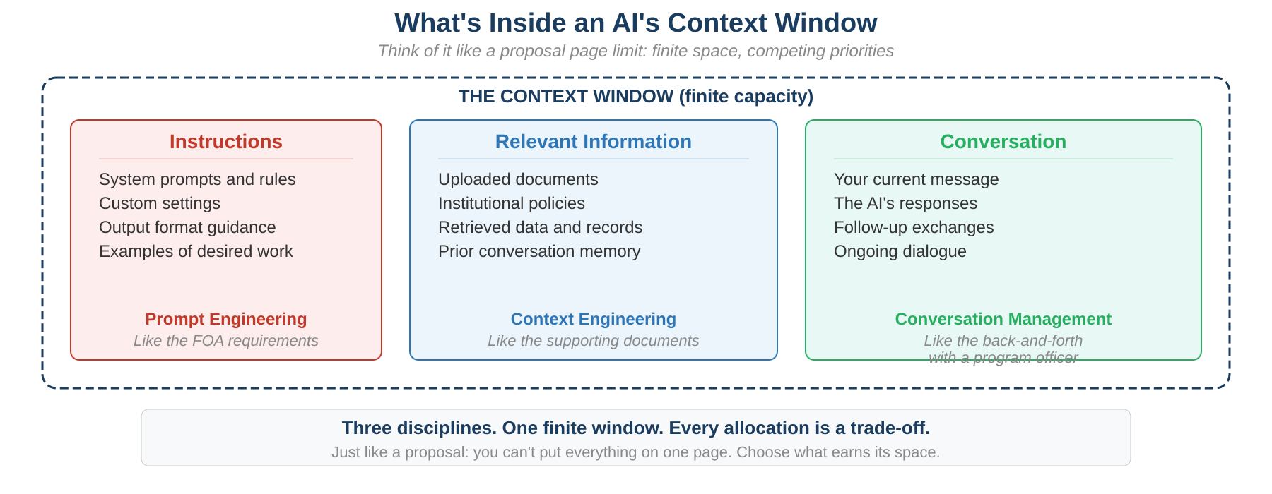
The total capacity is finite. Everything competes for the same limited space. And here's the critical insight: the quality of what the AI produces depends directly on what's in that window. Give it the right instructions, the right information, and a focused conversation, and it performs remarkably well. Give it vague instructions, irrelevant documents, and a sprawling chat history, and it degrades, even if the underlying model is exactly the same. Just like a proposal: the same PI with the same science will get different review scores depending on how well the narrative is assembled within the page limit.

Three Parts of the Window, Three Disciplines
Each part of the context window has its own emerging discipline, and understanding how they relate helps clarify what's actually changing in how we work with AI.
Prompt engineering is the discipline of optimizing the instructions. It was born in the era when most AI interactions were single-turn: you typed a request, the model responded, and that was it. There was no uploaded document, no persistent memory, no retrieved data. The wording of your request was the main lever you could pull, and learning to pull it well made a real difference. For research administrators, this meant learning to write prompts that could draft a facilities description, summarize a federal register notice, or reformat a budget justification to match a sponsor's template. That skill remains valuable.
Context engineering is the discipline of optimizing the relevant information. As AI tools evolved to handle document uploads, database access, web search, and persistent memory, users gained influence over a much larger portion of the context window. Context engineering asks: what information should the model have access to for this specific task? What's the minimum set of documents that gives it what it needs without overloading the window with noise? It's the difference between uploading the entire Uniform Guidance and uploading just the three sections on cost allowability that are relevant to the question at hand. Like assembling a just-in-time response for a sponsor: you don't send everything in the file, you send exactly what they asked for.
Conversation management is the discipline of optimizing the ongoing interaction and the balance across all three parts of the window. This is the piece the industry hasn't fully named yet, but it's arguably where the most practical skill lies for everyday users. Conversation management means knowing when a thread has gone on long enough that the AI is losing track of the original instructions. It means recognizing when to start a fresh conversation and re-upload the key documents rather than trying to course-correct a degraded one. It means being strategic about how many follow-up questions you ask before the dialogue itself crowds out the information the model needs. Anyone who has managed a long email chain with a program officer and eventually decided it was cleaner to start a new message with a fresh summary understands this instinct perfectly.
Prompt Engineering | Context Engineering | Conversation Management
Optimizes the instructions: how you phrase the request and define the task. | Optimizes the information: what documents, data, and knowledge the model can see. | Optimizes the interaction: when to continue, when to reset, how to keep the window balanced.
Like writing to a sponsor's FOA requirements. | Like assembling the supporting documents for a proposal. | Like managing a back-and-forth with a program officer.

Why This Matters for Research Administration
Research administrators already think in terms of all three disciplines, even if they've never used these names. When you onboard a new grants specialist, you don't just hand them a task and say "figure it out." You give them the institutional policies, the sponsor guidelines, the templates, the historical examples, and the unwritten rules about how things actually work. You build the environment that makes them effective. Then you manage the ongoing relationship: checking in, course-correcting, knowing when to step back and let them work versus when to intervene with new information.
Working with AI is the same. Instead of asking "Can you draft a budget justification?" and hoping the model guesses your sponsor's requirements, you set up custom instructions with your institutional context (prompt engineering), upload the FOA and rate agreements (context engineering), and then manage the interaction strategically, knowing when to ask follow-ups, when to provide clarification, and when the conversation has run long enough that it's time to start fresh (conversation management).
This reframing matters because it changes who benefits from AI. Prompt engineering rewarded the person who was best at talking to the machine. Context engineering and conversation management reward the person, or team, or institution, that is best at organizing information and managing processes. Think about what makes a great pre-award administrator: it's not that they write the most eloquent emails to the sponsor. It's that they know which documents to assemble, what information to surface at what moment, and when a conversation needs to be reset with a clean summary. Those are exactly the skills that make someone effective with AI.

What This Looks Like in Practice
You don't need to be a developer to apply these ideas. Here are a few ways they show up in everyday AI use for research administration:
Build your institutional context once, then reuse it. Set up custom instructions with your F&A rate, your institutional type, your key compliance frameworks, and your preferred output style. This is like building a proposal template library: you invest the time once, and every future interaction starts from a stronger position. That's prompt engineering at the institutional level.
Upload strategically, not exhaustively. When you need the AI to review a budget against sponsor guidelines, upload the specific sections of the FOA that address cost allowability, not the entire 200-page solicitation. Think of it like a just-in-time request from a sponsor: you send exactly what they asked for, nothing more. Overloading the AI is like attaching every policy in your shared drive to an audit response. The important information gets buried. That's context engineering.
Know when to start a new conversation. If you've been going back and forth with an AI for dozens of messages and the quality is slipping, the conversation itself may be crowding out the instructions and documents the model needs. Starting fresh and re-uploading the key materials can dramatically improve results. It's the same instinct that tells you when an email chain with a subrecipient has gotten too tangled and it's time to schedule a call and reset. That's conversation management.
Curate what the AI doesn't see. Context engineering isn't just about adding more information. It's also about knowing what to leave out. Just as you wouldn't include preliminary data from an unrelated project in a proposal, you shouldn't feed the AI documents that are tangentially relevant but ultimately noise. Choosing the right three pages from a 200-page manual is itself an act of context engineering.

Reusable Workflows: Build Once, Use Everywhere
Once you've figured out the right combination of instructions, documents, and interaction patterns for a particular task, the natural next step is to save it so you don't have to reinvent it every time. This is where reusable AI workflows come in, and it's where context engineering starts to look less like an individual skill and more like an institutional capability.
A workflow packages the context engineering decisions you've already made: which documents to provide, what instructions to include, what output format to expect, and how tasks chain together. Instead of each person in your office independently figuring out how to get the AI to extract deadlines from a funding announcement, you build the workflow once, test it, and share it. The next person just uploads their document and runs it. The prompt engineering, context engineering, and conversation management are all baked into the workflow itself. Tools like Vandalizer, developed by the University of Idaho's AI for Research Administration team, are designed around exactly this principle: letting RAs encode their institutional knowledge into reusable AI workflows that deliver consistent results regardless of who runs them.
Think of it as the difference between a one-off email to a sponsor and a standard operating procedure. Both get the job done, but the SOP ensures consistency, reduces errors, and means a new staff member can execute the process on day one. Reusable AI workflows do the same thing: they turn individual context engineering into organizational infrastructure.

The Skills That Are Evolving
All three skills matter: writing clear instructions, assembling the right information, and managing the interaction strategically. They work together, and the higher-leverage work is increasingly about what happens around the prompt: what information has been assembled, how it's been organized, and how the ongoing conversation is managed so the model has what it needs at every step. The shift is from linguistic craftsmanship to systems thinking.
For research administrators, this should feel familiar. The work of research administration has always been about making sure the right information is in the right place at the right time so that decisions can be made well. Whether that's assembling a proposal package, preparing for a site visit, or briefing a PI before a program officer call, the skill is the same: curate the context, manage the conversation, and trust that good preparation leads to good outcomes.
The people who will get the most out of AI in the years ahead won't be the ones who write the cleverest prompts. They'll be the ones who design the best environments for AI to work in and manage those interactions most strategically. If you've spent your career organizing complex information, navigating regulatory frameworks, and building processes that make other people's jobs easier, you already have a head start.

