When Can AI Be Used in Research Administration?
It Comes Down to One Question: Does It Matter How the Work Got Done?

Let's start with what's genuinely exciting. AI tools are remarkably capable, and they are getting better fast. They can digest hundreds of pages of sponsor guidelines in seconds, draft polished narrative text from rough notes, and surface patterns in financial data that would take a human analyst hours to find. For research administration offices that are chronically understaffed and facing growing regulatory complexity, that kind of capability is not a luxury. It's a lifeline.
Anyone who has spent a proposal deadline week copying institutional boilerplate into yet another template, or manually cross-referencing budget line items against a 90-page funding opportunity announcement, can immediately see the appeal. AI can take real, tedious, time-consuming work off people's plates, and it can do so at a scale and speed that no amount of hiring can match. That potential is worth taking seriously, and this post is not an argument against it.
But precisely because these tools are so capable, it's worth being deliberate about where we deploy them. The enthusiasm around AI often outpaces a careful conversation about where it belongs in our workflows, and where it doesn't. Not every task in research administration is the same, and the consequences of getting that distinction wrong can be serious.
In 1979, an internal IBM training slide offered a warning that has only grown more relevant: "A computer can never be held accountable, therefore a computer must never make a management decision." Nearly fifty years later, AI is vastly more capable than the mainframes IBM had in mind. But the core insight still holds. Accountability is a human quality. When a task requires someone to stand behind a judgment, to be answerable for the outcome, a computer (no matter how powerful) cannot fill that role.
That principle points to a practical test: does it matter how the task was completed? The answer isn't always yes or no. It's a continuum.

A Continuum, Not a Switch
At one end of the continuum, every step in the workflow must be auditable. The value of the work depends not just on what was produced but on demonstrating how it was produced and who was responsible at each stage. At the other end, the individual components of a workflow just need to work, one way or another. Nobody asks how the formatting got done or who drafted the first version of a boilerplate paragraph. They only care that the final product is correct and complete. Most research administration tasks fall somewhere between these two poles.
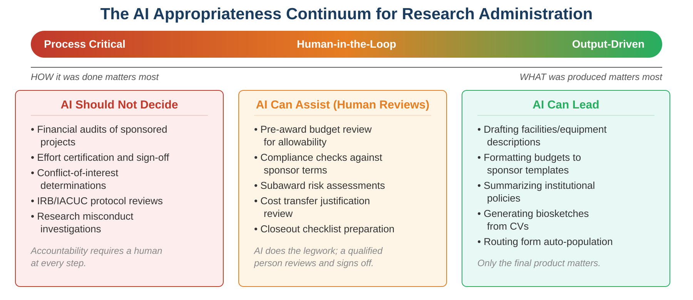

One End: When the Process Is the Point
Some tasks exist specifically so that a qualified person can attest that they reviewed something and found it acceptable. Consider a few concrete examples:
When a department conducts a financial audit of a sponsored project, the auditor is certifying not just that the numbers add up, but that they personally examined expenditures, verified allowability, and exercised professional judgment. If an AI flags every transaction as compliant, that isn't an audit. It's a scan. Similarly, effort certification requires a principal investigator to personally confirm that reported effort reasonably reflects how their time was actually spent. An AI cannot know that, and more importantly, cannot be held responsible if the certification turns out to be wrong. The same applies to IRB and IACUC protocol reviews, conflict-of-interest determinations, and research misconduct investigations. Each of these tasks derives its authority from the fact that a human being stood behind the conclusion.
Powerful black boxes are still black boxes. No matter how sophisticated the model, we often cannot fully explain how it reached a conclusion. And there is a second, equally important problem: reproducibility. AI models are inherently stochastic. Ask the same question twice and you may get two different answers. In contexts where accountability depends on a transparent, human-driven process whose results can be independently verified, that combination of opacity and inconsistency is disqualifying.

The Case for Auditable Tools
This doesn't mean that technology has no role at the process-critical end of the continuum. It means we need to reach for the right kind of technology: tools whose steps can be written down, reviewed, and repeated exactly.
Data scientists have worked under this constraint for years. When an analysis needs to be defensible, they don't reach for a tool that produces answers they can't explain. They use functional programming in languages like R or Python, where every transformation is an explicit, readable step in a script. They use pivot tables in Excel, where the logic of the aggregation is visible to anyone who opens the file. They write SQL queries that can be saved, version-controlled, and re-run by a colleague to verify the result. The common thread is not just transparency but reproducibility: a colleague can take the same inputs, follow the same steps, and arrive at the same output every time. That matters most when the output needs to be exact, such as a dollar figure in an expenditure report or a compliance determination. When the output is more qualitative (a drafted paragraph, a summarized policy), exact reproducibility is less important than getting to a correct and complete result, which is part of what makes those tasks better suited for AI.
Research administration can apply the same principle. If you need to reconcile expenditures across multiple funding sources, a Python script or an Excel workbook with clearly labeled formulas gives you a result and a paper trail. An auditor can open the file, follow the logic step by step, and confirm that the methodology was sound. Better yet, they can re-run it themselves and get the identical result. If you need to assess whether a set of cost transfers meet the timeliness requirements in your institutional policy, a structured query against your financial system is both faster than doing it by hand and fully reproducible.
The distinction matters. An AI model might give you the same answer, but when someone asks "how did you arrive at this conclusion?" the best you can offer is "the model said so." And if they run the same prompt again tomorrow, they might get a different answer. With auditable tools, the answer is the methodology itself, laid out in plain view, producing the same result every time it's executed. That difference is everything when the stakes involve federal funding, regulatory compliance, or institutional reputation.

The Middle: Human-in-the-Loop
Between the two extremes lies a wide range of tasks where AI can contribute meaningfully, as long as a qualified person reviews and signs off on the output. This human-in-the-loop model may be where AI delivers the most practical value in research administration.
Take pre-award budget review. AI could scan a proposed budget against a sponsor's cost principles, flag items that appear unallowable, and organize its findings into a summary. But a grants specialist still reviews that summary, applies context the AI may lack (such as a prior agreement with the sponsor about a specific line item), and makes the final determination. Or consider subaward risk assessments: AI could pull together audit findings, SAM.gov status, and prior performance data for a subrecipient, but a human decides whether the risk level warrants additional monitoring terms. Compliance checks against sponsor terms and cost transfer justification reviews follow the same pattern.
The key distinction is accountability. If a person reviews AI-generated analysis, validates it, and puts their name behind the conclusion, the process retains its integrity. The stochastic nature of AI matters less here because the human reviewer is the one making the final judgment, not the model. The "how" still matters, but the human's review and sign-off is what satisfies that requirement, not whether every preliminary step was done by hand.

The Other End: When Only the Output Matters
At the far end of the continuum are tasks where the process is essentially invisible to the recipient. Drafting a facilities and equipment description for a grant proposal is a good example: the content is largely institutional boilerplate, and no reviewer will ask whether a human or an AI assembled it. Reformatting a budget justification to meet a sponsor's template, generating a biosketch from a CV, summarizing institutional policies for an internal routing form, or auto-populating fields on a proposal routing sheet: these are all tasks where the only measure of success is whether the final product is accurate and complete.
That said, "let AI lead" does not mean "let AI go unchecked." Accuracy still matters, and it needs to be measured. AI tools can hallucinate facts, misread documents, or quietly introduce errors that look plausible at a glance. Before relying on AI for any output-driven task, teams should validate its performance: spot-check a sample of outputs against known-good results, track error rates over time, and establish a threshold below which human review gets added back in. Trust in these tools should be earned through evidence, not assumed.
This is where the power of AI that we started with pays off most directly. Research administrators are often stretched thin, juggling dozens of proposals and compliance deadlines simultaneously. Letting AI handle this kind of work at scale and speed frees up human attention for the tasks further along the continuum that truly demand it.

Applying the Test in Practice
Before integrating any tool into a research administration workflow, I'd encourage teams to ask: "If someone asked us how this task was completed, would the answer matter? Could a colleague re-run it and get the same result?" And be honest about what "the same result" means. For some tasks, exact reproducibility is non-negotiable: a financial reconciliation must produce identical numbers every time, down to the penny. For others, a similar result may be perfectly acceptable: two AI-drafted facilities descriptions won't be word-for-word identical, but if both are accurate and complete, the difference doesn't matter. Where a task falls on that question helps determine where it belongs on the continuum.
Process Critical | Human-in-the-Loop | Output-Driven
Use auditable, reproducible tools: scripts, queries, spreadsheets with visible logic. Every step is documented and repeatable. | Let AI do the prep work. A qualified person reviews, validates, and signs off on the output. | Let AI lead, but measure accuracy. Spot-check outputs, track error rates, and add review back in if quality slips.

Moving Forward Thoughtfully
IBM's 1979 warning was about mainframes, not large language models. But the principle it captures is timeless: accountability cannot be automated. The question isn't whether AI has a place in research administration. It clearly does, and the potential it offers is real. The question is whether we're thoughtful enough to place it at the right point on the continuum for each task we do, and to reach for transparent, reproducible alternatives when the process matters as much as the result.
Research administration exists to uphold the integrity of the research enterprise. As we bring new tools into our work, we should make sure we're strengthening that integrity, not quietly hollowing it out.

