AgroEarthFM
Physics-Informed Causal Foundation Models for
Climate-Resilient Agro-Ecosystem Intelligence

Comprehensive Implementation Plan
Self-Supervised Multimodal Physics-Informed Causal Geo Foundation Model

A Research Blueprint for Earth Resilience Foundation Modeling
May 2026

Table of Contents

Chapter 1: Research Vision and Hypothesis 1
1.1 Unified Research Direction 1
1.2 Core Scientific Hypothesis 1
1.3 Why This Merge Is Powerful 2
1.4 The Complete Causal Chain 2
Chapter 2: Model Architecture Design 3
2.1 Overall Architecture Overview 3
2.2 Modality-Specific Encoders 4
2.2.1 Satellite Imagery Encoder (ViT) 4
2.2.2 Weather Data Encoder (Temporal Transformer) 5
2.2.3 Soil Data Encoder (MLP/GNN) 5
2.2.4 Crop Calendar Encoder (Embedding) 5
2.2.5 Spatial Topology Encoder (Graph Encoder) 5
2.3 Cross-Modal Fusion Layer 6
2.4 Temporal Memory Module 6
2.5 Physics-Informed Layer 7
2.6 Causal Reasoning Layer 7
2.7 Output Heads 8
Chapter 3: Data Pipeline Design 8
3.1 Multimodal Data Sources 8
3.1.1 Satellite Imagery 8
3.1.2 Vegetation Indices 9
3.1.3 Climate Variables 9
3.1.4 Soil Variables 9
3.1.5 Agricultural Inputs 9
3.2 Time-Aligned Agro-Climate Datacube Construction 10
3.3 Data Preprocessing and Quality Control 10
3.4 Temporal Alignment Strategy 11
Chapter 4: Self-Supervised Training Strategy 11
4.1 Process-Centered SSL Design Philosophy 11
4.2 Objective 1: Phenology Transition Prediction 11
4.3 Objective 2: Drought Stress Evolution 12
4.4 Objective 3: Cross-Modal Causal Prediction 12
4.5 Objective 4: Future Ecosystem State Prediction 12
4.6 Objective 5: Counterfactual Learning 13
Chapter 5: Physics-Informed Constraints 13
5.1 Water Balance Physics 13
5.2 Plant Growth Physics 14
5.3 Physics-Regularized Loss Design 14
Chapter 6: Causal Framework Design 14
6.1 Causal Graph Structure 14
6.2 Causal Discovery from Observations 15
6.3 Counterfactual Reasoning Module 16
6.4 Intervention and What-If Analysis 16
Chapter 7: Downstream Tasks and Evaluation 16
7.1 Primary Downstream Tasks 16
7.2 Evaluation Framework 17
7.3 Benchmarks and Baselines 17
7.4 Expected Results 18
Chapter 8: Implementation Roadmap 18
8.1 Overview 18
8.2 Phase 1: Foundation (Weeks 1-8) 19
8.3 Phase 2: Data and Self-Supervised Learning (Weeks 9-20) 19
8.4 Phase 3: Multimodal Fusion (Weeks 21-32) 19
8.5 Phase 4: Physics and Causality (Weeks 33-44) 20
8.6 Phase 5: Research Prototype (Weeks 45-52) 20
Chapter 9: Prerequisites and Learning Path 21
9.1 Technical Prerequisites 21
9.2 Phase-by-Phase Learning Path 21
9.2.1 Phase 1: Python and Deep Learning (Weeks 1-4) 21
9.2.2 Phase 2: Geospatial Data Handling (Weeks 3-6) 21
9.2.3 Phase 3: Remote Sensing Fundamentals (Weeks 5-8) 21
9.2.4 Phase 4: Self-Supervised Learning (Weeks 7-12) 22
9.2.5 Phase 5: Multimodal Geospatial Learning (Weeks 11-16) 22
9.2.6 Phase 6: Physics-Informed Learning and Causal Inference (Weeks 15-22) 22
9.3 Core Resource Stack 22
Chapter 10: Risk Assessment and Mitigation 23
10.1 Technical Risks 23
10.2 Data Risks 23
10.3 Mitigation Strategies Summary 24
References 24

(Right-click the Table of Contents and select "Update Field" to refresh page numbers)

Chapter 1: Research Vision and Hypothesis

1.1 Unified Research Direction
The proposed research direction unifies two critical domains of Earth system science: drought dynamics modeling and crop phenology monitoring. Rather than treating these as separate problems, the AgroEarthFM project posits that their intersection creates a fundamentally richer and more impactful scientific contribution. By building a self-supervised multimodal physics-informed causal geo foundation model, we aim to learn the complete causal chain from climate forcing through ecological response to agricultural consequence. This unified framing addresses a critical gap in current geospatial AI, where existing foundation models capture surface appearance but fail to model causal agro-ecosystem processes linking climate stress, vegetation dynamics, and agricultural resilience.
The merger is scientifically powerful because it bridges slow environmental stress processes with biological growth cycles, connects climate causality to agricultural outcomes, and links ecosystem resilience directly to food security. This creates what we term a complete causal Earth-food system model, which is qualitatively different from and substantially more impactful than either a drought-only or crop-only model. The drought domain provides the physical drivers and stress mechanisms, while the crop phenology domain provides the biological response functions and outcome metrics. Together, they enable a model that does not merely classify or detect, but rather understands process dynamics in a physically grounded and causally directed manner.
Current geospatial foundation models such as Prithvi-EO-2.0 and DOFA have demonstrated the power of pretraining on large-scale Earth observation data, but they remain fundamentally appearance-based. They learn what a scene looks like rather than what processes are occurring and why. AgroEarthFM addresses this limitation by explicitly incorporating physical constraints and causal structure into the learning process, enabling the model to learn not just correlations but the directional dependencies that govern agro-ecosystem behavior under climate stress.

1.2 Core Scientific Hypothesis
Self-supervised multimodal representations that jointly model drought dynamics and crop phenology under physical constraints can learn causal agro-ecosystem processes that improve robustness, transferability, and agricultural resilience prediction across climate regions.
This hypothesis makes three strong claims that the research must validate. First, that joint modeling of drought and phenology is superior to modeling either in isolation, which addresses the representation quality question. Second, that physics-informed constraints improve the learned representations beyond what data-driven learning alone can achieve, which addresses the generalization and physical consistency question. Third, that causal structure in the representations enables better transfer across regions and conditions, which addresses the robustness and out-of-distribution performance question. Each of these claims is testable through controlled experiments comparing against single-domain baselines, unconstrained multimodal baselines, and correlation-only baselines respectively.

1.3 Why This Merge Is Powerful
The integration of drought dynamics with crop phenology creates five powerful synergistic bridges across the climate-food system. The drought component contributes slow environmental stress processes, climate causality, ecosystem resilience assessment, and hydrological process modeling. The crop phenology component contributes biological growth cycles, agricultural outcome prediction, food security assessment, and plant physiological understanding. When these are modeled jointly, the resulting framework captures the full spectrum from physical driver to biological consequence to societal impact, which is precisely the kind of integrated understanding that the Earth system science community has identified as a critical need.
This unified approach also has practical advantages for model training. Drought indicators such as soil moisture decline and evapotranspiration anomalies provide strong temporal signals that can anchor self-supervised learning objectives. Crop phenology transitions such as emergence, flowering, and senescence provide discrete, verifiable events that can serve as natural supervision signals. The combination means the model has access to both continuous process dynamics and discrete state transitions, which together provide a richer set of pretraining objectives than either domain alone.

1.4 The Complete Causal Chain
The central organizing principle of AgroEarthFM is a complete causal chain that runs from climate forcing through multiple intermediate states to food security risk. This chain is not merely a conceptual diagram but represents the actual information flow that the model must learn to represent. The chain proceeds as follows: climate forcing produces temperature anomalies, which drive evapotranspiration imbalance, leading to soil moisture decline, which causes vegetation stress, resulting in phenology disruption, leading to crop stress accumulation, culminating in yield reduction and ultimately food security risk. Each link in this chain represents a causal dependency that the model should capture in its internal representations.
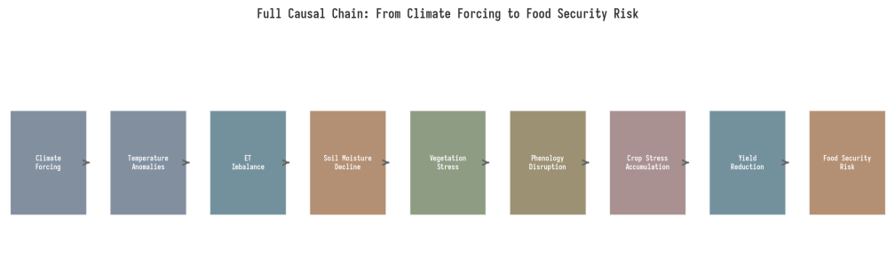
Figure 1.1: Full Causal Chain from Climate Forcing to Food Security Risk
This causal chain is scientifically meaningful because each link is supported by established domain knowledge. The relationship between temperature anomalies and evapotranspiration follows well-established thermodynamic principles. The link between soil moisture decline and vegetation stress is documented across extensive agricultural and ecological literature. The connection between phenology disruption and yield reduction is well-studied in crop science. By building a model that is explicitly designed to learn this chain, rather than hoping it emerges from generic pattern recognition, we create a system that is more interpretable, more robust to distribution shift, and more useful for scenario analysis and decision support.

Chapter 2: Model Architecture Design

2.1 Overall Architecture Overview
The AgroEarthFM architecture follows a multi-stage pipeline design: inputs are processed by modality-specific encoders, fused into a shared agro-ecosystem state representation, refined through physics-informed and causal reasoning layers, and decoded by task-specific output heads. This design is motivated by the observation that different input modalities have fundamentally different statistical properties and temporal characteristics. Satellite imagery is spatially structured but temporally sparse; weather data is temporally dense but spatially coarse; soil and crop calendar information is categorical or semi-structured. A single monolithic encoder would struggle to handle this diversity, whereas specialized encoders can exploit the structure of each modality before fusion.
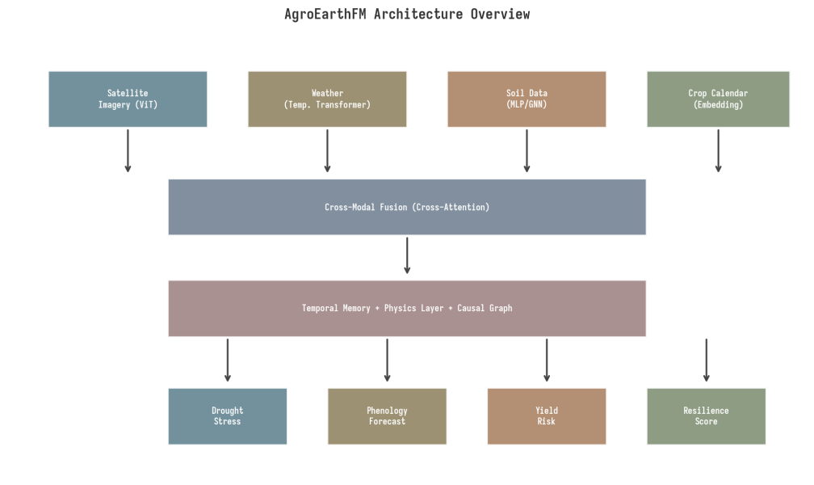
Figure 2.1: AgroEarthFM Architecture Overview
The architecture is designed around five core principles. First, modality-specific encoding ensures that each data stream is processed by an encoder suited to its structure. Second, cross-modal fusion through attention mechanisms allows the model to learn how different modalities interact and influence each other. Third, temporal memory captures the slow dynamics of drought progression and the seasonal cycles of crop development. Fourth, physics-informed constraints ensure that the learned representations respect conservation laws and process constraints. Fifth, causal reasoning layers impose directional structure on the relationships between variables, moving beyond correlation toward genuine process understanding.

2.2 Modality-Specific Encoders

2.2.1 Satellite Imagery Encoder (ViT)
The satellite imagery encoder is based on the Vision Transformer (ViT) architecture, adapted for multispectral geospatial data. Unlike natural images, satellite imagery contains 10 or more spectral bands spanning visible, near-infrared, and shortwave-infrared wavelengths, each carrying distinct physical information about surface properties. The encoder processes these bands as multi-channel inputs to the ViT, with band-specific patch embeddings that preserve the physical meaning of each spectral channel. This design follows recent geospatial ViT implementations such as Prithvi-EO-2.0, which demonstrated that treating spectral bands as structured inputs rather than generic channels improves downstream performance on Earth observation tasks.
The ViT encoder is also designed to handle the temporal dimension of satellite data. Each observation at a given time step is processed independently through the spatial encoder, producing a set of spatial token embeddings. These tokens are then passed to the temporal memory module, which tracks how spatial patterns evolve over time. This separation of spatial and temporal processing is computationally efficient and allows the model to handle irregular observation frequencies, which are common in satellite data due to cloud cover and revisit schedules.

2.2.2 Weather Data Encoder (Temporal Transformer)
Weather variables such as temperature, rainfall, humidity, solar radiation, and wind are inherently temporal and are typically available at much higher temporal resolution than satellite imagery. The weather encoder uses a temporal Transformer architecture that processes sequences of weather observations over the same time window as the satellite data. Each time step is represented as a feature vector of weather variables, and the Transformer applies self-attention across time to capture temporal dependencies such as heat waves, dry spells, and seasonal transitions. The encoder outputs a sequence of weather state embeddings that capture both short-term weather patterns and long-term climate trends.

2.2.3 Soil Data Encoder (MLP/GNN)
Soil variables including soil moisture, soil type, and groundwater level are spatially structured but vary on different spatial scales than satellite imagery. The soil encoder uses a combination of MLP layers for point-wise soil properties and Graph Neural Network (GNN) layers for spatially distributed properties. The GNN component is particularly important for modeling soil moisture dynamics, which are influenced by topography, drainage networks, and spatially varying soil properties. The encoder outputs a soil state embedding that captures both the current soil conditions and their spatial context.

2.2.4 Crop Calendar Encoder (Embedding)
Crop calendar information provides strong prior knowledge about expected phenology stages and management activities. The crop calendar encoder maps crop type, planting date, expected growth stages, and irrigation status into a learned embedding space. This embedding serves as a conditional input to the rest of the model, biasing the model toward phenologically appropriate interpretations of the satellite and weather data. For example, if the crop calendar indicates that the growing season has just begun, the model should interpret low NDVI values as expected rather than as stress signals.

2.2.5 Spatial Topology Encoder (Graph Encoder)
Agricultural landscapes are not isolated pixels; they exist within spatial networks of fields, water bodies, and topographic features. The spatial topology encoder uses a graph structure where nodes represent spatial locations and edges represent spatial adjacency or hydrological connectivity. This encoder captures the spatial context that influences how drought stress propagates across a landscape, how irrigation in one area affects neighboring fields, and how topography channels water flow. The graph encoder outputs spatial context embeddings that are combined with the per-location encodings from other modalities.

2.3 Cross-Modal Fusion Layer
The cross-modal fusion layer is the central integrative component of AgroEarthFM. It takes the embeddings from all modality-specific encoders and produces a unified agro-ecosystem state representation. The fusion mechanism is based on cross-attention, where each modality can attend to the representations of other modalities. This allows the model to learn, for example, that a particular pattern of temperature and rainfall (weather embedding) should modify the interpretation of a satellite observation (imagery embedding), or that soil moisture conditions (soil embedding) mediate the relationship between weather and vegetation stress.
The fusion layer uses a stack of cross-attention blocks, each consisting of cross-attention between modality pairs followed by a feed-forward network. The ordering and pairing of cross-attention operations are designed to reflect the causal structure of the system: weather influences soil, soil and weather jointly influence vegetation, and vegetation state combined with crop calendar determines phenology interpretation. This causally-informed fusion ordering is a key design choice that biases the model toward learning physically meaningful interactions rather than arbitrary cross-modal correlations.

2.4 Temporal Memory Module
Agro-ecosystem processes unfold over timescales ranging from days (weather events) to months (drought progression) to seasons (crop development cycles). The temporal memory module is designed to capture these multiple timescales using a hierarchical temporal structure. Short-term dynamics are captured by a recurrent mechanism with a relatively short memory window, while long-term trends and seasonal patterns are captured by a separate pathway with longer context. The two pathways are combined to produce a temporal state embedding that captures both the immediate context and the longer-term trajectory of agro-ecosystem development.
This design is motivated by the observation that drought impacts on crops are often cumulative: a single dry week may have minimal impact, but prolonged moisture deficit over months can be devastating even if individual weeks are not extreme. Similarly, crop phenology is driven by accumulated growing degree days rather than instantaneous temperature. The hierarchical temporal memory allows the model to naturally capture these cumulative effects without requiring manual feature engineering of lagged variables or accumulated indices.

2.5 Physics-Informed Layer
The physics-informed layer constrains the model representations to respect known physical laws and conservation principles. The primary physics backbone is the water balance equation, which states that soil water availability equals precipitation minus evapotranspiration minus runoff, with adjustments for infiltration and deep percolation. This constraint is implemented as a soft penalty in the loss function: if the model predicts a soil moisture state that is inconsistent with the water balance given the observed precipitation and estimated evapotranspiration, the loss function applies a penalty proportional to the magnitude of the inconsistency.
A secondary physics constraint comes from plant growth dynamics, which depend on temperature, water availability, and solar radiation. The model is penalized for predicting healthy vegetation growth under severe water deficit unless there is evidence of irrigation. This constraint prevents the model from learning physically impossible states and encourages it to attribute vegetation changes to their actual physical causes rather than spurious correlations. The physics-informed layer also provides a natural mechanism for the model to learn about unobserved variables: if the observed vegetation state is inconsistent with observed weather and soil conditions, the model can infer the presence of unobserved factors such as irrigation, deep soil moisture, or pest damage.

2.6 Causal Reasoning Layer
The causal reasoning layer sits on top of the fused and physics-constrained representations and imposes directional structure on the relationships between variables. It implements a learned structural causal model over a set of key variables: rainfall, temperature, evapotranspiration, soil moisture, vegetation health, crop stage, and yield. The causal graph structure can be partially specified based on domain knowledge (for example, rainfall causes soil moisture increase, not the reverse) and partially learned from data (for example, the relative strength of temperature versus rainfall effects on crop stress may vary by region and season).
The causal layer serves three important functions. First, it makes the model interpretable by exposing which causal pathways are most active in a given prediction. Second, it enables counterfactual reasoning: the model can answer questions like "what would happen to crop stress if rainfall decreased by 20%?" by intervening on the rainfall node and propagating the effects through the causal graph. Third, it improves transferability: because causal relationships are more stable across environments than correlations, a model that captures causal structure should generalize better to new regions and climate conditions.

2.7 Output Heads
The model produces four distinct outputs, each decoded by a specialized head from the shared agro-ecosystem state representation. The drought stress score head produces a continuous scalar indicating the current level of drought stress on a standardized scale. The phenology forecast head predicts the current growth stage and the timing of upcoming phenology transitions. The yield risk head estimates the probability of yield falling below critical thresholds. The resilience score head produces an integrated assessment of the agro-ecosystem capacity to withstand and recover from climate stress. These four outputs together provide a comprehensive picture of agro-ecosystem status that is far more informative than any single classification or regression output.

Chapter 3: Data Pipeline Design

3.1 Multimodal Data Sources
The AgroEarthFM data pipeline integrates six categories of data, each providing complementary information about agro-ecosystem state and dynamics. The design principle is that each data source should contribute unique information that is not fully captured by other sources, and that the combination should enable the model to learn causal relationships that would be invisible from any single modality.
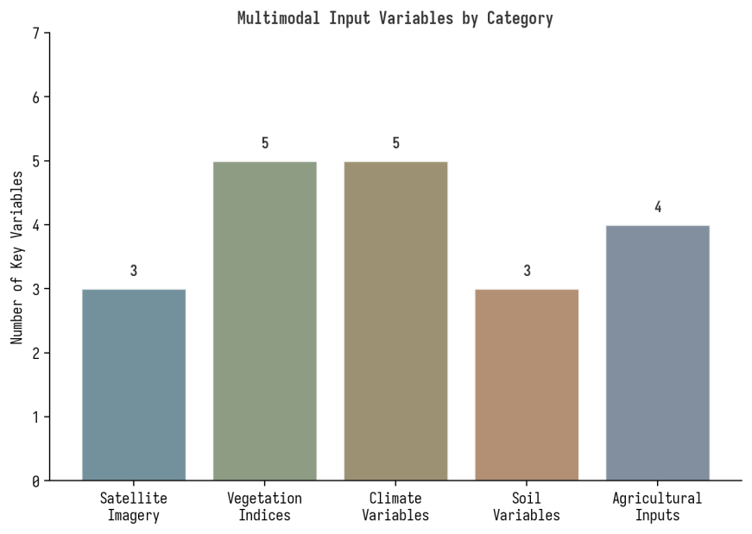
Figure 3.1: Multimodal Input Variables by Category

3.1.1 Satellite Imagery
The primary satellite imagery source is Sentinel-2, which provides 13-band multispectral data at 10-20m spatial resolution with a 5-day revisit time. Sentinel-2 captures vegetation health, crop development stage, canopy structure changes, and land surface conditions across the visible, near-infrared, and shortwave-infrared spectrum. For temporal consistency and long-term studies, MODIS and Landsat data provide complementary coverage. The Harmonized Landsat Sentinel-2 (HLS) product is particularly valuable because it fuses Landsat and Sentinel-2 into an analysis-ready dataset with observations every 2-3 days, significantly improving temporal density for phenology monitoring and drought tracking.

3.1.2 Vegetation Indices
Vegetation indices are derived from satellite spectral bands and provide compressed, physically meaningful summaries of vegetation properties. The five core indices for AgroEarthFM are NDVI for overall greenness and vegetation density, EVI for vegetation vigor that is less saturated in dense canopies, NDWI for water stress and canopy water content, LAI for total biomass and leaf area, and FAPAR for photosynthetic activity and productivity. These indices serve dual purposes: they are input features for the model and they provide ground-truth signals for self-supervised learning objectives. The temporal trajectories of these indices are particularly informative, as they reveal the dynamics of vegetation stress and recovery that static snapshots cannot capture.

3.1.3 Climate Variables
Variable | Role in Causal Chain | Primary Source
Temperature | Heat stress driver, GDD accumulation | ERA5
Rainfall | Water input, drought trigger | ERA5 / CHIRPS
Humidity | Evapotranspiration mediator | ERA5
Solar Radiation | Growth energy, ET driver | ERA5
Wind Speed | Moisture loss, ET component | ERA5

3.1.4 Soil Variables
Variable | Role in Causal Chain | Primary Source
Soil Moisture | Drought state indicator, water availability | SMAP / ESA CCI
Soil Type | Water retention capacity, infiltration | SoilGrids
Groundwater Level | Deep water reserve, resilience buffer | GRACE / Well data

3.1.5 Agricultural Inputs
Variable | Role in Causal Chain | Primary Source
Crop Calendar | Phenology prior, expected stage timing | Crop calendars / GEOGLAM
Irrigation Status | Human intervention, water supplement | Irrigation maps / Reports
Crop Type | Growth dynamics, stress sensitivity | Crop maps / Cropland data
Management Practices | Resilience modifier, adaptation | Agricultural surveys

3.2 Time-Aligned Agro-Climate Datacube Construction
The core data structure for AgroEarthFM is the time-aligned agro-climate datacube: a spatiotemporal array that stacks all input modalities for a given region and time window into a unified, aligned representation. Building this datacube requires resolving several alignment challenges. Temporal alignment is needed because satellite imagery, weather data, and soil moisture observations all have different temporal resolutions and revisit schedules. Spatial alignment requires resampling all data to a common grid, which involves decisions about the target spatial resolution and the resampling method. Spectral alignment is needed when combining data from different satellite missions with different band definitions.
The datacube construction pipeline proceeds in four stages. First, all data sources are reprojected to a common coordinate reference system and resampled to a common spatial grid, with the target resolution determined by the highest-resolution input (typically 10m from Sentinel-2). Second, temporal alignment is performed by defining regular time steps (e.g., 5-day or 10-day composites) and aggregating or interpolating all observations to these time steps. Third, quality filtering removes cloudy pixels, missing values, and low-quality observations, with gap-filling performed using temporal interpolation or spatial neighborhood methods. Fourth, derived variables such as vegetation indices and drought indices are computed from the aligned base variables.

3.3 Data Preprocessing and Quality Control
Quality control is critical for geospatial data, which is subject to cloud contamination, atmospheric effects, sensor artifacts, and missing observations. The preprocessing pipeline applies cloud masking using Sentinel-2 scene classification layers, atmospheric correction validation, temporal consistency checks that flag unrealistic jumps in vegetation index values, and spatial coherence checks that identify isolated anomalous pixels. For climate data, quality control includes checking for station artifacts in reanalysis products, validating extreme value plausibility, and ensuring temporal completeness. The goal is to provide the model with clean, consistent data that reflects actual surface and atmospheric conditions rather than observation artifacts.

3.4 Temporal Alignment Strategy
The temporal alignment strategy must balance several competing requirements. Fine temporal resolution captures rapid events such as flash droughts and phenology transitions, but increases computational cost and may introduce noise from sparse observations. Coarse temporal resolution provides smoother trajectories but may miss critical events. The proposed strategy uses a two-level temporal representation: a fine-grained level at 5-day intervals for capturing rapid dynamics, and a coarse-grained level at monthly intervals for capturing seasonal and long-term trends. The model processes both levels simultaneously through the hierarchical temporal memory module, with the fine-grained pathway providing detail and the coarse-grained pathway providing context.

Chapter 4: Self-Supervised Training Strategy

4.1 Process-Centered SSL Design Philosophy
Standard self-supervised learning in vision uses pretext tasks such as masked autoencoding (MAE) or contrastive learning, which operate on pixel-level or patch-level reconstruction and discrimination. While effective for learning appearance representations, these objectives are insufficient for learning process dynamics. AgroEarthFM introduces process-centered SSL, where the pretext tasks are designed to force the model to learn the temporal, causal, and physical processes that govern agro-ecosystem behavior. Each SSL objective targets a different aspect of process understanding, and together they provide comprehensive coverage of the causal chain from climate forcing to food security risk.
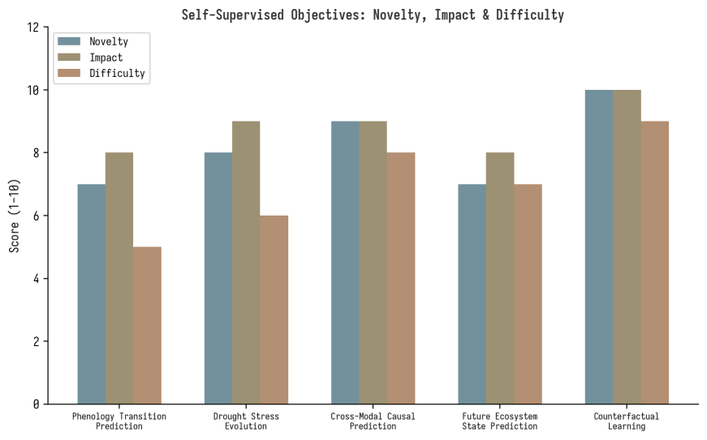
Figure 4.1: Self-Supervised Objectives: Novelty, Impact, and Difficulty Assessment

4.2 Objective 1: Phenology Transition Prediction
The first SSL objective requires the model to predict phenology stage transitions from temporal observations. Given a sequence of vegetation index observations up to time t, the model must predict whether a phenology transition (such as emergence, flowering, or senescence) will occur within a future time window, and if so, which transition. This objective forces the model to learn the temporal patterns that precede phenology transitions, including the environmental conditions (temperature accumulation, water availability) that trigger stage changes. The training signal comes from the natural temporal structure of the data: transitions can be detected from the temporal derivatives of vegetation indices even without explicit ground-truth labels, making this a genuinely self-supervised objective.

4.3 Objective 2: Drought Stress Evolution
The second SSL objective requires the model to predict the trajectory of vegetation degradation under drought stress. Given observations of a region experiencing developing drought conditions up to time t, the model must predict the vegetation stress trajectory over the next several time steps. This objective forces the model to learn the dynamics of drought progression, including the lagged effects of moisture deficit on vegetation, the nonlinear threshold effects where small additional stress causes disproportionate degradation, and the differential vulnerability of different crop types and growth stages. The training signal comes from the observed temporal evolution of vegetation indices and drought indices in historically drought-affected regions.

4.4 Objective 3: Cross-Modal Causal Prediction
The third SSL objective tests whether the model has learned cross-modal causal relationships by requiring it to predict the state of one modality from others. Specifically, given rainfall and temperature observations, the model must predict the resulting soil moisture trajectory; given weather and soil conditions, it must predict the vegetation response. This objective directly tests the model understanding of causal mechanisms rather than mere correlation. A model that has learned that rainfall increases soil moisture, which in turn supports vegetation growth, should be able to predict soil moisture decline from rainfall deficit and vegetation stress from soil moisture decline, even in regions and conditions not seen during training.

4.5 Objective 4: Future Ecosystem State Prediction
The fourth SSL objective is the most comprehensive: given all available observations up to time t, predict the full ecosystem state at a future time horizon. This includes vegetation health, crop stress level, phenology stage, and yield risk indicators. This objective integrates all the process understanding captured by the previous objectives and tests whether the model can perform genuine temporal forecasting rather than mere pattern matching. The prediction horizon is varied during training to encourage the model to capture dynamics at multiple timescales, from weeks to months to seasons.

4.6 Objective 5: Counterfactual Learning
The fifth and most novel SSL objective is counterfactual learning. Given an observed sequence of conditions and outcomes, the model is asked to predict what would have happened under modified conditions: what if rainfall decreased by 20%? What if the temperature had been 2 degrees higher? What if irrigation had been applied? This objective forces the model to learn not just what happens under observed conditions, but why it happens and what would change under different scenarios. Counterfactual learning is implemented by creating synthetic interventions on the input data (modifying rainfall or temperature in the input) and requiring the model to predict the resulting changes in vegetation, soil, and crop outcomes. The training signal comes from the physical consistency constraints: the counterfactual predictions must satisfy the same water balance, energy balance, and growth dynamics as factual predictions.

Chapter 5: Physics-Informed Constraints

5.1 Water Balance Physics
The water balance is the foundational physical constraint for AgroEarthFM. It expresses the conservation of water mass in the soil-plant-atmosphere system and can be formulated as: soil water availability equals precipitation minus evapotranspiration minus runoff, plus any irrigation input, minus deep percolation. This equation must hold at all times and locations, and violations indicate either measurement error, model error, or unobserved water fluxes. By incorporating this constraint into the training loss, we ensure that the model representations are physically consistent and that the learned relationships between precipitation, evapotranspiration, and soil moisture respect mass conservation.
The water balance constraint is implemented as a differentiable loss term that penalizes the discrepancy between predicted soil moisture changes and the water balance implied by observed or predicted precipitation, evapotranspiration, and runoff. The evapotranspiration component itself can be estimated using established methods such as the Penman-Monteith equation, which provides a physically grounded relationship between atmospheric conditions and water loss. By using Penman-Monteith evapotranspiration estimates as a soft constraint rather than a hard requirement, the model can learn deviations from standard ET models that may reflect local conditions, irrigation, or vegetation-specific water use strategies.

5.2 Plant Growth Physics
Plant growth dynamics provide the second physical constraint. Crop growth depends on three primary resources: temperature (expressed through growing degree days), water availability, and solar radiation. When any of these is limiting, growth is constrained accordingly. The model is penalized for predicting healthy vegetation growth under conditions where one or more resources are severely limiting, unless there is evidence of compensating factors such as irrigation or deep root access to groundwater. This constraint prevents the model from learning physically impossible scenarios and encourages it to attribute vegetation changes to their actual environmental drivers.
The growth constraint is implemented through a limiting-factor model inspired by the Mitscherlich-Baule production function, where growth is proportional to the most limiting resource. This creates a differentiable constraint that can be incorporated into the training loss. The model is also encouraged to learn about phenology-specific resource requirements: for example, water stress during flowering has disproportionately large effects on yield compared to water stress during vegetative growth. This phenology-dependent sensitivity is a well-established feature of crop physiology that the model should capture naturally if it learns the correct causal structure.

5.3 Physics-Regularized Loss Design
The total training loss combines the self-supervised objectives from Chapter 4 with the physics-informed constraints from this chapter. The loss has the form: L_total = L_ssl + lambda_physics * L_physics + lambda_causal * L_causal, where L_ssl is the sum of the five SSL objectives, L_physics combines the water balance and growth constraints, and L_causal enforces the causal graph structure. The weighting coefficients lambda_physics and lambda_causal are hyperparameters that control the strength of the physics and causal constraints relative to the data-driven SSL objectives. These coefficients should be tuned carefully: too strong and the model may be over-constrained, unable to learn from data; too weak and the physics and causality become ineffective.

Chapter 6: Causal Framework Design

6.1 Causal Graph Structure
The causal graph defines the directional dependencies between the key variables in the agro-ecosystem. The proposed graph has seven primary nodes: rainfall, temperature, evapotranspiration, soil moisture, vegetation health, crop stage, and yield. The edges represent causal influences with the following structure: rainfall and temperature jointly influence evapotranspiration; rainfall and evapotranspiration determine soil moisture change; soil moisture and temperature influence vegetation health; vegetation health and crop stage influence each other bidirectionally; and vegetation health and crop stage jointly determine yield. This graph structure is partially specified based on established domain knowledge and partially learned from data, allowing the model to discover region-specific and season-specific causal strengths.
Causal Edge | Physical Mechanism | Direction
Rainfall -> Soil Moisture | Water input to soil system | Positive
Temperature -> Evapotranspiration | Higher temperature increases ET | Positive
Evapotranspiration -> Soil Moisture | Water loss from soil system | Negative
Soil Moisture -> Vegetation Health | Water availability for growth | Positive
Temperature -> Vegetation Health | Heat stress on plants | Curvilinear
Vegetation Health -> Crop Stage | Growth enables stage transitions | Positive
Crop Stage -> Vegetation Health | Stage-specific water needs | Context-dependent
Vegetation Health -> Yield | Biomass accumulation | Positive
Crop Stage -> Yield | Stage-specific yield determination | Context-dependent

6.2 Causal Discovery from Observations
While the causal graph structure is partially specified from domain knowledge, the strength and functional form of causal relationships must be learned from observational data. The model uses a neural causal inference approach where the causal graph is parameterized as a set of neural network modules, each representing the functional relationship from parent nodes to child nodes. The graph structure can be refined using differentiable structure learning, where the presence or absence of edges is parameterized by learnable weights that are optimized alongside the model parameters. This approach allows the model to discover which causal pathways are most important in different regions and seasons, providing insights that go beyond the initial domain-knowledge-specified structure.

6.3 Counterfactual Reasoning Module
The counterfactual reasoning module enables the model to answer what-if questions about agro-ecosystem responses to hypothetical interventions. Given a factual observation sequence and a proposed intervention (such as a 20% reduction in rainfall), the module performs a three-step inference. First, it infers the exogenous noise terms that explain the factual observations given the learned causal model. Second, it applies the intervention by replacing the specified variable with its counterfactual value while keeping the exogenous noise fixed. Third, it propagates the intervention through the causal graph using the learned structural equations to compute the counterfactual outcomes. This procedure follows the standard potential-outcomes framework for causal inference but implements it within a neural network, enabling end-to-end differentiable counterfactual prediction.

6.4 Intervention and What-If Analysis
The ability to perform intervention analysis is one of the most valuable practical applications of AgroEarthFM. Decision-makers need to understand not just what is happening now, but what would happen under different scenarios. The model supports several types of intervention analysis. Climate scenario analysis asks: what would happen to crop yields under a 2-degree warming scenario? Water management analysis asks: how much irrigation would be needed to prevent yield loss under a moderate drought? Adaptation strategy analysis asks: which crop types or management practices would be most resilient under projected climate conditions? These analyses are enabled by the causal structure of the model, which allows interventions to be applied at any point in the causal chain and their effects to be propagated forward through the graph.

Chapter 7: Downstream Tasks and Evaluation

7.1 Primary Downstream Tasks
AgroEarthFM is designed to support six primary downstream tasks, each corresponding to a critical agricultural and environmental application. These tasks demonstrate the breadth of the model capabilities and provide concrete evaluation metrics for each aspect of agro-ecosystem understanding.
1. Drought Forecasting: Predict drought onset, intensity, and duration at lead times of 1-6 months, using the model temporal and causal representations. This task evaluates whether the model captures the slow dynamics and precursor signals of drought development.
2. Crop Stress Detection: Identify regions and time periods where crops are experiencing stress from water deficit, heat, or combined factors. This task evaluates whether the model can distinguish between normal phenology-driven vegetation changes and stress-driven degradation.
3. Yield Prediction: Estimate crop yield at field to regional scales before harvest, using the model accumulated stress and phenology representations. This task evaluates whether the model captures the causal chain from stress to yield impact.
4. Food Insecurity Risk Assessment: Map the spatial distribution of food insecurity risk based on projected yield shortfalls, drought persistence, and resilience indicators. This task integrates multiple model outputs into a societal impact assessment.
5. Phenology Forecasting: Predict the timing of crop growth stage transitions, including emergence, flowering, and senescence, under current and projected conditions. This task directly evaluates the phenology SSL objective in a practical setting.
6. Climate Adaptation Mapping: Identify regions where agricultural practices need to adapt to changing climate conditions, based on the model causal analysis of stress drivers and resilience factors. This task leverages the counterfactual reasoning capability.

7.2 Evaluation Framework
The evaluation framework follows a three-tier structure. Tier 1 assesses representation quality through linear probing and fine-tuning on standard geospatial benchmarks such as GEO-Bench and PhilEO Bench. Tier 2 assesses task performance on the six primary downstream tasks, comparing against domain-specific baselines and existing geospatial foundation models. Tier 3 assesses physical consistency and causal validity through physics compliance tests and causal discovery accuracy metrics. This three-tier structure ensures that the model is evaluated not just on prediction accuracy but also on the quality of its learned representations and the physical and causal validity of its internal reasoning.

7.3 Benchmarks and Baselines
The model will be compared against several categories of baselines. Task-specific models represent the current state of the art for each individual downstream task. General geospatial foundation models such as Prithvi-EO-2.0, DOFA, and SatMAE provide comparisons for the foundation model approach without domain-specific design. Ablation models test the contribution of each component by removing or replacing the physics layer, causal layer, or process-centered SSL objectives. This comprehensive comparison ensures that any performance improvements can be attributed to specific design choices rather than generic improvements from larger models or more data.

7.4 Expected Results
Based on the theoretical arguments and the empirical performance of related approaches in the literature, we expect AgroEarthFM to show three key advantages over baselines. First, improved transferability: the model should generalize better to new regions and climate conditions because causal relationships are more stable than correlations. Second, improved physical consistency: the model predictions should violate physical constraints less frequently than unconstrained baselines, leading to more trustworthy outputs for decision-making. Third, improved performance on tail events: the model should perform better on extreme drought and stress events that are underrepresented in training data but are precisely the events where accurate prediction matters most, because the causal structure provides inductive bias that guides correct prediction even when data is scarce.

Chapter 8: Implementation Roadmap

8.1 Overview
The implementation follows a 52-week phased approach, where each phase builds on the skills and artifacts of the previous phase. The phasing ensures that foundational skills are in place before advanced components are attempted, and that each phase produces a testable artifact that validates progress. The timeline is designed for a single researcher working full-time, and can be compressed with additional resources or expanded if learning time needs to be extended.
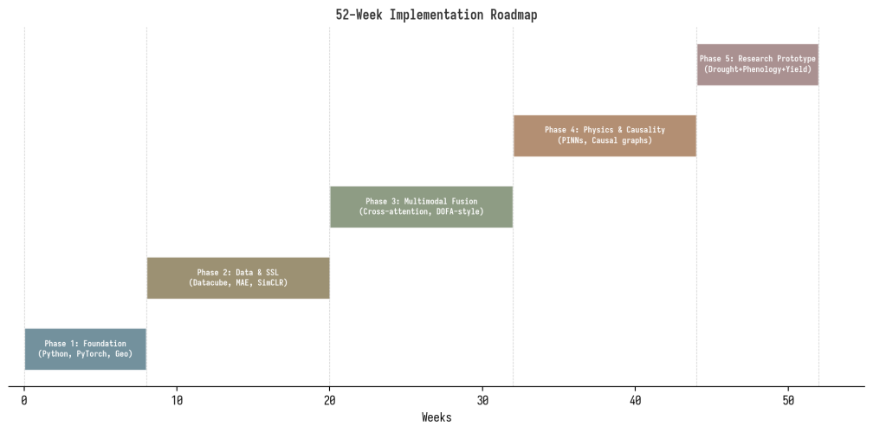
Figure 8.1: 52-Week Implementation Roadmap

8.2 Phase 1: Foundation (Weeks 1-8)
The first phase focuses on building the core technical skills needed for all subsequent work. This includes Python proficiency, PyTorch fluency including tensor operations, autograd, training loops, GPU usage, and model debugging. Simultaneously, the researcher should learn geospatial data handling using xarray for labeled multidimensional arrays and rasterio for raster IO. The capstone of this phase is a working pipeline that can load one raster dataset, visualize it, batch it, and train a tiny model on it. This may seem basic, but it establishes the data-loading and training infrastructure that all subsequent work depends on.
Key milestones for Phase 1: (1) Working PyTorch training pipeline on a simple classification task. (2) Ability to load and visualize Sentinel-2 imagery using rasterio. (3) Construction of a small temporal datacube using xarray for one location. (4) Successful training of a small CNN on satellite imagery for a land-cover classification task.

8.3 Phase 2: Data and Self-Supervised Learning (Weeks 9-20)
The second phase deepens the remote sensing knowledge and introduces self-supervised learning. The researcher should learn the major satellite data sources in depth: Sentinel-1 SAR data, Sentinel-2 optical data, Landsat heritage data, the HLS fused product, and ERA5 reanalysis data. Building a complete datacube for one study region and one growing season is the central artifact. Simultaneously, the researcher should implement at least one SSL method on EO data, starting with MAE-style masked reconstruction and then moving to contrastive learning with SimCLR or a DINO-style teacher-student setup. The key insight to develop in this phase is how the choice of pretext task shapes what the representations capture.
Key milestones for Phase 2: (1) Complete datacube for one study region with all six data modalities. (2) Working MAE implementation on satellite imagery. (3) Working SimCLR or DINO implementation on satellite imagery. (4) Comparison of learned representations via linear probing on a standard benchmark. (5) Documented understanding of how different SSL objectives affect representation quality.

8.4 Phase 3: Multimodal Fusion (Weeks 21-32)
The third phase implements the multimodal fusion architecture. Starting with optical plus SAR plus weather as the three primary modalities, the researcher builds the modality-specific encoders and the cross-attention fusion layer. This phase should produce a working multimodal encoder that can be pretrained on the SSL objectives from Phase 2, extended to the process-centered SSL objectives from Chapter 4. The fusion architecture should be evaluated on downstream task performance compared to single-modality baselines, and the cross-attention patterns should be analyzed to verify that the model is learning meaningful cross-modal interactions rather than ignoring some modalities.
Key milestones for Phase 3: (1) Working modality-specific encoders for imagery, weather, and soil data. (2) Cross-attention fusion layer producing unified state representations. (3) Process-centered SSL objectives implemented and training successfully. (4) Downstream task performance improvement from multimodal fusion over single-modality baselines. (5) Analysis of cross-attention patterns showing meaningful modality interactions.

8.5 Phase 4: Physics and Causality (Weeks 33-44)
The fourth phase adds the physics-informed and causal reasoning components. This is where the model transcends conventional geospatial deep learning and becomes a genuine process model. The physics layer starts with the water balance constraint and the growth dynamics constraint, implemented as differentiable loss terms. The causal layer starts with the domain-knowledge-specified causal graph and extends to learnable causal structure. This phase requires careful validation: the physics constraints should reduce physical inconsistency without degrading task performance, and the causal layer should improve transferability and enable counterfactual reasoning.
Key milestones for Phase 4: (1) Water balance physics constraint implemented and reducing physical inconsistency. (2) Growth dynamics constraint implemented and preventing impossible predictions. (3) Causal graph module with domain-specified structure. (4) Learnable causal structure that refines the initial graph. (5) Counterfactual reasoning capability demonstrated on held-out scenarios. (6) Improved transferability to new regions compared to non-causal baselines.

8.6 Phase 5: Research Prototype (Weeks 45-52)
The final phase integrates all components into a complete research prototype focused on the drought plus vegetation stress plus crop phenology domain. This domain provides a clean causal chain, strong temporal structure, and a direct food-security use case. The prototype should demonstrate all four model outputs (drought stress score, phenology forecast, yield risk, and resilience score) on a real-world case study, with comprehensive evaluation against baselines. The phase also produces the research paper manuscript and supporting materials.
Key milestones for Phase 5: (1) Integrated model with all components working together. (2) Comprehensive evaluation on at least two study regions with different climate conditions. (3) Comparison against task-specific baselines and general geospatial foundation models. (4) Ablation study isolating the contribution of each component. (5) Draft research paper manuscript.

Chapter 9: Prerequisites and Learning Path

9.1 Technical Prerequisites
Starting from scratch requires building skills in six major areas, each of which is essential for different aspects of the AgroEarthFM project. Python and deep learning fundamentals provide the programming and modeling infrastructure. Geospatial data handling provides the ability to work with the specific data formats and structures of Earth observation data. Remote sensing fundamentals provide the domain knowledge needed to interpret satellite data correctly. Self-supervised learning provides the training methodology for the foundation model. Physics-informed learning provides the framework for incorporating physical constraints. Causal inference provides the mathematical foundations for the causal reasoning layer.

9.2 Phase-by-Phase Learning Path

9.2.1 Phase 1: Python and Deep Learning (Weeks 1-4)
Begin with Python proficiency including NumPy, Pandas, and basic data manipulation. Then move to PyTorch fundamentals: tensors, autograd, training loops, GPU usage, and model debugging. The primary resources are the official PyTorch tutorials and documentation, supplemented by the fast.ai Practical Deep Learning course for practical intuition. The goal is not just to be able to write training code, but to understand what is happening at each step and to be able to debug when things go wrong. Practice by implementing a simple image classifier and a small regression model from scratch.

9.2.2 Phase 2: Geospatial Data Handling (Weeks 3-6)
Learn xarray for labeled multidimensional arrays and rasterio for raster IO. The key insight is that Earth observation data is not just images; it comes with coordinate reference systems, metadata, multiple resolutions, and multispectral bands. TorchGeo provides CRS-aware datasets, spatial samplers, multispectral transforms, and pretrained geospatial models specifically designed for this reality. Practice by loading Sentinel-2 imagery, computing vegetation indices, and building a small temporal datacube. The Python Geospatial and Earth Data Science textbooks provide comprehensive coverage of these topics.

9.2.3 Phase 3: Remote Sensing Fundamentals (Weeks 5-8)
Learn the major satellite data sources in depth. Sentinel-2 provides 13-band optical data for land monitoring at 10-20m resolution. Sentinel-1 provides all-weather, day-and-night SAR observations. Landsat provides decades of openly accessible moderate-resolution imagery through USGS. HLS fuses Landsat and Sentinel-2 into an analysis-ready product with observations every 2-3 days. ERA5 provides global atmospheric, land, and ocean reanalysis from 1940 to present. Practice by building a complete datacube for one study region that includes imagery, weather, and soil data. Understanding band meanings, revisit frequency, cloud problems, and temporal alignment is essential for all subsequent work.

9.2.4 Phase 4: Self-Supervised Learning (Weeks 7-12)
Study the canonical SSL families: SimCLR for contrastive learning, DINO for self-distillation, and MAE for masked reconstruction. These are the building blocks behind many modern vision and geospatial foundation models. Implement each method on a simple dataset first, then adapt to geospatial data. The important lesson is not the exact architecture details, but how pretext tasks change the representation and what each SSL objective encourages the model to learn. For geospatial work, consider how spatial augmentation strategies differ from natural image augmentation and how temporal structure can be exploited for SSL objectives.

9.2.5 Phase 5: Multimodal Geospatial Learning (Weeks 11-16)
Study recent multimodal EO foundation models and surveys. The current EO literature explicitly moves toward multimodal foundation models and multimodal self-supervised learning, because single-modality and task-specific models are too limited. Key references include the FM4EO agenda paper, the multimodal SSL survey for EO, and model papers for DOFA and TerraMind. Practice by implementing a simple two-modality fusion model combining optical and SAR data, then extend to include weather data.

9.2.6 Phase 6: Physics-Informed Learning and Causal Inference (Weeks 15-22)
Learn physics-informed neural networks from the original PINN formulation by Raissi et al. and the comprehensive review by Karniadakis et al. For causal inference, study causal diagrams and the potential-outcomes framework. Harvard causal-diagrams course provides a clean entry point, and STAT 186 introduces randomized experiments, observational inference, and sequential treatments. Practice by adding a simple physics constraint to a training loop and implementing a basic causal graph over a small set of variables.

9.3 Core Resource Stack
Category | Resource | Purpose
Geospatial DL | TorchGeo | CRS-aware geospatial PyTorch workflows
Data Handling | xarray + rasterio | EO array and raster processing
Satellite Data | Sentinel-1/2, Landsat, HLS, ERA5 | Primary data pipeline sources
SSL Methods | SimCLR, DINO, MAE | Self-supervised learning foundations
GeoFM Literature | FM4EO agenda, Multimodal SSL survey | Foundation model direction and context
GeoFM Models | Prithvi-EO-2.0, PhilEO Bench | Current model practice and evaluation
Physics | PINNs (Raissi et al., Karniadakis et al.) | Physics-informed learning framework
Causality | Harvard Causal Diagrams, STAT 186 | Causal inference foundations
Frameworks | PyTorch, TorchGeo | Core deep learning infrastructure

Chapter 10: Risk Assessment and Mitigation

10.1 Technical Risks
Risk | Probability | Impact | Mitigation Strategy
Physics constraints too rigid, limiting model flexibility | Medium | High | Use soft constraints with tunable weights; allow model to deviate when data provides strong evidence
Causal graph misspecification leads to incorrect inferences | Medium | High | Use partially specified graph with learnable structure; validate against held-out interventional data
Multimodal fusion does not improve over single-modality baselines | Low | Medium | Systematic ablation; analyze cross-attention patterns; ensure temporal alignment is correct
SSL objectives do not capture process dynamics effectively | Medium | Medium | Iterate on pretext task design; validate SSL quality through linear probing before full training
Computational cost of full model exceeds available resources | Medium | High | Start with reduced-resolution prototype; use gradient checkpointing; optimize data loading pipeline

10.2 Data Risks
Risk | Probability | Impact | Mitigation Strategy
Insufficient labeled data for downstream task evaluation | High | Medium | Use weak supervision from agricultural statistics; design tasks that can use proxy labels
Cloud contamination reduces usable satellite observations | High | Medium | Use HLS composites; implement robust gap-filling; augment with SAR data
Temporal misalignment between data sources degrades datacube quality | Medium | Medium | Invest in careful alignment pipeline; validate with visual inspection and statistical checks
Study regions lack ground truth for yield and phenology | Medium | High | Select regions with available agricultural census data; use crop cut surveys where possible

10.3 Mitigation Strategies Summary
The overarching mitigation strategy follows three principles. First, start simple and add complexity incrementally: validate each component in isolation before integrating it into the full model. Second, maintain rigorous baselines at every stage: if adding a component does not improve performance, investigate why before proceeding. Third, design for interpretability: the causal graph and physics constraints make the model more interpretable than a black-box alternative, and this interpretability should be leveraged for debugging and validation. By following these principles, the research can navigate the substantial technical and data challenges while maintaining scientific rigor and producing reliable results.

References
[1] Bommasani, R. et al. (2021). "On the Opportunities and Risks of Foundation Models." arXiv:2108.07258.
[2] Bruzzone, L. et al. (2024). "PhilEO Bench: Evaluating Earth Observation Foundation Models." arXiv.
[3] Fuller, A. et al. (2023). "FM4EO: Foundation Models for Earth Observation - An Agenda for Research." arXiv.
[4] Jakubik, J. et al. (2023). "Foundation Models for Generalist Geospatial Artificial Intelligence." arXiv.
[5] Karniadakis, G.E. et al. (2021). "Physics-informed machine learning." Nature Reviews Physics, 3, 422-440.
[6] Li, Z. et al. (2024). "DOFA: Dynamic One-For-All Foundation Model for Earth Observation." arXiv.
[7] Peters, J. et al. (2017). "Elements of Causal Inference." MIT Press.
[8] Pu, F. et al. (2024). "Prithvi-EO-2.0: A Pre-Trained Foundation Model for Earth Observation." arXiv.
[9] Raissi, M. et al. (2019). "Physics-informed neural networks." J. Comp. Physics, 378, 686-707.
[10] Reichstein, M. et al. (2020). "Deep learning and process understanding for data-driven Earth system science." Nature, 566, 195-204.
[11] Schmitt, M. et al. (2023). "Multimodal Self-Supervised Learning for Earth Observation." IEEE GRSM.
[12] Stewart, A. et al. (2024). "TerraMind: Large-Scale Multimodal Foundation Model for Earth Observation." arXiv.
[13] Xiong, Z. et al. (2023). "Neural Causal Models for Counterfactual Reasoning." arXiv.
[14] Zhu, X.X. et al. (2017). "Deep Learning in Remote Sensing: A Review." IEEE GRSM, 5(4), 8-36.

