AgroEarthFM
Next Steps Action Plan

Validation-Driven Revision and Implementation Readiness Plan
Addressing All Blocker, High-Priority, and Medium-Priority Findings

Consolidated from Three Independent Validation Reviews
May 2026

Table of Contents

Chapter 1: Validation Summary and Overall Assessment 1
1.1 Consolidated Validation Verdict 1
1.2 Cross-Review Agreement Matrix 1
1.3 Issue Priority Matrix 2
Chapter 2: Blocker Resolutions (Must-Resolve Before Implementation) 2
2.1 B1: Causal DAG Cycle Resolution 3
2.1.1 The Problem 3
2.1.2 The Resolution 3
2.1.3 Structural Equations 3
2.1.4 Acceptance Criterion 4
2.2 B2: Timeline Realism and MVRC Definition 4
2.2.1 The Problem 4
2.2.2 The Resolution: Minimum Viable Research Contribution 4
2.2.3 MVRC Scope 4
2.3 B3: Irrigation Data Gap 5
2.3.1 The Problem 5
2.3.2 The Resolution: Latent Residual Water-Input Inference 5
2.3.3 Acceptance Criteria 5
2.4 B4: Food Security Risk Scope 6
2.4.1 The Problem 6
2.4.2 The Resolution 6
2.4.3 Terminology Corrections 6
Chapter 3: High-Priority Resolutions 6
3.1 H1: Multi-Resolution Datacube Architecture 7
3.2 H2: Loss Function Specification 7
3.3 H3: Process-Model Baselines 8
3.4 H4: Missing Modality Protocol 8
3.5 H5: Tier 3 Evaluation Operationalization 8
Chapter 4: Revised Core Hypothesis and Claims 9
4.1 Final Revised Hypothesis 9
4.2 Atomic Testable Claims 9
4.3 Acceptable Final Claim (If Results Support It) 9
Chapter 5: Revised Architecture and Training 10
5.1 MVP Architecture 10
5.2 Sequential SSL Training Schedule 10
5.3 SSL Stability Monitoring 11
5.4 Revised Physics Framework 11
Chapter 6: Validation Matrix and Acceptance Gates 12
6.1 Core Hypothesis Validation Matrix 12
6.2 Implementation Gating Flow 13
Chapter 7: Revised 52-Week Roadmap 14
7.1 Roadmap Overview 14
7.2 Detailed Phase Breakdown 14
7.3 Pre-Implementation Artifacts Required 15
Chapter 8: Medium-Priority Quality Improvements 16
8.1 M1: Agronomy and Drought Science Knowledge Track 16
8.2 M2: SSL Collapse and Negative Transfer Monitoring 16
8.3 M3: Compute Specification 16
8.4 M4: Counterfactual Reclassification 16
8.5 M5: Cloud Coverage and Temporal Lag Strategies 17
Chapter 9: Ethical and Communication Constraints 17
Chapter 10: Immediate Action Items 18
10.1 Priority-Ordered Action Items 18
10.1.1 Week 1: Blocker Resolutions 18
10.1.2 Week 2: Scope Lock (Gate G0) 18
10.1.3 Weeks 3-8: Data Readiness (Gate G1) 18
10.1.4 Weeks 9-18: Baselines and Foundation (Gate G2) 19
10.1.5 Weeks 19-34: Core Model Development (Gates G3-G4) 19
10.1.6 Weeks 35-52: Evaluation and Integration (Gates G5-G7) 19
10.2 Success Criteria for the MVRC 19

(Right-click the Table of Contents and select "Update Field" to refresh page numbers)

Chapter 1: Validation Summary and Overall Assessment

1.1 Consolidated Validation Verdict
Three independent validation reviews have examined the AgroEarthFM Implementation Plan: a Chief Research Validation Architect review, an Independent Verification and Validation Lead review, and an External Feedback second-opinion review. All three converge on the same core conclusion: the research direction is scientifically promising and worth pursuing, but the plan is not yet implementation-ready in its current form. The strongest elements identified across all reviews are the unified drought-phenology framing, the process-centered self-supervised learning philosophy, and the ambition to move beyond appearance-based geospatial representations. The weakest elements are causal validation rigor, overly aggressive spatial harmonization, insufficient metric specificity, and implementation scope that exceeds what a single researcher can deliver in 52 weeks.
The overall readiness score across the three reviews converges at approximately 6.5 out of 10, with a decision status of "Conditional Go." This means that implementation may proceed only after targeted surgical revisions resolve four blocker-level issues and five high-priority issues. The validation reports are consistent with approximately 85-90% agreement between the independent reviews, with minor disagreements only on the handling of the irrigation residual detection strategy and the necessity of DSSAT/APSIM baselines for the first publication.

1.2 Cross-Review Agreement Matrix
Finding | Review 1 (CRVA) | Review 2 (IV&V) | Review 3 (External) | Consensus
DAG cycle must be fixed | Blocker | Must resolve | Fully agree | UNANIMOUS
Timeline too compressed | Blocker | Over-optimistic | Fully agree | UNANIMOUS
Irrigation data gap critical | Blocker | High severity | Agree, modify solution | AGREED with caveat
Food security overreach | Blocker | Medium-high | Fully agree | UNANIMOUS
Multi-resolution datacube | High | False precision | Strongly agree | UNANIMOUS
Loss weighting unspecified | High | Underspecified | Strongly agree | UNANIMOUS
Missing modality protocol | High | Not addressed | Strongly agree | UNANIMOUS
Tier 3 metrics undefined | High | Underspecified | Strongly agree, modify causal metric | AGREED with caveat
Process-model baseline | High | Missing | Partially agree | CONDITIONAL
Agronomy knowledge gap | Medium | Missing track | Agree | UNANIMOUS
SSL collapse risk | Medium | Not mentioned | Agree | UNANIMOUS
Counterfactual not SSL | Medium | Pseudo-supervised | Agree | UNANIMOUS

1.3 Issue Priority Matrix
The following matrix plots all identified issues by their impact on research validity against their implementation urgency. Blocker-level items occupy the upper-right quadrant and must be resolved before any implementation begins. High-priority items must be resolved before their corresponding implementation phases start. Medium-priority items should be addressed for quality but do not block progress.
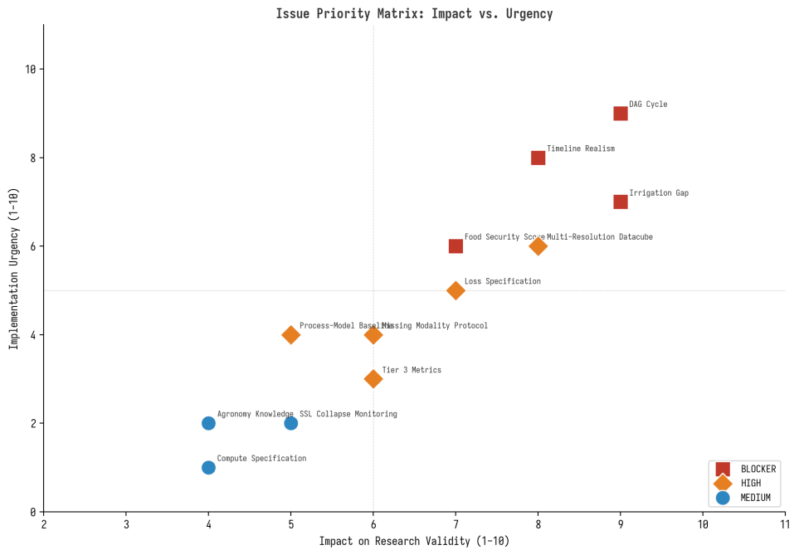
Figure 1.1: Issue Priority Matrix - Impact vs. Urgency

Chapter 2: Blocker Resolutions (Must-Resolve Before Implementation)

2.1 B1: Causal DAG Cycle Resolution

2.1.1 The Problem
The original causal graph included a bidirectional edge between Vegetation Health and Crop Stage, which violates the Directed Acyclic Graph (DAG) requirement of standard structural causal models. A cycle in the causal graph makes do-calculus and counterfactual inference inapplicable as described. This is not merely a technicality: it means that any counterfactual reasoning or interventional analysis performed with the original graph structure would produce mathematically invalid results. The model could generate confidently incorrect causal claims, which in a food-security context could have serious real-world consequences.

2.1.2 The Resolution
Replace the static bidirectional graph with a temporal DAG where nodes are time-indexed. The key insight is that the bidirectional influence between vegetation health and crop stage is actually a temporal feedback loop: vegetation health at time t influences crop stage at time t+1, and crop stage at time t influences vegetation health at time t. This temporal unrolling preserves the dynamic interaction while maintaining acyclicity within each time step. The revised temporal DAG structure is shown below.
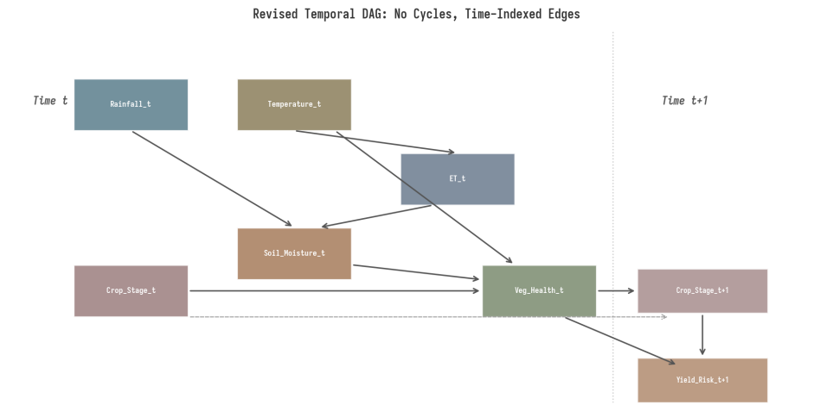
Figure 2.1: Revised Temporal DAG with Time-Indexed Nodes

2.1.3 Structural Equations
The revised temporal DAG is defined by the following structural equations, each of which specifies a causal mechanism that can be independently validated against domain knowledge:
Weather_t (Rainfall + Temperature) drives ET_t through the Penman-Monteith relationship.
Rainfall_t, ET_t, and latent water input I_latent_t jointly determine Soil_Moisture_t through the water balance.
Soil_Moisture_t, Temperature_t, and Crop_Stage_t jointly determine Vegetation_Health_t.
Vegetation_Health_t and accumulated GDD drive Crop_Stage_t+1.
Vegetation_Health_t, Crop_Stage_t, and stress accumulation drive Yield_Risk_t+1.

2.1.4 Acceptance Criterion
• The temporal DAG must be verified as acyclic after temporal unrolling through automated graph-traversal checks.
• No same-time directed cycles are permitted.
• Fallback: If the causal module proves unstable, remove it from the MVRC and treat the model as interpretability-only, not causally validated.

2.2 B2: Timeline Realism and MVRC Definition

2.2.1 The Problem
The original 52-week plan allocated only 8 weeks for Phase 5 (integration + evaluation + paper writing), which is severely compressed for the most novel and highest-risk technical work. Realistic assessment suggests the full plan requires 70-80 weeks for a single researcher. Phases 4 and 5 contain the most novel components (causal graph learning, counterfactual validation) which consistently take 2-3 times longer than estimated in research planning.

2.2.2 The Resolution: Minimum Viable Research Contribution
Define a 52-week Minimum Viable Research Contribution (MVRC) that is narrow enough to complete with high confidence but broad enough to constitute a publishable contribution. The full 10-chapter plan becomes the 24-month research vision, with the MVRC as the first deliverable. The MVRC focuses on the strongest and most defensible claims: multimodal drought-phenology representation learning with weak physics regularization.

2.2.3 MVRC Scope
Dimension | MVRC (Year 1) | Full Vision (Year 2+)
Crops | 1-2 crops | Multiple crop types
Regions | 2-3 contrasting agro-climatic regions | Global multi-biome
Tasks | Crop stress, phenology, yield risk | 6+ tasks including resilience scoring
SSL | Process-centered (4 objectives) | 5+ objectives including scenario augmentation
Physics | Weak water-balance regularization | Full water + growth + energy constraints
Causality | Temporal DAG diagnostics only | Full neural causal discovery + counterfactuals
Food Security | NOT included (agricultural production risk only) | Socioeconomic integration layer
Counterfactuals | Limited scenario-sensitivity tests | Formal counterfactual module

2.3 B3: Irrigation Data Gap

2.3.1 The Problem
Irrigation is identified as a critical confounding variable in the causal chain: it can decouple soil moisture from rainfall and vegetation health from drought. However, global irrigation maps are coarse, outdated, and unreliable at field scale. Without irrigation information, the model will systematically misattribute resilience, and the physics constraints may penalize the model for correctly detecting unobserved water inputs. This is the single most dangerous data gap because it directly affects both physics constraint validity and counterfactual reasoning reliability.

2.3.2 The Resolution: Latent Residual Water-Input Inference
Rather than treating irrigation detection as a direct classification task, add a latent variable I_latent to the water balance equation that captures all unobserved water inputs. The revised water balance becomes: soil moisture change equals precipitation plus I_latent minus evapotranspiration minus runoff minus drainage plus residual. The I_latent term may represent irrigation, groundwater access, model error, or measurement error. Only after validation against known irrigation maps, canal command areas, or field reports should this variable be labeled as irrigation.
This approach converts a data gap into a model inference capability, but with appropriate caution. The key principle is that water-balance residuals should not be automatically interpreted as irrigation. They represent a broader class of unobserved water anomalies that require domain-specific validation before causal attribution.

2.3.3 Acceptance Criteria
• The I_latent variable must improve error analysis and model interpretability.
• I_latent must not degrade transfer performance across regions.
• Fallback: Treat irrigation as an unresolvable confounder and uncertainty source, not as a model output.

2.4 B4: Food Security Risk Scope

2.4.1 The Problem
The final node in the original causal chain (Food Security Risk) is a socioeconomic outcome, not an agro-physical one. The model as designed has no socioeconomic encoder, no price/access/vulnerability data pipeline, and no mechanism to learn this link from remote sensing data alone. Including food security risk as a model output without the required data and methodology constitutes scope overreach that undermines the credibility of the entire research program.

2.4.2 The Resolution
Remove food security risk from the first model entirely. Reframe the relevant output as "agricultural production risk" or "yield-shortfall risk," which is directly supportable by the proposed data and model architecture. Food security risk becomes a downstream socioeconomic integration layer that requires its own data pipeline (market prices, storage infrastructure, population vulnerability, trade flows) and methodology. This layer is deferred to Year 2+ of the research program.

2.4.3 Terminology Corrections
Original Term | Revised Term | Reason
Causal foundation model | Causally informed agro-ecosystem prototype | Avoids overclaiming until causal validation is strong
Food-security risk | Agricultural production risk / yield-shortfall risk | Food security requires socioeconomic data not in first model
Counterfactual SSL | Physics-constrained scenario augmentation | Synthetic interventions are not strict self-supervised learning
Global cross-region generalization | Transfer across selected contrasting agro-climatic regions | Makes claim testable within available time and data
Irrigation detection | Latent residual-water-input inference | Water-balance residuals are not uniquely irrigation

Chapter 3: High-Priority Resolutions

3.1 H1: Multi-Resolution Datacube Architecture
The original plan proposed resampling all data to 10m Sentinel-2 resolution, which creates false precision. ERA5 climate data at approximately 25km resolution, SMAP soil moisture at approximately 36km, and GRACE groundwater at approximately 300km cannot support true 10m inference. Resampling them to 10m creates visually detailed but physically false precision that would undermine both the physics constraints and the causal claims. The revised approach uses a multi-resolution datacube where each variable is represented at its appropriate spatial and temporal scale, and the fusion module learns to bridge these scales.
Data Type | Native Scale | Treatment in Datacube | Token Type
Sentinel-2 / HLS optical | 10-30m | Fine-resolution visual/vegetation tokens | Spatial tokens
Landsat | 30m | Harmonized optical history | Spatial tokens
Vegetation indices | 10-30m or aggregated | Fine temporal vegetation trajectories | Temporal tokens
SoilGrids | ~250m | Static soil-context tokens | Context tokens
ERA5 climate | ~25km | Coarse temporal weather tokens | Regional tokens
CHIRPS rainfall | coarse/intermediate | Rainfall forcing tokens | Regional tokens
SMAP / ESA CCI soil moisture | ~36km | Coarse soil-moisture context | Regional tokens
Crop calendar | regional/crop-level | Prior embedding | Metadata tokens
Yield labels | field/admin level | Validation at matching aggregation level | Target only

The scale-aware fusion module must use cross-resolution attention mechanisms that allow fine-resolution tokens to attend to coarse-resolution context tokens and vice versa. This is fundamentally different from simply upsampling coarse data to the fine-resolution grid, and it preserves the uncertainty structure of each data source.

3.2 H2: Loss Function Specification
The original loss function was structurally correct but operationally underspecified, with no per-objective weights, no curriculum schedule for physics and causal losses, and no gradient conflict mitigation. The revised loss function addresses all of these issues.
L_total = sum of (alpha_i * L_SSL_i) + lambda_water(t) * L_water + lambda_growth(t) * L_growth + lambda_causal(t) * L_temporal_DAG + lambda_calib * L_calibration
The key design principles are: per-objective weights alpha_i that are tuned on a validation set; curriculum schedules where lambda values warm up from zero to their target values over the first epochs of each training phase; and gradient conflict monitoring using cosine similarity between objective gradients. If gradient conflict exceeds a threshold, PCGrad-style projection should be applied. The training schedule introduces objectives sequentially: warm-up with reconstruction and future prediction, then add cross-modal prediction, then process objectives, then physics, then causal-informed consistency only if previous phases pass their gates.

3.3 H3: Process-Model Baselines
The validation reviews identified a missing baseline category: process-based crop simulation models such as DSSAT, APSIM, or AquaCrop. However, all three reviews agreed that these models require detailed crop, cultivar, soil, management, and calibration data that may not be available for the MVRC scope. The recommended approach is staged: include simpler physically inspired baselines in the MVRC (GDD phenology models, SPI/SPEI/VHI drought index models, water-deficit models), and add AquaCrop/DSSAT/APSIM comparison only if the paper claims superiority over process-based crop simulation. If detailed management data are unavailable, the process-model comparison should be stated as future work rather than attempted with inadequate calibration data.

3.4 H4: Missing Modality Protocol
In real deployments, irrigation status, groundwater data, and even soil moisture will frequently be unavailable. The model must support missing or unavailable inputs gracefully. The resolution requires three components: a modality-present mask for each input that indicates whether the data is available; a learned missing-modality token that replaces absent inputs in the encoder; and modality dropout during training that randomly removes modalities to improve robustness. The validation protocol must test performance under missing-modality scenarios including full-modality, no soil moisture, no irrigation proxy, no SAR if SAR is included, and cloud-degraded optical observations.

3.5 H5: Tier 3 Evaluation Operationalization
The original Tier 3 evaluation (physical consistency and causal validity) was named but not defined. The revised plan specifies concrete metrics for both dimensions. For physics compliance, the metrics are water-balance residual RMSE, residual bias by region and season, impossible-state rate (counting predictions violating basic physical logic), and stress-under-deficit check (testing whether healthy growth is predicted under severe deficit without residual explanation). For causal plausibility, the metrics go beyond simple edge-recovery F1 against a domain-specified graph (which only tests recovery of the assumed prior, not objective correctness) to include directional sign correctness under known perturbations, stability of causal effects across regions and years, irrigated vs. rainfed contrast behavior, scenario monotonicity, and known-event case study agreement.

Chapter 4: Revised Core Hypothesis and Claims

4.1 Final Revised Hypothesis
A multimodal temporal representation trained on joint drought and crop-phenology process objectives, and regularized by weak water-balance constraints, will improve crop-stress detection, phenology forecasting, and yield-risk prediction under out-of-region, out-of-year, and extreme-event validation compared with single-domain, non-physics, and conventional machine-learning baselines.
This revised hypothesis makes three bounded, testable claims that replace the original overbroad claims about "across climate regions" and "causal foundation model." Each claim maps to a specific validation experiment, baseline, and failure condition, which is documented in the Validation Matrix in Chapter 6.

4.2 Atomic Testable Claims
Claim ID | Claim | Validation Requirement
C1 | Joint drought + phenology modeling improves representation quality | Compare joint model against drought-only and phenology-only models
C2 | Multimodal fusion improves performance and robustness | Compare fused model against satellite-only, weather-only, and soil-only models
C3 | Process-centered SSL improves transfer | Compare process SSL against generic MAE/contrastive SSL and supervised-from-scratch baselines
C4 | Weak physics regularization improves consistency without harming task skill | Compare with and without water-balance/growth constraints
C5 | Temporal causally informed structure improves interpretability and scenario behavior | Validate through temporal-DAG sign checks, invariance tests, and known-event sensitivity tests
C6 | The model performs better on difficult conditions | Evaluate on out-of-region, out-of-year, and drought-event holdouts

4.3 Acceptable Final Claim (If Results Support It)
AgroEarthFM demonstrates that joint drought-phenology process-centered multimodal representation learning, augmented with weak physical regularization, improves agricultural stress and phenology/yield-risk prediction under selected transfer and extreme-event settings compared with strong statistical, temporal, and non-physics baselines.
Claims not allowed in first-year output unless separately validated include: the system is a fully causal foundation model; the system predicts food-security risk directly; the model generalizes globally across all climate regions; counterfactual outputs are decision-grade causal estimates; and field-scale yield accuracy is proven using only administrative yield labels.

Chapter 5: Revised Architecture and Training

5.1 MVP Architecture
The revised first-year architecture is significantly simplified from the original design while preserving the core scientific contribution. The Spatial Topology GNN is merged with the Soil GNN into a single spatial-context encoder, the full neural causal discovery module is deferred, the counterfactual reasoning module is deferred or limited to a demo, and the food-security output head is removed. The resulting MVP architecture consists of a fine satellite encoder, a weather/climate temporal encoder, a soil/static context encoder, a crop calendar/crop type embedding, a scale-aware fusion module, a temporal memory module, a shared agro-ecosystem state representation, three output heads (crop stress, phenology forecast, yield risk), and weak physics regularization applied during training.

5.2 Sequential SSL Training Schedule
The revised SSL strategy introduces objectives sequentially rather than training all objectives simultaneously from the start. This approach reduces the risk of gradient conflict, makes debugging easier, and allows each objective to be validated before the next is added. The sequence is designed so that each objective builds on the representations learned by previous objectives.
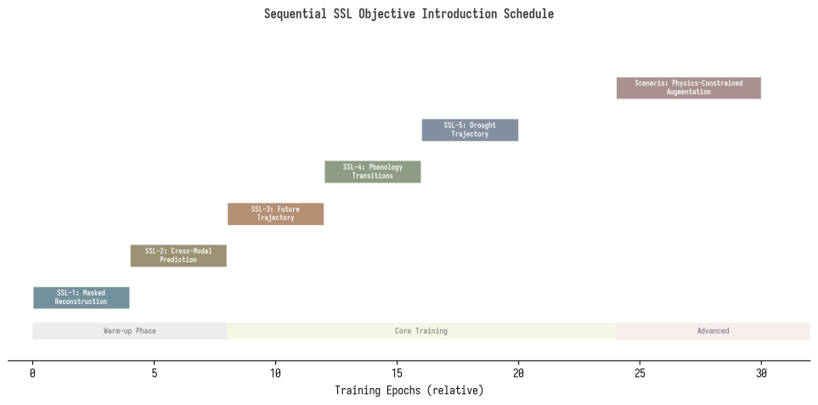
Figure 5.1: Sequential SSL Objective Introduction Schedule
Stage | Objective | Purpose | Activation Gate
SSL-1 | Masked spatiotemporal reconstruction | Learn basic EO representations | Always active
SSL-2 | Cross-modal masked prediction | Learn weather-soil-vegetation relationships | After SSL-1 stabilizes
SSL-3 | Future vegetation trajectory prediction | Learn temporal ecosystem dynamics | After SSL-2 stabilizes
SSL-4 | Phenology pseudo-transition prediction | Learn crop-stage timing | After SSL-3 stabilizes
SSL-5 | Drought stress trajectory prediction | Learn drought response dynamics | After SSL-4 stabilizes
Scenario-1 | Physics-constrained scenario augmentation | Scenario consistency (not strict SSL) | After physics layer validated

5.3 SSL Stability Monitoring
To prevent representation collapse and negative transfer between SSL objectives, the training pipeline must continuously monitor: embedding variance and rank, covariance spectrum condition number, nearest-neighbor diversity in representation space, objective-specific validation losses, gradient norms per objective, gradient cosine similarity between objectives, and linear-probe performance over time. The acceptance criteria are: no dimensional collapse detected, representation quality improves over supervised-from-scratch baseline, and no single SSL objective degrades all downstream tasks. If negative transfer is detected, the conflicting objective should be removed or downweighted.

5.4 Revised Physics Framework
The revised water-balance equation explicitly includes the latent residual water-input variable: soil moisture change equals precipitation plus I_latent minus evapotranspiration minus runoff minus drainage plus residual. The I_latent term captures unobserved water inputs including possible irrigation or groundwater contribution. The physics loss is uncertainty-weighted, meaning that the constraint strength is reduced when data uncertainty is high. This prevents the physics constraint from penalizing the model for correctly detecting conditions that the coarse input data cannot explain.
The plant-growth constraint now explicitly includes Growing Degree Day accumulation: GDD at time t equals max(0, T_mean at time t minus T_base), and accumulated GDD equals the sum of GDD from planting date to time t. This cumulative variable must be carried correctly across the hierarchical temporal memory module, which requires explicit design attention. The growth constraint uses a limiting-factor model where growth is proportional to the most limiting resource (water, temperature, or radiation), which creates a differentiable constraint that can be incorporated into the training loss.

Chapter 6: Validation Matrix and Acceptance Gates

6.1 Core Hypothesis Validation Matrix
Each atomic claim from Section 4.2 must pass through a specific validation experiment with defined baselines, success signals, and failure actions. This matrix ensures that no claim enters the final publication without empirical support.
Claim | Validation Experiment | Required Baseline | Success Signal | Failure Action
C1: Joint modeling improves representations | Train joint vs drought-only and phenology-only models | Single-domain SSL models | Statistically meaningful improvement on stress, phenology, yield tasks | Reduce complexity; inspect task conflict
C2: Multimodal fusion improves performance | Compare satellite-only, weather-only, soil-only, and fused models | Best single-modality model | Fused model improves OOD and extreme-event performance | Check alignment, missing data, attention collapse
C3: Process SSL improves transfer | Compare process SSL vs generic MAE/contrastive SSL and supervised baselines | Generic SSL + supervised-from-scratch | Better fine-tuning efficiency, transfer, extreme-event skill | Use generic SSL only
C4: Physics improves consistency | Compare with/without water and growth losses | Same model without physics | Lower physical residuals without major task degradation | Reduce physics weight or add residual term
C5: Causal structure improves interpretability | Temporal-DAG sign checks, invariance tests, known-event sensitivity | Non-causal multimodal model | Stable effect directions, plausible scenario behavior | Treat causal layer as interpretability only
C6: Better on difficult conditions | Hold out extreme drought years | LSTM/XGBoost/task-specific baselines | Improved recall/skill on rare severe events | Rebalance training, add event-focused objectives

6.2 Implementation Gating Flow
The implementation follows a gated structure where each phase must pass a go/no-go check before proceeding to the next phase. This ensures that resources are not wasted on components whose prerequisites have not been validated. The gates are designed to catch both technical failures (the component does not work) and scientific failures (the component does not provide the claimed benefit).
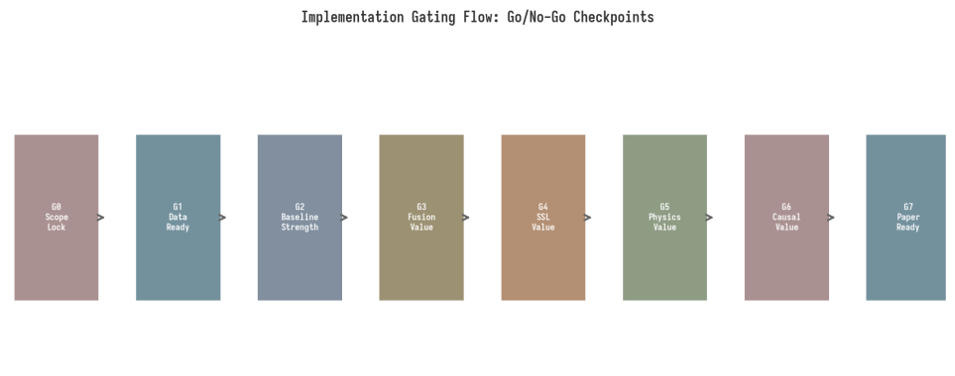
Figure 6.1: Implementation Gating Flow with Go/No-Go Checkpoints
Gate | Go Condition | No-Go Signal | Checkpoint Week
G0: Scope Lock | Final crop/region/task/metric selection is testable and data exists | No viable study region with sufficient data | Week 2
G1: Data Readiness | At least two regions have sufficient data; labels available | No reliable labels or severe missingness | Week 8
G2: Baseline Strength | At least one simple baseline beats climatology/persistence | Even baselines cannot beat climatology | Week 18
G3: Fusion Value | Fusion improves over best single-modality baseline | Fusion adds no value after alignment checks | Week 26
G4: SSL Value | Process SSL improves transfer or fine-tuning efficiency | SSL collapses or provides no benefit | Week 34
G5: Physics Value | Physics improves consistency without task collapse | Physics worsens both residuals and metrics | Week 40
G6: Causal Value | Temporal-DAG passes sign/monotonicity/invariance checks | Scenario behavior contradicts domain knowledge | Week 45
G7: Paper Readiness | Ablations support at least one clear contribution | Results broad but inconclusive | Week 50

Chapter 7: Revised 52-Week Roadmap

7.1 Roadmap Overview
The revised 52-week roadmap is structured around the MVRC scope, with each phase producing a testable artifact and passing through an acceptance gate before the next phase begins. The key difference from the original plan is that the causal and counterfactual modules are treated as late-stage additions that are only implemented if earlier gates pass, rather than as core components that must be completed regardless. This de-risks the timeline significantly while preserving the most important scientific contributions.
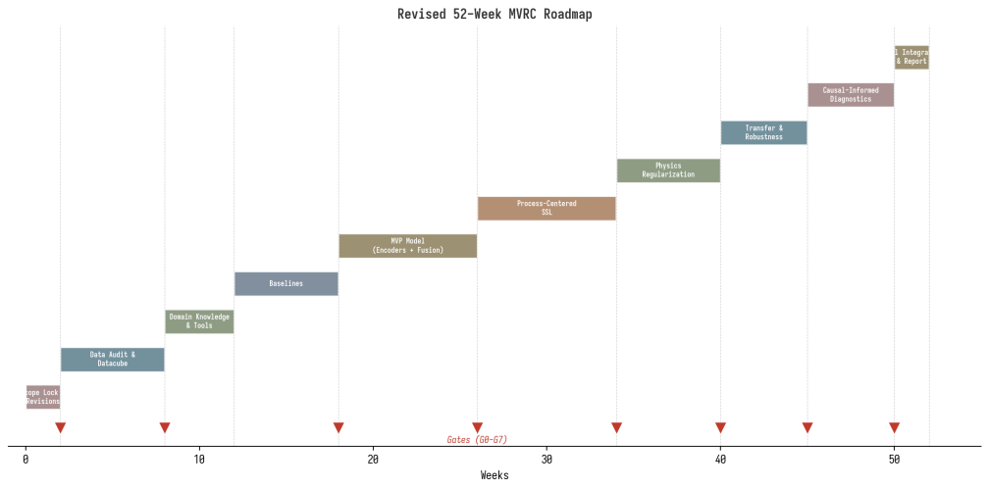
Figure 7.1: Revised 52-Week MVRC Roadmap

7.2 Detailed Phase Breakdown
Weeks | Phase | Key Deliverable | Gate
1-2 | Revision and Scope Lock | Revised hypothesis, MVRC definition, study region selection, task/metric specification | G0
3-8 | Data Audit and Datacube Prototype | Multi-resolution datacube for one pilot region, Data Readiness Report | G1
9-12 | Domain Knowledge and Tools | Agronomy/drought/phenology reading track completed, PyTorch/TorchGeo proficiency | None
13-18 | Baselines | Climatology, persistence, XGBoost/RF, GDD/SPI/VHI, LSTM/TCN benchmarks | G2
19-26 | MVP Model (Encoders + Fusion) | Satellite/weather/soil/crop encoders, scale-aware fusion module, modality masking | G3
27-34 | Process-Centered SSL | Future trajectory, phenology, and drought SSL objectives, linear probe evaluation | G4
35-40 | Physics Regularization | Water-balance and growth losses with ablation, uncertainty weighting | G5
41-45 | Transfer and Robustness Testing | Out-of-region/year/event evaluation, extreme-event performance | G6
46-49 | Causal-Informed Diagnostics | Temporal-DAG sign/invariance/scenario tests (conditional on G5-G6) | G6
50-52 | Final Integration and Report | Ablation tables, error analysis, manuscript-ready results | G7

7.3 Pre-Implementation Artifacts Required
Before any model training begins, the following ten artifacts must be completed and reviewed. These artifacts convert the validation findings into concrete specifications that guide implementation and prevent the most common failure modes identified in the reviews.
1. Scope-lock document with final crop, region, year, task, metric, and data selections.
2. Data Readiness Report with missingness profiles, cloud statistics, and label availability maps.
3. Baseline Benchmark Plan with exact models, features, and evaluation protocols.
4. Multi-resolution datacube specification with scale assignments for each data source.
5. Temporal DAG specification with structural equations and acyclicity verification.
6. Loss-schedule specification with per-objective weights, curriculum schedules, and gradient conflict thresholds.
7. Physics-validation protocol with residual metrics, acceptance criteria, and fallback path.
8. Causal-diagnostic protocol with sign checks, invariance tests, and scenario validation criteria.
9. No-leakage evaluation protocol with temporal split rules and preprocessing constraints.
10. Compute and reproducibility plan with GPU-hour estimates, storage requirements, and software versions.

Chapter 8: Medium-Priority Quality Improvements

8.1 M1: Agronomy and Drought Science Knowledge Track
All three validation reviews identified a critical gap in the learning path: the absence of a dedicated domain knowledge track for crop physiology, drought monitoring science, and phenology modeling. A researcher building a model to learn these processes without understanding them at the domain level will struggle to validate whether the model learned representations are scientifically meaningful. The recommendation is to add a 2-4 week agronomy and drought science reading track parallel to the Data Audit phase (Weeks 9-12), covering at minimum: one crop physiology textbook chapter on growth stages and stress responses, USGS/NOAA drought monitoring methodology (SPI, PDSI, VHI indices), one phenology extraction methods paper (e.g., TIMESAT approach), and the Penman-Monteith evapotranspiration formulation and its data requirements.

8.2 M2: SSL Collapse and Negative Transfer Monitoring
Large self-supervised training runs are susceptible to representation collapse, where the model converges to trivial solutions that encode no useful information. This risk was not addressed in the original plan but is a standard concern in SSL training. The resolution requires continuous monitoring of embedding variance, rank, and covariance spectrum during training, with automatic stopping and restart criteria if dimensional collapse is detected. Additionally, negative transfer between SSL objectives must be monitored through single-objective and multi-objective ablation comparisons. If adding an objective degrades other tasks, it should be removed or downweighted rather than allowed to harm the overall training.

8.3 M3: Compute Specification
The original plan did not estimate GPU requirements or training time, which is a significant operational gap. Before full training begins, the following must be documented: hardware specifications, GPU memory requirements per model component, estimated GPU-hours per experiment, total dataset size on disk, preprocessing time estimates, random seeds and software versions for reproducibility, and an experiment tracking system. A minimum reproducibility requirement should be enforced: every final result table must be reproducible from committed configuration files and fixed data splits.

8.4 M4: Counterfactual Reclassification
Objective 5 (Counterfactual Learning) should be renamed "Physics-Constrained Scenario Augmentation" and repositioned explicitly as a Phase 4+ activity, dependent on physics layer validation. This is not merely a terminology change: it reflects the fact that synthetic interventions are not self-supervised learning in the strict sense, because the training signal is generated by a data augmentation process that modifies observed inputs and uses physics constraints as the validation signal. This means the quality of counterfactual learning is bounded by the quality of the physics model, not the data, creating a sequential dependency that must be reflected in the training schedule.

8.5 M5: Cloud Coverage and Temporal Lag Strategies
In tropical agricultural regions where food insecurity risk is highest, cloud cover can exceed 80% during growing seasons, making 5-day composites unreliable for extended periods. The resolution requires region-specific cloud contamination thresholds and fallback protocols: when valid optical observations fall below a threshold, the model should fall back to SAR-derived moisture proxies, HLS composites with extended time windows, or monthly composites for coarse temporal context. Additionally, temporal lag alignment between weather forcing and vegetation response must be explicitly handled through lag-window ablation experiments that determine the optimal temporal offset for each modality pair.

Chapter 9: Ethical and Communication Constraints
The first-year model must not be presented as an operational food-security decision system. This constraint is essential because incorrect predictions about food security can influence policy decisions with real humanitarian consequences. The following language guidelines must be followed in all publications, presentations, and communications.
Category | Allowed Language | Avoid Language
Model type | Agricultural production-risk prototype | Food-security crisis prediction system
Outputs | Crop-stress monitoring model, yield-shortfall risk estimator | Guaranteed yield prediction, definitive risk assessment
Causal claims | Causally informed scenario analysis | Fully causal decision engine
Recommendations | Scenario-based analysis for climate adaptation research | Guaranteed climate adaptation recommendation
Scale claims | Field-to-regional scale estimates | Field-level ground truth if labels are administrative

All maps, risk outputs, and scenario analyses must include uncertainty estimates and explicit caveats about the model scope and validation status. Publications should clearly distinguish between what has been empirically validated and what remains a research hypothesis.

Chapter 10: Immediate Action Items

10.1 Priority-Ordered Action Items
The following action items are ordered by priority and should be completed sequentially. Items in the same priority band can be worked on in parallel. Each item includes a target completion date, a responsible party, and a deliverable that must be produced before the item is considered complete.

10.1.1 Week 1: Blocker Resolutions
1. Draft the revised hypothesis with bounded, testable claims. Replace "across climate regions" with "selected contrasting agro-climatic regions." Deliverable: Revised hypothesis document.
2. Design the temporal DAG specification with structural equations and acyclicity verification. Deliverable: Temporal DAG specification document.
3. Define the MVRC scope: 1-2 crops, 2-3 regions, 3 tasks, with explicit exclusion of food security risk. Deliverable: MVRC scope document.
4. Reframe all terminology per the corrections table (Section 2.4.3). Deliverable: Updated terminology reference sheet.

10.1.2 Week 2: Scope Lock (Gate G0)
5. Select the first study regions based on data availability criteria (crop map, satellite coverage, weather data, yield labels, drought events, irrigation information, temporal range). Deliverable: Region selection report.
6. Select the target crop(s) based on data availability and phenology data quality. Deliverable: Crop selection rationale.
7. Define exact evaluation metrics and acceptance thresholds for each task. Deliverable: Metric specification document.
8. Finalize the baseline benchmark plan with exact models, features, and protocols. Deliverable: Baseline plan.

10.1.3 Weeks 3-8: Data Readiness (Gate G1)
9. Conduct a data audit for each selected region: download test samples, check missingness profiles, assess cloud contamination, verify label availability. Deliverable: Data Readiness Report.
10. Design and implement the multi-resolution datacube specification. Deliverable: Working datacube prototype for one pilot region.
11. Begin the agronomy/drought/phenology reading track in parallel. Deliverable: Domain knowledge checklist completed.
12. Estimate compute requirements and validate against available infrastructure. Deliverable: Compute and reproducibility plan.

10.1.4 Weeks 9-18: Baselines and Foundation (Gate G2)
13. Implement all baselines: climatology, persistence, XGBoost/RF, GDD/SPI/VHI, LSTM/TCN. Deliverable: Baseline Benchmark Sheet.
14. Complete the loss-schedule specification with per-objective weights, curriculum schedules, and gradient conflict thresholds. Deliverable: Training configuration document.
15. Implement the no-leakage evaluation protocol with temporal split rules. Deliverable: Data split specification.

10.1.5 Weeks 19-34: Core Model Development (Gates G3-G4)
16. Implement the MVP architecture: satellite encoder, weather encoder, soil encoder, crop calendar embedding, scale-aware fusion, temporal memory, output heads. Deliverable: Working model with modality masking.
17. Implement SSL objectives sequentially: reconstruction, cross-modal prediction, future trajectory, phenology transitions, drought trajectories. Deliverable: SSL training pipeline with stability monitoring.
18. Implement physics regularization with uncertainty weighting and I_latent variable. Deliverable: Physics loss module with validation metrics.

10.1.6 Weeks 35-52: Evaluation and Integration (Gates G5-G7)
19. Run comprehensive transfer and robustness evaluation across all data splits. Deliverable: Evaluation matrix with pass/fail results.
20. If G5 passes: implement temporal-DAG diagnostics and scenario tests. Deliverable: Causal diagnostic report.
21. Complete final ablation study, error analysis, and manuscript. Deliverable: Publication-ready results and draft manuscript.

10.2 Success Criteria for the MVRC
The MVRC is considered successful if at least two of the following three core claims are empirically supported: (1) joint drought-phenology SSL improves transfer performance over single-domain and generic SSL baselines, (2) multimodal fusion improves extreme-event and out-of-region performance over single-modality baselines, and (3) weak physics regularization improves physical consistency without degrading task performance. The causal-informed component (Claim C5) is considered a bonus contribution that strengthens but does not define the publication. If only one core claim is supported, the research should be reframed as a negative-result or partial-success study rather than abandoned, because understanding why joint modeling or physics regularization failed is itself a valuable scientific contribution.

