PRACTICAL-10

10) Write a program to use Relay to control electrical equipment.

Ans:

**Circuit Diagram:**

j

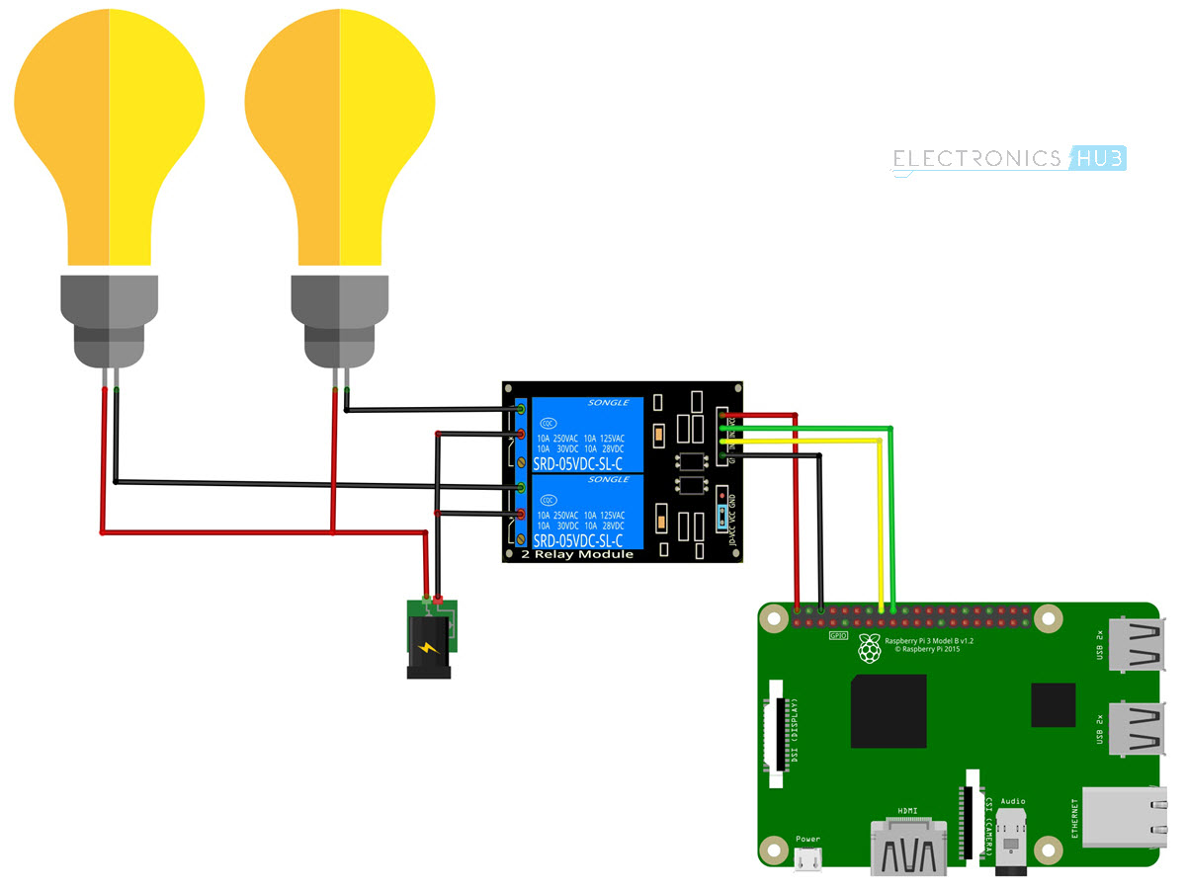

**Components Required**

* Raspberry Pi 3 Model B
* 2-Channel Relay Module
* Two Small Incandescent Bulbs (for demonstration in the output)
* Connecting wires
* Power Supply
* Computer

**Code:**

import RPi.GPIO as GPIO

import time

in1 = 16

in2 = 18

GPIO.setmode(GPIO.BOARD)

GPIO.setup(in1, GPIO.OUT)

GPIO.setup(in2, GPIO.OUT)

GPIO.output(in1, False)

GPIO.output(in2, False)

try:

while True:

for x in range(5):

GPIO.output(in1, True)

time.sleep(0.1)

GPIO.output(in1, False)

GPIO.output(in2, True)

time.sleep(0.1)

GPIO.output(in2, False)

GPIO.output(in1,True)

GPIO.output(in2,True)

for x in range(4):

GPIO.output(in1, True)

time.sleep(0.05)

GPIO.output(in1, False)

time.sleep(0.05)

GPIO.output(in1,True)

for x in range(4):

GPIO.output(in2, True)

time.sleep(0.05)

GPIO.output(in2, False)

time.sleep(0.05)

GPIO.output(in2,True)

except KeyboardInterrupt:

GPIO.cleanup()