**PRACTICAL – 8**

**Q.8)WAP for K-Means clustering**

## Initialisation

**Import pandas as pd**

**Import numpy as np**

**Import matplotlib.pyplot as plt**

df=pd.DataFrame({

'x':[12,20,28,18,29,33,24,45,45,52,51,52,55,53,55,61,64,69,72],

'y':[39,36,30,52,54,46,55,59,63,70,66,63,58,23,14,8,19,7,24]})

np.random.seed(200)

k=3

# centroids[i] = [x, y]

centroids={

i+1:[np.random.randint(0,80),np.random.randint(0,80)]

**for**i**in**range(k)

}

fig=plt.figure(figsize=(5,5))

plt.scatter(df['x'],df['y'],color='k')

colmap={1:'r',2:'g',3:'b'}

**for** i **in** centroids.keys():

plt.scatter(*centroids[i],color=colmap[i])

plt.xlim(0,80)

plt.ylim(0,80)

plt.show()

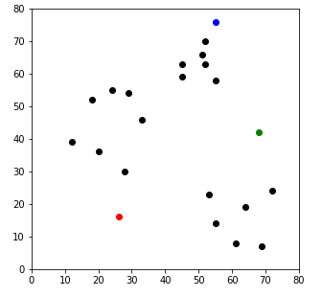

**## Assignment Stage**

**def**assignment(df,centroids):

**for**i**in**centroids.keys():

df['distance_from_{}'.format(i)]=(

np.sqrt((df['x']-centroids[i][0])**2+(df['y']-centroids[i][1])**2) )

centroid_distance_cols=['distance_from_{}'.format(i)**for**i**in**centroids.keys()]

df['closest']=df.loc[:,centroid_distance_cols].idxmin(axis=1)

df['closest']=df['closest'].map(**lambda**x:int(x.lstrip('distance_from_')))

df['color']=df['closest'].map(**lambda**x:colmap[x])

**return**df

df=assignment(df,centroids)

**print**(df.head())

fig=plt.figure(figsize=(5,5))

plt.scatter(df['x'],df['y'],color=df['color'],alpha=0.5,edgecolor='k')

**for**i**in**centroids.keys():

plt.scatter(*centroids[i],color=colmap[i])

plt.xlim(0,80)

plt.ylim(0,80)

plt.show()

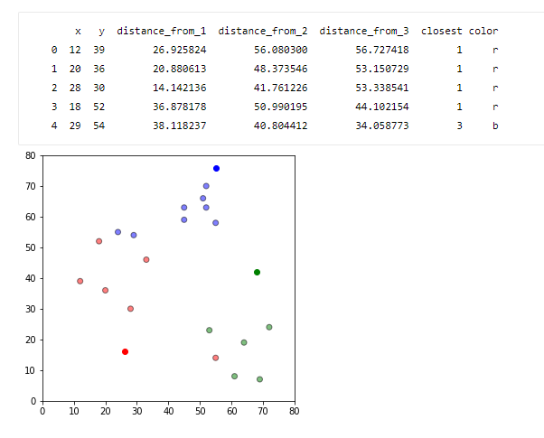

**## Update Stage**

**importcopy**

old_centroids=copy.deepcopy(centroids)

**def**update(k):

**for**i**in**centroids.keys():

centroids[i][0]=np.mean(df[df['closest']==i]['x'])

centroids[i][1]=np.mean(df[df['closest']==i]['y'])

**return**k

centroids=update(centroids)

fig=plt.figure(figsize=(5,5))

ax=plt.axes()

plt.scatter(df['x'],df['y'],color=df['color'],alpha=0.5,edgecolor='k')

**for**i**in**centroids.keys():

plt.scatter(*centroids[i],color=colmap[i])

plt.xlim(0,80)

plt.ylim(0,80)

**for**i**in**old_centroids.keys():

old_x=old_centroids[i][0]

old_y=old_centroids[i][1]

dx=(centroids[i][0]-old_centroids[i][0])*0.75

dy=(centroids[i][1]-old_centroids[i][1])*0.75

ax.arrow(old_x,old_y,dx,dy,head_width=2,head_length=3,fc=colmap[i],ec=colmap[i])

plt.show()

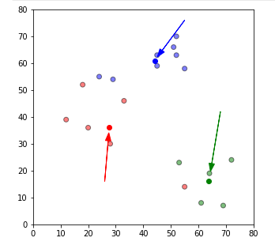

## Repeat Assigment Stage

df=assignment(df,centroids)

# Plot results

fig=plt.figure(figsize=(5,5))

plt.scatter(df['x'],df['y'],color=df['color'],alpha=0.5,edgecolor='k')

**for**i**in**centroids.keys():

plt.scatter(*centroids[i],color=colmap[i])

plt.xlim(0,80)

plt.ylim(0,80)

plt.show()

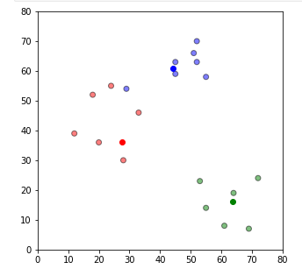

**# Continue until all assigned categories don't change any more**

**while**True:

closest_centroids=df['closest'].copy(deep=True)

centroids=update(centroids)

df=assignment(df,centroids)

**if**closest_centroids.equals(df['closest']):

**break**

fig=plt.figure(figsize=(5,5))

plt.scatter(df['x'],df['y'],color=df['color'],alpha=0.5,edgecolor='k')

**for**i**in**centroids.keys():

plt.scatter(*centroids[i],color=colmap[i])

plt.xlim(0,80)

plt.ylim(0,80)

plt.show()

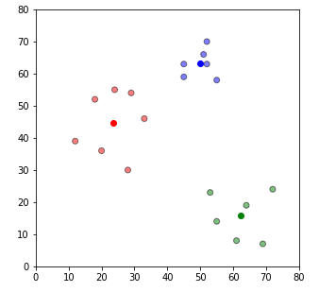

df=pd.DataFrame({

'x':[12,20,28,18,29,33,24,45,45,52,51,52,55,53,55,61,64,69,72],

'y':[39,36,30,52,54,46,55,59,63,70,66,63,58,23,14,8,19,7,24] } )

**fromsklearn.clusterimport**KMeans

kmeans=KMeans(n_clusters=3)

kmeans.fit(df)

labels = kmeans.predict(df)

centroids = kmeans.cluster_centers_

fig = plt.figure(figsize=(5, 5))

colors = map(**lambda** x: colmap[x+1], labels)

plt.scatter(df['x'], df['y'], color=colors, alpha=0.5, edgecolor='k')

**for**idx, centroid **in** enumerate(centroids):

plt.scatter(*centroid, color=colmap[idx+1])

plt.xlim(0, 80)

plt.ylim(0, 80)

plt.show()

