PRACTICAL-7

Subject Name: Machine Learning Lab

Subject_Code: **CAP858**

Uic Department

Q.7) Write a program for Support Vector Machine using python.

Ans:

Import numpy as np

Import matplotlib.pyplot as plt

Import pandas as pd

Df=pd.read_csv(‘data.csv’)

Df.head(10)

From sklearn.model selection import train_test_split

X=Df[[“grade1”,”grade2”]]

Y=Df[“label”]

X_train,X_test ,Y_train,Y_test= train_test_split(X,Y,test_size=0.35, random_state=4)

Print(X_train_shape)

Print(Y_train_shape)

X_train.head()

**Output:**

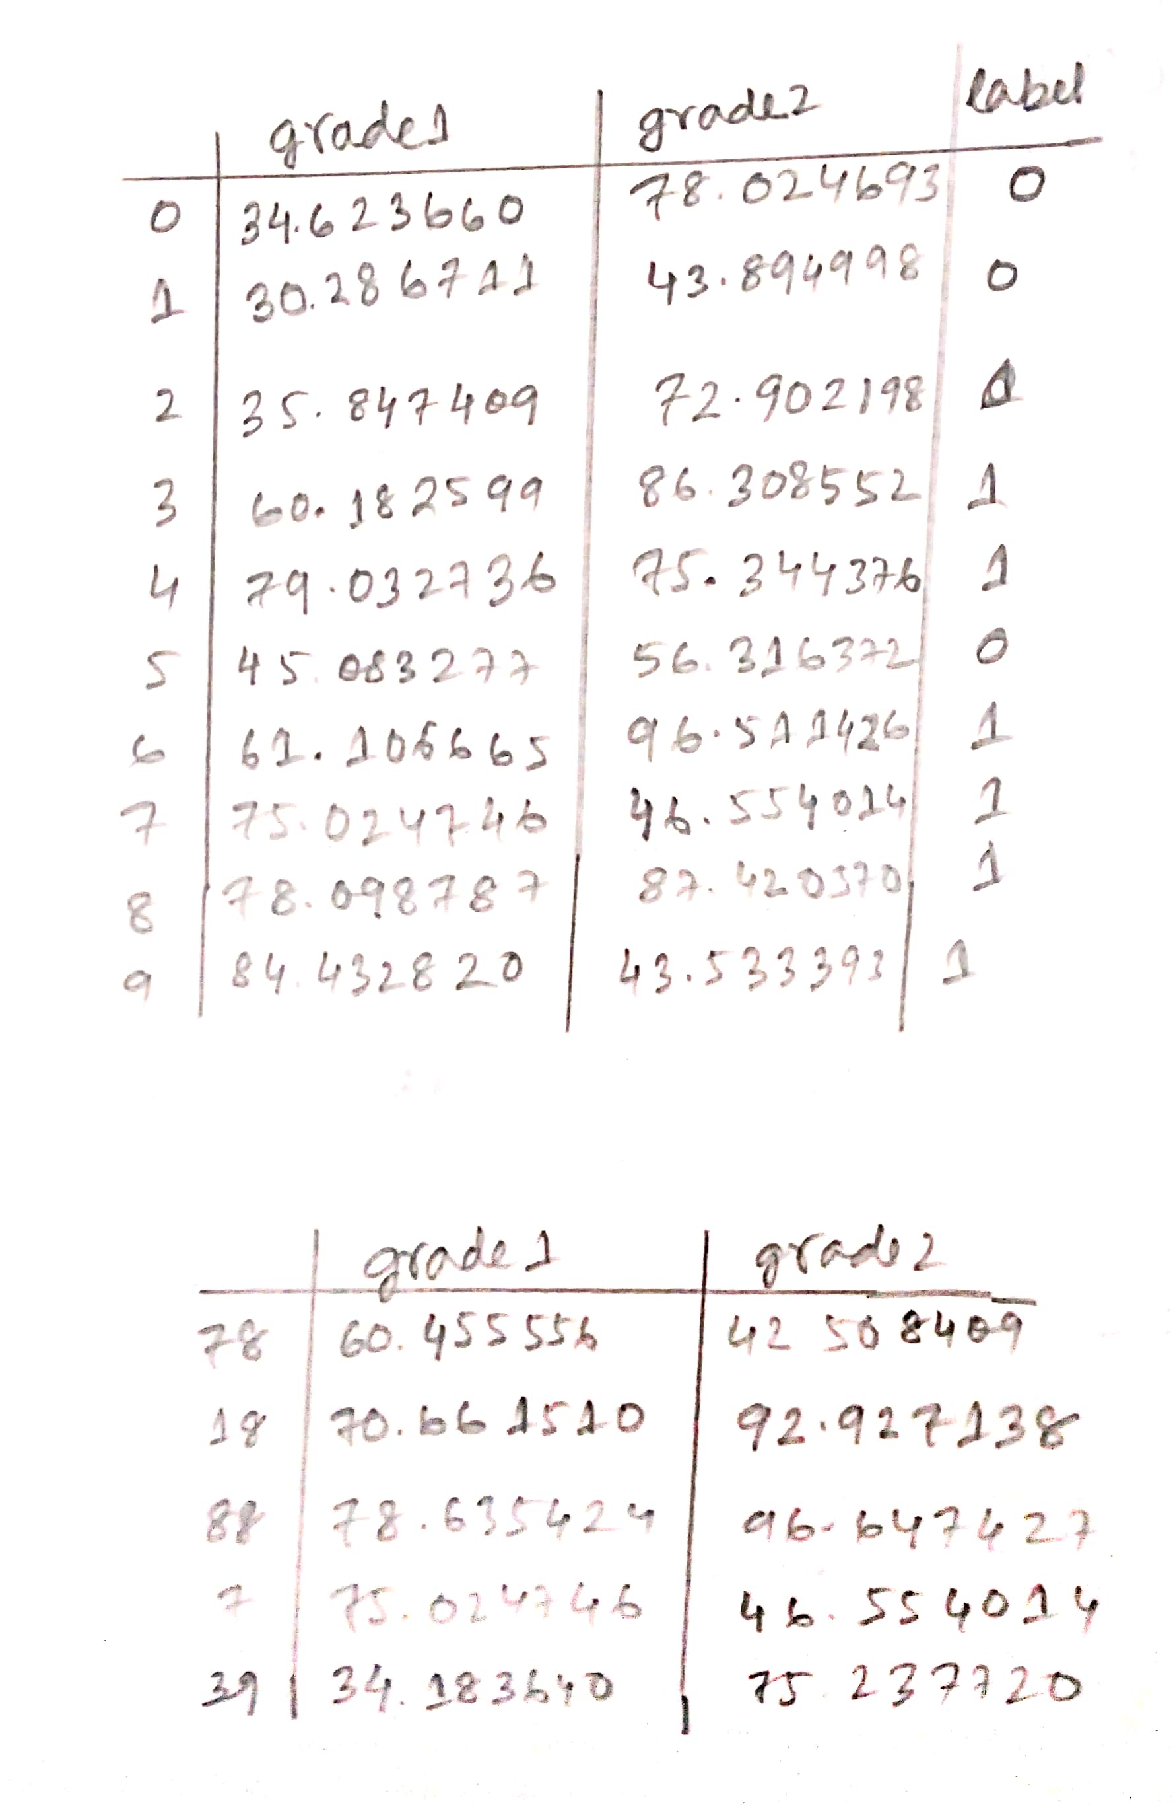

From sklearn import svm

Model =svm.svc(gamma=’scale’)

Model.fit(X_train,Y_train)

Score=Model.score(X_test,Y_test)

Print(“prediction accuracy:”,score,”%”)

F=np.array([60,6,60.9]).reshape(1,-1)

Print (f)

Res =Model.predict(F)

Res

YP=Model.predict(X_test)

plt.plot(X-train[‘garde1’],Y_train,’o’,color=’blue’)

plt.plot(X-test[‘garde1’],YP,’.’,color=’r’)

plt.legend([‘training values’,’predicted values’])

Output:

