**PRACTICAL-9**

**Subject:Machine Learning Lab**

**Q.9)Implementation of K Mean Clustering and Unclustering on Jupyter Notebook using Python.**

**Ans:**

import matplotlib.pyplot as plt

import pandas as pd

import seaborn as sns

iris = sns.load_dataset('iris')

labels = iris.species.unique()

iris.head()

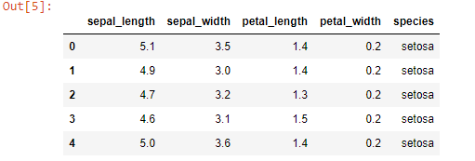

iris["species"] = pd.Categorical(iris["species"])

iris["species"] = iris["species"].cat.codes

iris.head()

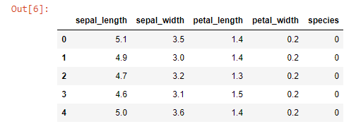

X = iris[['sepal_length','sepal_width']].values

y = iris.species

from sklearn.cluster import KMeans

model = KMeans(n_clusters= 3).fit(X)

centers= model.cluster_centers_

new_labels= model.labels_

print('Centroids :',centers)

print('\nLabels :',new_labels)

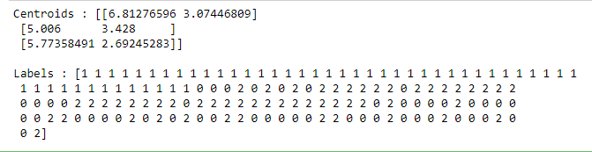

plt.figure(figsize=(12,8))

plt.scatter(X[:, 0], X[:, 1],c=y, s=60)

plt.xlabel('Sepal length', fontsize=18)

plt.ylabel('Sepal width', fontsize=18)

plt.title('Unclustered Data',fontsize=18)



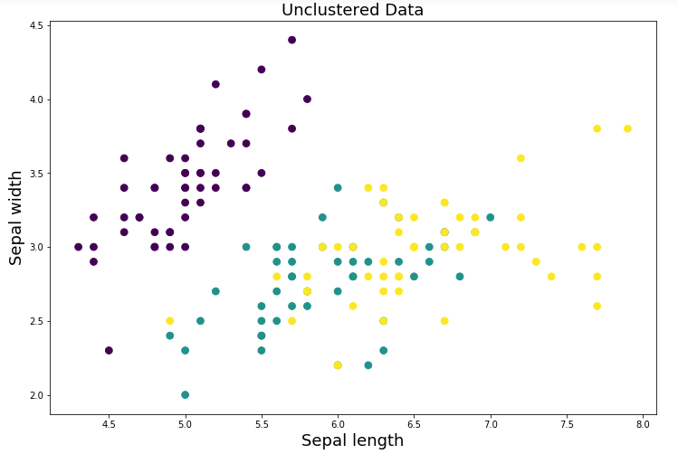

plt.figure(figsize=(12,8))

plt.scatter(X[:, 0], X[:, 1], c=new_labels,s=60)

plt.scatter(centers[:, 0], centers[:, 1], c='r', s=400, marker = '*', zorder=10);

plt.xlabel('Sepal length', fontsize=18)

plt.ylabel('Sepal width', fontsize=18)

plt.title('Clustered Data',fontsize=18)



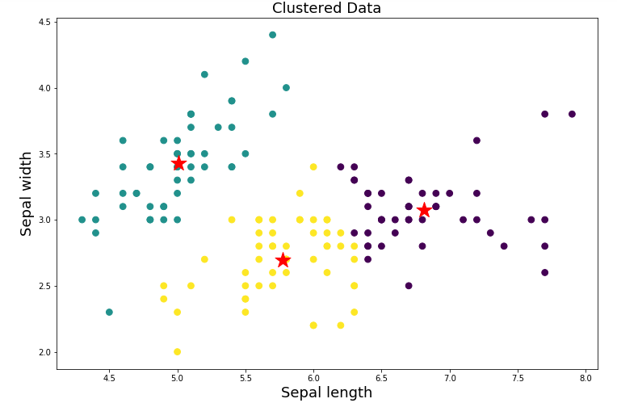

y_pred= model.predict([[2.3,5.6]])

print("Result :",labels[y_pred[0]])

