**Practical Assignment 2**

**Uid: 18mca8091**

**Name: Uday Chauhan**

**Question 1. Design the Tkinter GUI interface for sending the mail using Gmail. All students have to configure this problem with their own Gmail accounts and have to attach snapshots of received mail in their particular Gmail account by using this interface.**

**Sol:-**

from tkinter import *

from tkinter import ttk

import smtplib

gmail_user = 'uic.18mca8091@gmail.com'

gmail_password = '8988491681a'

def sendmail():

try:

var2=password.get()

cc=[receiver.get()]

bcc=[bcc1.get()]

var5=subject.get()

sent_from=gmail_user

msg = msgbody.get('1.0','end')

msgtosend = "From: %s\r\n" % gmail_user + "To: %s\r\n" % var2 + "CC: %s\r\n" % ",".join(cc) + "Subject: %s\r\n" % var5 + "\r\n" + msg

toaddrs = [var2] + cc + bcc

server = smtplib.SMTP_SSL('smtp.gmail.com', 465)

server.ehlo()

server.login(gmail_user, gmail_password)

server.sendmail(sent_from, toaddrs, msgtosend)

server.close()

print ('Email sent!')

ttk.Label(mainframe, text=str('Email sent!')).grid(column=4,row=9,sticky=W)

except Exception as e:

print ('Something went wrong...')

ttk.Label(mainframe, text=str(e)).grid(column=4,row=9,sticky=W)

root = Tk()

root.title("Compose Email")

mainframe = ttk.Frame(root, padding="3 3 12 12")

mainframe.grid(column=0, row=0, sticky=(N, W, E, S))

mainframe.columnconfigure(0, weight=1)

mainframe.rowconfigure(0, weight=1)

password = StringVar()

receiver = StringVar()

subject = StringVar()

msgbody = StringVar()

bcc1 = StringVar()

ttk.Label(mainframe, text="From ").grid(column=3, row=1, sticky=E)

ttk.Label(mainframe, text=str(gmail_user)).grid(column=4, row=1, sticky=(W, E))

ttk.Label(mainframe, text="To ").grid(column=3, row=2, sticky=E)

password_entry = ttk.Entry(mainframe, width=30, textvariable=password)

password_entry.grid(column=4, row=2, sticky=(W, E))

ttk.Label(mainframe, text="Cc ").grid(column=3, row=3, sticky=E)

receiver_entry = ttk.Entry(mainframe, width=30, textvariable=receiver)

receiver_entry.grid(column=4, row=3, sticky=(W, E))

ttk.Label(mainframe, text="Bcc ").grid(column=3, row=4, sticky=E)

receiver_entry = ttk.Entry(mainframe, width=30, textvariable=bcc1)

receiver_entry.grid(column=4, row=4, sticky=(W, E))

ttk.Label(mainframe, text="Subject ").grid(column=3, row=5, sticky=E)

subject_entry = ttk.Entry(mainframe, width=30, textvariable=subject)

subject_entry.grid(column=4, row=5, sticky=(W, E))

ttk.Label(mainframe, text="Attachments ").grid(column=3, row=6, sticky=E)

msgbody = Text(mainframe, width=60, height=10)

msgbody.grid(column=4, row=7, sticky=(W, E))

ttk.Button(mainframe, text="Send", command=sendmail).grid(column=4,row=8,sticky=E)

for child in mainframe.winfo_children(): child.grid_configure(padx=5, pady=5)

password_entry.focus()

root.mainloop()

**Output:-Sent Mail**

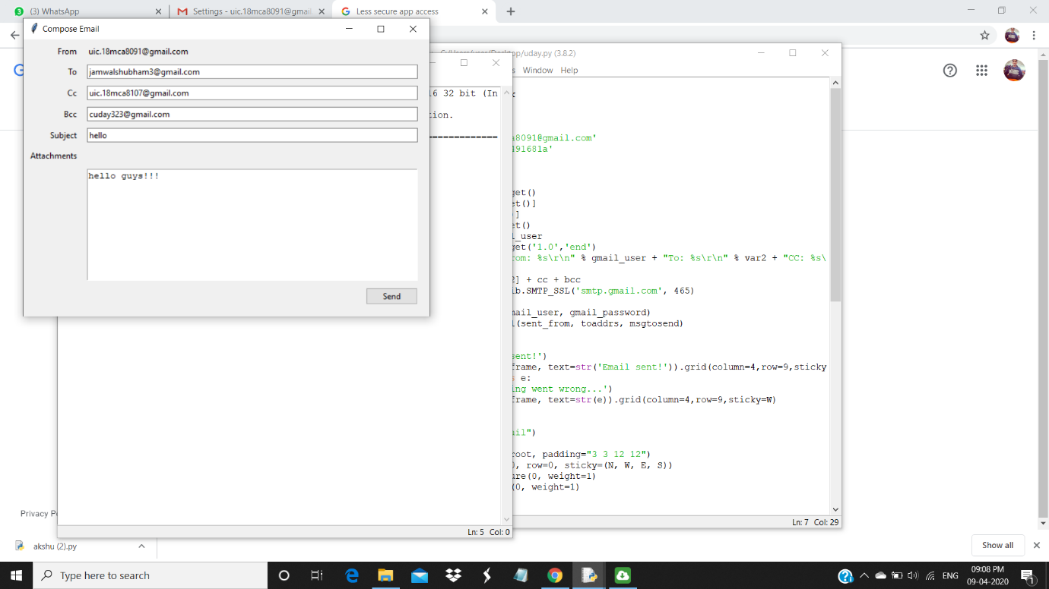

**Recived Mail**

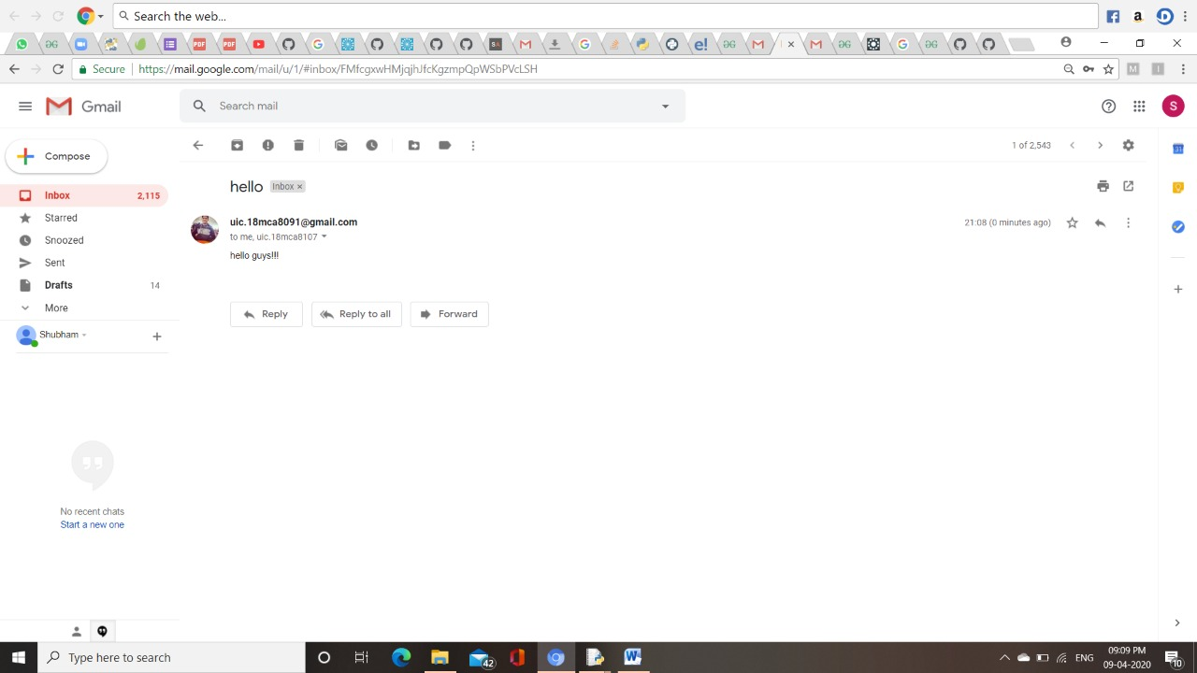

**CC Mail**

