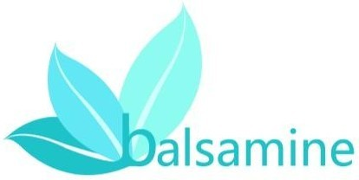

Manual of Balsamine
-the Natural Hair Dye

This product is a natural biological products, and different from the operation of traditional hair products.

Announcements
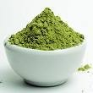
1、When it cannot be used up at once, this product should be saved in a refrigerator for it is a natural biological product. By thus the effect will not be influenced, but the period should not over two weeks.
2、Balsamine is a natural biological product, contains no toxic and allergenic substances such as aniline. According to the Ministry of Health, "Hygienic Standard for Cosmetics," Balsamine is a natural hair dye with no needs for allergy tests.
3、The dosage of one package is a proper amount for the short hair near ears or shorter, otherwise two or more is needed. Enough dosage could ensure dye hair effect.
4、If you go to the hair salon with this product, please do not use tools for aniline hair products, so as not to cause allergies.
5、It is better to perm first and dye later, or it will lead to fade.
6、At the first time, for some coarse hair not easy colored or thick white hair, the effect maybe lackluster and not satisfied. However, it could be reapplied again for the plant's color is limited. When it overlay, the color will be much fuller.
7、Balsamine is not recommended to use in other parts of the body. Hair dye accidentally gets in the eyes, wash with water immediately.
8、It should be keep in a cool, dry place where children cannot reach before open. Promptly save in the refrigerator after opening in order to avoid mildew.

Speclal instructions
1、The use method of this material is to wear special gloves, pour the cream in the hands and mix thoroughly, daub it from
the hair root to hair tip evenly in all the hair, make hair full of

dye evenly.
2、Impaired hair (with dandruff, tinea capitis, and tetanus, etc.) after using the product may be a slight
irritation, damage to the scalp is a normal reaction which is not allergy, can disappear within a short time, but avoid scratching .
Tip: Please buy Balsamine products at specify the branch, beware of counterfeit.

3、Balsamine is a natural biological product, a color is limited. In order to avoid lackluster, it is better to use self-heating device (heating plastic cap or hot towel) to achieve the best color results. Without heating device, the waiting time should be extended to two hours, but not too long, in case of clogging the pores.
4、Black and dark brown dye used for reapply. If you use in black hair, no color.
5、Please do not use together with other products, or influence the color effect. The product already contains enough active ingredients.

Method of application
1、It will acquire better effects if the hair dye could ferment half an hour before dye. Take a full amount of hair powder, mixed with Super-repair Essence Lotion, then slowly add clean water and mix thoroughly, to avoid excessive water. A box of powder should be match with 450ml-500ml of pure water, except of Black and Dark Brown. If the needed amount have been reduced, the water should be reduced accordingly and avoid been too thin or too thick. The mixture shall stretches easily and won't drop down when it is applied to hair. Black and Dark Brown need to add 50ml-100ml of pure water can be enough.
2、Wear plastic gloves, daub it evenly on the hair, and repeatedly rubbing the scalp hair to fully absorb. As for Black and Dark brown without nutrients, rubbing is not needed.
3、Covered the hair with a plastic film, and then heated by evaporation cap. After 20-minute heating, wait hair cool thoroughly (20-30minutes or longer for the natural category).Without heating, the natural category will need 2 hours, Black & Dark Brown 1 hour.
4、Clean hair with water, then use the shampoo, because the powder is fine and smooth, it may need twice wash. After cleaning thoroughly, dry the hair with blower.
Lawsone
By Dr. Boyan Bonev © 2003
University of Nottingham
Eng-Phys, MSc, PhD, P Phys, MRSC
and Catherine Cartwright-Jones

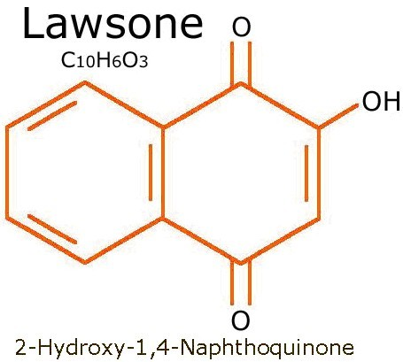
Henna, Lawsonia inermis, contains a red-orange pigment, lawsone, the molecule of which is also known as hennotannic acid. When henna leaves are crushed in an acidic medium and applied to skin, the lawsone molecules migrate from the henna paste, traverse the outermost layer of the skin, Stratum corneum and stain the skin. Prolonged applications of henna result in diffusion of the pigment deeply into the skin.

Synthetic hair dye can mess you over

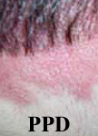
Para-phenylenediamine, or a close chemical variant of para-phenylenediamine is in virtually every chemical hair dye, even most hair dyes which claim to be natural. There is now an epidemic of sensitization (allergic reaction) to this chemical because of over-exposure. The allergic reactions can be severe and require hospitalization. Long term effects of exposure to this chemical include lupus, asthma, non-Hodgkins lymphoma, and there appear to also be links to breast, uterine and bladder cancer.

How does hair go gray?
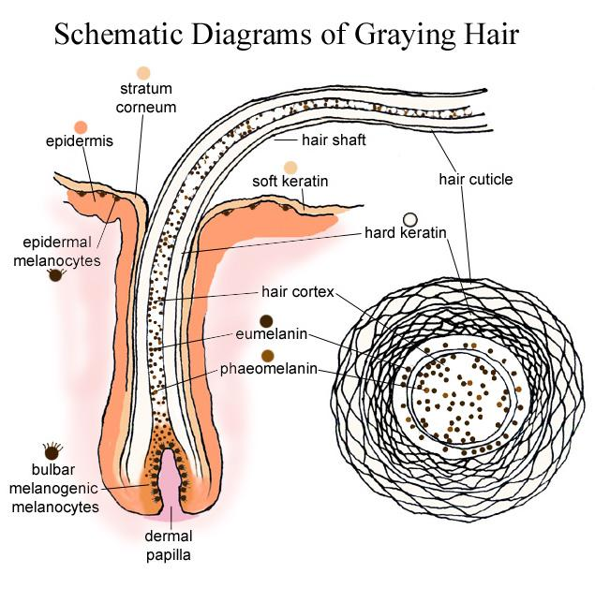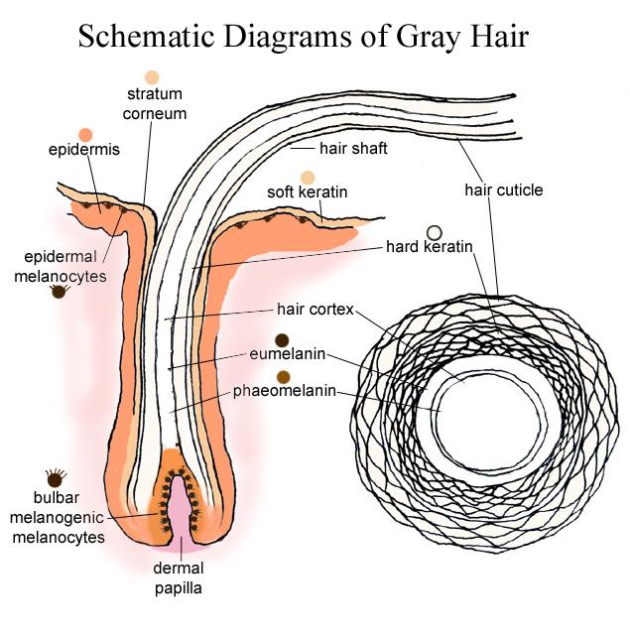
What happens when you dye gray hair
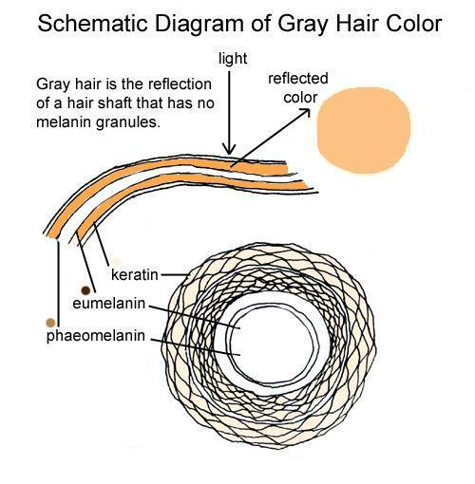
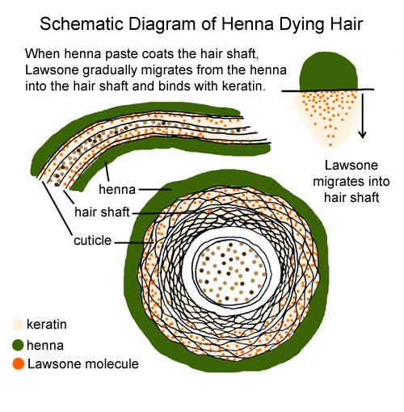

How can you find out if the henna hair dye you've been using has toxic metallic salts?
Harvest some of your hair.
Mix one ounce (30 ml) of 20-volume peroxide and 20 drops of 28% ammonia.
Put your harvested hair in the peroxide-ammonia mix (this is in synthetic hair dye).
If there's lead in the henna you've used, your hair will change color immediately.
If there's silver nitrate in the henna you've been using, there will be no change in hair color, because silver is coating the hair. However, silver nitrate leaves a greenish cast to your hair, so you can tell by that.
If there's copper in the henna you've used, your hair will start to boil, the hair will be hot and smell horrible, and the hair will disintegrate.
With all that crap, frequently unlisted, in some henna products, no wonder henna's gotten a bad rap!
Why do some boxes of "colored henna" have no declaration of ingredients? Some countries where these products are initially manufactured do not have laws requiring the declaration of ingredients in cosmetics. So, they can put anything they want in that box and they don't have to tell you what's in it. If someone in the USA imports these mixes, they are not required by law to go back and discover what's in the bulk mix that was passed through customs marked as "henna", and they don't have to declare it on their package. This is how a company can have a dozen "colors of henna" from blonde to black, and sell them without listing their ingredients .. and they usually do. The person selling the product may have no idea what's in the box, or they may know and not want to tell you. If its a box of hair dye that claims to be henna and it claims to dye hair something other than red, and the powder inside is not green ... it is NOT HENNA. Many products labeled "herbal henna" actually contain para-phenylenediamine. If you're allergic to chemical hair dye and you use "herbal henna" you may to have an allergic reaction to the chemicals in it. The claim of "no ammonia, no peroxide, all natural" does not mean you're getting safe, pure henna.
 | Nature dyes agent | Chemical dyes agent
PPD | × | √
Hydrogen Peroxide | × | √
Ammonia | × | √
Metal | × | √
Our products

Auburn Henna
A Revolution of hair dye! It is not only a hair dye, but also a hair conditioner. It is a natural hair formula without any chemical additive. You could use it trustly and get the bright natural color from the herbs. The continuous use of it could improve our hair quality and bring us the amazing effect of treatment of white hair. (For white-haired people, including the allergic.)
Nature Hair Conditioner
It could treat different kinds of scalp problems effectively. It is made of natural herbs which belong to the traditional Chinese medicine. It could inhibit the appearance of white hair, cure dandruff and hair loss effectively. In addition, it could help the skin to discharge toxins of the chemical dye.
Just say goodbye to rough dry hair and re-acquire a luster and flexible hair! You would have a healthy and beautiful hair in a short as long as you use it intensively. (For all people, including the allergic.)
Jet Black
Without any harmful ingredients, it could bring back a natural black hair! It is healthy&safety for scalp and hair. At same time, it does not fade away easily and has no unpleasant smell.( For white-haired people, but the highly allergic should be given a test before use)
Brunette
Without any harmful ingredients, it is especially suitable for those with too much white hair. It prefers to use in combination with Red Brown Henna and brings back a natural black hair without any damage to the scalp and hair. (For white-haired people, but the highly allergic should be given a test before use)

