AR_VR_XR HW3

M2023067 김의찬

# Feature

Extract feature points using SIFT in cv2 and then perform matching. Select a feature point from image 1, then choose the two closest features from image 2. At this point, the selected features from image 2 must be the closest to the feature chosen from image 1 when compared with all features in image1. Additionally, the first closest feature must satisfy the condition: first closest feature * 0.75 > second closest feature.  
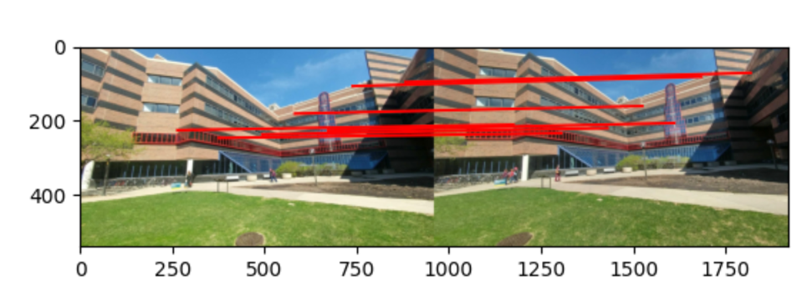

Use RANSAC to filter out outliers from the matchings. At this point, use some of the matchings to create the Essential matrix (E), classify inliers and outliers through transformation, and derive the optimal E.스크린샷, 하늘, 잔디, 야외이(가) 표시된 사진

Draw the epipolar lines using the obtained inliers and the Essential matrix E.

# Camera Pose

Recalculate E using the obtained inlier matchings. E can have four possible camera poses, calculate the corresponding R and C. Create a projection matrix for each case, transform it into 3D, restore it back to 2D, validate the process, and then derive the appropriate R and C.

# PnP

After deriving R and C using RANSAC, refine R and C using the Levenberg-Marquardt method.  
