PAPER title in times new roman (TNR), 14 point-bold
and centered

FirstName FamilyName^{1*} and FirstName FamilyName²
^{1*}Affiliation of FirstName author (TNR, 11 point, Italic)
²Affiliation of SecondName author (TNR, 11 point, Italic)
^{1*}name1@emailaddress.xxx, ²name2@emailaddress.yyy
(* indicates the corresponding author)

ABSTRACT
The abstract should not exceed 300 words, Times New Roman (TNR), 11 point and Italic. Avoid citing references and uncommon abbreviations here, but if essential they must be defined at their first mention in the abstract itself. Please do not use equation editor for equations and mathematical expressions in abstract. Use symbol or plain text instead. The paper should at least contain the following section: Introduction, Method, Results and Discussions, Conclusion, Acknowledgement, Funding, Author Contribution, Conflict of Interest, and References.
Keywords: Includes three to six keywords, separated by commas, capitalise each word, use Italic and sorted alphabetically.

Received for review: dd-mm-yyyy; Accepted: dd-mm-yyyy; Published: dd-mm-yyyy
DOI:

Introduction (TNR, 11-point)
All papers must be written in English. Use 11-point Times New Roman font throughout the paper except for the section headings that should be 11-point Times New Roman bold. The first paragraph following a heading should not be indented.
The following paragraphs must be indented 10 mm. Note that there is no line spacing between paragraphs unless a subheading is used. Symbols for physical quantities in the text should be written in italics. It is recommended that the paper does not exceed 20 pages, with A4-sized (21 x 29 cm) pages with top and bottom margins of 2.5 cm and left and right margins of 1.8 cm. Leave one blank line before each secondary heading.
Define abbreviations and acronyms the first time they are used in the text, even after they have been defined in the abstract.
Paper files can be in the following formats: DOC, DOCX, or RTF. Microsoft Word documents should not be locked or protected. Do not include page numbers in the paper file.
The introduction section must include the study background, a short literature survey and objective(s). A specific section on literature review is also encouraged.
The paper must have these sections:
- Content sections: At least on Introduction, Method, Results and Discussions, Conclusion (these sections must be numbered)
- Supporting sections: Acknowledgement, Funding, Author Contribution, Conflict of Interest, and References (these sections must not be numbered)

Headings and Footnotes
Limit paper sections and sub-sections to 3 heading levels. Make sure heading levels are clearly indicated in the paper text.
Footnotes are not permitted. If your paper contains footnotes, move the information into the main text or the reference list, depending on the content.

Illustrative Material
Illustrations must be original or photographic prints of originals and must be in good resolution. Arrange them throughout the paper and do not group them together at the end. Use extra line spacing between illustrations. Text size in illustrations must be proportionate to 10-point TNR. All illustrations must have a caption beneath an illustration, centre-justified in 10-point TNR.

Figure and Table (TNR, 11-point)
Figure captions must be typed beneath a figure in good resolution. Table captions must be typed above a table. Do not break a table across pages. Should the table must be longer than 1 portrait page orientation, use landscape orientation to fit in, or break the table into a few tables and name them according to xx(a), xx(b), … convention. Use extra line spacing between figures and tables. Text size in tables must be 10-point TNR. Text size in figures must be proportionate to 10-point TNR. All figures and tables must have a caption, centre-justified in 10-point TNR, and must be in the same page. All figures and tables must be cited in the paragraph and located on the same page it is first referred, or the next page if the figure or table takes up a whole page. When citing a table or a figure in text, refer to it by its number, such as “Figure 1” or “Table 2.” Please do not refer them by their position relative to the text (e.g., “the figure below”) or its page number (e.g., “the table on page 12”). Do not break table across pages.

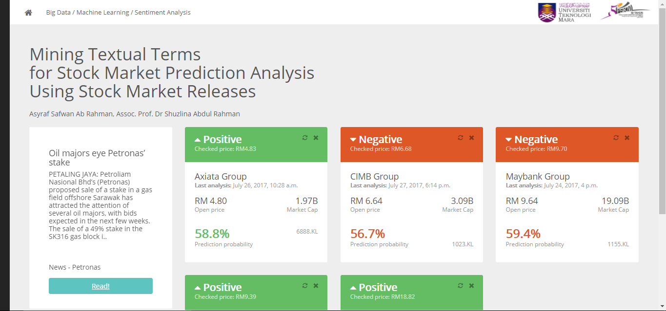
Figure 1. Figure Captions Should be Placed below the Illustrations and Centred.

Table 1. Table Captions Should be Placed above the Tables and Centred.
Title 1 | Title 2
Text/ Numeric | Text/ Numeric
Text/ Numeric | Text/ Numeric
Text/ Numeric | Text/ Numeric

Mathematical Typesetting
MathType should be used for equations and mathematical expressions. Use extra line spacing between equations. The equation size must be 10-point TNR.
Equations should be numbered consecutively and appear in parentheses. All equation numbers must appear on the right-hand side of the equation and should be referred to within the text, in the form of Equation (1). Below is example:

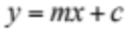 (1)

Acknowledgement

List here acknowledgment to individuals / organizations who have provided some significant assistance to the research.
The section should not be numbered.

Funding

Please state the source of funding obtained to support the research. If no funding received, the authors should state: The author(s) received no specific funding for this work.
The section should not be numbered.

Author Contribution
Please state each author’s contribution here. For example: Author1 prepared the literature review and oversaw the article writing. Author2 wrote the research methodology and performed fieldwork. Author3 conducted the statistical analysis and interpreted the results.
Collaborative writing with international authors has added merit, thus contributors are encouraged to include international co-authors in their work.
The section should not be numbered.

Conflict of Interest
The authors should declare if any conflicts of interest exist. If no conflict exists, the authors should state: The authors have no conflicts of interest to declare.
The section should not be numbered.

Citations
Please ensure that every reference cited in the text is also present in the reference list (and vice versa) and follow the APA convention.
Write authors’ surname when there are one or two authors, and write first author and “et al.” when more than two authors. Depending on the sentence, either the year only is placed in parentheses, or the author's surname followed by parentheses. In case of more than one citation, write the author’s surname and year separated by a comma are placed together in parentheses in chronological order. For example:
“Sentiment analysis was conducted by Liu (2015) … “
“A study on semantic knowledge LDA concluded … (Tajbakhsh & Bagherzadeh, 2019).”
“In a study of semantic knowledge LDA, Tajbakhsh and Bagherzadeh (2019) argued that ...”
“There is a correlation between correlation between two words in a post (Yusof et al., 2015; Mutalib et al., 2016; Tajbakhsh & Bagherzadeh, 2019)”.

References
The section should not be numbered. Please ensure that every reference cited in the text is also present in the reference list (and vice versa) and follow the APA convention. The references should be at least 15 with 30% from the last FIVE (5) years.
References should be listed together at the end of the paper in alphabetical order by author’s surname. Leave space between references.
The section should not be numbered.
List of references indents 10 mm from the second line of each reference. See examples in the list of references below.
Journal Article
Tajbakhsh, M. S., & Bagherzadeh, J. (2019). Semantic knowledge LDA with topic vector for recommending hashtags: Twitter use case. Intelligent Data Analysis, 23(3), 609-622.
Markissa, J. D. (2019). The case of Cow and Cats. Intelligent Data Analysis, 4(1), 12-28.
Books
Liu, B. (2015). Sentiment Analysis: Mining Opinions, Sentiments, and Emotions. Cambridge: Cambridge University Press.
Abba, B. (2016). The West and The East. Cambridge: Cambridge University Press.

Chapters in Books
Yusof, N. N., Mohamed, A., & Abdul-Rahman, S. (2015, September). Reviewing classification approaches in sentiment analysis. In International conference on Soft Computing in Data Science (pp. 43-53). Springer, Singapore.

Proceedings Papers
Mutalib, S., Abdullah, M. H., Abdul-Rahman, S., & Aziz, Z. A. (2016, December). A brief study on paddy applications with image processing and proposed architecture. In Systems, Process and Control (ICSPC), 2016 IEEE Conference on (pp. 124-129). IEEE.

Web Pages
Ray, S. (2015). Essentials of Machine Learning Algorithms (with Python and R Codes). A post at AnalyticsVidhya available at http://​ www.​ analyticsvidhya.​ com/​ blog, 8.-learning-algorithms/

For further guidelines in APA style you can visit http://www.apastyle.org/

Similarity Report
Before submission, authors must check the paper using plagiarism/ similarity detection software such as Turnitin or iThenticate. The use of Ouriginal is not accepted. The similarity index MUST NOT EXCEED 25% including references. The similarity report (1 page) must be submitted together with the paper.

