# CS-119 Lab #12

# Expected Learning Objectives

Python coding review

Variables

Arrays

User defined methods

Loops

Sorting

Mean and median values

## Overview

Being the last lab of the semester, this lab is to prepare you for moving onto a regular programming class where the problem statements are often not very detailed.

## Exercise 1

Design and implement a Python application that will accept an array of 10 integers, sort it, and display the list in descending order.

Write pseudocode or you may do a flowchart to describe the process. Hint: You may use the Python sort code presented in the chapter to sort string values and modify it as needed to sort integers.

Put your Python code to sort the array in a method called sort_integers()

Call your file Ex1Sort.py. You are given the following array: nums1 = [12, 67, 13, 5, 45, 19, 13, 15, 23, 3]

Your program output should look something like this:

Sample program output

## Exercise 2

Design and implement a Python application that will accept an array of integers, display the array, calculate and display the mean and median values of the array. You are given the following 2 arrays:

nums1 = [12, 67, 13, 5, 45, 19, 7, 15, 23, 3]

nums2 = [12, 67, 13, 5, 45, 19, 7, 15, 23, 3, 32]

The mean is essentially the average value of the array. Put your Python code in a user defined method called calc_mean().

The median is the *middle value* of a *sorted* array. If an array contains an even number of elements, the median value is the mean (average) of the middle two values. Put your Python code in a user defined method called calc_median()

Call your file Ex2Median.py

Write pseudocode or you may do a flowchart to describe the process.

Be sure to test your program with both arrays.

Your program output should look something like this:

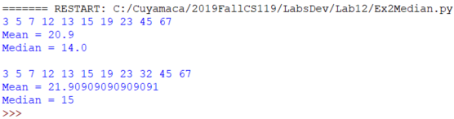

Grading Criteria:

| Deliverable | Points | Breakdown |
| --- | --- | --- |
| Exercise 1 pseudocode | 10 | Complete, makes sense, clearly describes process |
| Exercise 1 Python code | 15 | Complete, produces correct output, appropriate use of comments and modularization |
| Exercise 2 pseudocode | 10 | Complete, makes sense, clearly describes process |
| Exercise Python code | 15 | Complete, produces correct output, appropriate use of comments and modularization |
| **Lab Total** | **50** |  |