# CS-119 Turning in Labs on Canvas

One key real world software development skill is keeping your work organized. Many modern Integrated Development Environments (IDE’s) write quite a bit of code for you behind the scenes and they tend to create a number of sub-folders and files. Fortunately, Python IDLE is quite a bit simpler than most IDEs but it is still *critical* you keep the files for a given assignement together so you can work on your programming project on another computer or turn it in and get full credit for your work – well, assuming it all works.

Your hard drive and/or flash drive should have a labs folder with sub-folders for labs 1 – 12 as shown below. A Test folder to organize experimental work is always a good idea.

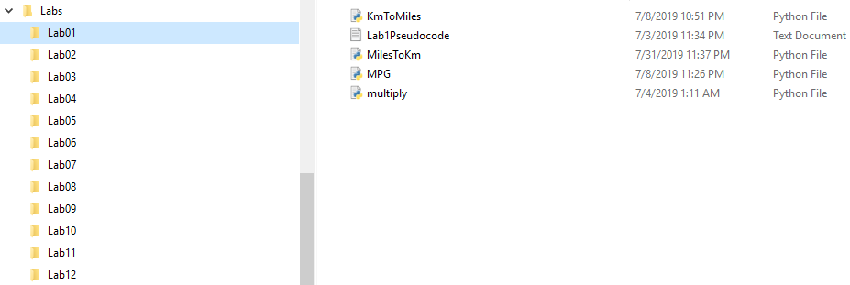

Using lab 1 as an example, the lab 1 folder should have all deliverable files (Python code, pseudocode, flowcharts, models, etc.) called for in the lab exercises.

Before turning in your lab, be sure to check the rubric found at the end of the lab handout to make sure you have all deliverable items completed. You will also find the same rubric in the Canvas assignment page. These often vary with each lab so check carefully.

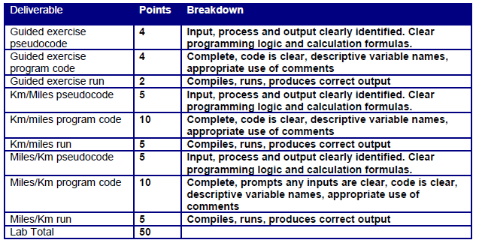

The only way everything can be uploaded to Canvas is to compress it into a zip file. There are other compression formats but zip is readily available in Windows and on a Mac. You ***do not*** need to download or purchase any special software. Using either My Computer or Windows Explorer, locate your Lab 1 folder:

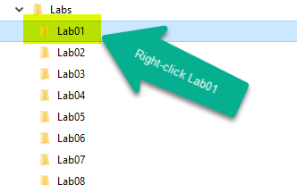

Right-click the lab 1 folder. In the pop-up menu, select Send to and then Compressed (zipped) folder.

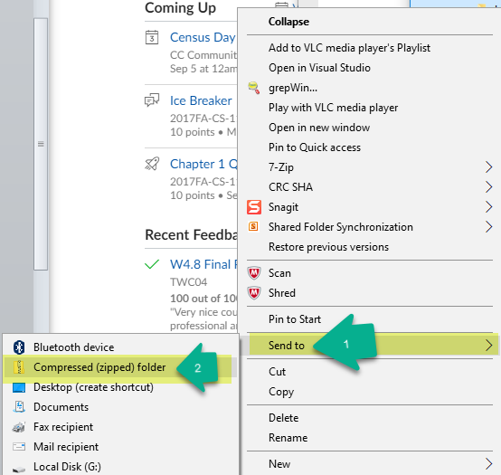

Locate the zip file. This is what you need to upload and turn in. Make a note of the drive/folder so you can easily locate it and upload it.

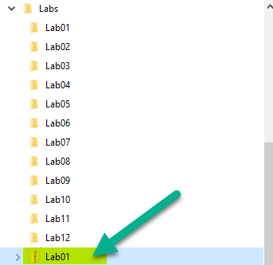

Login to Canvas, select Assignments and then select Lab 1 (or the lab you’re trying to turn in).

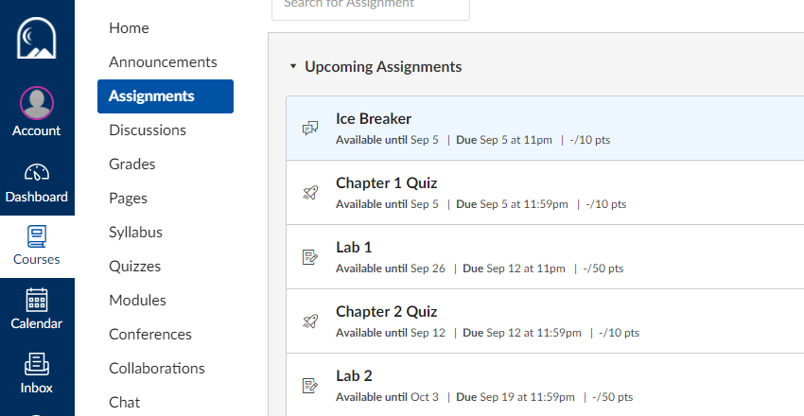

Click Submit Assignment

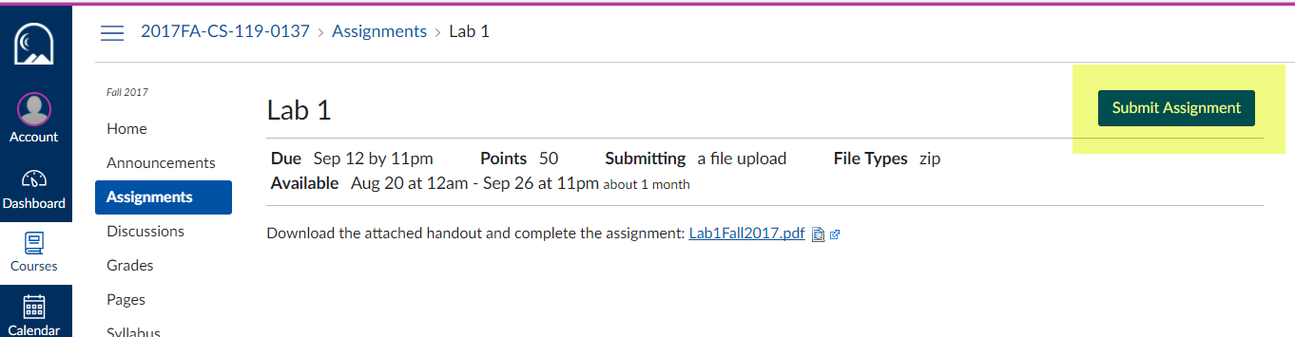

Select Choose File

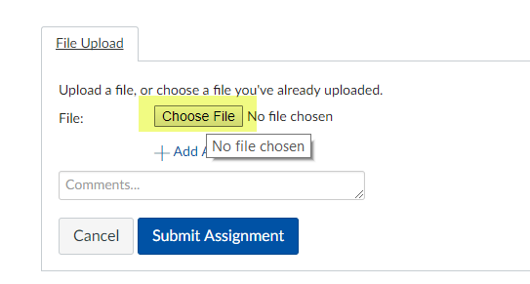

Browse to wherever you saved your zip file, select it and then click Open.

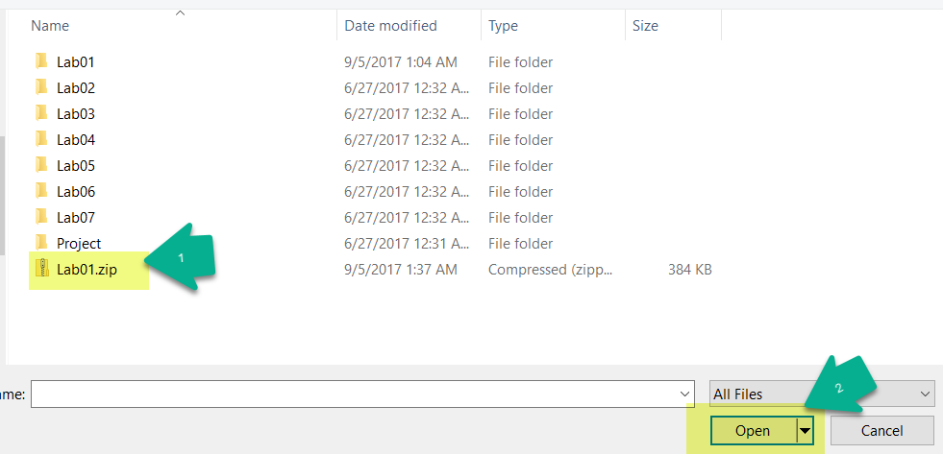

Double check to make sure you have the right file and click the Submit button. Before submitting, you may add a comment if there’s something special I need to know about your assignment.

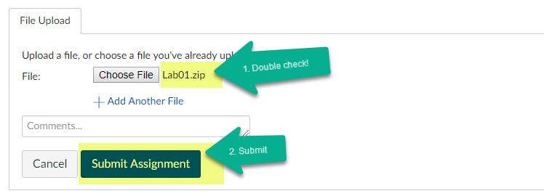

If everything is successful you’ll see the confirmation on the right side.

