**INTL550 Final Paper:**

**Understanding Protectionism in the Age of International Trade: The Incumbent’s Role**

Uğur İlker Darıcı

**Abstract**: This study aimed to understand contemporary strategies of protectionism and governments’ role in the protectionist processes. Particular attention has been devoted to non-tariff measures, which are labeled as the brand-new tools for trade protectionism. Unlike the literature which focuses on the business / workers associations more, the study explored the governmental side of the story and found that import / export ratio is an important indicator signaling an increase in the NTMs. Finally, study revealed that NTMs are not substitutes of tariffs, but they are complements, which is the exact opposite of what the literature suggests. The reason behind this may be the fact that once the sharp decrease in the tariff rates has stabilized, the gradual and small increases has been made by the governments with protectionist agendas together with application of NTMs.

INTL 550 Research Paper

Instructor David Carlson

May 2020

Koç University

**Uğur İlker Darıcı**

**INTL550 Final Paper:**

**Understanding Protectionism in the Age of International Trade: The Incumbent’s Role**

**1) Introduction:**

For centuries, there have been many advocates of free trade, benefits of which were stressed by a wide variety of scholars from A. Smith to academics of neoliberal economics. The latest triumph of ideas and interests regarding free trade occurred thereafter the WWII. In the modern sense, the first multilateral action taken by governments to a freer world trade was the GATT of 1947-1948 that was signed by mostly developed economies of the world. With this agreement, free trade has been set an ultimate goal to be reached. However, it took a long time. After the apparent triumph of and neoliberal economics during the 80s, free trade goal was accomplished roughly, and even most fiercely opposing countries of free trade followed one another to open their economies.

Long story short, the benefits of free trade is being speculated continuously for years and the followers of this trend are on the rise. However, trade protectionism – natural rival of the free trade – has never disappeared. It has just changed the shape. The rise of non-tariff barriers has presented governments new means of protecting the sectors that they found worth to protect. Furthermore, there have been many sectors such as apparel industry and agriculture subjected to high protection by governments for decades. Understanding the logic behind the protectionism in the age of global trade requires further evaluation of influencing factors of governments’ policy preferences.

Yet, in order to do so, we firstly need to understand what forms protectionist policies take in the 21st century. As it is a well-known fact, before the third quarter of 20th century, protectionism was applied through tariffs and customs tax, which were quite simple to measure and appreciate its difference through sectors and countries. However, from then on, gradual demolishment of tariffs due to the gradual liberalization of import across the globe make protectionist policies harder to discern. Even, some believed that history has ended, and open markets have prevailed. Yet, the picture is more complex. As the paper will show in the subsequent parts, it seems that trade protectionism has never ended, and just changed its shape. Rise of non-tariff barriers (NTBs), also known as non-tariff measures (NTMs) have marked a new stage in the history: the age of new protectionism.

In this stage, NTMs are used to substitute tariffs (Mansfield & Busch, 1995). UNCTAD defines non-tariff measures as “NTMs include all policy-related trade costs incurred from production to final consumer, with the exclusion of tariffs” (UNCTAD 2013). More broadly, NTMs are the measures that have an implicit or explicit distorting effect on the international trade. For example, the Common Agricultural Policy can be seen as a NTM since it has an implicit effect on the free trade. However, most of the time, it is hard to distinguish a NTM from other trade policies that have unintended consequences on the free movement of goods since there is no clear-cut difference between them. That’s why UNCTAD (and possibly WTO) defines them as NTMs, since NTBs are now seen as a specific definition of quotas and voluntary export restraints.

Furthermore, there are plenty of NTMs according to World Trade Organization. WTO divides NTMs into two categories: technical & non-technical measures. Technical measures are the following: (a) sanitary and phytosanitary (SPS) measures which are expected to protect all living creatures from epidemics & diseases; (b) wide variety of technical barriers (TBTs); (c) pre-shipment inspection and other formalities which includes quality, quantity, and price control of products before they exit the exporting country by an independent organization. Control of toys’ components, shape, durability produced in China before they exit China constitutes an example of these technical protectionist measures. Also, in 2017, a group of experts called Rosselhoznadzor from Russia landed Turkey to inspect the quality standards of tomatoes, which can be interpreted as a pre-shipment inspection as well.

On the other hand, some of the non-technical measures can be counted as (a) price control measures, including additional taxes and charges; (b) measures affecting competition (transportation, advertisement etc.); (c) distribution restrictions, (d) intellectual property; (e) non-automatic licensing, quotas, prohibitions and quantity-control measures other than for SPS or TBTs. As stated earlier, there is no clear-cut difference between public welfare-oriented measures and NTMs. So, the conclusion is that it is hard to determine if a trade measure is protectionist policy or only public health/public welfare-oriented one.

In such a setting, the Organization of Economic Co-Operation and Development (OECD) lends a crucially significant assistance for the researcher. Since 2014, OECD publishes Service Trade Restrictiveness Index (STRI) which reveals national and sectoral variations in protectionist trade policy preferences in 22 major services industries. It “provides a rich source of information for trade policy makers, trade negotiators and researchers, and an instrument for impact assessment of trade liberalization. The STRI further allows individual countries to benchmark their services market regulations against the global best practice, identify outlier restrictions and current bottlenecks.” (STRI 2019, Abstract)

Analyzing laws and regulations collected from 36 OECD and 9 non-OECD countries qualitatively, the STRI identifies trade protectionism within 5 categories: Barriers to competition, restrictions on foreign entry, regulatory transparency, restrictions on movement of people, and other discriminatory measures. Then, overall score between 0 and 1 is given to the 22 distinct sectors in 45 different countries where 0 stands for complete openness to trade and 1 stands for full protectionism of the domestic sector. Table.1 shows the average service trade restrictiveness index calculated on the bases of STRI data. As table indicates, Turkey, together with Iceland and Mexico, ranks on the higher end among OECD countries in protecting their industries, whereas Czechia, Latvia and Netherlands ranks on the lower end.

Source: OECD – STRI (Average calculations and tabulations is my work)

In short, Economic nationalism and protectionist agendas did not come to a close. Also, as the table shows, there is a certain variation in trade protectionism in the world and the factors effecting trade protectionism remains as a puzzle waiting for an explanation.

**2) Theory and Hypotheses**

Even though the literature review is not presented in this paper due to the time and space constraints[1], literature review suggests sectors that are not fit in the high competition environment, i.e. global trade, seek for protection before the government. For example, it was the liberalization of agricultural imports and US’ farmers incapacity to compete with Canadian farmer behind the Smooth - Hawley act of 1930 which is labeled as the most protective measure taken by the US governments. Moreover, import liberalization era eroded tariffs and replace them with the NTMs, which is easier for governments to provide since their trade-distorting effects are harder to be conceived. So, based on the literature, the paper assumes that

*Assumption I: High competition environment pushes some domestic sectors to lobby for trade protectionism in the form of NTMs.*

Also, it is often argued that the only vital factor in securing trade protectionism by a petitioning sector is the sector’s ability to organize. Paper argues, however, securing trade protectionism is a two-fold game in the sense that incumbent’s survival calculations are as crucial as petitioning sectors characteristics. Treating governments as passive entities in trade policy making processes results in getting the picture half. The role of government and macroeconomic indicators should be also included in the account. Table.2 summarizes the theory.

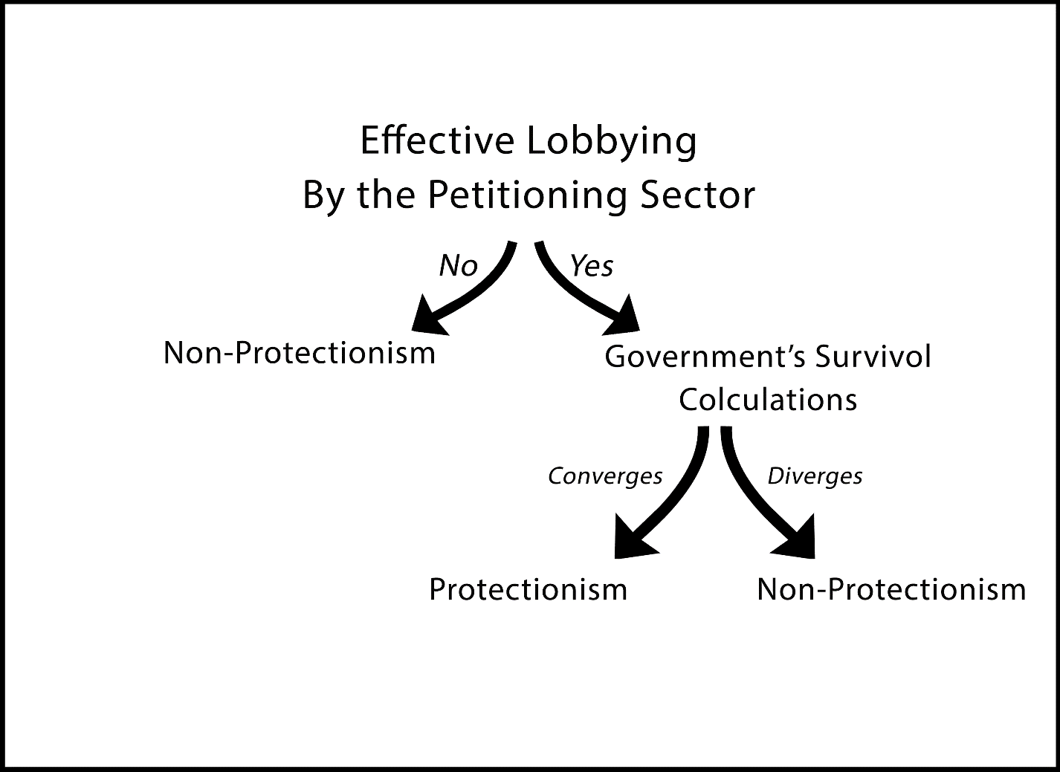

In this way, paper argues that it is the alignment of interests between the incumbent and the petitioning sectors that provides sectoral protection. So, if and only if effective lobbying of sectoral interest group for protection overlaps with the survival calculations of the incumbents, then the protectionist trade policies are taken place. So, neither effective lobbying nor government’s survival calculations are sufficient conditions. Yet, both are necessary conditions for trade protectionism, and these two should be come together for such an outcome. If there is no alignment of interests between the petitioning and ultimate powerholder, it is expected that there would not be protectionist trade policies.

So, assuming that there is an organized group lobbying for trade protectionism in the form of NTMs, then how should the government look like to grant the protection?

For instance, as the unemployment rises, the odds of incumbent’s survival decrease, according to economic-voting theory. So, it is expected that governments would be more likely to grant protection to its industries in a high unemployment environment. By doing so, the incumbent aims to improve unemployment rate through creating job opportunities in the protected sectors. So,

*Hypothesis I: If nation-wise unemployment rises, the incumbent will more likely grant protection for the petitioning sectors.*

Moreover, Wallerstein (1987) makes a class-based analysis of the relationship between unemployment and protectionism. He argues that the unionized working class is better at protecting its employment opportunities from the foreign competition. Also, based on the theory introduced above, paper argues that not only unionized workers but also overall unemployment effects the government’s trade policy preferences. However, to control the relationship between unionization and unemployment, and to empirically test Wallerstein’s argument, So, the second hypothesis is the following:

*Hypothesis 2: The more unionized business and workers, the more likely the government to grant protection.*

Trade deficit, on the other hand, is another “evil” for the incumbent that is lowering its odds of sticking to power. Since an unsustainable trade deficit may create economic bottlenecks as it was the case across the developing countries in the 70s. Empirically, these bottlenecks were usually “taken care of” through government changes and coup d’états. As a result, proposed theory also hypothesize that

*Hypothesis 3: As the import/export ratio increases, the incumbent is more likely to grant protection.*

Foreign direct investment inflows and outflows, on the other hand, are expected to have a statistically significant effect on trade protectionism. For example, evidently, if a government wants to attract FDI into the country, then it should lower the barriers. On the other hand, if a government wants to keep the investor inside, then it should create a well-protected profitable environment. So, it is expected that as the outflows increases, then the government should higher the entry barriers. In this way,

*Hypothesis 4: The amount of FDI inflows correlates negatively with the protectionist measures in the form of NTMs*

*Hypothesis 5: The amount of FDI outflows correlates positively with the protectionist measures in the form of NTMs*

Lastly, GDP growth and tariff rates are controlled because of their possible effects on the protectionist measures. NTMs are treated as substitutes of the tariffs. So, in the analysis, a negative correlation between them should be observed. Also, thinking of growing GDP as an indicator of rising competitiveness, then GDP growth may have an effect on the protectionist measures.

*Hypothesis 6: As the tariff rates increase, the NTMs decreases*

*Hypothesis 7: GDP growth rate correlates negatively with the NTMs*

**3) Data & Measurement**

To operationalize and measure the dependent variable, trade protectionism, study utilizes the Service Trade Restrictiveness Index prepared by OECD, which quantitatively measures NTMs after a qualitative analysis of laws and regulations. In this way, the variation in the dependent variable, differentiation in trade protectionism, has been revealed, and the robustness of the study has been reinforced. Since the OECD does not present a handy API, Service Trade Restrictiveness Index was downloaded, and cells were formatted so that it can be merged with World Bank data. Then, the mean of service trade restrictiveness for 45 country were calculated and turned to percentages. (Same procedures were applied to OECD generated Trade Union Density data. The raw data is available at: <https://stats.oecd.org/Index.aspx?DataSetCode=TUD>)

On the other hand, to measure the effects of independent variables mentioned above, firstly, relevant World Bank data have been imported using World Bank API. In order to normalize the data to some extent, all the data gathered from World Bank was selected in the form of weighted and time-effects controlled percentages. Also, to test the Import/Export ratio hypothesis, import numbers of the selected countries have been divided by their export numbers, and since all the remaining independent variables are in percentages, the outcome ratios were multiplied by 100 to have a more meaningful coefficients.

Finally, due to data availability, a cross-sectional study containing 36 OECD countries and 10 partnering countries for the year of 2018 has been designed. If the null values were dropped, the data would shrink so much so that its explanatory power for a quantitative analysis would be in danger. So, by accepting shortcoming, null values were filled with the means of every column.

**4) Results**

Having generated the dataset, multiple linear regression (OLS) analysis was run. The results counter-intuitively indicate that there is a statistically significant positive correlation among non-tariff measures and tariff rates, GDP growth, and import/export ratios. However, a statistically significant relationship among the NTMs and unemployment rate, unionization and foreign direct investment inflows and outflows could not be observed. Table.3 shows the results:

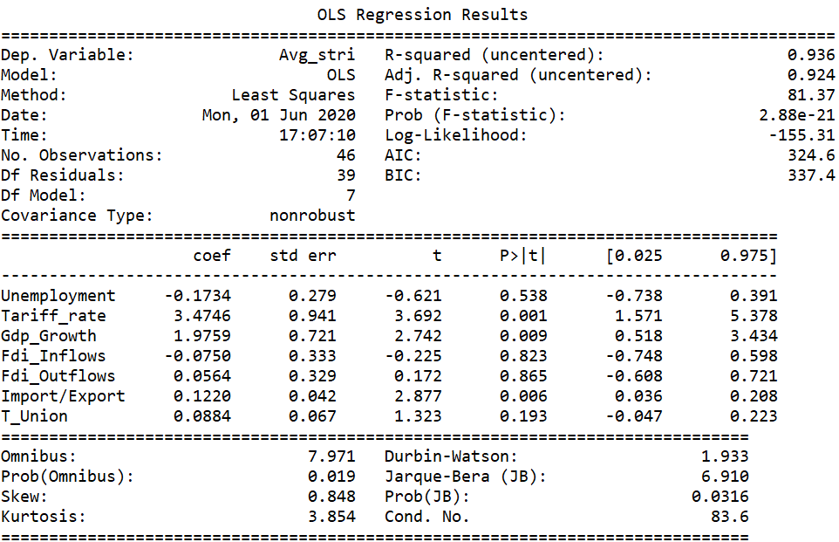

On the other hand, when the positivity / negativity of the correlation coefficients are considered, though statistically insignificant, FDI inflows negatively correlated with the NTMs as expected. Also, sign of the FDI outflow’s correlation coefficient was in line with the anticipation. Yet, most of the correlations were not in line with the hypotheses. For example, while a positive relationship between unemployment and NTMs is expected, the results indicate vice versa. Moreover, while a negative correlation of NTMs with the GDP growth and tariff rates was predicted, again the results were vice versa.

Study also could not find any evidence supporting Unemployment, Foreign Direct Investment and Unionization Hypotheses. Both were statistically insignificant, and their correlation coefficient were so low. Finally, only statistically significant variables in the prior regression were included in the second model and it is observed that their coefficients changed. Table.4 shows the second model:

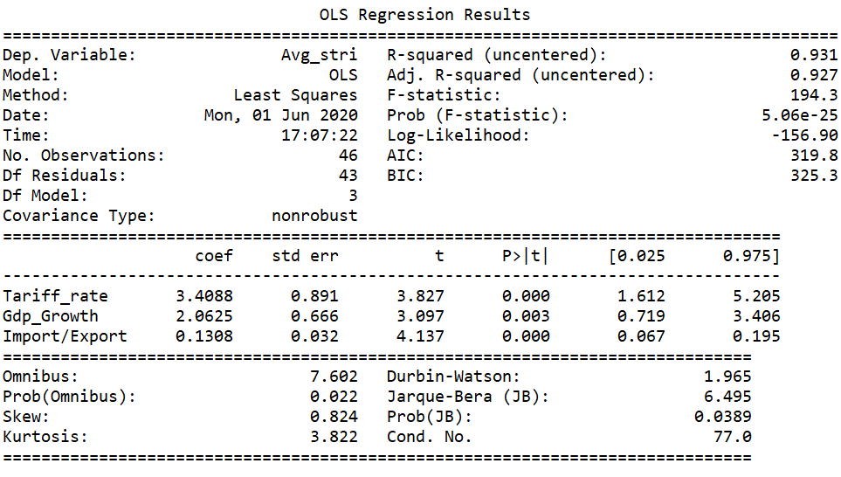

Again, considering the p-values and standard errors, it can be asserted that NTMs positively correlate with the Tariff rates, GDP growth, and import-export ratios.

**5) Discussion & Conclusion**

Trade deficit is one of the main concerns of the contemporary economists and politicians. Historical evidence shows that if it cannot be dealt with, it may have severe consequences for the incumbent. Even in 2020, trade deficit is still a major macroeconomic issue that most of the developing world is suffering from. In such a setting, governments may utilize protectionist policies to better preserve their domestic economies and prepare them for international competition. Also, hardening foreign entry may be an attempt to keep the profit within the country. Based on these reasoning, the result of the study indicates that import / export ratio is an important indicator in understanding the trade policy preferences of the countries.

|  |  |  |
| --- | --- | --- |
| Table.4 | (1) | (2) |
| VARIABLES | Model | Model 2 |
|  |  |  |
| Unemployment | -0.173 |  |
|  | (0.279) |  |
| Unionization | 0.088 |  |
|  | (0.067) |  |
| FDI Inflows | -0.075 |  |
|  | (0.333) |  |
| FDI Outflows | 0.056 |  |
|  | (0.329) |  |
| Tariff Rate | 3.475*** | 3.409*** |
|  | (0.941) | (0.891) |
| GDP Growth | 1.976** | 2.062*** |
|  | (0.721) | (0.666) |
| Import/Export | 0.122*** | 0.131*** |
|  | (0.042) | (0.032) |
| Observations | 46 | 46 |

Standard errors in parentheses

*** p<0.01, ** p<0.05, * p<0.1

Also, as table.4 indicates, counter-intuitively, there is a strong positive relation with the tariff rates and NTMs. It seems, in the age of international trade, NTMs are not substitutes of tariffs but they are complements, which is the exact opposite of what the literature suggests. The reason behind this may be the fact that once the sharp decrease in the tariff rates has stabilized, the gradual and small increases has been made by the governments with protectionist agendas together with application of NTMs.

Finally, shockingly, a strong statistically significant relationship between GDP growth and NTMs has been found in the study. However, clearly, this is not to say that protectionist economies grow faster than the liberal economies. Yet, this finding opens new horizons for the research to focus on the relationship between economic growth and protectionism.

**5) Acknowledgements**

This paper is an outcome of my curiosity towards trade protectionism and economic nationalism starting from my undergraduate years. Some parts of the literature review are taken from my previous literature review essay that I wrote at Boğaziçi University in 2019 and revisited. Apart from that all work in this paper is my own studies and made for the purposes of INTL550.

**6) Bibliography**

* Drope, J. M. (2007). The Political Economy of Nontariff Trade Barriers in Emerging Economies. Political Research Quarterly, 60(3), 401–414. <https://doi.org/10.1177/1065912907305682>
* Eichengreen, B. (1986). The Political Economy of the Smoot-Hawley Tariff. International Political Economy. 2003. Routledge. 37-47.
* Feenstra, R. C., Grossman, G. M., Douglas A. I. (1996). The Political Economy of Trade Policy. MIT press.
* Goldstein, J. (1986). The Political Economy of Trade: Institutions of Protection. The American Political Science Review, 80(1), 161-184. doi:10.2307/1957089
* Hanif, a., Alavi, r., Ghani, G., & Duasa, J. (2010). The Determinants of non-tariff barriers in Malaysia's Agricultural Sector.
* Magee, S.P. (1997). Endogenous protection: the empirical evidence. in D.C. Mueller (ed.), Perspectives on Public Choice: A Handbook, Cambridge: Cambridge University Press, pp. 526-61.
* OECD (2019). Service Trade Restrictiveness Index. Last Access: 24 May 24, 2020 from <https://stats.oecd.org/Index.aspx?DataSetCode=STRI>
* UNCTAD. (2013). Non-Tariff Measures to Trade: Economic and Policy Issues for Developing Countries. Developing Countries in International Trade Studies. United Nations Publication.
* Wallerstein, M. (1987). Unemployment, Collective Bargaining, and the Demand for Protection. American Journal of Political Science, Vol. 31, No. 4 (Nov., 1987), pp. 729-75.
* Worthington, Alton B. H. (2019). MNCs, NTBs, and New Protectionism: Trade Barriers in an Era of Global Capital. Doctoral Dissertation. University of Michigan

1. I can present my literature review, if asked to do so.