An Introduction to Databases for Accountants – VERSION 2.2

# Author Information

Vic Anand, Ph.D.

Assistant Professor of Accountancy – University of Illinois at Urbana-Champaign

R.C. Evans Data Analytics Fellow - University of Illinois-Deloitte Foundation Center for Business Analytics[1]

# Learning Objectives

* Design and create a database for relational data.
  + Write basic SQL to create tables.
  + Learn how data should be stored to reduce or eliminate redundancy.
  + Learn how transaction-level accounting data should be stored.
* Design and create a database from the perspective of a user of financial reporting.
  + Extract information from a database for financial reporting.
    - Retrieve data from one table.
    - Merge data from multiple tables.
    - Aggregate and filter data from one or more tables.
  + Compute financial statement line items from transaction-level data.
* Integrate database skills with Python skills by using the SQLite and Pandas packages.

# Introduction

One of the important data analytics tasks that an accountant will undertake is merging data from multiple sources. This need might arise when, for example, the accountant wishes to compute profit per customer (i.e. customer profitability analysis) or profit per cost object. Typically, the accountant must retrieve transaction-level data from multiple sources and then merge this data before analyzing it further. Transaction-level data is often stored in databases. Thus, practicing accountants interact with data from databases whether they realize it or not.

The purpose of this case is to introduce accounting students to databases. In this case, you will assume the role of a preparer of financial statements. You will create a database to store transaction-level data for a fictitious company and then compute some common accounting metrics like revenue and cost of goods sold. Within the database, you will create separate tables to store customer information and customers’ orders. You will also create a table to store information about the company’s products. Finally, you will retrieve data from these tables, merge that data, and transform it into useful numbers like revenue or cost of goods sold.

## Company Description

In this case, we borrow data from the famous Northwind Traders database, a sample database that Microsoft provides with its Microsoft Access database software. Northwind Traders (NWT) is a fictitious company that sells gourmet food products. The original Microsoft-supplied database contains tables for NWT’s customers, employees, suppliers, inventory, customer orders, supplier orders, and more. However, in this case, you will only work with a subset of that data.

## Introduction to Databases

A database is a collection of data, typically organized into tables. Each table consists of rows (called records) and columns (called fields), and is similar to an Excel worksheet. Figure 1 shows a subset of the table that stores information about NWT’s products. Notice that the table has one row per product. Also notice that the columns contain different information about each product, such as its name and price.

While a database table may appear similar to a spreadsheet, there are some key differences. Unlike a spreadsheet, each table column must contain the same type of data. For example, the Product Name column contains text data and the List Price column contains numeric data. A database strictly enforces column data types. The reason for this constraint is that it often does not make sense to store different data types in the same column. For example, it would not make sense to store text data in price or cost columns.[2]

Another key difference between a database table and a spreadsheet is the primary key. A primary key is a field (or fields) that uniquely identifies each record. In products table shown in Figure 1, the Product Code field is the primary key. This code is different for every product and can therefore uniquely identify each product.

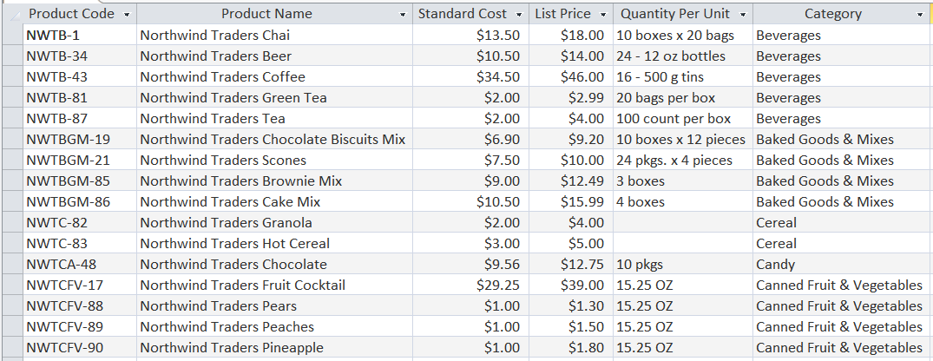

Figure 1: Northwind Traders' products table

You might wonder whether a product’s name can serve as a primary key. It could if each product has a unique name. However, what if the company offers the same product in different sizes? We would need to add a new record to the table for the other sizes, but the product name would be the same for all sizes. Therefore, since the product name might not always be unique, it is not a good candidate for a primary key.[3]

### Common Brands of Databases

Some common brands of databases that you might encounter are Oracle, MySQL, Microsoft SQL Server, Microsoft Access, and PostgreSQL. In this case, we will work with SQLite, a lightweight, simple database. Everything you learn here is transferable to other common types of databases.

### Client-Server vs. Embedded Databases

Many databases, such as those used in websites, utilize a client-server model. For example, when a Capital One credit cardholder makes a purchase, the details of their card transaction are stored on a database that is hosted by Amazon Web Services. Thus, the database that Capital One uses is “remote” and their transaction server, the client, needs to communicate with a remote database server.

Embedded databases are integrated within their apps. For example, if you play a computer game on your gaming console, game data might be stored in an embedded database that resides on your console. Phone apps like Dropbox also use embedded databases to keep track of local files.

In this case, we will work with an embedded database, SQLite. Because it is embedded, it is stored in a single file on your computer, and you can easily view and interact with it.

## Prerequisites

* You should have access to Jupyter notebooks (or JupyterLab) running Python 3.
  + If you do not have access to Jupyter notebooks, I recommend you use [Microsoft Azure Notebooks](https://notebooks.azure.com/). This is a free service from Microsoft that you can run in a browser that requires no additional software on your computer.
  + If you wish to work on your own computer, I suggest you download and install the [Anaconda distribution of Python](https://www.anaconda.com/). This is a premiere distributions of Python that is designed for data science. It includes a Jupyter notebook server and JupyterLab.
* You will need access to the following Python packages, both of which are included with Microsoft Azure Notebooks and with Anaconda.
  + pandas
  + sqlite3
* Basic knowledge of SQL. If you need a tutorial or a refresher, I recommend either of:
  + <https://www.w3schools.com/sql/>
  + <https://www.sololearn.com/Course/SQL/>
* The program [DB Browser for SQLite](http://sqlitebrowser.org/).
  + This free software allows you to create and manage SQLite databases.
  + It is available for Windows and Mac.
  + While it is possible to do this entire case using only Python, DB Browser will simplify many of the tasks and will allow you to easily visualize the database tables.

# Creating a Database with Tables for Customers and Products

This section provides instructions and guidance for the first three deliverables. In sum, you will first create a blank database with an empty products table. Then you will populate that table with data from a file that accompanies the case. Finally, you will create and populate a table to store customer data.

## Create a Blank Database

You will now create a blank database. While it is possible to do this entirely from Python, we will use a tool, DB Browser for SQLite, to simplify your task.

1. Download and install [DB Browser for SQLite](http://sqlitebrowser.org/).
2. Open DB Browser for SQLite. You will see a window similar to that shown in Figure 2.
3. Click on the New Database button, circled in red in Figure 2.
4. Navigate to the folder in which you wish to store your database and save your database file as NWT.db.

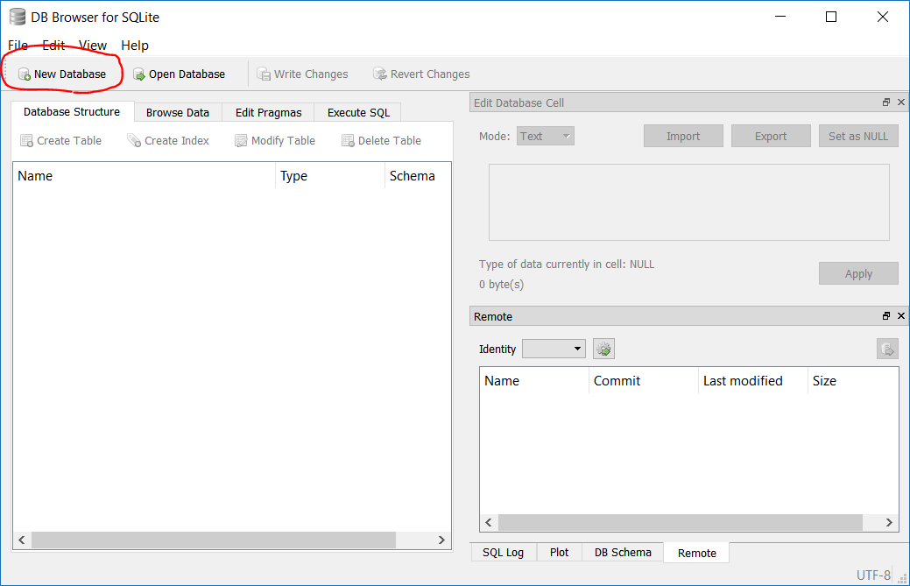

Figure 2: DB Browser for SQLite with no database loaded

## Create a New Table Named *tblProducts*

A new dialog will appear that will allow you to create a table (see Figure 3). If it does not, click the *Create Table* button. Name your new table tblProducts, then click the Add field button. Follow the steps below to create the products table.

1. Replace the text Field1 with ProductCode. Change the type to TEXT, and select the PK checkbox (this tells SQLite that ProductCode will be your primary key column).
2. Continue to click the *Add field* button and populate the dialog with all the fields shown in the right snapshot of Figure 3.
   1. Make sure the *PK* checkbox is checked for the ProductCode field (and only for that field!).
   2. I strongly recommend that you do not use spaces in the field names. While it is allowed, your life will be much easier if you do not use spaces.
3. Note that, as you add fields, the bottom panel of the dialog updates to show the SQL code that is generated. Ultimately, DB Browser will execute SQL code to create a new table. The graphical user interface automates the process of writing SQL.
4. When you have populated the dialog with all of the fields shown in Figure 3, click the OK button in the bottom right.
5. Verify that the table structure was correctly saved by comparing your DB Browser window to that shown in Figure 4.
6. In the main window for DB Browser (Figure 4), click the *Write Changes* button. This will save the new table to the database file. **Don’t skip this step!!**

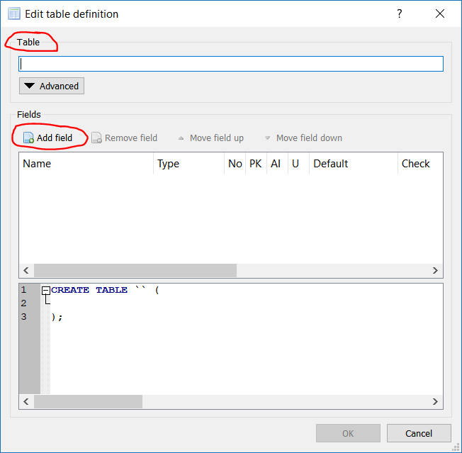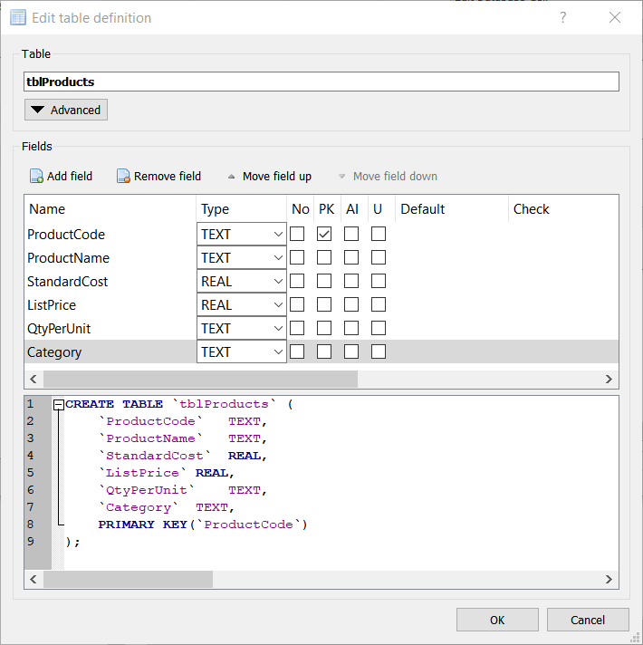

Figure 3: Dialog for creating a new database table. The left dialog appears after you first create a new database, or when you click the Create Table button. The right dialog shows the dialog populated with the fields needed for the Products table. Note that the bottom panel of the right dialog shows the SQL code to create the table.

You have completed the first deliverable, which is summarized below.

**DELIVERABLE 1: Create database file *NWT.db*. Within that file, create an empty table named *tblProducts* with the correct table structure.**

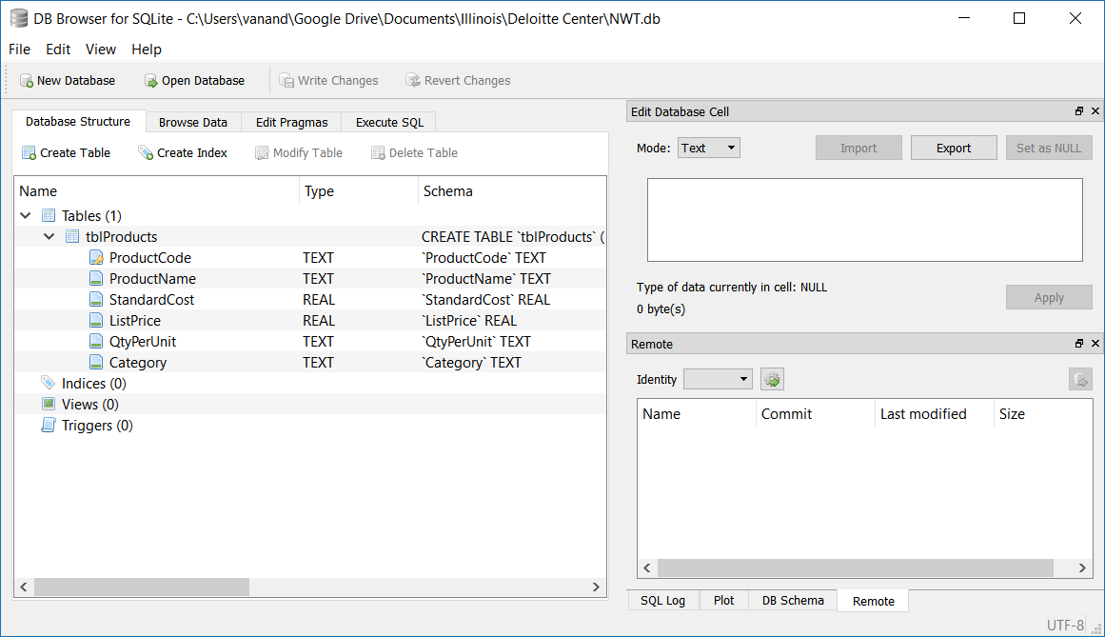

Figure 4: DB Browser window showing correctly configured products table (tblProducts)

## Adding Data to the Products Table

You have now created a database file and, within it, a table that can store information about the company’s products. However, the table is empty. It has a structure, but no records. Thus, your next task is to populate the table with data from the file Products.csv that accompanies the case. There are multiple ways to accomplish this:

1. Using the Browse tab in DB browser, click the New Record button and manually type data from the CSV file. You would need to do this for each of the 45 rows in Products.csv. I strongly discourage this approach, as it has the following consequences:
   1. It is error-prone.
   2. It is time-consuming.
   3. You will be subject to ridicule from me, your professor, and your peers.
2. Using the Execute SQL tab of DB Browser, write an SQL [INSERT INTO](https://www.w3schools.com/sql/sql_insert.asp) statement that inserts multiple rows. You could open the *Products.csv* file in Excel and use some Excel formulas to create this statement.
3. (Recommended approach) Use the Pandas and sqlite3 packages in Python. Students who are using a remote Jupyter server (e.g. Azure Notebooks) will need to upload their *NWT.db* and *Products.csv* files to that server. The following tips should help:
   1. Make a backup copy of your NWT.db file.
   2. Consider reading [this tutorial on working with SQLite databases using Pandas](https://www.dataquest.io/blog/python-pandas-databases/).
   3. In Python, import the pandas and sqlite3 packages, e.g.  
      import pandas as pd  
      import sqlite3
   4. Open a connection to the database in Python. Do so using the connect function of the sqlite3 library, e.g. conn = sqlite3.connect('NWT.db').
   5. Load the data from *Products.csv* into a Pandas DataFrame.
   6. Transfer the data from your Pandas DataFrame into a table by using the [*to_sql*](https://pandas.pydata.org/pandas-docs/stable/generated/pandas.DataFrame.to_sql.html) method, e.g. df.to_sql(…).
      1. You will need to specify the arguments to the *to_sql* function.
      2. I strongly recommend you use the *name*, *con*, *if_exists*, and *index* arguments.
   7. Close the connection to your database with the Python command conn.close(). That will close the connection to the database and commit your changes.
   8. You can see the results in DB Browser.
   9. If you wish to delete all the rows from *tblProducts* and try again, you can easily do so in DB Browser. On the *Execute SQL* tab, type DELETE FROM tblProducts; and press the execute button. After the query executes, click the *Write Changes* button.

Upon successful completion of these steps, you will have satisfied deliverable 2:[4]

**DELIVERABLE 2: Populate table *tblProducts* with data from the file *Products.csv*.**

## Creating and Populating a Customers Table

Using the file *Customers.csv* that accompanies this case, create and populate a new table in the database, *tblCustomers*. Use your judgment in choosing data types for the columns and in choosing the primary key column(s).

**DELIVERABLE 3: Create and populate *tblCustomers* with data from the file *Customers.csv*.**

# Tracking Customer Orders

This section provides instructions and guidance for the next four deliverables. In sum, you will create and populate an orders table, *tblOrders1*, then answer questions about why this table is poorly designed. Then you will create and populate another orders table, *tblOrders2*, whose design rectifies the flaws in *tblOrders1*. Then you will write an SQL query to retrieve and merge data from the orders, products, and customer tables. Finally, you will create and populate two tables, *tblOrders3* and *tblOrderDetails*, that constitute the final design of our order tracking system.

For the remainder of this case, assume that all customers pay for their orders immediately in cash (i.e. no receivables).

## Customer Orders: First Try

What information should an orders table in a database store? For now, assume you want to store the order date, the customer name, the product ordered, quantity ordered, unit price paid, and the shipping date.

### Create a New Table named *tblOrders1*

Create a new table in your database named *tblOrders1*. Within that table, create the columns shown in Table 1. Remember: do not use spaces in column names.

|  |  |  |
| --- | --- | --- |
| Field | Data Type | Description |
| OrderDate | Text | Date on which the order was placed |
| CustomerName | Text | Customer name |
| Product | Text | The product ordered |
| Quantity | Integer | The number of units of the product ordered (assume no fractional units) |
| Price | Real | The unit price the customer agreed to pay |
| ShipDate | Text | The date on which the product shipped |

Table 1: Structure for table *tblOrders1*

### Refining tblOrders1

Does this table structure work? No! Are we missing something? Yes! With the current table structure, we cannot uniquely identify an order. One possible solution is to set the primary key to two existing columns, the order date and the customer name. However, that would only work if customers never place two orders on the same day.

Let’s follow the best practice of creating a separate column called *OrderID* with data type integer. Mark the column as the primary key, and also add the attribute “auto increment”. If you use DB Browser, you can add these attributes by checking the PK and AI boxes. The “auto increment” attribute tells the database to automatically generate a new order ID every time a new row is added. Neat, huh?

When you have created all the columns (the six columns in the bulleted list above, plus the *OrderID*), click the *Write Changes* button in DB Browser to save your changes.

### Populating tblOrders1 with Sample Data

Populate *tblOrders1* with the three orders shown in Table 2 below. I suggest you add these three rows manually using DB Browser. Do this by going to the *Browse Data* tab and clicking on *New Record* once for each row. After you add the rows, don’t forget to click the *Write Changes* button.

|  |  |  |  |  |  |  |
| --- | --- | --- | --- | --- | --- | --- |
| OrderID | Order Date | Customer Name | Product | Quantity | Price | Ship Date |
| 1 | 2018-10-10 | Company AA | Northwind Traders Chai | 100 | $18.00 | 2018-10-10 |
| 2 | 2018-10-11 | Company AA | Northwind Traders Beer | 500 | $14.00 | 2018-10-11 |
| 3 | 2018-10-11 | Company H | Northwind Traders Olive Oil | 200 | $21.35 | 2018-10-11 |

Table 2: Sample data to be inserted into *tblOrders1*

**DELIVERABLE 4:**

**a. Create table *tblOrders1* using the structure shown in Table 1, and with primary key column *OrderID*.**

**b. Populate table *tblOrders1* with the data shown in Table 2.**

***Answer the following in a Jupyter notebook:***

**c. Explain why storing the product name and customer name in every row of the orders table is inefficient, unwise, and downright stupid. What can go wrong with this design?**

**d. Propose a better design for incorporating the product and customer information into the orders table.**

## Customer Orders: Second Try

Let’s try a different design for our orders table. However, before we do, I need you to check a setting in DB Browser. Click on the tab titled *Edit Pragmas*, and make sure that *Foreign Keys* is checked.

You will now create a new database table, *tblOrders2*. To save you the grunt work of entering in the details of each column, do the following. In DB Browser, click on the *Execute SQL* tab. Paste the SQL code from Figure 5 into the appropriate box in DB Browser, and then execute it. Don’t forget to click the *Write Changes* button after you execute this SQL code.

**CREATE** **TABLE** `tblOrders2` **(**

`OrderID` **INTEGER PRIMARY KEY AUTOINCREMENT,**

`OrderDate` TEXT**,**

`Customer` **INTEGER,**

`Product` TEXT**,**

`Quantity` **INTEGER,**

`Price` **REAL,**

`ShipDate` TEXT**,**

**FOREIGN** **KEY(**`Customer`**)** **REFERENCES** `tblCustomers`**(**`CustomerID`**),**

**FOREIGN** **KEY(**`Product`**)** **REFERENCES** `tblProducts`**(**`ProductCode`**)**

**);**

Figure 5: SQL code to create tblOrders2

**DELIVERABLE 5:**

**a. Create *tblOrders2* using the SQL from above.**

**b. The following line of SQL code attempts to insert the first row from Table 2 above. Type this SQL code into *Execute SQL* tab of DB Browser and run it. You should receive an error. What is the error, what does it mean, and why did you receive it? Answer this question in your Jupyter notebook.**

**INSERT INTO tblOrders2 (OrderDate, Customer, Product, Quantity, Price, ShipDate)**

**VALUES ('2018-10-10', 'Company AA', 'Northwind Traders Chai', 100, 18.00, '2018-10-10');**

**c. Populate *tblOrders2* with the three rows from Table 2, but substitute product codes for the product names and customer ID’s for customer names.**

***Answer the following in a Jupyter notebook:***

**d. What is a foreign key? You might need to Google this.**

**e. What is a foreign key constraint?**

**f. Why is the design of *tblOrders2* superior to that of *tblOrders1*? Hint: read the section titled “*What is good database design?”* on** [**this web page**](https://support.office.com/en-us/article/Database-design-basics-EB2159CF-1E30-401A-8084-BD4F9C9CA1F5#bmgood)**.**

## Customer Orders: Third and Final Try

Our second design of the orders table was, unfortunately, not sufficient. It cannot handle a situation in which a customer orders multiple products in one order. This is common in retailing. For example, think about your past orders from Amazon. Did you ever order more than one product?

How can we redesign our orders table to accommodate multiple products? The naïve solution is to add multiple product columns. But this is a poor design because it imposes a maximum order size. Even if you have 20 product columns, a customer might order 25 items.

Best practice is to create two tables to store orders. The first table, *tblOrders3*, will have one record per order. The second table, *tblOrderDetails*, will have one row per product per order. Thus, there will be a one-to-many relationship between *tblOrders3* and *tblOrderDetails*.

**Deliverable 6:**

**a. Create a new table *tblOrders3* using the structure implied by the file *Orders.csv* that accompanies this case. Make sure to set a primary key column. Also set a foreign key constraint for customers. Hint: use the SQL code in Figure 5 as a template, or use the foreign key field in the DB Browser *Add Field* dialog.**

**b. Populate *tblOrders3* with data in the file *Orders.csv*.**

**c. Create a new table *tblOrderDetails* using the structure implied by the file *Order Details.csv* that accompanies this case. Also set foreign key constraints for orders *and* product codes. Hint: use the SQL code in Figure 5 as a template, or use the foreign key field in the DB Browser *Add Field* dialog.**

**d. Populate *tblOrderDetails* with data in the file *Order Details.csv*.**

# Queries: Extracting Information from the Database

Companies store data at the transaction level. When it is time to prepare financial statements, they retrieve transaction-level data from their accounting systems and aggregate it into line items, such as revenue. In this final part of the case, you will do this. Hopefully, you will see why the database structure we created aids in preparing financial statements. If you think about it, you will also see why the database structure also lends itself to auditing.

Computing meaningful numbers, such as revenue, requires data from multiple tables, as well as some aggregation. Before we jump into that, let’s learn how to work with data from a single table.

## Retrieving Data from a Single Table

### The SQL SELECT statement

The SQL SELECT statement is at the heart of SQL. It is the most useful piece of SQL you can learn. The basic syntax is:

SELECT column(s) FROM table_name;

Executing a line of SQL such as this will retrieve all the rows from one or more columns of table_name. It’s that simple.

It is also possible to perform basic transformations in a SELECT statement. For example, say I want to compute the contribution margins of the products in this database. If we assume that the purchase price equals the standard cost (i.e. no variance), then we could write:

SELECT ListPrice - StandardCost FROM tblProducts;

Executing this will produce a list of numbers, such as that shown in red in the left of Figure 6.[5] This query is not very useful, as we observe the contribution margins, but cannot see which products are associated with which margins. Also notice that the column name is not meaningful. We can rectify both of these by executing a more elaborate SELECT statement:

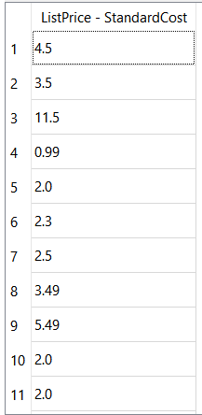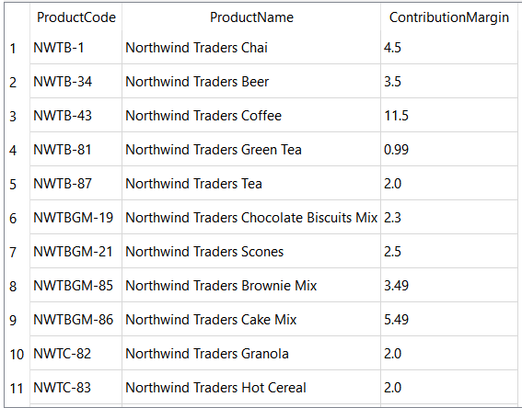

Figure 6: Contribution margins of products, computed using the SQL statement SELECT ListPrice - StandardCost FROM tblProducts; This output is from DB Browser.

SELECT ProductCode, ProductName, (ListPrice – StandardCost) AS ContributionMargin FROM tblProducts;

Running that statement produces output as shown in blue in the right of Figure 6. Notice that I used the AS keyword to rename the computed column.

Finally, we can use the SELECT statement to filter our query results by adding a WHERE clause. For example, if I want all products whose contribution margin exceeds $10.00 by executing this statement:

SELECT ProductCode, ProductName, (ListPrice – StandardCost) AS ContributionMargin

FROM tblProducts

WHERE ContributionMargin > 10.00;

**DELIVERABLE 7:**

**a. Write an SQL SELECT statement that retrieves all columns for all customers located in Washington state. Execute your statement and show the results in your Jupyter notebook. If you use DB Browser, you will have to copy and paste your results.**

**- Hint1: enclose text strings in either single or double quotes.**

**- Hint2: SELECT * FROM … will retrieve all columns.**

**b. Write an SQL SELECT statement that retrieves all columns for all customers located in either New York or Massachusetts. Execute your statement and show the results in your Jupyter notebook. If you use DB Browser, you will have to copy and paste your results.**

**- Hint: Check out the SQL IN operator.**

## Retrieving Data from Multiple Tables

Say your manager asks for a list of all orders over a certain time. You could simply run an SQL query to retrieve all orders from *tblOrders* in relevant timeframe, but the output would not be meaningful. Table orders has the following fields: *OrderID*, *CustomerID*, *OrderDate*, *ShipDate*. Without details of the orders (i.e. which products were ordered) and details of the customer (e.g. the customer name), output from *tblOrders* would simply be a list of numbers.

Your database has tables that store product, customer, and order information. In order to see all the rows in the orders table, but with product and customer names substituted for codes, you will need to retrieve and merge data from all three tables.

You could use an SQL query (specifically an INNER JOIN), but I’m going to have you use Python and Pandas to do the merge. This way, you will learn how to connect to and work with a database using Python. If you want more help on interacting with SQLite databases from Pandas, see [this webpage](https://www.dataquest.io/blog/python-pandas-databases/).

### Connecting to your database using Python and Pandas

The following code opens a connection to your database, reads all rows from a table into a Pandas DataFrame, and closes the connection. Let’s look at this code in more detail. The variable *conn* is a connection to your database file. The *sqlite3* package knows how to “talk” to database files and retrieve data from them. The conn variable handles all of that for you. The Pandas function *read_sql_query* uses *conn* to execute an SQL statement and retrieve the results as a DataFrame. Neat, huh? Note that you should always close your connections when you are done with them. If you don’t, some tables in the database might remain locked.

import pandas as pd

import sqlite3

conn = sqlite3.connect(‘c:\\users\\vanand\\desktop\\NWT.db’)

df = pd.read_sql_query(‘SELECT * FROM tblCustomers’, conn)

conn.close()

### Merging Data from Two DataFrames

You can use the above to retrieve data from multiple database tables into Pandas. Once you have done so, you can merge data using the function pd.merge. This function essentially performs an SQL join.

Let’s work through an example. Consider the data frames shown in Figure 7. The data frame on the left is a list of customers and their ZIP codes. The data frame on the right is a list of ZIP codes and their desirability. Say we want to merge the two data frames into one where each row shows the customer’s name, ZIP code, and desirability of that ZIP code.

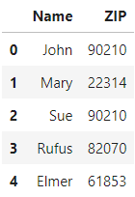 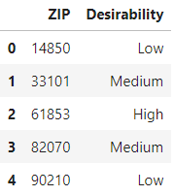

Figure 7: Sample data frames for use in merge example. Left data frame is dfLeft. Right data frame is dfRight.

The following code performs a merge, and the output is shown in Figure 8. The code works as follows. A Pandas merge (and an SQL join) require that you specify which data frame (or table) is the left one and which is the right. You have to specify the type of join, using the how argument, and the column(s) on which to merge.

pd.merge(left=dfLeft, right=dfRight, how='inner', on=['ZIP'])

Notice that Mary is missing from the output, as are the ZIP codes 14850 and 33101. That’s because we performed an inner join. It works as follows. It iterates over all rows of the left table. For each row of the right table, if the joined columns match, it merges the data from the left and right rows and puts them into the output. If there’s no match, the row from the left table is omitted from the output. Since Mary’s ZIP code, 22314, is not in the right table, Mary is not shown in the final output. Also, since none of our customers live in 14850 or 33101, those rows do not appear in the output.

Say we want to show all customers in the output, regardless of whether we have information on their ZIP code. We could use a left join (in the above code, use how='left'). It operates similarly to the inner join, but includes every row from the left table, even if there is no match in the right. Notice the output in Figure 8. Mary appears, but since there’s no matching ZIP code in the right table, there’s a NaN value in the desirability column.

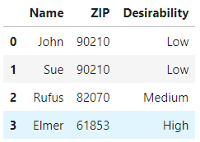 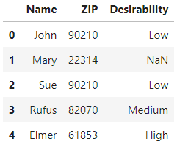

Figure 8: Sample merges. The left data frame used an inner join. The right data frame used a left join.

**DELIVERABLE 8: Creating a list of orders and their details.**

**In this deliverable, you will create a dataset containing one row per order per product ordered. For example, if customer A ordered 3 products yesterday, and customer B ordered 5 products the day before, your dataset will have 8 rows. Each row will show details of the product ordered, the customer name, price paid, etc.**

**You will perform this analysis in Python using Pandas. To do that, you need to first import the database tables *tblCustomers*, *tblOrderDetails*, *tblOrders3*, and *tblProducts* into Python as Pandas DataFrames.**

**a. Merge the DataFrames containing *tblOrders3* and *tblCustomers*. The resulting DataFrame should have one row per order, regardless of whether there’s a matching row in the customers table. The output columns in the merged DataFrame should be *OrderID*, *OrderDate*, *ShipDate*, *CustomerID*, *CustomerName*, and *ZIP*. In your Jupyter notebook, show the head of your merged DataFrame. Also tell me how many rows it has.**

**- Hint1: Use Pandas’ merge function.**

**- Hint2: Think about the column(s) you will use to perform the merge.**

**- Hint3: Make sure you use the correct type of join.**

**b. Merge the output from part (a) with *tblOrderDetails*. There are some orders in *tblOrders3* that do not have matching rows in *tblOrderDetails*. Omit those rows by choosing the proper join type. In your Jupyter notebook, show the head of your merged DataFrame. Also tell me how many rows it has.**

**c. There are 48 orders in *tblOrders3* and but 58 rows in tblOrderDetails. How many rows do you have in your output from part b? Why?**

**d. Merge the output from part (b) with the Products table using an inner join. The only columns you should retrieve from the Products table are *ProductCode*, *ProductName*,and *StandardCost*. In your Jupyter notebook, show the head of your merged DataFrame. Also tell me how many rows it has.**

## Putting it all together: Computing some accounting line items

The final deliverables are all queries that compute accounting numbers from transaction data.

**DELIVERABLES 9 – 12: Use the data frame you created in deliverable 8, part d to answer the following questions.**

**9. What is the company’s total revenue from orders in the database?**

**10. Compute revenue in each quarter of 2017. Assume revenue is recognized on the shipment date.**

**11. Assume the company had no variances, i.e. the actual cost equaled the standard cost for all products. Compute revenue and profit by product in 2017. Your output should be a data frame showing, for every product, the product code, product name, total revenue, and total profit. Sort the data frame in descending order by profit. Which product was most profitable?**

**12. Compute revenue and profit by customer in 2017. Which customer generated the most revenue?**

**Hint: When you import data from the database into Pandas, convert the dates to Pandas dates.**

# Submitting Your Deliverables

When you are done, you should have:

* An SQLite database file NWT.db.
  + It should have 6 tables (customers, order details, orders1, orders2, orders3, and products).
  + All of the tables should be populated with data.
  + All tables should have the correct structure (columns with proper names and data types, primary key set).
* A Jupyter notebook containing:
  + Code you wrote for the queries and the output.
  + Answers to qualitative questions above.

1. I thank The Deloitte Foundation for their generous financial support in preparation of this case.
2. Many modern databases store unstructured data, such as speech, video, and text. For simplicity, and for didactic purposes, this case assumes you are working with structured data.
3. Manufacturing companies issue part numbers and retailers issue SKU (stock keeping unit) numbers for their products. These numbers can be used as primary keys in their databases.
4. You may be wondering whether it was possible to create a blank database and an empty *tblProducts* using Python. The answer is yes, and the tutorial referenced above shows you how to do so. However, I chose to have you work with DB Browser so you can more easily visualize what is happening.
5. Note that this query’s output is not stored anywhere. This query does not create a table. The data is simply held in whatever program’s memory, such as DB Browser, and must be explicitly saved if you want to use it later.