Personal Details
Name  Gender  Date Of Birth  Place Of Birth Height  Marital Status Religion  Mother Tongue | Shakuntala Dirsam  Female  20-01-1998  Ghodadongri  5 feet 0 inches (152 cm)  Single  Hindu  Gondi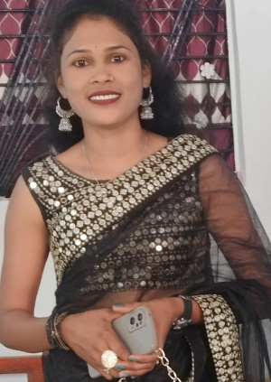
Highest Education | BA, MA History
Family Details
Father's Name Bhaiyalal
Mother's Name Meso
Total Brothers 02
Total Sisters 01
Contact Details
Address Village - Pipari, Post + Teh - Ghodadongri Dist
-Betul, Madhya Pradesh



