Physics-Aware Lightweight Segmentation for Quantitative Holographic Cell Analysis with Optical Mass Preservation
Usama Ikram¹, Youhyun Kim², and Inkyu Moon^{1,2,*}
^{1.} Department of Artificial Intelligence, DGIST, Daegu 42988, South Korea
^{2.} Department of Robotics & Mechatronics Engineering, DGIST, Daegu 42988, South Korea
*Corresponding author: inkyu.moon@dgist.ac.kr
Abstract
Digital holographic microscopy yields label-free phase images from which cellular dry mass can be derived, but segmentation networks trained with overlap losses do not constrain the phase integrated inside the predicted boundary. We propose a physics-aware lightweight segmentation framework in which phase-mask contrast, boundary-gradient alignment, and integrated-phase preservation terms, computed on background-referenced phase in radians, are added to a class-weighted Dice loss, and Low-Rank Adaptation (LoRA) adapts pretrained encoders to 32-bit phase maps of red blood cells. MobileNet-UNet, MobileSAM, and EdgeSAM were trained at five LoRA ranks with four loss configurations and three seeds (180 runs). EdgeSAM (r=32), the primary configuration, retained all four morphology classes in every seed (Dice 0.738 ± 0.006, integrated-phase error (IPE) 3.02 ± 0.84%); MobileSAM (r=8) reached a higher Dice (0.810 ± 0.006) with weaker instance separation; MobileNet-UNet lost the spherocyte class in every run with the full objective. The full objective lowered the IPE relative to Dice alone in 42 of 45 seed-paired comparisons, but the 95% intervals excluded zero in only 3 of 15 architecture–rank configurations. With merged rank-8 weights, the EdgeSAM forward pass took 4.11 ± 0.43 ms (ONNX Runtime, FP32). Over 47 days of storage, projected cell area decreased by about 44% in both the annotation and the predictions, whereas a decrease of dry mass was not statistically supported under date clustering. Predicted per-image dry mass agreed with the annotation within a median absolute relative error of 3.9 ± 0.5%, with weak correlation (r = 0.38 ± 0.14). Absolute dry mass was not independently validated, and no held-out test cohort was available.
Index Terms—Quantitative Digital Holographic Microscopy, Quantitative Phase Imaging, Physics-Aware Segmentation, Optical Mass Preservation, Lightweight Deep Learning.
- Introduction
Holography was introduced by Dennis Gabor in 1947 as a two-step process of recording and reconstructing an optical wavefront, which he called microscopy by reconstructed wavefronts [1] and for which he received the Nobel Prize in Physics in 1971 [2]. His in-line geometry gave reconstructions of limited quality because the virtual image, the conjugate real image, and the transmitted wave reach the observer together [2]. Leith and Upatnieks resolved this twin-image problem with the off-axis hologram, in which the object and reference waves reach the recording plane along directions separated by a finite angle and which, combined with laser illumination, extended holography to three-dimensional objects [2, 3].
Digital recording followed advances in electronic detection and computation. Goodman and Lawrence demonstrated digital image formation from electronically detected holograms in 1967 [4], and Schnars and Jueptner recorded holograms directly on a CCD target and reconstructed them numerically in 1994 [5]. In digital holography (DH), the photosensitive emulsion is replaced by a CCD or CMOS image sensor, the sampled interference pattern is stored as a digital hologram, and the object field is recovered by numerical propagation rather than by optical reconstruction [6, 7]. Because DH requires no imaging lens [8] and reconstructs both the amplitude and the phase of the object wave [9], it provides direct quantitative access to the optical field.
Applied to microscopy, DH is known as digital holographic microscopy (DHM) [9], which combines digital holography with optical microscopy to provide wide-field, label-free quantitative phase microscopy of transparent and semi-transparent specimens [10]. A DHM system consists of a light source, an interferometer containing a microscope objective, a digital image sensor, and a computer for hologram storage and processing [6], and the approach has been applied to biological specimens since early in-line implementations [11, 12]. Because a single hologram contains information describing the microscopic volume, numerical reconstruction permits refocusing at different depths, which makes the technique non-destructive and well suited to living cells [13, 14].
Quantitative phase imaging (QPI) uses the refractive index of the specimen as an endogenous imaging contrast and represents the measured data as quantitative maps of the optical path length delay introduced by the sample [15, 16, 17]. Operating on unlabelled specimens, it avoids photobleaching and exhibits lower phototoxicity than fluorescence microscopy [15, 18]. The phase measured at each pixel is the integral of the refractive index difference between the cell and its surrounding medium through the cell thickness, and refractive index is related to mass through the specific refractive increment, whose typical average value for cells is 0.18 to 0.20 mL/g [19]. The measured phase is therefore proportional to the cellular content excluding water, the cellular dry mass [15, 19], a relationship in use since the 1950s for label-free measurement of cell growth [19, 20, 21]. Because dry mass is obtained by integrating the phase over the cellular region, the boundary that defines this region determines the accuracy of the measurement.
This is particularly valuable in hematological analysis, where red blood cell (RBC) morphology reports on cellular integrity during storage [22]. In stored blood, healthy discocytes are progressively transformed into echinocytes and then into spherocytes, a process termed the RBC storage lesion [23, 24], accompanied by a loss of cell surface area and surface-to-volume ratio [25] and by weakened deformability [23]. Over a 42-day storage period the proportion of discocytes decreases while that of echinocytes and spherocytes increases [24], so the morphology distribution is used to evaluate the quality of stored blood [23]. DHM has quantified three-dimensional geometric and chemical changes of single RBCs during the storage lesion [25], and deep learning has been combined with label-free DHM to assess storage lesions automatically, for which reliable segmentation of individual cells is a prerequisite [26].
Segmentation is regarded as mandatory for the quantitative analysis of QPI data [27]. Conventional image-processing pipelines are affected by background phase variations, holographic artifacts, and weak phase transitions near adjacent cells, and they require several processing stages and careful parameter adjustment to extract a single cell [26]; the Empirical Gradient Threshold method, distance-transform processing, and marker-controlled watershed segmentation have been used for this purpose [28, 29, 30]. Learning-based methods delineate complex boundaries more flexibly, with U-Net style encoder-decoder networks as established baselines [27], and AI-assisted segmentation supports automated tasks such as cell counting and biophysical parameter quantification [16].
Lightweight segmentation models are attractive for quantitative biomedical imaging because they reduce inference latency and memory requirements while retaining the spatial resolution needed for accurate boundary localization [31]. MobileNet-UNet replaces a heavyweight encoder with a MobileNetV2 backbone, using depthwise separable convolutions and inverted residual bottlenecks [32]. Among foundation models, MobileSAM replaces the image encoder of the Segment Anything Model (SAM) with TinyViT by decoupled distillation while retaining the mask decoder [33], and EdgeSAM distils SAM into a RepViT architecture with a prompt-in-the-loop strategy that preserves prompt-to-mask interactions [34].
Because full-network adaptation of large, pre-trained models is computationally expensive and prone to overfitting on limited biomedical data, parameter-efficient fine-tuning updates only a small task-specific subset of parameters, through approaches such as BitFit, structural adapters, and Visual Prompt Tuning [35]. Low-Rank Adaptation (LoRA) adds trainable low-rank decomposition matrices to selected modules, adapting the model while largely preserving the pre-trained representation [36].
Despite these advances, an important limitation remains. Cross-Entropy and Dice, the standard objectives for biomedical segmentation [27], optimize spatial classification or geometric overlap and place no explicit constraint on the quantitative phase enclosed by the predicted cell boundary [37]. In QPI, however, that boundary is not only a geometric contour but the measurement domain over which the phase is integrated, so a prediction can achieve high geometric overlap while still introducing an error in the integrated phase that propagates into phase-derived quantities such as cellular dry mass [37]. This distinction between a geometric segmentation boundary and a quantitative measurement boundary motivates objectives that explicitly preserve the phase-integrated optical information enclosed by the predicted region, a requirement referred to here as optical-mass preservation.
A second limitation concerns domain adaptation and computational cost. Lightweight and foundation vision models are pretrained on natural RGB datasets [38], whereas quantitative phase images are single-channel distributions whose values represent optical phase rather than color and reflectance [39], so direct transfer can be suboptimal, while unrestricted full fine-tuning on small and imbalanced datasets risks overfitting and the degradation of minority morphological classes. Large models such as the original SAM also impose computational and memory requirements that limit their use in resource-constrained environments [33, 40, 41, 42], and deep learning applied to holographic data, although much faster than iterative reconstruction, requires substantial computational resources and training data [43].
This work addresses these limitations with a physics-aware lightweight segmentation framework. We introduce a Physics-Aware Phase Consistency Loss that incorporates quantitative phase information into the segmentation objective through three complementary constraints: Phase-Mask Contrast (PMC), a global constraint on foreground localization based on cell-to-background phase contrast; Boundary-Gradient Alignment (BGA), which encourages predicted boundaries to follow spatial phase transitions; and Integrated-Phase Preservation (IPP), which explicitly constrains the quantitative phase integrated within the predicted cellular region. The objective is evaluated on the background-referenced phase in radians rather than on the standardized network input, so that the preserved physical quantity is not altered by input normalization. LoRA then adapts lightweight models pretrained on natural images to the holographic phase domain with most parameters frozen, which also regularizes training on a small, imbalanced dataset.
Three representative lightweight architectures, MobileNet-UNet [32], MobileSAM [33], and EdgeSAM [34], are evaluated on quantitative phase images of red blood cells recorded over a 47-day storage period. Each architecture is trained at five LoRA ranks with four loss configurations and three training seeds, so that segmentation accuracy, integrated-phase preservation, training stability, and computational efficiency can be compared across convolutional, transformer-based, and hybrid designs, and the predicted boundaries are then used for phase-derived measurements across the storage period.
- Method
  - Overall Framework
The proposed framework treats the predicted cell boundary as a quantitative measurement domain rather than as a purely geometric contour. As illustrated in Fig. 1, the pipeline consists of four main stages: standardization of the quantitative phase maps, segmentation by a LoRA-adapted lightweight network, optimization with the Physics-Aware Phase Consistency Loss, and extraction of phase-derived cellular measurements.
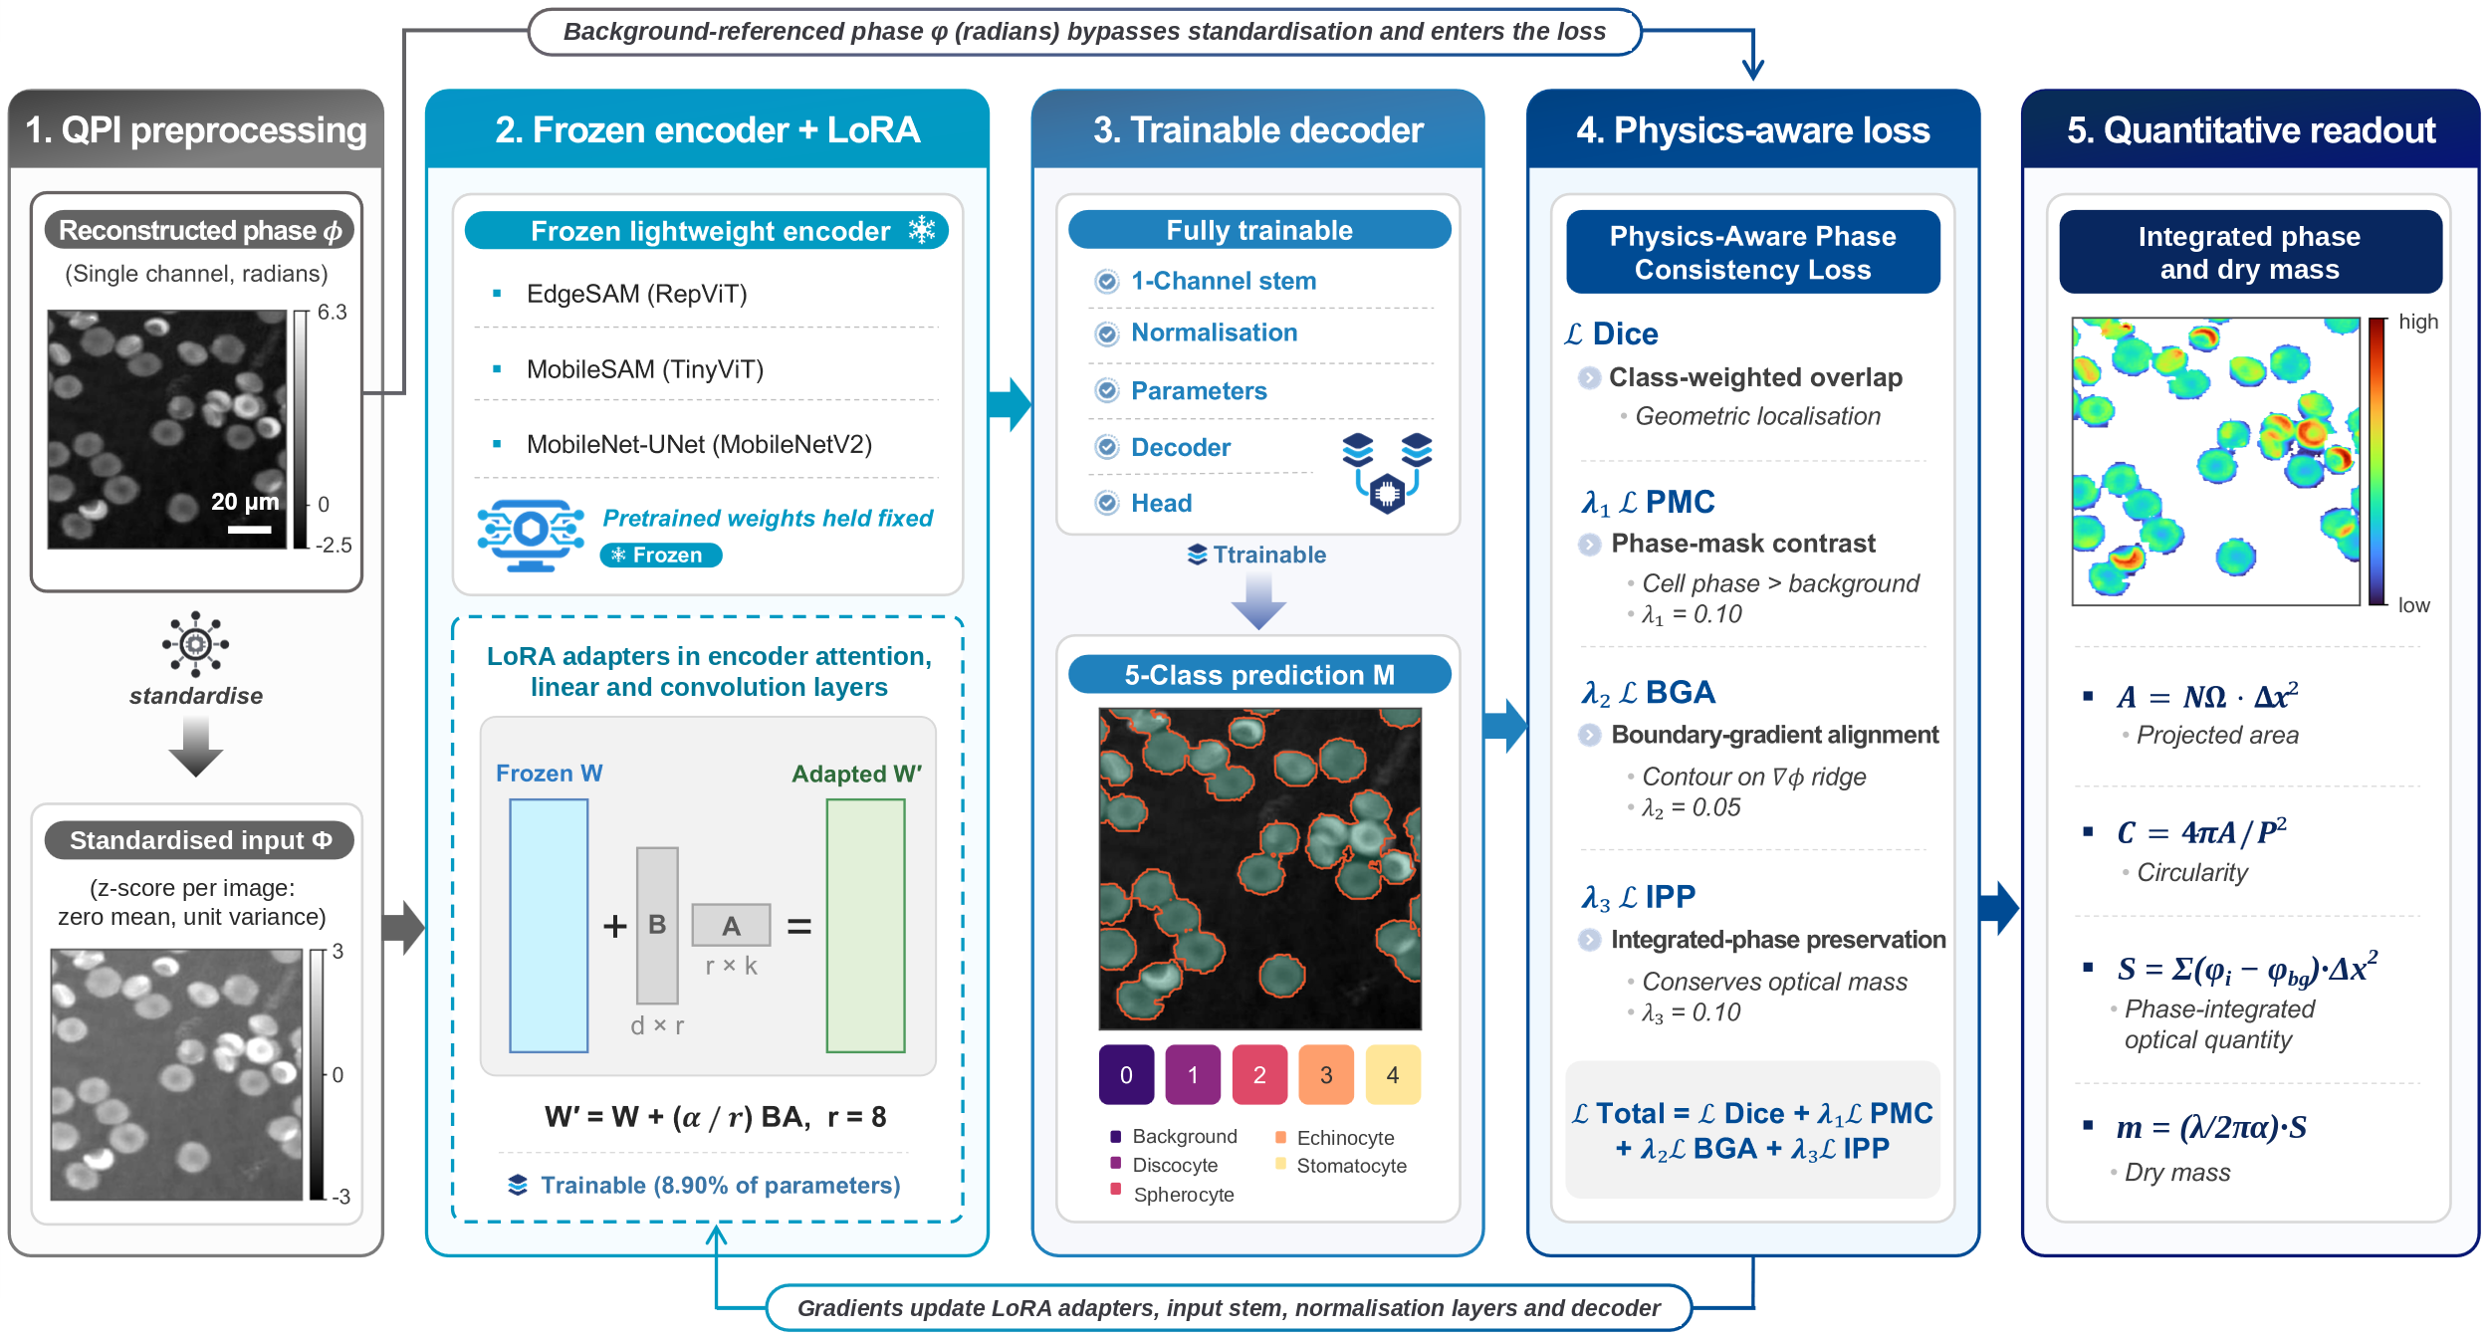
Fig. 1 Overview of the physics-aware lightweight segmentation framework. A LoRA-adapted encoder and a trainable decoder segment the standardized phase map into five classes; the PMC, BGA, and IPP terms act on the background-referenced phase in radians; the predicted masks are the measurement domains for projected area, circularity, integrated phase, and dry mass.
  - QPI Preprocessing
The input data are single-channel quantitative phase maps stored as 32-bit floating-point arrays in radians on a 768 × 768 pixel grid. They are used directly, without conversion to an 8-bit grey-level representation, and the original 768 × 768 maps are not resized or cropped when the dataset is prepared. The maps represent the quantitative phase delay associated with the optical path difference introduced by the cells. Because the measured phase depends jointly on refractive-index contrast and specimen thickness, it is treated as an optical phase quantity rather than as a direct measurement of geometric cell thickness or volume.
No phase unwrapping is applied to the maps. The 103 maps identified by an acquisition date in their file names (all 66 validation maps and 37 training maps) are confined to approximately [0, 2π), so cells whose phase exceeds this range appear wrapped. No reliable unwrapped version of these maps is available, and an automatic unwrapping attempt was not reliable enough to use. Wrapping is therefore handled in the quantitative phase analysis. A cell is flagged if, within 2 px of it, the phase lies within 0.3 rad of the 2π limit or two neighbouring pixels differ by more than π. Flagged cells are omitted from the wrapping-excluded variants of the per-cell quantitative phase and dry-mass results (Section 2.6). Segmentation training, segmentation metrics, and the global integrated-phase error include flagged cells.
The ground-truth semantic masks were drawn on 8-bit exports of the phase maps. They were transferred to the 768 × 768 grid of the phase maps by affine registration (scale and translation, estimated by enhanced correlation coefficient maximization) followed by nearest-neighbour resampling, so the registration acts on the masks and not on the phase maps. Pixels of the grid outside the annotated field of view (14% of the grid on average) receive an ignore label and are excluded from every loss term and every metric. The masks contain five classes, identified by mask value: background (0), discocyte (1), spherocyte (2), echinocyte (3), and stomatocyte (4).
The maps do not share a common zero level. For each image, the median phase of annotated background pixels lying more than 5 px from any cell was therefore subtracted once when the dataset was built, so that all maps are referenced to their own background. The subtracted offsets ranged from 0.66 to 2.50 rad for the 103 date-named maps and from −0.24 to −0.02 rad for the remaining 145 training maps. The resulting background-referenced phase is kept in radians and, at the resolution of the network input, is the quantity used in the physics-aware loss. At evaluation, the integrated-phase error is computed from it on the original 768 × 768 grid. The dry-mass calculation additionally uses a per-image background estimate taken from the non-cellular region of the analysed mask (Section 2.6). Whether the zero level of the delivered phase maps carries physical information or is an arbitrary baseline could not be established from the available records, and no calibration record is available.
The network input is formed separately from the same background-referenced phase. The map is resized by bilinear interpolation to the input size of each architecture (256 px for EdgeSAM and MobileNet-UNet, 1024 px for MobileSAM) and then standardized to zero mean and unit variance per image; masks are resized by nearest-neighbour interpolation. This standardization applies only to the network input and does not enter the physics-aware terms, which are evaluated in single precision on the resized background-referenced phase in radians, outside mixed-precision autocast. Segmentation metrics and phase measurements are evaluated on the original 768 × 768 grid, to which the network predictions are upsampled.
Data augmentation is restricted to transformations that preserve the quantitative phase values and cellular morphology exactly. Each training image is used in four orientations: the original and its three lossless 90° rotations. Of the 256 base training images, 182 have floating-point phase maps, which gives 728 training views; the remaining 74 are not used because their floating-point maps are unavailable. All 66 validation images have floating-point maps and are not rotated. Flipping, translation, cropping, intensity perturbations, nonlinear contrast transformations, and phase-value modifications are not applied, because they could alter the quantitative optical information that the proposed framework is designed to preserve.
  - Lightweight Segmentation Models
Three lightweight architectures are evaluated: a convolutional encoder-decoder (MobileNet-UNet) and two models built on the lightweight image encoders of the Segment Anything family (MobileSAM and EdgeSAM). All three take a single-channel phase map and output logits for the five mask classes. Their encoders are initialized from pretrained weights, with the three-channel input stem replaced by a single-channel convolution whose filters are the average of the pretrained RGB filters. The decoders are initialized randomly and trained on the phase data.
MobileNet-UNet pairs an ImageNet-pretrained MobileNetV2 encoder with a U-Net-style decoder of four blocks, each consisting of a transposed convolution, concatenation with the skip connection from the encoder stage of matching resolution, and a convolution with batch normalization and a ReLU6 activation, followed by a final upsampling and a 1 × 1 classifier. The skip connections retain the fine spatial information required for accurate cellular boundary delineation [32].
MobileSAM and EdgeSAM replace the heavyweight ViT-H encoder of the original SAM with a distilled TinyViT backbone (MobileSAM) and a RepViT-M1 backbone (EdgeSAM) [33, 34]. Neither model uses the prompt encoder or the mask decoder of the original SAM. In EdgeSAM, the 256-channel encoder output is decoded by four transposed-convolution stages, each with batch normalization and a ReLU6 activation, and a 1 × 1 classifier. In MobileSAM, a single transformer decoder layer, in which one learned token per class attends to the encoder features, produces the class logits as the product of each class token and the bilinearly upsampled feature map; a single learned embedding stands in for the prompt. In both models the logits are bilinearly resized to the input size. The TinyViT encoder of MobileSAM operates at 1024 × 1024 pixels, whereas EdgeSAM and MobileNet-UNet operate at 256 × 256 pixels. EdgeSAM is evaluated as a computationally efficient architecture rather than as evidence of embedded deployment. The three networks therefore differ in encoder, decoder, and input size, and also in learning rate and batch size (Section 3.2), so differences between them in the Results cannot be attributed to the encoder alone.
  - LoRA-Based Lightweight Adaptation
LoRA is employed to adapt pretrained lightweight segmentation networks to the distinct statistical and structural characteristics of holographic phase images. For a pretrained weight matrix W, the adapted weight is expressed as:
$W'=W+(B⋅A)×\frac{α}{r}$ , (1)
where W is the frozen pretrained weight matrix, B and A are trainable low-rank matrices, r is the rank of the low-dimensional adaptation space, and α is a scaling factor. To evaluate the balance between adaptation capacity and parameter efficiency, LoRA rank-sweep experiments are performed using the ranks specified in the experimental protocol.
LoRA modules are inserted into the encoders only; all remaining pretrained weights are frozen. In EdgeSAM, modules are inserted into every linear layer and every non-grouped convolution of the RepViT encoder. In MobileSAM, they are inserted into the fused query-key-value projection of every attention block of the TinyViT encoder. In MobileNet-UNet, they are inserted into every non-depthwise convolution of the MobileNetV2 encoder. For convolutional layers, the low-rank update is implemented as a 1 × 1 convolution to r channels followed by a convolution with the original kernel size. The scaling factor is set to α = r, so the update has unit scale at every rank; A is initialized with a Kaiming scheme and B with zeros, so training starts from the pretrained function; and LoRA dropout is zero. To address the structural domain shift from three-channel natural images to single-channel quantitative phase maps, the single-channel input stem is trainable: directly in MobileSAM, and through its low-rank update in EdgeSAM and MobileNet-UNet, where the pretrained stem kernel itself stays frozen. The scale and shift parameters of all normalization layers and the complete segmentation decoder with its final projection head (including, for MobileSAM, the learned prompt embedding and class tokens) also remain trainable. Because the decoders are trained in full, the fraction of trainable parameters differs among architectures. At rank 8 the numbers of trainable parameters are 534,205 of 6,004,333 (8.9%) for EdgeSAM, 673,184 of 6,719,932 (10.0%) for MobileSAM, and 5,584,173 of 7,773,357 (71.8%) for MobileNet-UNet; the counts for all ranks are given in Table S-1. After training, the low-rank updates are merged into the base weights, so the deployed network has the same structure and inference cost for every rank.
  - Physics-Aware Phase Consistency Loss
Conventional segmentation objectives optimize geometric agreement between predicted and annotated masks but do not explicitly constrain the quantitative phase signal enclosed by the predicted boundary. In QPI, however, the predicted mask defines the spatial domain over which phase information is integrated for subsequent biophysical analysis. We therefore introduce a Physics-Aware Phase Consistency Loss that combines geometric segmentation with constraints derived directly from the quantitative phase distribution.
    - Multi-Class Dice Loss
To mitigate class imbalance among rare morphology degradation types (e.g., stomatocytes), the baseline biological segmentation loss is defined as a class-weighted, smoothed Multi-Class Dice Loss:
$L_{Dice}=\frac{1}{\sum_{c=0}^{4}{w_{c}}}\sum_{c=0}^{4}{w_{c}}\left(1-\frac{2|P_{c}∩G_{c}|+1}{|P_{c}|+|G_{c}|+1}\right)$, (2)
where $w_{c}∈\{0.5,1.0,1.5,2.0,2.0\}$ correspond to the background and the four morphology classes, respectively. A Laplace smoothing factor of $+1$ prevents zero division on background-only patches. The Dice term is computed from the softmax probabilities over annotated pixels, per image, and averaged over the images of a batch. All loss terms are evaluated in single precision, outside the mixed-precision autocast used for the network forward pass.
    - Phase-Mask Contrast Term
To ensure the predicted cell region physically maintains higher phase values than the surrounding medium, the contrast term penalizes predictions where the mean background phase exceeds the mean cell phase by a predefined margin:
$L_{PMC}=\text{max}(0,μ_{bg}-μ_{cell}+\text{margin})$, (3)
where $μ_{cell}$ and $μ_{bg}$ denote the mean background-referenced phase (in radians) over annotated pixels, weighted by the predicted foreground probability and by one minus that probability, respectively; the margin is 0.1 rad. This term provides a global physical constraint on foreground localization but does not by itself guarantee accurate cellular boundaries.
    - Boundary-Gradient Alignment Term
Because probabilistic network outputs $[0,1]$ and physical phase measurements exist on fundamentally incompatible scales, spatial gradient magnitudes for both the predicted mask ($∇M$) and the background-referenced phase map ($∇Φ$) are first max-normalized per-sample to a $[0,1]$ scale. The segmentation boundary is then structurally aligned with strong phase gradients via an $L_{1}$ penalty, implemented as the mean absolute difference over annotated pixels (gradients are forward differences, a one-pixel rim next to unannotated pixels is excluded, and $ε={10}^{-8}$.
$L_{BGA}={∥\frac{∇M}{\text{max}(∇M)+ϵ}-\frac{∇Φ}{\text{max}(∇Φ)+ϵ}∥}_{1}$. (4)
This term geometrically anchors the predicted measurement boundary to phase transitions present in the measured QPI data.
    - Integrated-Phase Preservation Term
The key quantitative constraint of the proposed framework is preservation of the phase signal integrated over the segmented cellular domain. For a background-referenced quantitative phase map φ_{i}, predicted foreground probability M_{i}, and ground-truth foreground mask G_{i}, the predicted and reference integrated phase quantities are $S_{pred}=\sum_{i}{M_{i}{}_{i}},$ $S_{GT}=\sum_{i}{G_{i}{}_{i}}$. The IPP loss is then defined as the ground-truth-normalized relative error:
$L_{IPP}=\frac{\left|S_{pred}-S_{GT}\right|}{\left|S_{GT}\right|+ϵ}.$ (5)
Here $ε={10}^{-4}$ and the sums run over annotated pixels. The relative formulation makes the penalty insensitive to the absolute scale of the phase integral. The physics-aware terms are averaged over the images of a batch that contain annotated cells. The IPP term directly constrains the integrated phase quantity used in subsequent optical-mass analysis. Under the conventional specific refractive increment assumption, this quantity is proportional to cellular dry mass; therefore, preserving the integrated phase during segmentation is intended to support reliable downstream dry-mass estimation.
    - Final Loss Function
The final objective combines the biological segmentation task with the three physics-aware constraints:
$L_{total}=L_{Dice}+λ_{1}L_{PMC}+λ_{2}L_{BGA}+λ_{3}L_{IPP}$ , (6)
where $λ_{1}$, $λ_{2}$, and $λ_{3}$ control the relative contributions of the PMC, BGA, and IPP terms, respectively. All physics-aware terms are evaluated using the binary cellular foreground probability rather than individual morphology classes. This separates the morphological classification objective from the physical requirement that the total cellular measurement domain be accurately preserved. PMC is intended to provide coarse phase-based foreground localization, BGA to anchor the predicted boundary to phase transitions, and IPP to preserve the integrated quantitative phase.
  - Quantitative Phase-Derived Cellular Measurements
The principal purpose of the proposed physics-aware segmentation is to enable reliable quantitative cellular measurements from the predicted mask. For each connected cellular component, we therefore extract projected area, circularity, integrated phase, and dry mass. The projected area is calculated as:
$A=N_{Ω} Δx_{\text{eff}}^{2}$ , (7)
where N_{Ω} is the number of pixels in Ω , and Δx_{eff} is the effective object-plane pixel pitch, defined as the camera pixel pitch divided by the system magnification. For the imaging system used in this study, Δx_{eff} = 0.1441 μm/px, and the projected area is therefore expressed in μm². Cell circularity is defined as:
$C=\frac{4πA}{P^{2}}$ , (8)
where P denotes the perimeter of the segmented component. Circularity characterizes the two-dimensional projected outline of a cell, while complementary phase information reflects variations in the cell’s optical thickness profile. The central optical quantity used in this study is the integrated phase over the segmented cellular domain, relative to the local background:
S=i∈Ω​i-bg Δxeff2 , (9)
Here, S_{φ} represents the area-integrated quantitative phase associated with the cell, incorporating the coupled contributions of refractive-index contrast and optical thickness. The background level ${}_{bg}$ is the median phase of the non-cellular pixels of the analysed mask (annotated or predicted) that lie more than 5 px from any cell. It serves as the primary phase-derived optical quantity whose preservation is explicitly enforced by the IPP loss. Under the conventional assumption that cellular refractive-index increment is approximately proportional to dry-mass concentration, cellular dry mass can be estimated from the integrated phase as:
$m=\frac{λ}{2πα}S_{}$ , (10)
where λ is the illumination wavelength and α is the specific refractive increment of cellular solids. In this study, λ = 666 nm and α = 0.2 mL/g were used, with the latter corresponding to the specific refractive increment for haemoglobin-dominated RBCs. With $Δx_{\text{eff}}$ = 0.1441 $μ$m, one radian per pixel corresponds to 0.0110 pg. The dry-mass values are phase-derived estimates computed from these physical constants alone; no calibration to a reference mean corpuscular haemoglobin (MCH) value is applied, and the estimates were not validated against an independent measurement of cell mass. Because the zero level of the delivered maps could not be established independently (Section 2.2), dry mass is referenced to the background of each analysed mask, and absolute values in pg should be read with this limitation. The background level is estimated separately for the annotated and for the predicted mask, so the comparison of predicted with annotation-derived dry mass includes the effect of this estimate. Equations (9) and (10) establish the physical motivation for optical-mass preservation in the proposed segmentation framework: errors in the predicted measurement boundary alter the integrated phase and therefore propagate directly into dry-mass estimates. The proposed loss consequently optimizes segmentation not only for geometric agreement but also for preservation of the phase-integrated information required for quantitative biophysical analysis.
Per-cell measurements are obtained from 4-connected components of the class-agnostic foreground (annotated or predicted) on the native 768 × 768 grid, and each component is assigned the class that covers most of its pixels. Components with a projected area outside 15–200 $μ$m², and components that touch an unannotated region, are excluded, which removes isolated pixel artifacts, cells cut by the annotated field, and large multi-cell clusters. The same filter is applied to the annotation and to the prediction. No instance separation is applied, so touching cells in a prediction merge into one component; the number of predicted components is therefore not a cell count. The perimeter is calculated with the Crofton estimator, which reduces sensitivity to pixelation. Cells flagged as phase-wrapped (Section 2.2) are excluded from the composition, agreement, and storage-trend analyses (Figs. 7 and 8, Table 5, and Tables S-4 to S-6); the component-fate analysis of Fig. S-6 includes them. The segmentation loss and the global integrated-phase error use the background-referenced phase of Section 2.2. The per-cell integrated-phase error of Section 3.3.2 additionally subtracts a least-squares background plane.
- Experiments
  - Dataset and Imaging Configuration
The experimental evaluation was designed to assess three core aspects of the proposed framework: (1) multi-class segmentation accuracy across different RBC morphologies, (2) preservation of quantitative phase information and optical-mass-related measurements, and (3) computational efficiency of the lightweight segmentation architectures. The framework was evaluated using a dataset of single-channel quantitative phase images acquired with a DHM system during long-term blood storage experiments [26, 44]. Blood samples (2 mL each) were collected from three healthy donors under a protocol approved by the Institutional Review Board of DGIST (Approval No. DGIST-180713-BR-012-01), with the same samples imaged repeatedly over the storage period. The quantitative phase maps were numerically reconstructed from off-axis holograms and represent the phase delay associated with the optical path difference introduced by the RBCs. The annotated dataset consists of 322 images with five-class masks (256 training and 66 validation images), of which 248 have floating-point phase maps and are used in this study: 182 training and 66 validation images (Section 2.2). The 66 validation images contain six images at each of eleven storage time points over 47 days (days 0, 5, 8, 12, 15, 19, 23, 27, 30, 37, and 47). Of the 182 training images, 37 carry a storage-day label (days 5 to 47) and 145 do not. The ground-truth semantic masks contain five classes: background, discocyte, spherocyte, echinocyte, and stomatocyte. Cells were manually annotated and classified by an expert biologist using representative example morphologies as classification criteria, and the cells were segmented into multi-label masks. Laterally touching cells and multi-cell clusters are most evident at day 15, where the foreground occupies about half of the annotated field (mean fraction 0.48 of the annotated pixels in the six day-15 images, range 0.40 to 0.54); they are discussed in Section 4.8. With the three lossless rotations of each training image, the training set comprises 728 views; the validation images are not rotated.
Holograms were recorded with an off-axis transmission digital holographic microscope based on a Mach-Zehnder interferometer [26, 44], as shown in Fig. 2. The light source was a 666 nm laser diode, and the effective pixel size at the sample is 0.1441 µm. The object wave was reconstructed numerically: the +1 diffraction order was isolated by spatial filtering in the Fourier domain to remove the zero order and twin image, and the phase was recovered using a Fresnel-approximation numerical diffraction calculation. The resulting phase maps are provided as 768 × 768 floating-point arrays in radians (Section 2.2). Phase unwrapping is not applied; the treatment of phase wrapping is described in Section 2.2.
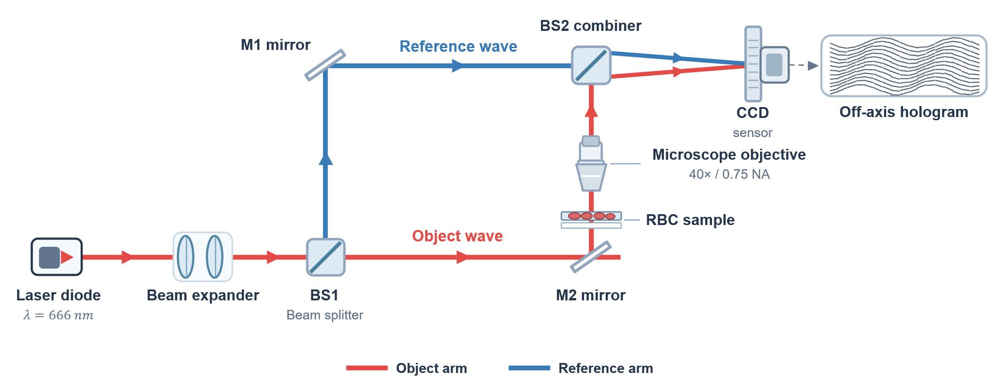
Fig. 2 Schematic of the off-axis transmission Mach-Zehnder DHM setup used to acquire the RBC dataset. BS1/BS2, beam splitters; M1/M2, mirrors. Schematic redrawn for this manuscript; not to scale.
  - Training Configuration
All networks were optimized with AdamW and a cosine-annealing learning-rate schedule over 50 epochs, without warm-up or gradient clipping. The forward pass used mixed-precision (FP16) autocast to reduce memory consumption, whereas the loss terms were evaluated in single precision (Section 2.5). Training images were presented in shuffled order with the rotation augmentation of Section 2.2. No class-balanced sampling was used; class imbalance among the morphology classes was addressed only by the class weights of the Multi-Class Dice Loss (Section 2.5.1).
The architectures were trained with their own settings, which were not harmonized: the learning rate was 5 × 10⁻⁴ for EdgeSAM and MobileSAM and 1 × 10⁻³ for MobileNet-UNet; the batch size was 16, 8, and 16; and the input size was 256, 1024, and 256 pixels for EdgeSAM, MobileSAM, and MobileNet-UNet, respectively. The checkpoint after the last epoch was used for every reported segmentation result. LoRA rank-sweep experiments were conducted using r ∈ {2, 4, 8, 16, 32}. The rank sweep and the comparison of loss configurations were each trained with three random seeds (42, 43, and 44), and results are given as mean ± standard deviation over the seeds. Full fine-tuning was run for a single seed (42) with the same learning rate as the LoRA runs of the same architecture. All configurations were evaluated on the same 66-image validation split. In total, 180 LoRA runs (three architectures × five ranks × four loss configurations × three seeds) and 3 full fine-tuning runs were trained.
  - Evaluation Metrics
The proposed framework was evaluated using three complementary categories of metrics: segmentation performance, quantitative phase preservation, and computational efficiency.
    - Segmentation Performance
Spatial agreement between predicted and ground-truth masks was evaluated using the Dice coefficient and Intersection-over-Union (IoU). Both metrics were macro-averaged exclusively over the four foreground RBC morphology classes. A morphology class that was not predicted by the model was assigned a score of zero rather than being excluded from the average. This evaluation strategy prevents the dominant background class from inflating the aggregate performance and enables failures in minority morphology classes to be directly reflected in the reported scores. To additionally evaluate instance-level separation in densely distributed cellular regions, the Aggregated Jaccard Index (AJI) was calculated. Dice and IoU were pooled over all validation images for each class before averaging over the four foreground classes. For AJI, instances are the connected components of the binary foreground, pooled over images. A class is considered lost in a run if its Dice is below 0.05; the number of such runs is reported with the results.
    - Quantitative Phase Preservation
The physical fidelity of the predicted measurement boundaries was evaluated using the IPE. This metric quantifies the relative difference between the phase-integrated optical quantities obtained from the predicted and ground-truth cellular regions, consistent with the integrated-phase definition in Eq. (9). For a predicted integrated phase S_{pred} and the corresponding ground-truth value S_{GT}, IPE is defined as
$IPE(\%)=\frac{\left|S_{pred}-S_{GT}\right|}{\left|S_{GT}\right|+ϵ}100.$ (11)
IPE was evaluated both globally and for individual RBC morphology classes, on the original 768 × 768 grid, using the background-referenced phase of Section 2.2. The class of each pixel is the arg-max of the upsampled logits, so the evaluation uses a hard mask, whereas the loss uses the soft foreground probability. For each image, $S_{pred}$ and $S_{GT}$ are accumulated by summing the phase over all annotated pixels of the relevant region (the full foreground for the global formulation, or the corresponding class mask for the class-specific IPE), and Eq. (11) is evaluated per image; the reported global IPE is the mean of these per-image values, and the class-specific IPE is the mean over the images that contain that class. Because Eq. (11) operates on $\left|S_{pred}-S_{GT}\right|$, IPE is an absolute (unsigned) error, so over- and under-estimation in different images cannot cancel in the reported mean; within one image, however, the phase is summed over all cells before the absolute value is taken, which is why a per-cell IPE is also reported. A morphology class with zero detections gives $S_{pred}$= 0 and therefore an IPE of exactly 100%, which is how the complete-detection-failure cases of Section 4.4 enter the average.
In addition to the global formulation in Eq. (11), a per-cell IPE was computed on the connected components defined in Section 2.6 (projected area 15 to 200 µm²). Each ground-truth cell was matched one-to-one with a predicted cell by greedy assignment at IoU ≥ 0.5, and the relative phase-integral error was evaluated for each matched cell after subtracting a least-squares background plane from the phase. The per-cell IPE therefore refers to plane-corrected phase and is a different quantity from the global IPE, which uses the median-referenced phase. Unmatched ground-truth cells are counted as missed and are excluded from the error statistics. Per-cell results are reported in Section 4.4 without the cells flagged as phase-wrapped (61 of 2049 annotated cells, 3.0%; Section 2.2). A lower IPE indicates that the predicted segmentation boundary more accurately preserves the phase-integrated optical information associated with the cell and therefore provides a more reliable measurement domain for subsequent optical-mass and dry-mass analysis. Boundary accuracy was additionally evaluated using the boundary F1-score with a 2-pixel tolerance. The globally pooled boundary F1-score quantifies the spatial agreement between predicted and annotated cellular contours and complements IPE by evaluating geometric boundary fidelity independently of the integrated phase quantity. Together, boundary F1 and IPE provide complementary measures of geometric boundary accuracy and optical-mass preservation, respectively.
    - Computational Efficiency
Computational efficiency was characterized using median forward-pass latency, tail latency, throughput in frames per second (FPS), trainable parameter count, and GPU-memory footprint. These metrics were used to quantify the computational requirements of each lightweight architecture on a desktop-class GPU.
  - Computational Benchmarking Protocol
Computational benchmarking was performed on an NVIDIA RTX A5000 GPU with strict FP32 arithmetic (TensorFloat-32 disabled) to characterize the relative inference efficiency of the evaluated lightweight architectures. Profiling was conducted independently of training to avoid interference from training-related overhead. Each model was run at batch size 1 on 16 validation phase maps that were cycled through on the GPU. For PyTorch, 50 unrecorded warm-up iterations were followed by 500 individually timed, synchronized forward passes per timing pass. For ONNX Runtime, this procedure (50 warm-up and 500 timed forward passes) was applied to each of three fresh sessions per timing pass, giving 150 warm-up and 1500 timed forward passes per model and pass. Each architecture was run in native PyTorch and through static-graph execution in ONNX Runtime (ORT) with the CUDA Execution Provider; all three architectures, MobileSAM included, were exported to ONNX. ORT inputs and outputs were bound to the GPU (IO binding). Timing covers the model forward pass only, using inputs that have already been resized and z-scored and are resident on the GPU. Image loading, resizing, z-scoring, input-to-GPU transfer, and post-processing of output logits are excluded. Network input sizes are 256 × 256 px for EdgeSAM and MobileNet-UNet and 1024 × 1024 px for MobileSAM.
The benchmark uses the rank-8 LoRA models of seed 42 with the low-rank updates merged into the base weights. After the merge, the LoRA matrices are deleted from the merged modules, and only rank 8 was timed. The weights are the best-validation checkpoints stored for these runs (epoch 50 for EdgeSAM, 38 for MobileSAM, and 34 for MobileNet-UNet), whereas the segmentation results elsewhere use the last-epoch checkpoints; the weight values are not expected to affect latency. Timing was repeated in three separate processes (timing passes), with the architecture order rotated between passes and fresh ONNX Runtime sessions, and a new ONNX export, created for each pass. Each pass used 16 validation phase maps selected according to its sampling seed (42, 43, and 44); these are timing-pass sampling seeds, not training seeds. For ONNX Runtime, the timed runs from the three fresh sessions were pooled within each timing pass before percentiles were calculated. These were repeated inference measurements of the same trained checkpoints, not independent training runs. Between passes, the sampled validation maps and the architecture order differed, and the ONNX export and sessions were recreated; the reported variation includes these sources together with run-to-run measurement variability and does not capture training variability. P50 and P99 are reported as mean ± sample standard deviation (n − 1) across the three timing passes, FPS (1000/P50 of each pass) as the range of the three per-pass values, and the GPU-memory footprint as the maximum of the per-pass measurements. GPU-memory footprint was obtained as the baseline-subtracted device-level used memory (torch.cuda.mem_get_info) read after the timed loop (once for PyTorch, and once per session for ONNX Runtime), relative to a reading taken before the model was moved to the GPU (PyTorch) or before ONNX Runtime session creation and GPU input binding (ONNX Runtime). The baseline was read after the CUDA context and base CUDA libraries had been initialized; this follows from the order of operations in the code and was not checked by a separate measurement. The value is not a continuously sampled peak, is device-wide, and may include memory reserved by the PyTorch allocator or the ONNX Runtime arena; for ONNX Runtime, the largest reading across the three fresh sessions was used for each pass. Numerical equivalence between the ONNX and PyTorch models was verified on all 66 validation images, with acceptance criteria of at least 99.9% agreement of the arg-max labels, a change in mean Dice of at most 0.001, and a per-image relative difference in total dry mass relative to the PyTorch prediction of at most 0.1% on average and 0.5% at the 99th percentile; all three architectures met these criteria. Because merging yields the same network at every rank, the forward-pass cost does not depend on the rank in principle; latency and memory were nevertheless measured only for the rank-8 checkpoints, and EdgeSAM (r=32) was not timed.
The purpose of this experiment was to establish the relative computational efficiency of the candidate architectures under a controlled GPU environment rather than to demonstrate actual embedded deployment. The resulting forward-pass latency, throughput, GPU-memory footprint, and parameter measurements therefore characterize the computational requirements of the evaluated models on a desktop-class GPU.
  - Ablation Studies
Three groups of ablation experiments were designed to systematically evaluate the contribution of the major components of the proposed framework. First, a LoRA rank-sweep analysis was conducted using $r∈\{2,4,8,16,32\}$ to characterize the relationship among adaptation capacity, segmentation accuracy, quantitative phase preservation, and parameter efficiency. In the main text, EdgeSAM (r=32) is the primary configuration and MobileSAM (r=8) the sensitivity comparison, together with the same-rank comparison of the three architectures at r=8; this is a presentation choice (Section 4.1), not the output of a formal selection rule, and the complete rank sweep with every seed is given in Section S-I of the Supplementary Information. Second, LoRA adaptation at r=8 was compared with full fine-tuning of the corresponding network under the same objective, learning rate, and validation split. Full fine-tuning was run for a single seed, so this comparison indicates the direction of the effect and is not a statistical comparison. For MobileNet-UNet, LoRA at r=8 already trains 71.8% of the parameters (Section 2.4), so the comparison does not contrast a small with a full set of trainable parameters for this architecture. This experiment evaluates whether parameter-efficient adaptation can preserve segmentation performance and minority morphology classes while substantially reducing the number of trainable parameters. Third, a component-wise ablation of the Physics-Aware Phase Consistency Loss was performed for all three lightweight architectures at all five ranks. Starting from the Multi-Class Dice-only baseline, the PMC, BGA, and IPP terms were progressively introduced. The resulting models were compared using segmentation metrics, boundary F1-score, and IPE. Each configuration was trained with three seeds. The ablation tests whether adding the physics-aware terms changes segmentation accuracy and integrated-phase preservation relative to the Dice-only baseline.
  - Statistical Analysis
Statistical analyses were performed to evaluate storage-associated changes in RBC morphology and phase-derived quantitative measurements. Because cells segmented from the same QPI share common acquisition conditions, individual cells were not treated as statistically independent observations. The image was therefore used as the unit of analysis, with each image represented by the median of its detected cells. Cell-level distributions were reported as descriptive summaries. Monotonic associations between quantitative measurements and storage duration were evaluated using Spearman rank correlation. The early-to-late change of a quantity was calculated as the relative change of the median of the per-image medians between the early storage period (days 0 to 8; 18 images) and the late storage period (days 37 to 47; 12 images). This is a pooled comparison of the two periods and differs from the daily values normalised to day 0 that are shown in Fig. 8b. Agreement between measurements derived from predicted and manually annotated boundaries was assessed using Pearson correlation of the per-image medians, Lin’s concordance correlation coefficient (CCC) [45], the median absolute relative error (MdARE), and Bland-Altman bias [46]. MdARE was computed as the median, across images, of the absolute difference between predicted-mask and annotation-mask dry mass divided by the annotation-mask dry mass, using per-image median dry-mass values. Bland-Altman bias is the mean predicted-minus-annotation difference in pg. Segmentation and integrated-phase metrics are reported as mean ± standard deviation over three training seeds. Differences between configurations of the same architecture are paired by seed, with 95% t-intervals over the three seed differences; with three seeds these intervals are wide and indicate the direction of an effect rather than a precise magnitude. Because the six images of a date come from the same samples (three donors imaged repeatedly; the assignment of images to donors is not documented), images are not independent observations. Storage trends were therefore additionally assessed as an exploratory sensitivity analysis with the 11 acquisition dates (one per storage day, six images each) as clusters. The test statistic was the image-level Spearman correlation between the per-image median and storage day. Its two-sided permutation p-value was obtained by permuting the storage-day labels across the 11 dates as whole blocks (10,000 permutations). 95% percentile intervals were obtained from 2,000 bootstrap resamples of the dates, and the range of the image-level correlation after leaving out each date in turn was also calculated. With 11 clusters and an unknown donor structure, this date-clustered analysis is approximate. For EdgeSAM (r=32) and MobileSAM (r=8), each agreement and trend statistic was computed separately for each training seed (42, 43, 44) and is reported as mean ± SD (n − 1) over the three per-seed values; p-values are listed per seed and are not averaged, and cells are not pooled over seeds. To test whether the prediction error depended on storage time, the same date-clustered test was applied to the per-image difference between predicted and annotation-derived median dry mass. Permutation p-values are Monte Carlo estimates and can differ in the third decimal between runs. The agreement analysis excludes cells flagged as phase-wrapped (Section 2.2).
- Results
The proposed lightweight, physics-aware segmentation framework was evaluated using the DHM dataset to assess three principal aspects: multi-class segmentation performance, preservation of phase-integrated optical information for quantitative cell analysis, and computational efficiency. Particular emphasis was placed on determining whether accurate segmentation boundaries could simultaneously support reliable optical-mass-related measurements across different RBC morphologies.
  - Segmentation Accuracy Comparison
The three architectures were first compared at the same LoRA rank (r=8), with EdgeSAM additionally at r=32 (Table 1, Fig. 3; mean ± SD over three training seeds). No single aggregate metric was sufficient to compare them. MobileSAM (r=8) achieved the highest mean Dice (0.810 ± 0.006) and the lowest global IPE (1.32 ± 0.09%) and retained all four annotated classes in every seed, but its AJI (0.262 ± 0.017) was lower than that of EdgeSAM (r=32) (0.335 ± 0.020); its boundary F1 (0.802 ± 0.011) was similar to that of MobileNet-UNet (0.814 ± 0.003).
TABLE 1 Segmentation accuracy and integrated-phase error at the same LoRA rank (r=8) and for EdgeSAM (r=32), full objective. Mean ± SD over training seeds 42, 43, and 44.
Architecture | LoRA rank | Trainable params | Mean Dice | AJI | Boundary F1 | Global IPE (%) | Seeds with a lost class
MobileNet-UNet | 8 | 5.58 M (71.8%) | 0.412 ± 0.004 | 0.551 ± 0.053 | 0.814 ± 0.003 | 2.60 ± 0.07 | 3/3 (seed 42: 2, 4; seed 43: 2, 4; seed 44: 2, 4)
MobileSAM | 8 | 0.67 M (10.0%) | 0.810 ± 0.006 | 0.262 ± 0.017 | 0.802 ± 0.011 | 1.32 ± 0.09 | 0/3
EdgeSAM | 8 | 0.53 M (8.9%) | 0.647 ± 0.114 | 0.249 ± 0.043 | 0.608 ± 0.009 | 3.81 ± 1.82 | 1/3 (seed 44: 2)
EdgeSAM | 32 | 1.47 M (21.2%) | 0.738 ± 0.006 | 0.335 ± 0.020 | 0.642 ± 0.005 | 3.02 ± 0.84 | 0/3
A class is lost in a seed when its Dice is below 0.05; the mask values of the lost classes are given after the seed (2 spherocyte, 4 stomatocyte). Per-class Dice: Fig. 3; class-specific IPE: Table S-3.

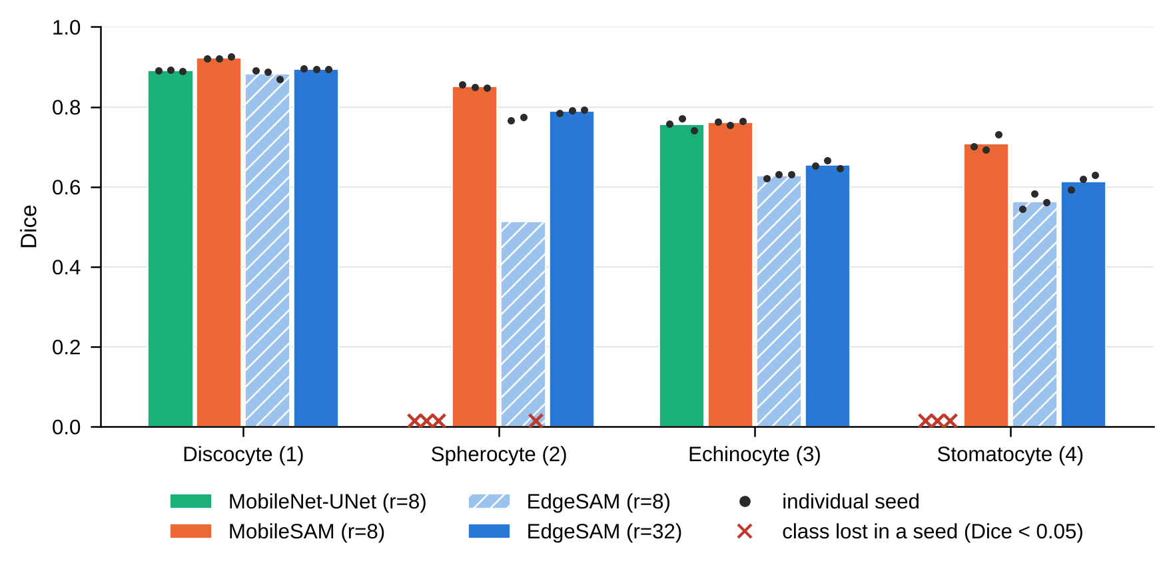
Fig. 3 Per-class Dice of the configurations of Table 1. Bars: mean of three seeds; dots: individual seeds; crosses: a class lost in a seed (Dice < 0.05). Mask values: 1 discocyte, 2 spherocyte, 3 echinocyte, 4 stomatocyte.
The per-class Dice scores (Fig. 3) show where the configurations differ. MobileNet-UNet lost spherocytes and stomatocytes (mask values 2 and 4; Dice 0.000) in all three seeds, despite the highest AJI of the compared configurations (0.551 ± 0.053) and a boundary F1 of 0.814 ± 0.003. MobileSAM (r=8) retained all four classes (Dice 0.923, 0.851, 0.760, and 0.708 for mask values 1 to 4). EdgeSAM (r=8) lost spherocytes in one of three seeds (seed 44; mean Dice 0.647 ± 0.114), whereas EdgeSAM (r=32) retained every class in every seed (Dice 0.895, 0.789, 0.655, and 0.614). Aggregate boundary and instance metrics can therefore hide the complete loss of a minority class, and such losses depended on the training seed. Because the predicted boundary is the domain over which the phase is integrated, a configuration that misses a morphology class cannot provide class-specific phase-derived measurements, whatever its aggregate scores.
With 0.67 M trainable parameters, MobileSAM (r=8) gave the highest mean Dice and no lost class. EdgeSAM needed 0.53 M trainable parameters at r=8 but was less stable across seeds; at r=32 (1.47 M) it retained every class in every seed and had a higher AJI than MobileSAM (r=8), at a lower Dice and boundary F1. The seed-paired difference between EdgeSAM (r=32) and EdgeSAM (r=8) was +0.091 (95% interval −0.196 to +0.379) in Dice, not separable from zero, and +0.086 (95% interval +0.026 to +0.146) in AJI.
No configuration was best on all criteria. EdgeSAM (r=32) is used as the primary configuration for the loss-ablation and storage analyses because it combined complete class retention in every seed with the highest AJI of the SAM-based configurations, and MobileSAM (r=8) is used as the sensitivity comparison because it had the highest Dice and the lowest IPE; this is a presentation choice, not the result of a selection rule applied to the validation data. The relation between accuracy and forward-pass throughput at rank 8 is shown in Fig. S-3.
The complete rank sweep (r = 2, 4, 8, 16, and 32) is given for all three architectures and every seed in Table S-1 and Figs. S-1 and S-2. The dependence on rank was not monotonic. For EdgeSAM, r=32 gave the highest Dice, AJI, and boundary F1 and the lowest IPE of the five ranks, and spherocytes were lost in seed 44 at r = 2, 8, and 16. MobileSAM gave a Dice between 0.808 and 0.813 at r = 2 to 16, but at r=32 one seed (43) collapsed in the second epoch and lost two classes. MobileNet-UNet lost at least one class in every seed at every rank.
  - Parameter-Efficient Adaptation versus Full Fine-Tuning
LoRA at r=8 was compared with full fine-tuning of each architecture under the same objective, learning rate, and validation split (Table 2, Fig. 4). Full fine-tuning was run once (seed 42), so Table 2 compares it with the seed-42 LoRA run. For EdgeSAM, full fine-tuning gave a mean Dice of 0.559 (LoRA: 0.706), lost spherocytes, and raised the global IPE from 3.13% to 8.31%. For MobileSAM, full fine-tuning retained only discocytes (mean Dice 0.217; LoRA: 0.810). For MobileNet-UNet, whose LoRA configuration already trains 71.8% of the parameters, full fine-tuning did not resolve the loss of spherocytes and stomatocytes (mean Dice 0.418; LoRA: 0.412).
In this comparison, training all parameters did not improve adaptation to the phase images, and restricting adaptation to low-rank updates is consistent with retaining useful pretrained representations. Because full fine-tuning was run for one seed, the comparison cannot separate the adaptation method from the training seed; for EdgeSAM in particular, LoRA (r=8) also lost spherocytes in one of its three seeds.
TABLE 2 LoRA (r=8) versus full fine-tuning, full objective, training seed 42.
Architecture | Adaptation | Trainable params | Mean Dice | AJI | Boundary F1 | Global IPE (%) | Lost classes
MobileNet-UNet | LoRA (r=8) | 5.58 M (71.8%) | 0.412 | 0.603 | 0.816 | 2.52 | 2, 4
MobileNet-UNet | Full fine-tuning | 7.62 M (100.0%) | 0.418 | 0.642 | 0.825 | 2.17 | 2, 4
MobileSAM | LoRA (r=8) | 0.67 M (10.0%) | 0.810 | 0.243 | 0.792 | 1.42 | none
MobileSAM | Full fine-tuning | 6.66 M (100.0%) | 0.217 | 0.448 | 0.808 | 2.16 | 2, 3, 4
EdgeSAM | LoRA (r=8) | 0.53 M (8.9%) | 0.706 | 0.224 | 0.615 | 3.13 | none
EdgeSAM | Full fine-tuning | 5.69 M (100.0%) | 0.559 | 0.278 | 0.635 | 8.31 | 2
Lost classes by mask value (Dice < 0.05). Three-seed LoRA results: Table 1.

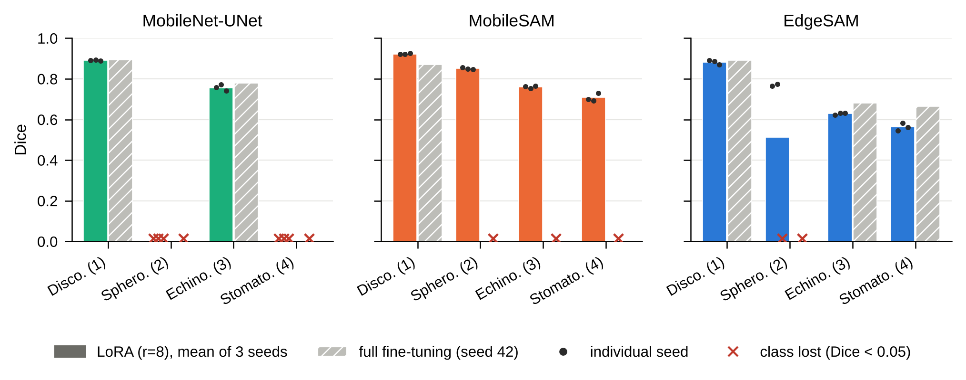
Fig. 4 Per-class Dice of LoRA (r=8; bars: mean of three seeds, dots: individual seeds) and full fine-tuning (hatched; seed 42). Crosses mark a lost class (Dice < 0.05).
  - Physics-Aware Loss Ablation
The contribution of each loss term was assessed by adding PMC, BGA, and IPP in turn to the Dice loss (Table 3, Fig. 5; all ranks in Table S-2). Over the full rank sweep, the mean global IPE of the full objective was lower than that of Dice alone in 15 of the 15 architecture–rank configurations, but the seed-paired 95% interval excluded zero in only 3 of them. For individual seeds, the full objective gave a lower IPE than Dice alone in 42 of 45 comparisons (EdgeSAM 15, MobileSAM 14, MobileNet-UNet 13 of 15) and a lower IPE than Dice with PMC and BGA in 36 (EdgeSAM 10, MobileSAM 13, MobileNet-UNet 13). These counts do not separate the effect of the objective from training instability: a class was lost with Dice alone in 6 of 15 EdgeSAM runs, 3 of 15 MobileSAM runs, and 13 of 15 MobileNet-UNet runs, and with the full objective in 3, 1, and 15 runs, respectively. The full objective thus reduced class loss for EdgeSAM and MobileSAM but not for MobileNet-UNet, which lost classes in more runs with the full objective than with Dice alone.
TABLE 3 Component-wise ablation of the physics-aware loss (mean ± SD over three seeds). Each row adds one term to the row above; shaded rows are the full objective.
Configuration | Loss | Mean Dice | Boundary F1 | AJI | Global IPE (%) | Seeds with a lost class
EdgeSAM (r=32) | Dice | 0.619 ± 0.109 | 0.519 ± 0.212 | 0.329 ± 0.015 | 11.20 ± 6.46 | 2/3 (43; 44)
 | + PMC | 0.680 ± 0.113 | 0.638 ± 0.027 | 0.388 ± 0.059 | 7.45 ± 7.17 | 1/3 (44)
 | + PMC + BGA | 0.746 ± 0.006 | 0.643 ± 0.011 | 0.406 ± 0.034 | 3.64 ± 0.82 | 0/3
 | + PMC + BGA + IPP (full) | 0.738 ± 0.006 | 0.642 ± 0.005 | 0.335 ± 0.020 | 3.02 ± 0.84 | 0/3
MobileSAM (r=8) | Dice | 0.811 ± 0.005 | 0.808 ± 0.012 | 0.248 ± 0.022 | 1.53 ± 0.27 | 0/3
 | + PMC | 0.813 ± 0.009 | 0.805 ± 0.002 | 0.242 ± 0.035 | 1.60 ± 0.24 | 0/3
 | + PMC + BGA | 0.813 ± 0.005 | 0.806 ± 0.004 | 0.259 ± 0.034 | 1.48 ± 0.11 | 0/3
 | + PMC + BGA + IPP (full) | 0.810 ± 0.006 | 0.802 ± 0.011 | 0.262 ± 0.017 | 1.32 ± 0.09 | 0/3
EdgeSAM (r=8) | Dice | 0.624 ± 0.095 | 0.496 ± 0.209 | 0.334 ± 0.052 | 10.82 ± 5.39 | 1/3 (43)
 | + PMC | 0.672 ± 0.109 | 0.621 ± 0.031 | 0.386 ± 0.033 | 7.97 ± 6.80 | 1/3 (44)
 | + PMC + BGA | 0.735 ± 0.010 | 0.628 ± 0.013 | 0.390 ± 0.046 | 4.25 ± 1.07 | 0/3
 | + PMC + BGA + IPP (full) | 0.647 ± 0.114 | 0.608 ± 0.009 | 0.249 ± 0.043 | 3.81 ± 1.82 | 1/3 (44)
MobileNet-UNet (r=8) | Dice | 0.485 ± 0.294 | 0.814 ± 0.054 | 0.623 ± 0.111 | 15.48 ± 12.73 | 2/3 (42; 44)
 | + PMC | 0.414 ± 0.181 | 0.782 ± 0.022 | 0.585 ± 0.071 | 19.79 ± 6.71 | 3/3 (42; 43; 44)
 | + PMC + BGA | 0.544 ± 0.292 | 0.812 ± 0.052 | 0.602 ± 0.125 | 13.96 ± 12.46 | 2/3 (42; 44)
 | + PMC + BGA + IPP (full) | 0.412 ± 0.004 | 0.814 ± 0.003 | 0.551 ± 0.053 | 2.60 ± 0.07 | 3/3 (42; 43; 44)
Seeds in which at least one class was lost (Dice < 0.05) are given in parentheses. All ranks: Table S-2; class-specific IPE and Dice: Table S-3.

For EdgeSAM (r=8), Dice alone gave a mean Dice of 0.624 ± 0.095 and a global IPE of 10.82 ± 5.39%, with spherocytes lost in seed 43. Adding PMC gave 0.672 ± 0.109 and 7.97 ± 6.80%, again with one lost class (seed 44), whereas adding BGA gave 0.735 ± 0.010, a boundary F1 of 0.628 ± 0.013, an IPE of 4.25 ± 1.07%, and no lost class; the mean spherocyte Dice rose from 0.343 with Dice alone to 0.524 with PMC and 0.783 with PMC and BGA (Table S-3). An example of predicted contours on the phase-gradient magnitude is shown in Fig. S-4. At r=32, Dice alone lost spherocytes in two of three seeds (seeds 43, 44; Dice 0.619 ± 0.109, IPE 11.20 ± 6.46%) and Dice with PMC in one (seed 44; 0.680 ± 0.113, 7.45 ± 7.17%), whereas Dice with PMC and BGA (0.746 ± 0.006) and the full objective (0.738 ± 0.006) lost no class.
Adding IPP gave the lowest mean global IPE for EdgeSAM at both ranks (3.81 ± 1.82% at r=8 and 3.02 ± 0.84% at r=32; Fig. 5), without a higher boundary F1 than Dice with PMC and BGA. Relative to Dice with PMC and BGA, the seed-paired change in IPE was −0.63 (95% interval −0.75 to −0.51) percentage points at r=32, with a Dice change of −0.008 (95% interval −0.039 to +0.023), whereas at r=8 it was −0.44 (95% interval −4.77 to +3.90) percentage points and not separable from zero. For MobileSAM (r=8), the four loss configurations gave mean Dice values within 0.003 of each other and global IPEs between 1.32% and 1.60%, and the difference between the full objective and Dice alone was −0.21 (95% interval −0.75 to +0.33) percentage points. For MobileNet-UNet (r=8), the mean IPE fell from 15.48 ± 12.73% with Dice alone to 2.60 ± 0.07% with the full objective, but classes were lost in two or three seeds in every configuration and the paired difference (−12.88 (95% interval −44.66 to +18.90) percentage points) was not separable from zero. For EdgeSAM, the ablation is therefore consistent with complementary terms: PMC lowered the IPE but did not prevent class loss, BGA removed the lost classes, and IPP gave the lowest IPE. For MobileSAM and MobileNet-UNet, no effect of an individual term could be separated from seed-to-seed variation with three seeds.
To check whether IPP introduces a phase-dependent bias, the false-negative rate of ground-truth foreground pixels was computed within per-image quartiles of the background-referenced phase, with and without IPP (Dice with PMC and BGA versus the full objective). Missed pixels concentrated in the lowest-phase quartile for EdgeSAM (r=32: 32.1 ± 2.3% without and 28.0 ± 2.5% with IPP; r=8: 33.0 ± 3.2% and 26.0 ± 5.1%; at most 8.1% in the other quartiles of any seed), for MobileSAM (r=8: 20.8 ± 1.2% and 23.2 ± 0.8%; at most 0.7% elsewhere), and for MobileNet-UNet (r=8: 26.8 ± 5.3% and 25.7 ± 1.1%), so IPP did not increase the low-phase bias of EdgeSAM or MobileNet-UNet and increased it slightly for MobileSAM. Robustness to background variation was tested by adding constant offsets and low-order tilt, defocus-like, and astigmatism-like fields to the validation phase maps. For the four configurations of Table 1, the mean Dice changed by at most 0.0034, as expected for constant offsets because each network input is standardized. The IPE computed on the perturbed phase without re-referencing increased with the offset (EdgeSAM (r=32): 3.02% without and 3.20% at the largest offset; EdgeSAM (r=8): 3.81% and 4.24%).
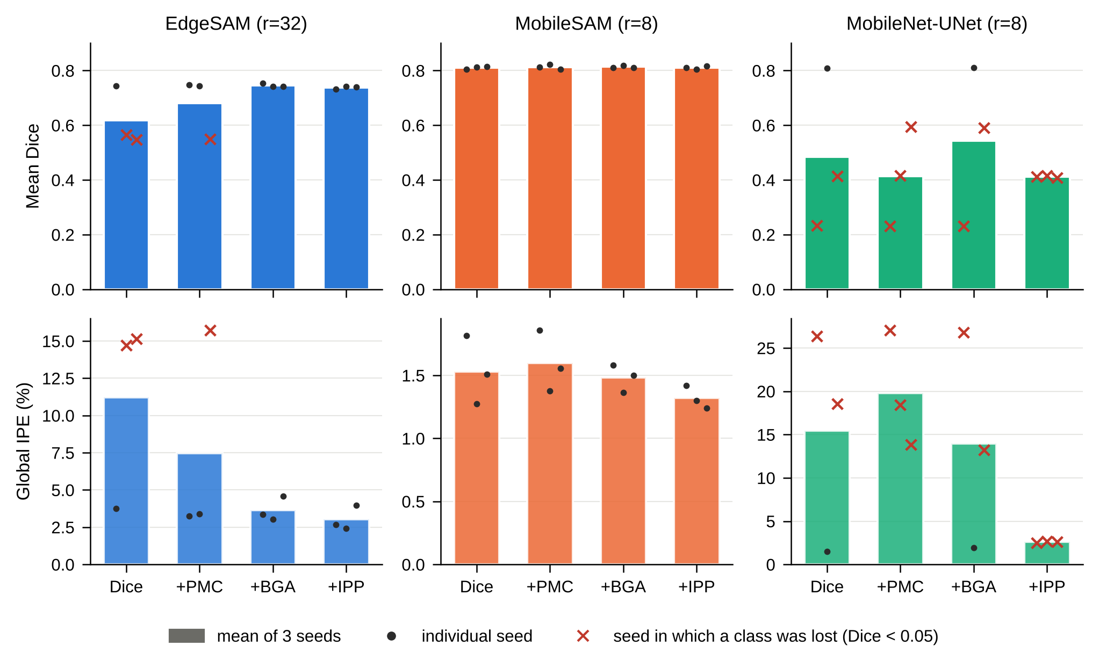
Fig. 5 Component-wise loss ablation for EdgeSAM (r=32), MobileSAM (r=8), and MobileNet-UNet (r=8): mean Dice (top) and global IPE (bottom). Each step adds one term to the previous configuration. Bars: mean of three seeds; dots: individual seeds; crosses: seeds in which a class was lost.
  - Integrated-Phase and Optical-Mass Preservation Analysis
The global IPE was 1.32 ± 0.09% for MobileSAM (r=8), 2.60 ± 0.07% for MobileNet-UNet (r=8), and 3.81 ± 1.82% and 3.02 ± 0.84% for EdgeSAM at r=8 and r=32 (Table 1). Global IPE alone does not characterize per-cell measurement quality: MobileNet-UNet lost spherocytes and stomatocytes in every seed, which gives a class-specific IPE of 100% for both (Table S-3), and EdgeSAM (r=8) varied more between seeds (SD of the global IPE 1.82 percentage points). When annotated cells were matched one-to-one to predicted components at IoU ≥ 0.5, 66.6 ± 1.8% of the annotated cells were recovered by EdgeSAM (r=32) and 66.7 ± 0.7% by MobileSAM (r=8); for the matched cells (wrapped cells excluded), the median absolute per-cell IPE was 1.88 ± 0.24% and 1.11 ± 0.09%, and the 90th percentile 16.2 ± 1.7% and 8.3 ± 1.3%, respectively. Integrated-phase fidelity must therefore be read together with class coverage, instance separation, and seed-to-seed stability, and no configuration was best on all of these criteria.
  - Computational Efficiency Analysis
Forward-pass latency and GPU memory were measured for the rank-8 models with merged LoRA weights in strict FP32 on an NVIDIA RTX A5000 at batch size 1, with native PyTorch and ONNX Runtime (Table 4; Section 3.4). ONNX Runtime reduced the median latency of EdgeSAM from 10.64 ± 1.45 ms to 4.11 ± 0.43 ms (229.1–277.0 frames per second across the three timing passes) and that of MobileNet-UNet from 5.66 ± 0.10 ms to 2.53 ± 0.19 ms, whereas MobileSAM, which operates on 1024 × 1024 px inputs, was slower with ONNX Runtime (25.43 ± 0.21 ms) than with PyTorch (20.35 ± 0.15 ms). The GPU-memory footprint was larger with ONNX Runtime than with PyTorch for all three architectures. MobileNet-UNet had the lowest latency but lost two classes in every seed. EdgeSAM (r=32), the configuration used in the storage analysis, was not timed; because merging yields the same network at every rank, its forward-pass cost is expected to equal that of the rank-8 model, but this was not measured. The timings cover the forward pass only, on a desktop-class GPU, and do not establish end-to-end or embedded performance.
TABLE 4 Forward-pass latency, throughput, and GPU memory of the rank-8 models (LoRA merged) in strict FP32 on an NVIDIA RTX A5000 at batch size 1. Latency: mean ± SD over three timing passes.
Model (r=8) | Runtime | Input (px) | P50 latency (ms) | P99 latency (ms) | Throughput (frames/s) | GPU memory (MB)
EdgeSAM | PyTorch | 256 × 256 | 10.64 ± 1.45 | 12.97 ± 1.53 | 81.3–102.8 | 42
 | ONNX Runtime | 256 × 256 | 4.11 ± 0.43 | 5.58 ± 0.31 | 229.1–277.0 | 132
MobileNet-UNet | PyTorch | 256 × 256 | 5.66 ± 0.10 | 8.00 ± 0.63 | 174.7–180.4 | 52
 | ONNX Runtime | 256 × 256 | 2.53 ± 0.19 | 3.33 ± 0.79 | 373.7–431.0 | 152
MobileSAM | PyTorch | 1024 × 1024 | 20.35 ± 0.15 | 20.51 ± 0.13 | 48.8–49.5 | 358
 | ONNX Runtime | 1024 × 1024 | 25.43 ± 0.21 | 25.56 ± 0.18 | 39.1–39.7 | 1178
Throughput: 1000/P50 of each timing pass, range over the three passes. GPU memory: baseline-subtracted device-level reading after the timed loop, maximum over the passes (not a continuously sampled peak). Timing covers the model forward pass with preprocessed, GPU-resident inputs (Section 3.4).
  - Visualization of Segmentation and Morphology Classification Results
Qualitative results are shown in Fig. 6 for one 256 × 256 px window per annotated class, chosen from the annotation alone as the window with the most pixels of that class, before the predictions were inspected; all four predictions shown come from the same training seed. The windows are examples, not a statistical sample. Consistent with its Dice of zero for these classes (Fig. 3), MobileNet-UNet assigned cells annotated as spherocytes and stomatocytes to other classes; over all validation pixels, this model (seed 42) predicted 68% of the annotated spherocyte pixels and 82% of the annotated stomatocyte pixels as discocyte. The SAM-based configurations assigned most annotated spherocytes, echinocytes, and stomatocytes to the annotated class, with errors concentrated on stomatocytes: 68% of the annotated stomatocyte pixels were predicted as stomatocyte by MobileSAM (r=8), 52% by EdgeSAM (r=8), and 56% by EdgeSAM (r=32) (seed 43), and 22% to 30% as discocyte. Where cells touch, the predicted foreground of all models tended to form joined regions. An annotated cell (15 to 200 µm², not touching an unannotated region) was counted as bridged when one predicted component covered at least 30% of its pixels and of the pixels of another annotated cell; 35.1–36.9% of the annotated cells were bridged for MobileSAM (r=8; seeds 43 and 44), 33.4–41.8% for EdgeSAM (r=8; seeds 43 and 44), 30.5–35.3% for EdgeSAM (r=32; seeds 42 to 44), and 13.2% for MobileNet-UNet (r=8; seed 42), with overlapping ranges for the SAM-based configurations and no statistical test. These predictions therefore do not show that one SAM-based configuration separates adjacent cells better than another, consistent with their similar AJI values (Table 1). Limited instance separation is a possible source of per-cell measurement error, but its effect on the dry-mass estimates was not quantified separately.
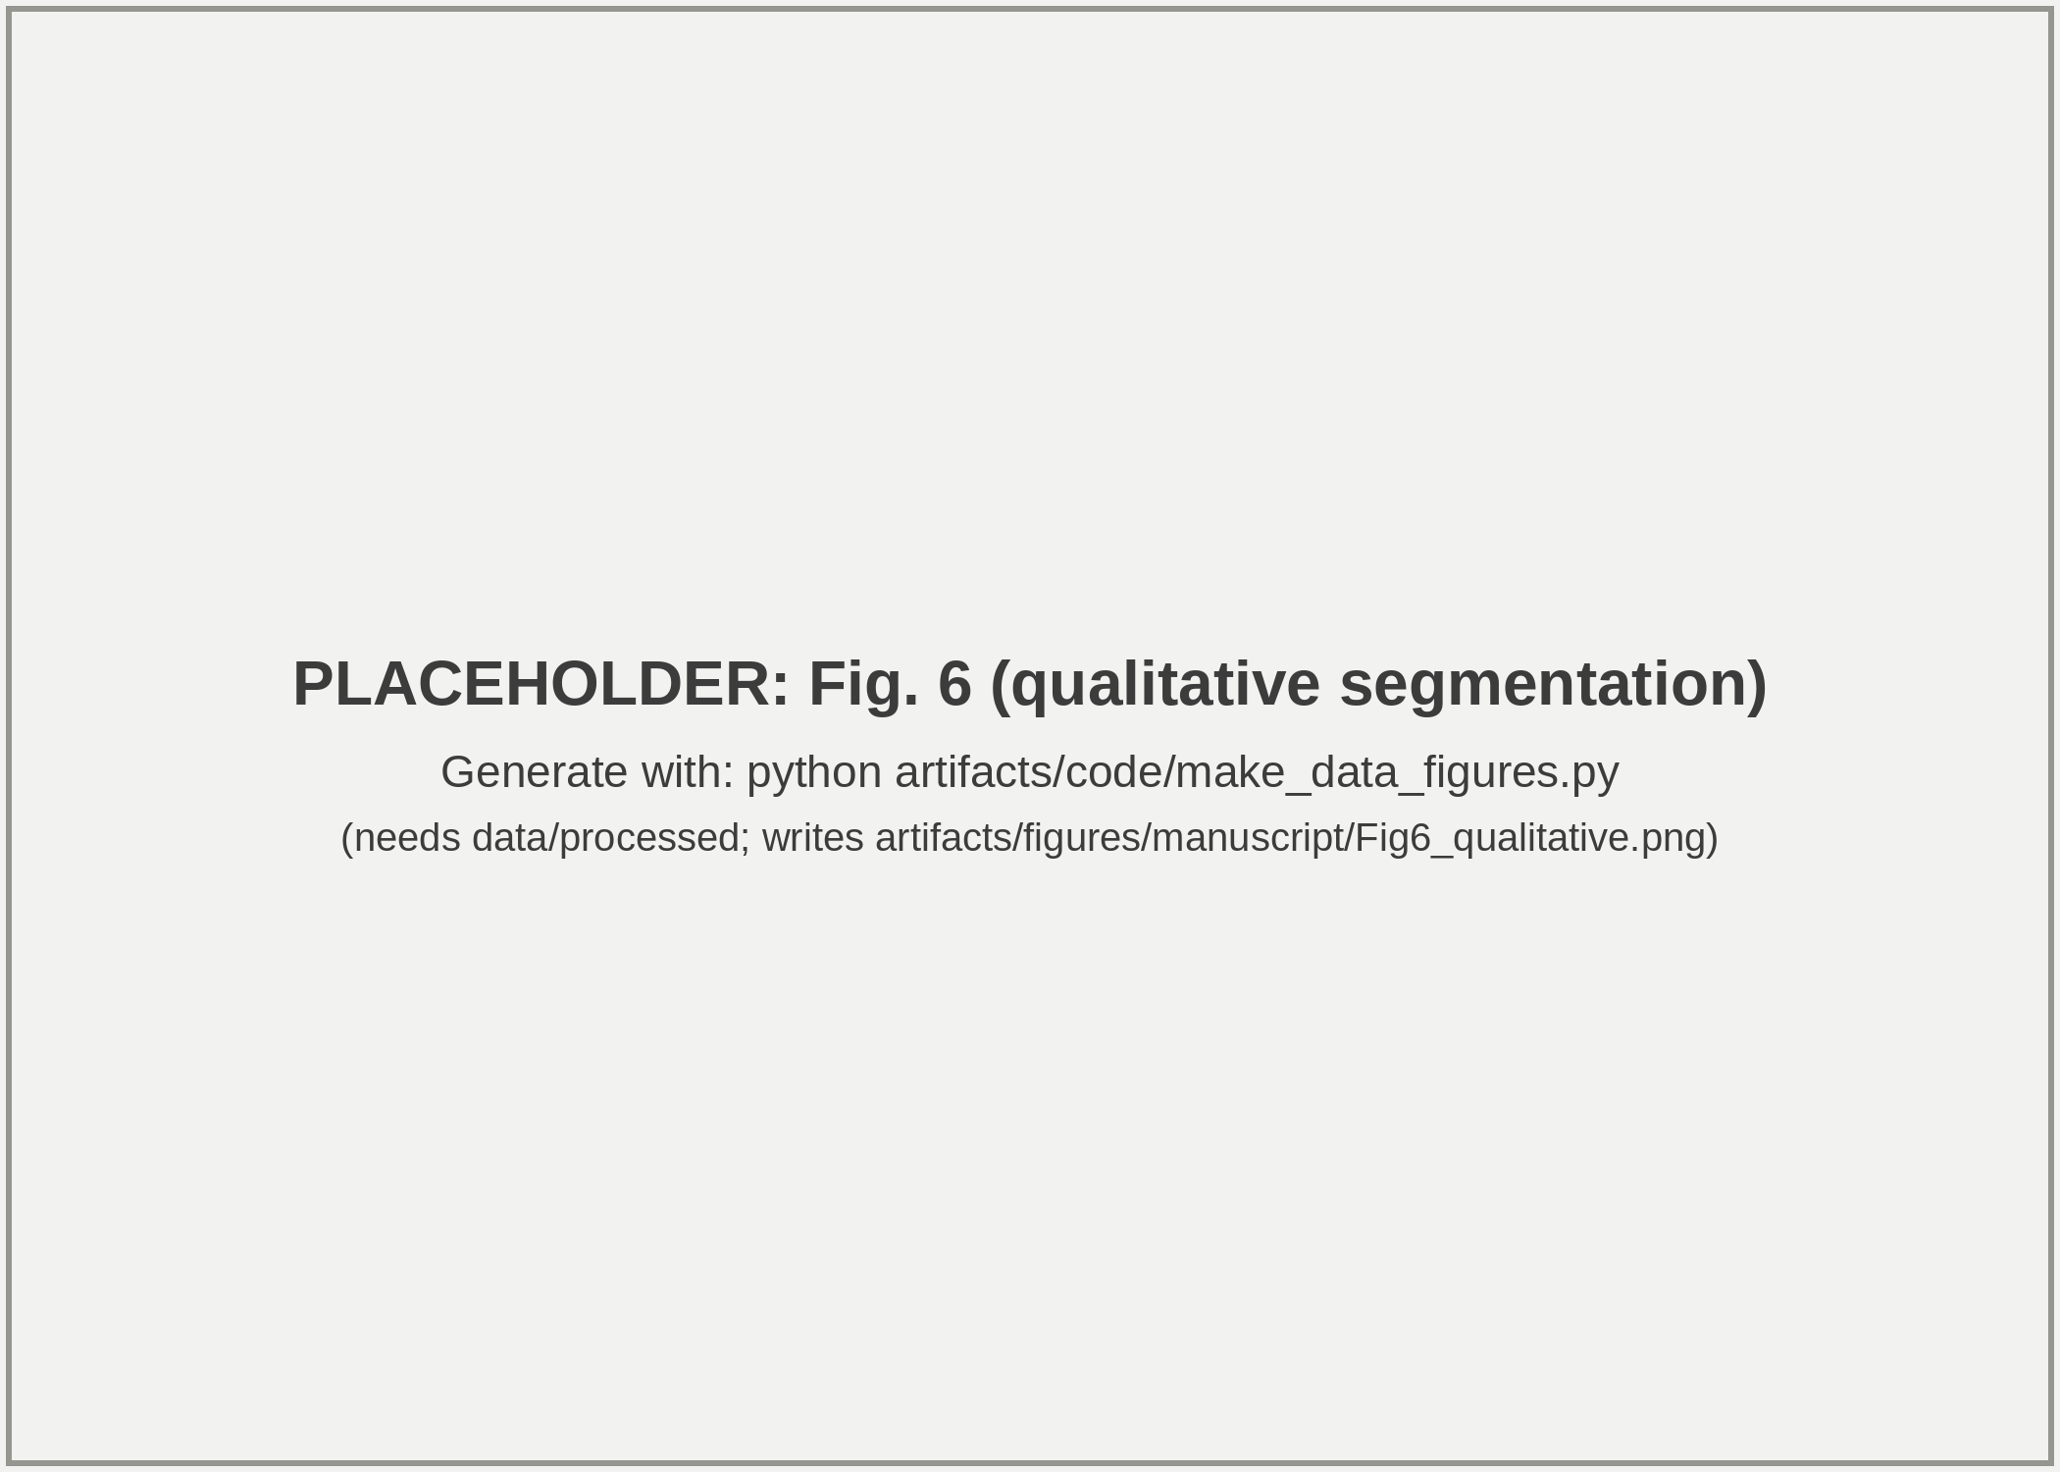
Fig. 6 Qualitative segmentation in four 256 × 256 px validation windows, one per annotated class (rows; mask values 1 to 4). Columns: phase, annotation, and the predictions of MobileNet-UNet (r=8), MobileSAM (r=8), EdgeSAM (r=8), and EdgeSAM (r=32), all from training seed 42. Grey: outside the annotated field of view.
  - Storage-Induced Morphology Degradation
Storage-associated changes in RBC morphology and phase-derived properties were examined over the 47-day storage period with the masks predicted by EdgeSAM (r=32) for each of the three training seeds, and with MobileSAM (r=8) as the sensitivity comparison. Each storage day is represented by six validation images from the same samples, which are not independent observations (Section 3.6); the analysis therefore describes cross-sectional population changes, not the tracking of individual cells.
Class composition was computed for each storage day as the share of cells assigned to each class, pooling the six images of the day; cells are 4-connected foreground components of 15 to 200 µm² that do not touch an unannotated region and are not phase-wrapped (Section 2.6). For the predictions, the shares were computed for each seed and averaged (Fig. 7; per-seed values in Supplementary Data 1). Discocytes predominated at day 0 (93.0% in the annotation, 91.7% in the prediction) and fell to 10.5% and 11.0% by day 47, when spherocytes (58.8% and 67.4%) and echinocytes (30.3% and 20.9%) predominated. Stomatocytes remained a minority class, with an annotated share of 4.9% at day 0, 14.8% at day 19 (24 of 162 annotated cells), and 0.4% at day 47, against 6.3%, 11.9% (seed range 7.3–14.6%), and 0.7% for EdgeSAM (r=32) and 6.3%, 9.4% and 1.0% for EdgeSAM (r=8).
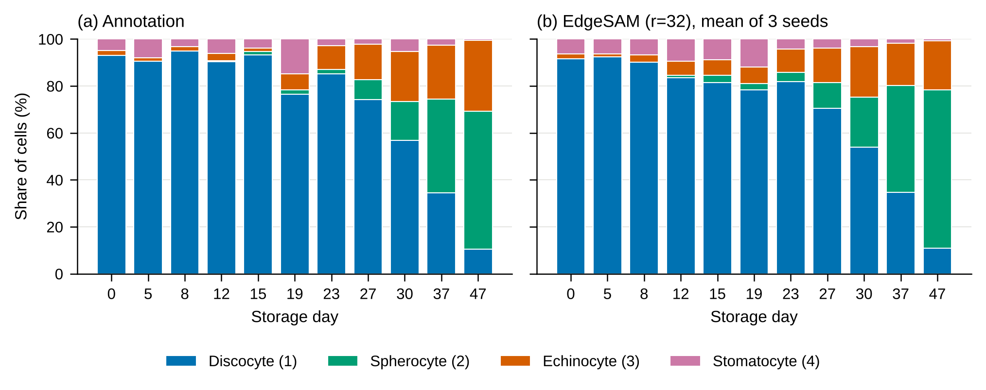
Fig. 7 Class composition over the 47-day storage period: (a) annotation; (b) EdgeSAM (r=32), mean of seeds 42, 43, and 44. Cells of the six images of each day are pooled (93 to 230 annotated cells per day); phase-wrapped cells are excluded.

The predicted composition reproduced the direction and approximate timing of the annotated shift, but not its exact values: averaged over the three seeds, predicted and annotated shares differed by 2.6 percentage points on average over the 11 days and four classes, with a maximum of 11.8 percentage points (discocytes on day 15, where few predicted components passed the cell filters), and by up to 17.7 percentage points for an individual seed. For MobileSAM (r=8), the mean difference was 1.5 and the maximum 13.0 percentage points. Because predicted components are not cell counts, the predicted composition describes the components that passed the cell filters. Representative phase images over the storage period are shown in Fig. S-5.
  - Quantitative Phase-Derived Cellular Analysis Across Storage
After exclusion of wrapped cells, the annotation contains 1988 cells in the 66 validation images, and the EdgeSAM (r=32) predictions contain 1,338, 1,378, 1,437 kept components for seeds 42, 43, and 44 (Table S-4). Projected cell area decreased with storage (Fig. 8b, Table 5): between early (days 0 to 8) and late storage (days 37 to 47), the median area changed by −43.9% in the annotation and by −44.3 ± 1.2% in the predictions. With the 11 acquisition dates as clusters, the permutation p-value of this trend was 0.017 for the annotation and 0.001, 0.008, 0.005 for seeds 42, 43, and 44, and every 95% date-bootstrap interval of the Spearman correlation excluded zero, for the annotation only narrowly (−0.85 to −0.004). The median dry mass changed by −0.8% in the annotation and by −6.1 ± 0.3% in the predictions, but a decrease was not statistically supported under date clustering (p = 0.26 for the annotation and 0.10, 0.17, 0.086 for the three seeds; every bootstrap interval included zero; Table S-6). Treating the 66 images as independent observations would give p = 0.008, 0.052, 0.036 for the three seeds, but this ignores that the six images of a date come from the same samples and is therefore not used. The absence of a supported trend is not evidence that dry mass was constant, because a test with 11 clusters has limited power. The change in projected area was thus not accompanied by a statistically supported change in phase-derived dry mass (Fig. 8b, c).
Dry mass from the predicted masks was compared with that from the annotation masks using the per-image median dry mass (66 images per seed). For EdgeSAM (r=32), the median absolute relative error (MdARE) was 3.9 ± 0.5% (4.5, 3.8, 3.5% for seeds 42, 43, and 44), the Bland-Altman bias 0.46 ± 0.68 pg with 95% limits of agreement from −5.1 to +6.0 pg, the Pearson correlation r = 0.38 ± 0.14 (0.29, 0.31, 0.55), and the concordance correlation coefficient 0.32 ± 0.17 (Fig. 8a, Table 5). For MobileSAM (r=8), MdARE was 2.9 ± 0.2%, r = 0.24 ± 0.10, and CCC 0.21 ± 0.11. The correlations are weak and depend on the seed, partly because the annotation-derived per-image medians span a narrow range (25.0 to 33.0 pg). MdARE is a median, not an upper bound: half of the images had larger relative errors, and the limits of agreement show errors of several pg for individual images. To test for a storage-dependent bias, the per-image difference between predicted and annotation-derived median dry mass was related to storage day with the same date-clustered test. For EdgeSAM (r=32), this correlation was weakly negative (Spearman ρ = −0.29, −0.21, −0.23 for the three seeds) but not statistically supported (p = 0.078, 0.19, 0.088; every bootstrap interval included zero), and for MobileSAM (r=8) no association was found (p = 0.78, 0.63, 0.98). The larger early-to-late change in the predicted than in the annotated dry mass therefore cannot be attributed to a storage-dependent bias with these data. Both segmentations are evaluated on the same phase maps, each with its own background estimate, so these values describe agreement between segmentations and not the accuracy of absolute dry mass (Section 2.6).
The predicted components that pass the cell filters are not cell counts: touching cells can merge into one component and fragments are discarded. On days 8, 12, and 15, the number of kept EdgeSAM (r=32) components was only 0.52, 0.49 and 0.29 of the annotated cell count (mean over seeds; open markers in Fig. 8b, c), against 0.70 to 0.96 on the other days; MobileSAM (r=8) showed the same pattern (0.48, 0.46 and 0.17). On day 15, including wrapped components and averaged over the three seeds, the six images yielded 61.3 kept components for 211 annotated cells, with 116 fragments smaller than 15 µm², 22 components larger than 200 µm², and 46 components of admissible size touching the unannotated region, while the predicted foreground area was 0.98 of the annotated area (Fig. S-6). The low counts on these days are consistent with merging and fragmentation in crowded images and do not indicate a reduction in cell number; predicted mean area and dry mass on these days are selection-biased and are not interpreted biologically. With MobileSAM (r=8), the early-to-late change was −40.6 ± 1.3% for area (p = 0.004, 0.007, 0.024) and −2.6 ± 0.4% for dry mass (p = 0.36, 0.23, 0.34) (Table 5, Table S-5).
TABLE 5 Dry-mass agreement with the annotation and storage trends in the 66 validation images (11 acquisition dates). Mean ± SD over seeds 42, 43, and 44; p-values per seed.
Segmentation | MdARE (%) | Bias (pg) | Pearson r | CCC | Δ area (%) | p, area | Δ dry mass (%) | p, dry mass | p, bias vs day
Annotation (reference) | – | – | – | – | −43.9 | 0.017 | −0.8 | 0.26 | –
EdgeSAM (r=32) | 3.9 ± 0.5 | 0.46 ± 0.68 | 0.38 ± 0.14 | 0.32 ± 0.17 | −44.3 ± 1.2 | 0.001, 0.008, 0.005 | −6.1 ± 0.3 | 0.10, 0.17, 0.086 | 0.078, 0.19, 0.088
MobileSAM (r=8) | 2.9 ± 0.2 | 0.66 ± 0.31 | 0.24 ± 0.10 | 0.21 ± 0.11 | −40.6 ± 1.3 | 0.004, 0.007, 0.024 | −2.6 ± 0.4 | 0.36, 0.23, 0.34 | 0.78, 0.63, 0.98
MdARE, bias, Pearson r, and CCC compare the per-image median dry mass of prediction and annotation. Δ: change of the median of the per-image medians between early (days 0 to 8, 18 images) and late storage (days 37 to 47, 12 images). p: two-sided permutation test of the image-level Spearman correlation with storage day, permuting the 11 acquisition dates as whole blocks (10,000 permutations); bias vs day: the same test on the per-image difference prediction − annotation. Wrapped cells excluded. Bootstrap intervals and per-day values: Tables S-4 to S-6. Absolute dry mass was not independently validated.
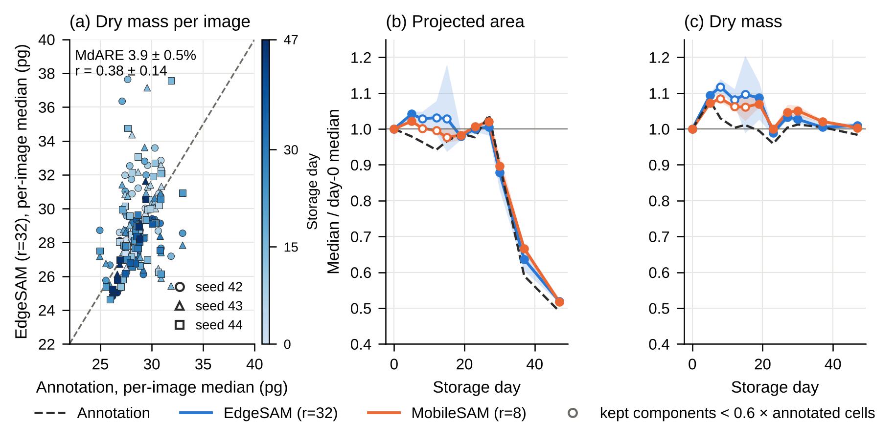
Fig. 8 Dry mass and projected area over storage. (a) Per-image median dry mass of EdgeSAM (r=32) against the annotation (markers: seeds; colour: storage day; dashed: identity). (b) Projected area and (c) dry mass: per-day median of the per-image medians divided by the day-0 value for EdgeSAM (r=32) and MobileSAM (r=8) (line: mean of seeds; band: seed range) and for the annotation (dashed). Open markers: days on which kept components were fewer than 0.6 of the annotated cells.
- Discussion
The results indicate that physics-aware lightweight segmentation can lower the integrated-phase error of the predicted measurement domain by treating the predicted cell boundary as a quantitative measurement domain rather than solely as a geometric contour. Conventional segmentation objectives such as Dice and Cross-Entropy primarily optimize spatial agreement between predicted and annotated masks and do not explicitly account for the quantitative phase information enclosed by the predicted boundary. In QPI, however, boundary placement directly determines the region over which the phase signal is integrated for subsequent phase-derived biophysical analysis. The ablation results are consistent with this distinction: for EdgeSAM (r=32), the full Physics-Aware Phase Consistency Loss gave a global IPE of 3.02 ± 0.84% compared with 11.20 ± 6.46% with Dice-only optimization (3.81 ± 1.82% versus 10.82 ± 5.39% at r=8), although with three seeds the paired differences are wide (−8.18 percentage points, 95% interval −23.52 to +7.15 at r=32; −7.01, −19.68 to +5.66 at r=8). For MobileNet-UNet, the IPE was 2.60 ± 0.07% with the full objective and 15.48 ± 12.73% with Dice alone, but this architecture lost classes in every configuration. These findings indicate that geometric overlap alone does not fully characterize the suitability of a segmentation mask for quantitative QPI measurements.
The three components of the proposed physics-aware objective provide complementary constraints on the predicted measurement domain. PMC incorporates phase-based foreground information, BGA encourages cellular contours to follow spatial phase transitions, and IPP directly constrains the quantitative phase integrated within the predicted cell region. The component-wise ablation further showed that these constraints must operate together with geometric segmentation objectives. In particular, for EdgeSAM, PMC alone did not remove the loss of spherocytes in individual seeds, whereas the addition of BGA removed the lost classes and raised the mean Dice of spherocytes (Table S-3). Incorporating IPP gave the lowest global IPE for EdgeSAM at both ranks, with a paired reduction relative to Dice with PMC and BGA that was separable from zero at r=32 (−0.63 percentage points) but not at r=8. For MobileSAM and MobileNet-UNet, no component-wise effect could be separated from seed-to-seed variation with three seeds.
Preserving integrated phase is particularly important because segmentation errors propagate directly into downstream phase-derived measurements. Projected area and circularity depend on the predicted cellular boundary, while cellular dry mass is estimated from the phase integrated over the segmented region. Consequently, a segmentation mask with high conventional overlap can still introduce quantitative measurement error if its boundary systematically excludes cellular phase information or includes background regions. This measurement-oriented perspective is especially relevant to RBC storage analysis, where changes in cellular morphology and phase-derived biophysical properties provide complementary information on storage-associated cellular alterations [47, 48]. DHM and QPI are particularly advantageous in this context because they enable label-free quantitative cellular analysis without the staining requirements of conventional imaging approaches. Dry-mass estimates derived from EdgeSAM (r=32) predictions agreed with the annotation-based per-image median to within a median absolute relative error of 3.9 ± 0.5%, but the correlation between predicted and annotated per-image medians was modest and depended on the training seed (r = 0.38 ± 0.14; 0.29 to 0.55 across seeds; CCC = 0.32 ± 0.17). The per-image medians of the annotation cover a narrow range (25.0 to 33.0 pg), which limits what a correlation across images can show. These values quantify agreement between two segmentations of the same phase maps and are not an accuracy measurement against an independent measure of dry mass. MdARE describes the typical image and is not an upper bound on the error of an individual image.
The comparison among lightweight architectures and adaptation strategies indicates that computational efficiency must be considered together with segmentation and measurement reliability. LoRA-adapted MobileSAM (r=8) retained all four classes in every seed, and EdgeSAM (r=32) did so with a higher AJI than MobileSAM, whereas EdgeSAM (r=8) lost one class in one of three seeds. In the single full fine-tuning runs, EdgeSAM lost one class and MobileSAM lost three, despite updating substantially more parameters. These results suggest, without separating the effect of the method from that of the training seed, that restricting adaptation to low-rank parameter updates can help retain pretrained representations for relatively small and imbalanced QPI datasets while substantially reducing the number of trainable parameters. The LoRA rank analysis (Supplementary Information, Table S-1) showed that EdgeSAM (r=32) gave the highest Dice, AJI and boundary F1 and the lowest IPE of the five ranks tested, without a monotonic trend across ranks, at the cost of more trainable parameters (1.47 M versus 0.53 M at r=8). Rank-specific latency and memory were not measured.
In the rank-8 benchmark, ONNX Runtime reduced the median forward-pass latency of EdgeSAM from 10.64 ± 1.45 ms with PyTorch to 4.11 ± 0.43 ms (229.1–277.0 FPS across three timing passes) in strict FP32 on an NVIDIA RTX A5000, at a larger GPU-memory footprint (132 versus 42 MB). In the same rank-8 benchmark, MobileNet-UNet had the lowest latency (2.53 ± 0.19 ms with ONNX Runtime) but lost two of the four annotated classes (spherocytes and stomatocytes; mask values 2 and 4) in all three seeds, and MobileSAM had the highest latency (25.43 ± 0.21 ms with ONNX Runtime, 20.35 ± 0.15 ms with PyTorch) and GPU-memory footprint among the evaluated rank-8 benchmark configurations, with no latency benefit from ONNX Runtime. The benchmark measured rank-8 models only. Separately, in the segmentation comparison, MobileSAM (r=8) had higher Dice, boundary F1 and lower global integrated-phase error than EdgeSAM (r=32), whereas EdgeSAM (r=32) had higher AJI; these are descriptive observations over three seeds without a statistical test. The timings cover the model forward pass only and do not establish end-to-end processing speed. These results characterize performance on a desktop-class GPU rather than actual edge-device deployment; validation on low-power embedded platforms will be required to establish real-world edge performance.
The biological analysis further illustrates the use of the proposed measurement-oriented segmentation framework. Across the 47-day storage period, the predicted RBC populations exhibited systematic morphological changes, accompanied by a decrease of projected cell area of about 44% between early and late storage in both the annotation and the predictions, a decrease that is supported when the 11 acquisition dates are treated as clusters. A decrease of dry mass was not statistically supported for the annotation or for EdgeSAM (r=32) under the same analysis, and we make no statement about the cause of the area decrease. Cellular dry mass was estimated from the integrated quantitative phase using the known illumination wavelength, effective pixel pitch, and specific refractive increment, with no calibration of the phase scale to a reference mean corpuscular haemoglobin value (Section 2.6). Absolute dry mass in pg was not independently validated. This enables relative comparison of phase-derived dry-mass measurements across storage time points and between predicted and annotation-derived measurement boundaries.
Several limitations remain. The LoRA rank and loss configuration were selected using the available validation set, and an independent held-out test cohort was not available. The framework was evaluated only on RBC QPI data, and its generalizability to other cell types, imaging conditions, and densely crowded cellular environments remains to be established. No phase unwrapping was applied, and 61 of 2049 annotated cells (3.0%) were flagged as possibly wrapped and excluded from the per-cell analyses; specimens with a larger optical thickness than RBCs would require reliable unwrapping before this framework is applied. For EdgeSAM (r=8), the full physics-aware objective had a lower AJI than Dice-only optimization (0.249 versus 0.334), whereas at r=32 the AJI was similar (0.335 versus 0.329); because the Dice-only runs lost classes in some seeds, these comparisons are confounded, and the trade-off between integrated-phase preservation and individual-cell separation was not resolved. For MobileSAM and MobileNet-UNet, no effect of the individual loss terms could be separated from seed-to-seed variation with three seeds, so the effect of IPP on these architectures was not established and should not be assumed to transfer across architectures. In addition, LoRA adaptation was performed offline, and adaptation to changes in imaging conditions or optical aberrations was not investigated. The dataset used in this study provides only the reconstructed phase channel; the corresponding amplitude images were not available, as the original holograms were not retained by the data provider, so incorporating amplitude information was not evaluated in this work. Amplitude images could potentially provide complementary information in the low-phase and boundary regions where segmentation errors were found to concentrate (Section 4.3), and represent a promising direction for future work. Further limitations concern the storage analysis. The zero level of the delivered phase maps could not be established independently (Section 2.2), so absolute dry mass in pg was not independently validated. The images come from three donors imaged repeatedly over 11 acquisition dates, and the assignment of images to donors is not documented, so donor-level modelling was not possible and the date-clustered inference (11 clusters) is approximate and exploratory. Predicted components are class-agnostic connected components; on days 8, 12 and 15 their number is 0.29 to 0.52 of the annotated cells, so they are not cell counts and the predicted means on these days are selection-biased (the component-fate analysis was performed for EdgeSAM (r=32) only). The dry-mass analysis covers EdgeSAM (r=32) (main analysis) and MobileSAM (r=8) (sensitivity analysis); the other architectures and ranks were not analysed for dry mass. Touching cells can merge into one predicted component, so limited instance separation is a possible source of per-cell error whose effect on dry mass was not isolated. Future work will therefore focus on validation using independent QPI datasets and additional cell types, improving instance separation while maintaining integrated-phase preservation, and evaluating the framework on embedded computing platforms.
Overall, the present results are consistent with optical-mass preservation as a measurement-oriented principle for physics-aware QPI segmentation, within the limits of the three-seed evidence reported here. In this framework, optical-mass preservation is achieved by constraining the integrated quantitative phase within predicted cellular regions rather than by interpreting QPI as a direct measurement of geometric volume. By combining this physical constraint with lightweight architecture design and parameter-efficient adaptation, the proposed framework is intended to support computationally efficient holographic cell segmentation in which predicted boundaries serve as measurement domains for subsequent relative quantitative cellular analysis.
- Conclusion
This study presented a physics-aware lightweight segmentation framework for quantitative holographic cell analysis, in which predicted cell boundaries serve as quantitative measurement domains. The proposed Physics-Aware Phase Consistency Loss explicitly incorporates quantitative phase information into segmentation optimization, in addition to conventional geometric segmentation terms. The physics-aware objective gave the lowest global integrated-phase error for EdgeSAM at ranks 8 and 32 in the ablation, whereas for MobileSAM and MobileNet-UNet no component-wise effect could be separated from seed-to-seed variation with three seeds. Combined with LoRA-based adaptation, EdgeSAM (r=32), the primary configuration, and MobileSAM (r=8), the sensitivity comparison, retained all four annotated classes in every training seed, whereas EdgeSAM (r=8) lost one class in one seed and MobileNet-UNet lost two classes in every seed; forward-pass latency was measured for the rank-8 models only.
The evaluated architectures showed different trade-offs between segmentation accuracy, class retention, integrated-phase error and forward-pass cost, and no single selection criterion was applied. Application to RBC populations over a 47-day storage period showed storage-associated shifts in class composition in both the annotation and the EdgeSAM (r=32) predictions and a decrease of projected cell area of about 44% between early and late storage in both annotation and predictions. EdgeSAM (r=32) agreed with the annotation-derived per-image median dry mass to within a median absolute relative error of 3.9 ± 0.5% (r = 0.38 ± 0.14, CCC = 0.32 ± 0.17; three training seeds); a decrease of dry mass was not statistically supported, absolute dry mass was not independently validated, and predicted component counts on the crowded days 8, 12 and 15 are not cell counts.
Overall, the results indicate that integrated-phase preservation can be incorporated as an explicit training term in lightweight QPI segmentation, which lowered the integrated-phase error of EdgeSAM in this study. This measurement-oriented framework provides a basis for computationally efficient quantitative holographic cell analysis, with future work extending validation to independent QPI datasets, additional cell types, and embedded computing platforms.

Author contributions
Usama Ikram implemented the lightweight segmentation framework, LoRA-based adaptation, and Physics-Aware Phase Consistency Loss; conducted the training, ablation, and computational benchmarking experiments; performed the quantitative phase and statistical analyses; prepared the figures and tables; and wrote the initial draft of the manuscript. Youhyun Kim contributed to the quantitative phase imaging experiments, data preparation, and interpretation of the quantitative holographic cell analysis results, and reviewed the manuscript. Inkyu Moon conceived and supervised the study, provided expertise in digital holographic microscopy and quantitative phase imaging, provided the red blood cell storage dataset and computational resources, guided the interpretation of the results, and reviewed and edited the manuscript. All authors read and approved of the final manuscript.

Funding
This work was supported by the National Research Foundation of Korea (NRF) grant funded by the Korean government (MSIT) in 2026 (Grant No. RS-2026-25611334, Project Title: AI Mechanician: A Physics- and Math-Based AI that Identifies and Unifies Multi-Transport Phenomena in Irregular Porous Media from Visualization). This work was supported by the InnoCORE program of the Ministry of Science and ICT (26-InnoCORE-02).

Data availability
The data generated and/or analyzed during the current study are available from the corresponding author upon reasonable request.

Declarations
Conflict of interest
The authors declare that they have no competing interests.
Ethics approval and consent to participate
Blood samples were collected from three healthy donors under a protocol approved by the Institutional Review Board of DGIST (Approval No. DGIST-180713-BR-012-01), and informed consent was obtained from all donors.
Consent for publication
Not applicable.

References
[1] D. Gabor, A new microscopic principle. Nature 161, 777-778 (1948).
[2] A. Beléndez, J. T. Sheridan, and I. Pascual, Celebrating holography anniversaries: a historical perspective. Proc. SPIE 12151, 1215102 (2022).
[3] E. N. Leith and J. Upatnieks, Reconstructed wavefronts and communication theory. J. Opt. Soc. Am. 52(10), 1123-1130 (1962).
[4] J. W. Goodman and R. W. Lawrence, Digital image formation from electronically detected holograms. Appl. Phys. Lett. 11, 77-79 (1967).
[5] U. Schnars and W. Jüptner, Direct recording of holograms by a CCD target and numerical reconstruction. Appl. Opt. 33, 179-181 (1994).
[6] R. Kumar and G. Dwivedi, Emerging scientific and industrial applications of digital holography: an overview. Eng. Res. Express 5(3), 032005 (2023).
[7] B. Javidi, A. Carnicer, A. Anand, et al., Roadmap on digital holography. Opt. Express 29(22), 35078-35118 (2021).
[8] T. Tahara, X. Quan, R. Otani, Y. Takaki, and O. Matoba, Digital holography and its multidimensional imaging applications: a review. Microscopy 67(2), 55-67 (2018).
[9] Z. Huang and L. Cao, Quantitative phase imaging based on holography: trends and new perspectives. Light Sci. Appl. 13(1), 145 (2024).
[10] P. Gao and C. Yuan, Resolution enhancement of digital holographic microscopy via synthetic aperture: a review. Light Adv. Manuf. 3, 6 (2022).
[11] W. Xu, M. Jericho, I. Meinertzhagen, and H. Kreuzer, Digital in-line holography for biological applications. Proc. Natl. Acad. Sci. 98(20), 11301-11305 (2001).
[12] I. Moon and B. Javidi, 3-D visualization and identification of biological microorganisms using partially temporal incoherent light in-line computational holographic imaging. IEEE Trans. Med. Imaging 27(12), 1782-1790 (2008).
[13] E. M. Mihaylova, Imaging of live cells by digital holographic microscopy. Photonics 11, 980 (2024).
[14] B. Kemper and G. V. Bally, Digital holographic microscopy for live cell applications and technical inspection. Appl. Opt. 47(4), A52-A61 (2008).
[15] Y. Park, C. Depeursinge, and G. Popescu, Quantitative phase imaging in biomedicine. Nat. Photonics 12(10), 578-589 (2018).
[16] J. Park, B. Bai, D. Ryu, et al., Artificial intelligence-enabled quantitative phase imaging methods for life sciences. Nat. Methods 20(11), 1645-1660 (2023).
[17] T. Cacace, V. Bianco, and P. Ferraro, Quantitative phase imaging trends in biomedical applications. Opt. and Lasers Eng. 135, 106188 (2020).
[18] Y. Cotte, F. Toy, P. Jourdain, et al., Marker-free phase nanoscopy. Nat. Photonics 7(2), 113-117 (2013).
[19] T. L. Nguyen, S. Pradeep, R. L. Judson-Torres, et al., Quantitative phase imaging: recent advances and expanding potential in biomedicine. ACS Nano 16(8), 11516-11544 (2022).
[20] S. Aknoun, J. Savatier, P. Bon, et al., Living cell dry mass measurement using quantitative phase imaging with quadriwave lateral shearing interferometry: an accuracy and sensitivity discussion. J. Biomed. Opt. 20(12), 126009 (2015).
[21] M. E. Kandel, Y. R. He, Y. J. Lee, et al., Phase imaging with computational specificity (PICS) for measuring dry mass changes in sub-cellular compartments. Nat. Commun. 11, 6256 (2020).
[22] A. Anand, I. Moon, and B. Javidi, Automated disease identification with 3-D optical imaging: a medical diagnostic tool. Proc. IEEE 105(5), 924-946 (2017).
[23] M. Jiang, M. Shao, X. Yang, et al., Automatic classification of red blood cell morphology based on quantitative phase imaging. Int. J. Opt. 2022, 1240020 (2022).
[24] C. Roussel, M. Dussiot, M. Marin, et al., Spherocytic shift of red blood cells during storage provides a quantitative whole cell-based marker of the storage lesion. Transfusion 57(4), 1007-1018 (2017).
[25] K. Jaferzadeh and I. Moon, Quantitative investigation of red blood cell three-dimensional geometric and chemical changes in the storage lesion using digital holographic microscopy. J. Biomed. Opt. 20(11), 111218 (2015).
[26] E. Kim, S. Park, S. Hwang, I. Moon, and B. Javidi, Deep learning-based phenotypic assessment of red cell storage lesions for safe transfusions. IEEE J. Biomed. Health Inform. 26(3), 1318-1328 (2021).
[27] Y. Jo, H. Cho, S. Y. Lee, et al., Quantitative phase imaging and artificial intelligence: a review. IEEE J. Sel. Top. Quantum Electron. 25(1), 6800914 (2019).
[28] F. Yi, I. Moon, B. Javidi, et al., Automated segmentation of multiple red blood cells with digital holographic microscopy. J. Biomed. Opt. 18(2), 026006 (2013).
[29] I. Moon, K. Jaferzadeh, E. Ahmadzadeh, et al., Automated quantitative analysis of multiple cardiomyocytes at the single-cell level with three-dimensional holographic imaging informatics. J. Biophotonics 11(12), e201800116 (2018).
[30] F. Yi, I. Moon, B. Javidi, et al., Cell morphology-based classification of red blood cells using holographic imaging informatics. Biomed. Opt. Express 7(6), 2385-2399 (2016).
[31] R. Poudel, S. Liwicki, and R. Cipolla, Fast-SCNN: Fast semantic segmentation network. arXiv:1902.04502 (2019).
[32] B. Bag, H. Maity, and C. Koley, UNet MobileNetV2: Medical image segmentation using deep neural network (DNN). J. Mech. Contin. Math. Sci. 18(1), 21-29 (2023).
[33] C. Zhang, D. Han, Y. Qiao, et al., Faster Segment Anything: Towards lightweight SAM for mobile applications. arXiv:2306.14289 (2023).
[34] C. Zhou, X. Li, C. Loy, and B. Dai, EdgeSAM: Prompt-in-the-loop distillation for on-device deployment of SAM. arXiv:2312.06660 (2023).
[35] M. Jia, L. Tang, B. Chen, et al., Visual prompt tuning. In European Conference on Computer Vision (2022).
[36] E. Hu, Y. Shen, P. Wallis, et al., LoRA: Low-rank adaptation of large language models. Int. Conf. Learn. Represent. (ICLR) (2022).
[37] S. Park, J. Lee, J. Park, and I. Moon, HoloFluoNet: Live cell imaging intelligence based on fused holography and fluorescence for virtual staining, cell segmentation, classification, and viability analysis. Eng. Appl. Artif. Intell. 161, 112323 (2025).
[38] O. Russakovsky, J. Deng, H. Su, et al., ImageNet large scale visual recognition challenge. Int. J. Comput. Vis. 115(3), 211-252 (2015).
[39] B. Rappaz, P. Marquet, E. Cuche, et al., Measurement of the integral refractive index and dynamic cell morphometry of living cells with digital holographic microscopy. Opt. Express 13(23), 9361-9373 (2005).
[40] I. Moon and B. Javidi, AI-driven digital holographic microscopy for label-free quantitative cellular analysis: toward low-cost and field-deployable platforms. Biomed. Opt. Express 17(5), 2349-2370 (2026).
[41] C. Nguyen and T. Hy, Efficient deep learning for medical imaging: Bridging the gap between high-performance AI and clinical deployment. arXiv:2602.00910 (2026).
[42] Y. Xu, T. M. Khan, Y. Song, and E. Meijering, Edge deep learning in computer vision and medical diagnostics: a comprehensive survey. arXiv:2605.06714 (2026).
[43] A. E. G. Madsen, M. A. Panah, P. E. Larsen, F. Nielsen, and J. Glückstad, On-axis digital holographic microscopy: current trends and algorithms. Opt. Commun. 537, 129458 (2023).
[44] I. Moon, F. Yi, Y. Lee, et al., Automated quantitative analysis of 3D morphology and mean corpuscular hemoglobin in human red blood cells stored in different periods. Opt. Express 21(25), 30947-30957 (2013).
[45] L. I.-K. Lin, A concordance correlation coefficient to evaluate reproducibility. Biometrics 45(1), 255-268 (1989).
[46] J. M. Bland and D. G. Altman, Statistical methods for assessing agreement between two methods of clinical measurement. Lancet 1(8476), 307-310 (1986).
[47] S. Rogers, X. Ge, M. Brummet, et al., Quantifying dynamic range in red blood cell energetics: Evidence of progressive energy failure during storage. Transfusion 61(5), 1586-1599 (2021).
[48] M. Bardyn, B. Rappaz, K. Jaferzadeh, et al., Red blood cells ageing markers: a multi-parametric analysis. Blood Transfusion 15(3), 239 (2017).

