Supplementary Information
Physics-Aware Lightweight Segmentation for Quantitative Holographic Cell Analysis with Optical Mass Preservation
Usama Ikram¹, Youhyun Kim², and Inkyu Moon^{1,2,*}
¹Department of Artificial Intelligence, DGIST, Daegu 42988, South Korea
²Department of Robotics & Mechatronics Engineering, DGIST, Daegu 42988, South Korea

*Corresponding author: inkyu.moon@dgist.ac.kr (I. Moon)

S-I. LoRA Rank Sweep for All Architectures
Table S-1 lists the segmentation and integrated-phase results of the full objective for every architecture and LoRA rank (r = 2, 4, 8, 16, and 32), and Fig. S-1 shows every training seed. The main text uses EdgeSAM (r=32) as the primary configuration and MobileSAM (r=8) as the sensitivity comparison (shaded rows); this choice is descriptive and not the result of a selection rule. The dependence on rank was not monotonic for any architecture. Training was unstable in some seeds (Fig. S-2): EdgeSAM lost the spherocyte class in seed 44 at r = 2, 8, and 16, MobileSAM (r=32) collapsed in seed 43 in the second epoch and lost two classes, and MobileNet-UNet lost at least one class in every seed at every rank. Latency and memory were measured for the rank-8 models only (Table 4 of the main text).
TABLE S-1 LoRA rank sweep, full objective. Mean ± SD over seeds 42, 43, and 44; shaded: configurations used in the main text.
Architecture | LoRA rank | Trainable params | Mean Dice | AJI | Boundary F1 | Global IPE (%) | Seeds with a lost class (mask values)
EdgeSAM | 2 | 0.30 M (5.2%) | 0.625 ± 0.108 | 0.249 ± 0.017 | 0.598 ± 0.020 | 4.45 ± 2.71 | 1/3 (seed 44: 2)
 | 4 | 0.38 M (6.5%) | 0.703 ± 0.009 | 0.252 ± 0.021 | 0.615 ± 0.012 | 3.48 ± 0.91 | 0/3
 | 8 | 0.53 M (8.9%) | 0.647 ± 0.114 | 0.249 ± 0.043 | 0.608 ± 0.009 | 3.81 ± 1.82 | 1/3 (seed 44: 2)
 | 16 | 0.85 M (13.4%) | 0.665 ± 0.114 | 0.277 ± 0.022 | 0.623 ± 0.024 | 4.66 ± 3.53 | 1/3 (seed 44: 2)
 | 32 | 1.47 M (21.2%) | 0.738 ± 0.006 | 0.335 ± 0.020 | 0.642 ± 0.005 | 3.02 ± 0.84 | 0/3
MobileSAM | 2 | 0.63 M (9.4%) | 0.808 ± 0.003 | 0.264 ± 0.013 | 0.801 ± 0.006 | 1.30 ± 0.09 | 0/3
 | 4 | 0.64 M (9.6%) | 0.811 ± 0.004 | 0.268 ± 0.037 | 0.803 ± 0.002 | 1.34 ± 0.07 | 0/3
 | 8 | 0.67 M (10.0%) | 0.810 ± 0.006 | 0.262 ± 0.017 | 0.802 ± 0.011 | 1.32 ± 0.09 | 0/3
 | 16 | 0.73 M (10.8%) | 0.813 ± 0.002 | 0.279 ± 0.054 | 0.801 ± 0.013 | 1.29 ± 0.18 | 0/3
 | 32 | 0.85 M (12.3%) | 0.687 ± 0.234 | 0.283 ± 0.020 | 0.794 ± 0.023 | 1.76 ± 0.53 | 1/3 (seed 43: 2, 4)
MobileNet-UNet | 2 | 5.47 M (71.4%) | 0.410 ± 0.004 | 0.534 ± 0.029 | 0.816 ± 0.006 | 2.61 ± 0.23 | 3/3 (seed 42: 2, 4; seed 43: 2, 4; seed 44: 2, 4)
 | 4 | 5.51 M (71.6%) | 0.406 ± 0.002 | 0.560 ± 0.035 | 0.805 ± 0.006 | 2.50 ± 0.19 | 3/3 (seed 42: 2, 4; seed 43: 2, 4; seed 44: 2, 4)
 | 8 | 5.58 M (71.8%) | 0.412 ± 0.004 | 0.551 ± 0.053 | 0.814 ± 0.003 | 2.60 ± 0.07 | 3/3 (seed 42: 2, 4; seed 43: 2, 4; seed 44: 2, 4)
 | 16 | 5.73 M (72.4%) | 0.414 ± 0.002 | 0.505 ± 0.012 | 0.805 ± 0.009 | 3.09 ± 0.65 | 3/3 (seed 42: 2, 4; seed 43: 2, 4; seed 44: 2, 4)
 | 32 | 6.04 M (73.4%) | 0.476 ± 0.108 | 0.541 ± 0.049 | 0.824 ± 0.014 | 5.83 ± 5.75 | 3/3 (seed 42: 2, 4; seed 43: 2, 4; seed 44: 2)
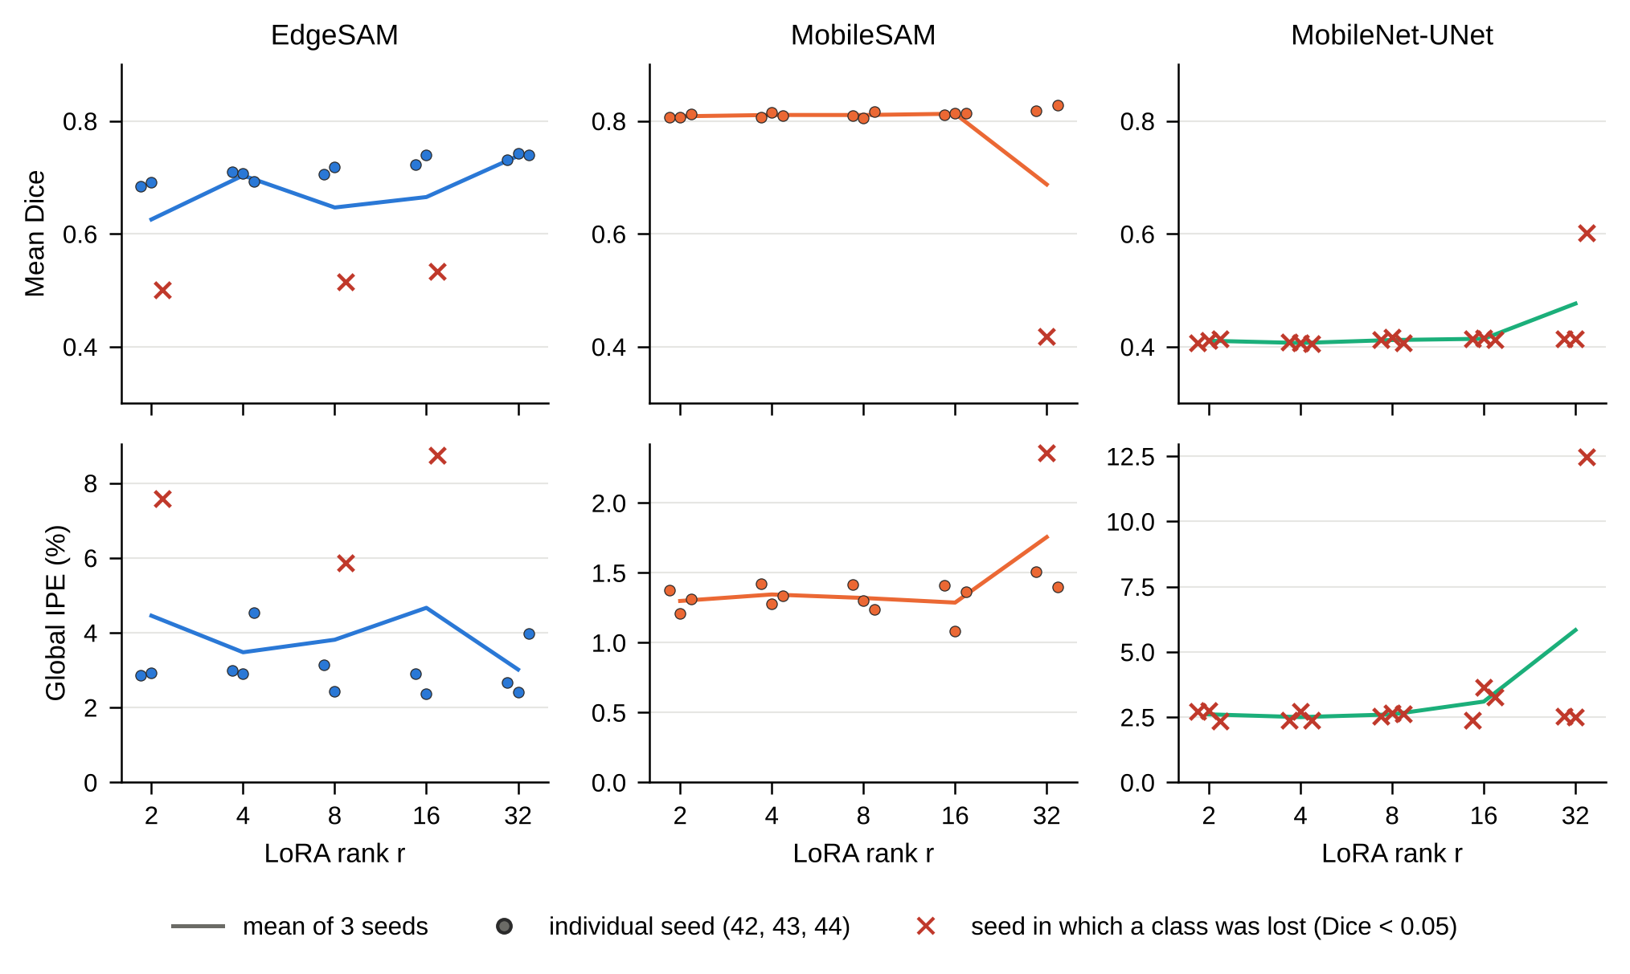
Fig. S-1 Mean Dice (top) and global IPE (bottom) against LoRA rank, full objective. Dots: individual seeds; crosses: seeds in which a class was lost (Dice < 0.05); line: mean of three seeds.
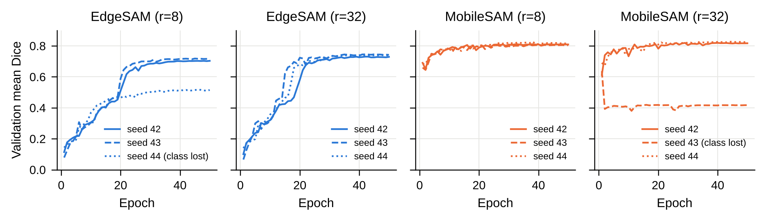
Fig. S-2 Validation mean Dice during training of EdgeSAM and MobileSAM at r=8 and r=32, one line per seed; seeds that ended with a lost class are marked in the legend.
S-II. Loss Ablation at All LoRA Ranks
Table S-2 gives the component-wise ablation (D: Dice only; P: Dice with PMC; B: Dice with PMC and BGA; F: full objective with IPP) for every architecture and rank. Over the 15 architecture–rank configurations, the mean global IPE of the full objective was lower than that of Dice alone in 15 and lower than that of Dice with PMC and BGA in 13; the seed-paired 95% interval excluded zero in 3 and 1 configurations, respectively. Over the 45 seed-paired comparisons, the full objective had the lower IPE in 42 against Dice alone and in 36 against Dice with PMC and BGA. A class was lost in 6, 3, and 13 of the 15 Dice-only runs of EdgeSAM, MobileSAM, and MobileNet-UNet, and in 3, 1, and 15 of the 15 full-objective runs. For EdgeSAM, the AJI of the full objective was higher than that of Dice with PMC and BGA in 0 of 15 seed-paired comparisons, and its Dice was higher than with Dice alone in 9 of 15.
TABLE S-2 Loss ablation at all LoRA ranks (means over seeds 42, 43, and 44).
Architecture | LoRA rank | Mean Dice (D / P / B / F) | Global IPE, % (D / P / B / F) | Seeds with a lost class (D / P / B / F)
EdgeSAM | 2 | 0.576 / 0.710 / 0.717 / 0.625 | 14.42 / 5.26 / 4.88 / 4.45 | 0 / 0 / 0 / 1
 | 4 | 0.610 / 0.727 / 0.723 / 0.703 | 10.96 / 4.68 / 4.98 / 3.48 | 1 / 0 / 0 / 0
 | 8 | 0.624 / 0.672 / 0.735 / 0.647 | 10.82 / 7.97 / 4.25 / 3.81 | 1 / 1 / 0 / 1
 | 16 | 0.621 / 0.741 / 0.742 / 0.665 | 11.05 / 3.71 / 3.43 / 4.66 | 2 / 0 / 0 / 1
 | 32 | 0.619 / 0.680 / 0.746 / 0.738 | 11.20 / 7.45 / 3.64 / 3.02 | 2 / 1 / 0 / 0
MobileSAM | 2 | 0.741 / 0.805 / 0.740 / 0.808 | 5.35 / 1.55 / 5.32 / 1.30 | 1 / 0 / 1 / 0
 | 4 | 0.811 / 0.806 / 0.741 / 0.811 | 1.44 / 1.50 / 5.23 / 1.34 | 0 / 0 / 1 / 0
 | 8 | 0.811 / 0.813 / 0.813 / 0.810 | 1.53 / 1.60 / 1.48 / 1.32 | 0 / 0 / 0 / 0
 | 16 | 0.813 / 0.813 / 0.817 / 0.813 | 1.54 / 1.58 / 1.55 / 1.29 | 0 / 0 / 0 / 0
 | 32 | 0.674 / 0.817 / 0.818 / 0.687 | 9.23 / 1.58 / 1.46 / 1.76 | 2 / 0 / 0 / 1
MobileNet-UNet | 2 | 0.416 / 0.413 / 0.549 / 0.410 | 17.98 / 19.88 / 12.40 / 2.61 | 3 / 3 / 3 / 3
 | 4 | 0.482 / 0.417 / 0.490 / 0.406 | 16.52 / 19.39 / 14.70 / 2.50 | 3 / 3 / 3 / 3
 | 8 | 0.485 / 0.414 / 0.544 / 0.412 | 15.48 / 19.79 / 13.96 / 2.60 | 2 / 3 / 2 / 3
 | 16 | 0.550 / 0.413 / 0.612 / 0.414 | 14.18 / 20.13 / 11.50 / 3.09 | 2 / 3 / 2 / 3
 | 32 | 0.359 / 0.486 / 0.418 / 0.476 | 20.83 / 15.96 / 19.54 / 5.83 | 3 / 3 / 3 / 3
S-III. Class-Specific Integrated-Phase Error and Dice
Table S-3 lists the class-specific IPE and Dice of the configurations of Table 1 and of the EdgeSAM loss ablation. A class that is not predicted in an image gives an IPE of 100% for that image, so the class-specific IPE is dominated by misclassification between morphologies; the global IPE over the whole foreground is the measure of integrated-phase preservation used in the main text.
TABLE S-3 Class-specific IPE (%) and Dice by mask value (1 discocyte, 2 spherocyte, 3 echinocyte, 4 stomatocyte), means over seeds 42, 43, and 44, including seeds in which a class was lost.
Configuration | Loss | IPE (%), 1 | IPE (%), 2 | IPE (%), 3 | IPE (%), 4 | Dice, 1 | Dice, 2 | Dice, 3 | Dice, 4
MobileNet-UNet (r=8) | + PMC + BGA + IPP (full) | 79.5 | 100.0 | 28.2 | 100.0 | 0.891 | 0.000 | 0.756 | 0.000
MobileSAM (r=8) | + PMC + BGA + IPP (full) | 7.2 | 22.1 | 28.7 | 55.2 | 0.923 | 0.851 | 0.760 | 0.708
EdgeSAM (r=8) | + PMC + BGA + IPP (full) | 22.5 | 51.5 | 34.3 | 49.6 | 0.882 | 0.513 | 0.628 | 0.563
EdgeSAM (r=32) | + PMC + BGA + IPP (full) | 6.4 | 24.2 | 28.7 | 52.2 | 0.895 | 0.789 | 0.655 | 0.614
EdgeSAM (r=8) | Dice | 6.5 | 64.2 | 28.7 | 49.4 | 0.893 | 0.343 | 0.668 | 0.592
EdgeSAM (r=8) | + PMC | 7.4 | 49.5 | 29.7 | 47.1 | 0.892 | 0.524 | 0.669 | 0.601
EdgeSAM (r=8) | + PMC + BGA | 7.6 | 22.1 | 31.5 | 46.7 | 0.892 | 0.783 | 0.654 | 0.612
EdgeSAM (r=32) | Dice | 7.0 | 71.2 | 30.8 | 43.6 | 0.898 | 0.272 | 0.675 | 0.630
EdgeSAM (r=32) | + PMC | 6.5 | 48.4 | 28.0 | 47.8 | 0.896 | 0.522 | 0.678 | 0.625
EdgeSAM (r=32) | + PMC + BGA | 6.4 | 24.8 | 30.4 | 44.6 | 0.896 | 0.781 | 0.678 | 0.627
S-IV. Segmentation Accuracy versus Inference Throughput
Fig. S-3 relates the mean Dice of the rank-8 models to their FP32 forward-pass throughput (Table 4 of the main text); both quantities refer to rank 8. Dice was evaluated with the PyTorch checkpoints and is plotted at the same value for both runtimes.
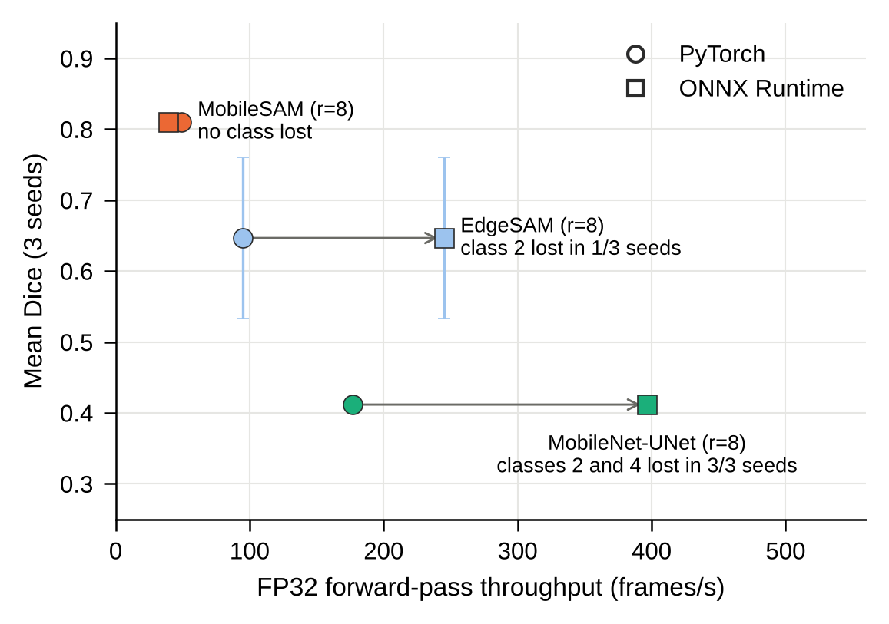
Fig. S-3 Mean Dice (mean ± SD over three seeds) against FP32 forward-pass throughput (mean of three timing passes) of the rank-8 models. Circles: PyTorch; squares: ONNX Runtime; class losses are noted next to each model.
S-V. Phase-Gradient Alignment of Predicted Contours
Fig. S-4 shows predicted cell contours on the phase-gradient magnitude for one validation window, as a qualitative illustration of the boundary cue used by the BGA term. Its quantitative effect is assessed by the loss ablation (Table 3 of the main text and Table S-2).
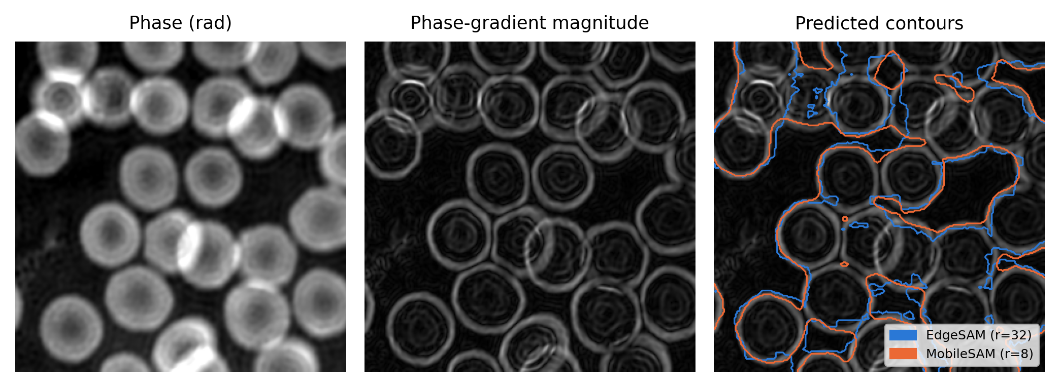
Fig. S-4 Phase map, phase-gradient magnitude, and contours of EdgeSAM (r=32) and MobileSAM (r=8) (seed 42) on the gradient magnitude, for the validation window with the most annotated foreground.
S-VI. Representative Phase Images over the Storage Period
Fig. S-5 shows one validation phase map from each of five storage days, with the EdgeSAM (r=32) contours.
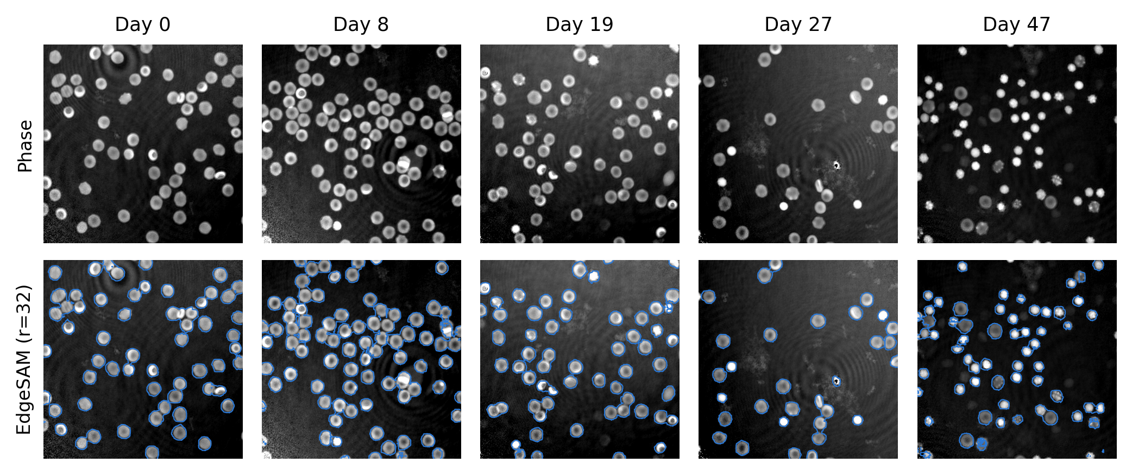
Fig. S-5 Phase maps from storage days 0, 8, 19, 27, and 47 (first validation image of each day); bottom row: EdgeSAM (r=32) contours (seed 42).
S-VII. Storage-Period Measurements per Day
Tables S-4 and S-5 give the per-day measurements behind Fig. 8 for EdgeSAM (r=32) and MobileSAM (r=8). Cells are 4-connected foreground components of 15 to 200 µm² that do not touch an unannotated region; phase-wrapped cells are excluded. Annotation columns give the mean and, in parentheses, the cell-level SD; prediction columns give the mean over seeds of the per-day cell mean and, in brackets, the smallest and largest seed value. Predicted components are not cell counts. On days marked †, fewer than 0.6 kept components were found per annotated cell, and the predicted means describe only the components that passed the filters. Fig. S-6 shows the kept-component ratio and the fate of all predicted components per day.
TABLE S-4 Per-day measurements: annotation and EdgeSAM (r=32), seeds 42, 43, and 44.
Day | Annotated cells | Area, annotation (µm²) | Dry mass, annotation (pg) | Kept components (seeds 42 / 43 / 44) | Kept / annotated | Area, prediction (µm²) | Dry mass, prediction (pg)
0 | 185 | 52.1 (21.6) | 31.7 (14.3) | 142 / 146 / 154 | 0.80 | 50.5 [48.4–52.6] | 31.5 [30.5–32.2]
5 | 211 | 51.2 (21.9) | 33.2 (15.0) | 139 / 144 / 159 | 0.70 | 58.5 [56.8–60.2] | 37.3 [36.7–37.7]
8 | 220 | 51.9 (24.4) | 34.9 (17.8) | 119 / 114 / 112 | 0.52 † | 59.3 [55.9–64.9] | 39.3 [37.4–42.3]
12 | 230 | 54.9 (31.8) | 36.3 (22.3) | 103 / 108 / 124 | 0.49 † | 61.6 [58.6–64.0] | 40.2 [38.6–41.2]
15 | 206 | 59.3 (32.6) | 40.9 (25.1) | 51 / 53 / 74 | 0.29 † | 60.7 [59.6–61.7] | 41.6 [40.1–42.8]
19 | 162 | 49.8 (23.7) | 32.2 (15.6) | 124 / 124 / 130 | 0.78 | 54.5 [50.7–57.7] | 35.5 [33.6–36.8]
23 | 108 | 49.5 (20.3) | 30.6 (12.4) | 92 / 95 / 95 | 0.87 | 49.8 [48.4–50.7] | 31.3 [30.8–31.7]
27 | 93 | 50.8 (22.9) | 33.0 (13.3) | 84 / 85 / 89 | 0.92 | 49.9 [48.6–51.5] | 33.2 [32.7–34.4]
30 | 188 | 46.0 (24.0) | 33.5 (15.2) | 160 / 164 / 161 | 0.86 | 44.5 [43.9–44.8] | 32.8 [32.5–33.0]
37 | 157 | 36.7 (16.8) | 31.0 (10.4) | 144 / 153 / 156 | 0.96 | 35.5 [33.9–37.3] | 30.1 [28.9–31.2]
47 | 228 | 27.1 (11.0) | 28.8 (7.5) | 180 / 192 / 183 | 0.81 | 28.9 [28.2–29.3] | 30.1 [29.4–30.6]
TABLE S-5 Per-day measurements: annotation and MobileSAM (r=8), seeds 42, 43, and 44.
Day | Annotated cells | Area, annotation (µm²) | Dry mass, annotation (pg) | Kept components (seeds 42 / 43 / 44) | Kept / annotated | Area, prediction (µm²) | Dry mass, prediction (pg)
0 | 185 | 52.1 (21.6) | 31.7 (14.3) | 138 / 138 / 140 | 0.75 | 52.5 [52.0–53.3] | 33.2 [32.9–33.8]
5 | 211 | 51.2 (21.9) | 33.2 (15.0) | 142 / 150 / 145 | 0.69 | 57.1 [56.1–58.4] | 37.7 [37.2–38.5]
8 | 220 | 51.9 (24.4) | 34.9 (17.8) | 104 / 105 / 107 | 0.48 † | 55.3 [54.8–55.8] | 37.3 [36.9–37.6]
12 | 230 | 54.9 (31.8) | 36.3 (22.3) | 105 / 104 / 106 | 0.46 † | 59.7 [58.4–61.0] | 39.7 [39.0–40.6]
15 | 206 | 59.3 (32.6) | 40.9 (25.1) | 34 / 32 / 40 | 0.17 † | 56.8 [51.2–62.7] | 39.1 [35.7–42.8]
19 | 162 | 49.8 (23.7) | 32.2 (15.6) | 127 / 127 / 130 | 0.79 | 52.2 [51.0–54.0] | 34.7 [34.0–35.5]
23 | 108 | 49.5 (20.3) | 30.6 (12.4) | 89 / 91 / 93 | 0.84 | 50.4 [49.4–51.6] | 31.7 [31.3–32.1]
27 | 93 | 50.8 (22.9) | 33.0 (13.3) | 81 / 81 / 83 | 0.88 | 52.9 [52.6–53.2] | 35.5 [35.2–35.7]
30 | 188 | 46.0 (24.0) | 33.5 (15.2) | 156 / 146 / 150 | 0.80 | 47.4 [45.9–48.2] | 35.4 [34.8–35.8]
37 | 157 | 36.7 (16.8) | 31.0 (10.4) | 147 / 146 / 146 | 0.93 | 39.2 [38.8–39.6] | 32.8 [32.4–33.2]
47 | 228 | 27.1 (11.0) | 28.8 (7.5) | 205 / 193 / 197 | 0.87 | 29.5 [28.0–30.6] | 31.5 [30.5–32.3]
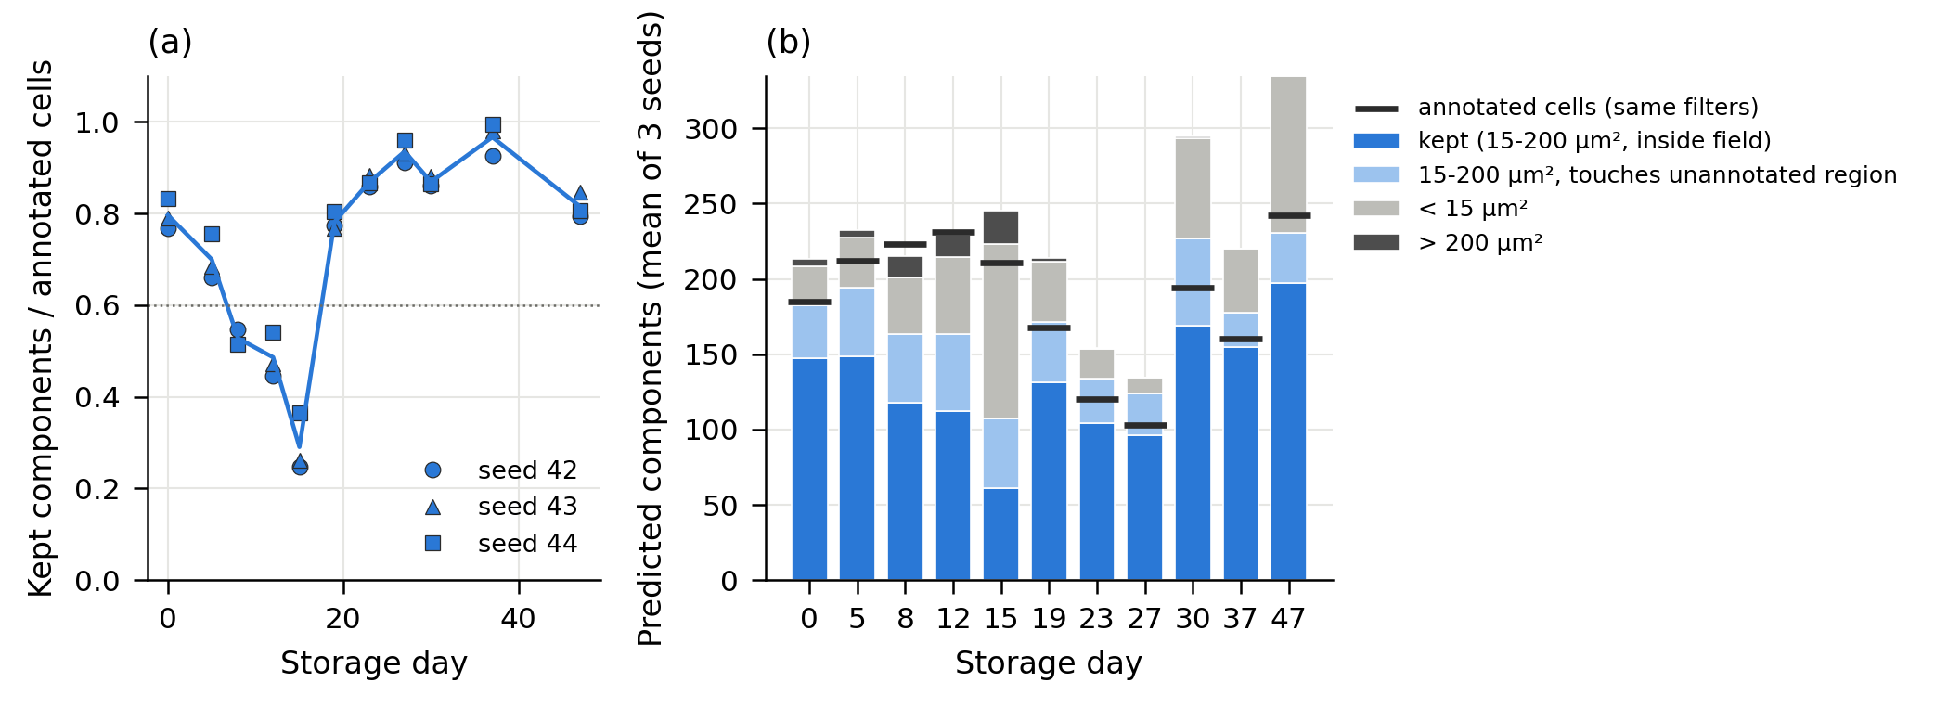
Fig. S-6 Predicted components of EdgeSAM (r=32) per storage day: (a) kept components divided by annotated cells (markers: seeds); (b) fate of the predicted components inside the annotated field (mean of three seeds, wrapped components included), with the annotated cells kept by the same filters.
S-VIII. Date-Clustered Storage Statistics
Table S-6 gives, for each segmentation and training seed, the image-level Spearman correlation with storage day, the permutation p-value with the 11 acquisition dates permuted as whole blocks (20,000 permutations), the 95% date-bootstrap interval (20,000 resamples), and the range of the correlation when each date is left out, for projected area, dry mass, and the per-image difference between predicted and annotation-derived dry mass. With 11 clusters and an undocumented donor structure, these tests are approximate and exploratory. For comparison, the table also gives the p-value of the image-level Spearman test that treats the 66 images as independent. That test is anti-conservative here, because the six images of a date share the same samples: for the EdgeSAM (r=32) dry mass it gives p = 0.008, 0.052, 0.036 for seeds 42, 43, and 44, whereas the date-clustered test gives p = 0.11, 0.17, 0.083. Conclusions in the main text are based on the date-clustered test.
TABLE S-6 Date-clustered storage statistics of the per-image medians (wrapped cells excluded).
Segmentation | Seed | Quantity (per-image median) | Spearman ρ | p (66 images as independent) | p (date permutation) | 95% date-bootstrap interval | Leave-one-date-out range
Annotation | – | Area | −0.53 | < 0.0001 | 0.019 | −0.85 to 0.03 | −0.64 to −0.38
Annotation | – | Dry mass | −0.11 | 0.36 | 0.27 | −0.33 to 0.11 | −0.20 to −0.04
EdgeSAM (r=32) | 42 | Area | −0.75 | < 0.0001 | 0.0008 | −0.93 to −0.27 | −0.84 to −0.66
EdgeSAM (r=32) | 43 | Area | −0.60 | < 0.0001 | 0.007 | −0.86 to −0.09 | −0.68 to −0.48
EdgeSAM (r=32) | 44 | Area | −0.60 | < 0.0001 | 0.005 | −0.86 to −0.10 | −0.68 to −0.47
EdgeSAM (r=32) | 42 | Dry mass | −0.32 | 0.008 | 0.11 | −0.56 to 0.07 | −0.49 to −0.27
EdgeSAM (r=32) | 43 | Dry mass | −0.24 | 0.052 | 0.17 | −0.47 to 0.05 | −0.35 to −0.18
EdgeSAM (r=32) | 44 | Dry mass | −0.26 | 0.036 | 0.083 | −0.48 to 0.05 | −0.41 to −0.20
EdgeSAM (r=32) | 42 | Dry-mass difference (prediction − annotation) | −0.29 | 0.020 | 0.078 | −0.46 to 0.05 | −0.39 to −0.22
EdgeSAM (r=32) | 43 | Dry-mass difference (prediction − annotation) | −0.21 | 0.085 | 0.20 | −0.43 to 0.08 | −0.31 to −0.15
EdgeSAM (r=32) | 44 | Dry-mass difference (prediction − annotation) | −0.23 | 0.059 | 0.090 | −0.41 to 0.04 | −0.34 to −0.18
MobileSAM (r=8) | 42 | Area | −0.59 | < 0.0001 | 0.005 | −0.87 to −0.10 | −0.66 to −0.46
MobileSAM (r=8) | 43 | Area | −0.59 | < 0.0001 | 0.006 | −0.86 to −0.09 | −0.67 to −0.46
MobileSAM (r=8) | 44 | Area | −0.49 | < 0.0001 | 0.027 | −0.81 to 0.03 | −0.60 to −0.33
MobileSAM (r=8) | 42 | Dry mass | −0.14 | 0.27 | 0.36 | −0.38 to 0.16 | −0.27 to −0.08
MobileSAM (r=8) | 43 | Dry mass | −0.20 | 0.11 | 0.24 | −0.45 to 0.14 | −0.36 to −0.15
MobileSAM (r=8) | 44 | Dry mass | −0.16 | 0.20 | 0.33 | −0.43 to 0.17 | −0.32 to −0.09
MobileSAM (r=8) | 42 | Dry-mass difference (prediction − annotation) | −0.03 | 0.80 | 0.79 | −0.19 to 0.14 | −0.11 to 0.01
MobileSAM (r=8) | 43 | Dry-mass difference (prediction − annotation) | −0.05 | 0.69 | 0.63 | −0.23 to 0.14 | −0.14 to −0.008
MobileSAM (r=8) | 44 | Dry-mass difference (prediction − annotation) | −0.003 | 0.98 | 0.98 | −0.22 to 0.22 | −0.11 to 0.04
S-IX. Per-Seed Storage Measurements
Table S-7 lists, for EdgeSAM (r=32) and MobileSAM (r=8), every training seed and storage day: the number of kept components, their ratio to the annotated cells, the mean and cell-level SD of projected area and dry mass, the mean circularity, and the share of components assigned to each class (mask values 1 to 4: discocyte, spherocyte, echinocyte, stomatocyte). Cells are not pooled across seeds; phase-wrapped cells are excluded. The annotation values for each day are given in Tables S-4 and S-5.
TABLE S-7 Per-seed, per-day measurements of the kept predicted components (six images per day). Kept: number of kept components; Kept / ann.: ratio to the annotated cells of the day; area and dry mass: mean (cell-level SD); Class 1 to 4: share of components by mask value.
Configuration | Seed | Day | Kept | Kept / ann. | Area (µm²) | Dry mass (pg) | Circularity | Class 1 (%) | Class 2 (%) | Class 3 (%) | Class 4 (%)
EdgeSAM (r=32) | 42 | 0 | 142 | 0.77 | 52.6 (22.5) | 32.2 (13.9) | 0.854 | 93.0 | 0.0 | 2.1 | 4.9
 |  | 5 | 139 | 0.66 | 60.2 (29.7) | 37.7 (18.4) | 0.810 | 95.0 | 0.0 | 0.7 | 4.3
 |  | 8 | 119 | 0.54 | 64.9 (38.6) | 42.3 (26.6) | 0.764 | 93.3 | 0.0 | 1.7 | 5.0
 |  | 12 | 103 | 0.45 | 64.0 (36.8) | 41.2 (23.9) | 0.762 | 84.5 | 1.0 | 5.8 | 8.7
 |  | 15 | 51 | 0.25 | 61.7 (34.3) | 41.8 (23.3) | 0.682 | 86.3 | 0.0 | 5.9 | 7.8
 |  | 19 | 124 | 0.77 | 57.7 (33.1) | 36.8 (19.9) | 0.792 | 83.1 | 2.4 | 7.3 | 7.3
 |  | 23 | 92 | 0.85 | 50.7 (20.7) | 31.7 (12.5) | 0.839 | 82.6 | 3.3 | 8.7 | 5.4
 |  | 27 | 84 | 0.90 | 49.6 (26.0) | 32.7 (14.0) | 0.841 | 70.2 | 10.7 | 14.3 | 4.8
 |  | 30 | 160 | 0.85 | 44.8 (25.6) | 33.0 (14.7) | 0.809 | 54.4 | 21.9 | 19.4 | 4.4
 |  | 37 | 144 | 0.92 | 37.3 (19.6) | 31.2 (12.9) | 0.831 | 34.7 | 45.1 | 18.1 | 2.1
 |  | 47 | 180 | 0.79 | 29.3 (14.5) | 30.2 (10.7) | 0.808 | 11.1 | 66.7 | 21.1 | 1.1
 | 43 | 0 | 146 | 0.79 | 50.4 (24.2) | 31.8 (14.8) | 0.875 | 91.8 | 0.0 | 2.1 | 6.2
 |  | 5 | 144 | 0.68 | 58.4 (30.3) | 37.5 (18.8) | 0.814 | 92.4 | 0.0 | 1.4 | 6.2
 |  | 8 | 114 | 0.52 | 57.1 (30.8) | 38.1 (21.1) | 0.789 | 87.7 | 0.0 | 4.4 | 7.9
 |  | 12 | 108 | 0.47 | 58.6 (34.7) | 38.6 (22.9) | 0.786 | 83.3 | 0.9 | 7.4 | 8.3
 |  | 15 | 53 | 0.26 | 59.6 (40.2) | 40.1 (23.7) | 0.736 | 75.5 | 5.7 | 5.7 | 13.2
 |  | 19 | 124 | 0.77 | 55.2 (33.0) | 36.1 (19.6) | 0.795 | 75.0 | 3.2 | 8.1 | 13.7
 |  | 23 | 95 | 0.88 | 50.2 (23.7) | 31.5 (13.4) | 0.837 | 84.2 | 4.2 | 9.5 | 2.1
 |  | 27 | 85 | 0.91 | 51.5 (26.8) | 34.4 (14.8) | 0.841 | 71.8 | 10.6 | 14.1 | 3.5
 |  | 30 | 164 | 0.87 | 44.8 (26.7) | 33.0 (15.3) | 0.796 | 54.3 | 21.3 | 22.0 | 2.4
 |  | 37 | 153 | 0.97 | 35.2 (16.5) | 30.1 (10.7) | 0.857 | 34.6 | 45.1 | 18.3 | 2.0
 |  | 47 | 192 | 0.84 | 29.2 (13.8) | 30.6 (11.8) | 0.827 | 10.9 | 65.6 | 22.4 | 1.0
 | 44 | 0 | 154 | 0.83 | 48.4 (20.3) | 30.5 (12.8) | 0.869 | 90.3 | 0.0 | 1.9 | 7.8
 |  | 5 | 159 | 0.75 | 56.8 (29.0) | 36.7 (17.8) | 0.809 | 89.9 | 0.0 | 1.9 | 8.2
 |  | 8 | 112 | 0.51 | 55.9 (32.7) | 37.4 (22.1) | 0.775 | 89.3 | 0.0 | 3.6 | 7.1
 |  | 12 | 124 | 0.54 | 62.2 (37.6) | 40.9 (24.5) | 0.746 | 83.1 | 0.8 | 4.8 | 11.3
 |  | 15 | 74 | 0.36 | 60.7 (38.3) | 42.8 (27.0) | 0.678 | 82.4 | 4.1 | 8.1 | 5.4
 |  | 19 | 130 | 0.80 | 50.7 (27.5) | 33.6 (17.7) | 0.804 | 76.9 | 2.3 | 6.2 | 14.6
 |  | 23 | 95 | 0.88 | 48.4 (19.9) | 30.8 (12.2) | 0.827 | 78.9 | 4.2 | 11.6 | 5.3
 |  | 27 | 89 | 0.96 | 48.6 (22.7) | 32.7 (12.9) | 0.820 | 69.7 | 11.2 | 15.7 | 3.4
 |  | 30 | 161 | 0.86 | 43.9 (25.0) | 32.5 (14.8) | 0.795 | 53.4 | 20.5 | 23.0 | 3.1
 |  | 37 | 156 | 0.99 | 33.9 (14.9) | 28.9 (8.2) | 0.849 | 34.6 | 46.2 | 17.9 | 1.3
 |  | 47 | 183 | 0.80 | 28.2 (12.7) | 29.4 (9.5) | 0.826 | 10.9 | 69.9 | 19.1 | 0.0
MobileSAM (r=8) | 42 | 0 | 138 | 0.75 | 52.2 (24.3) | 33.0 (15.4) | 0.920 | 90.6 | 0.0 | 2.9 | 6.5
 |  | 5 | 142 | 0.67 | 58.4 (30.9) | 38.5 (20.5) | 0.874 | 92.3 | 0.0 | 1.4 | 6.3
 |  | 8 | 104 | 0.47 | 55.8 (28.1) | 37.6 (17.8) | 0.872 | 93.3 | 0.0 | 3.8 | 2.9
 |  | 12 | 105 | 0.46 | 61.0 (37.3) | 40.6 (24.4) | 0.860 | 85.7 | 1.0 | 3.8 | 9.5
 |  | 15 | 34 | 0.17 | 56.6 (31.2) | 38.8 (20.4) | 0.862 | 79.4 | 2.9 | 11.8 | 5.9
 |  | 19 | 127 | 0.78 | 54.0 (29.1) | 35.5 (18.2) | 0.882 | 77.2 | 2.4 | 6.3 | 14.2
 |  | 23 | 89 | 0.82 | 51.6 (20.9) | 32.1 (13.1) | 0.909 | 86.5 | 1.1 | 10.1 | 2.2
 |  | 27 | 81 | 0.87 | 52.8 (29.4) | 35.7 (17.2) | 0.895 | 75.3 | 9.9 | 13.6 | 1.2
 |  | 30 | 156 | 0.83 | 45.9 (26.6) | 34.8 (16.7) | 0.898 | 54.5 | 18.6 | 22.4 | 4.5
 |  | 37 | 147 | 0.94 | 38.8 (21.4) | 32.4 (14.7) | 0.935 | 34.7 | 39.5 | 23.8 | 2.0
 |  | 47 | 205 | 0.90 | 28.0 (13.2) | 30.5 (11.3) | 0.931 | 8.8 | 61.5 | 29.3 | 0.5
 | 43 | 0 | 138 | 0.75 | 53.3 (25.3) | 33.8 (15.7) | 0.910 | 93.5 | 0.0 | 2.2 | 4.3
 |  | 5 | 150 | 0.71 | 56.1 (27.5) | 37.2 (18.2) | 0.884 | 93.3 | 0.0 | 1.3 | 5.3
 |  | 8 | 105 | 0.48 | 54.8 (25.4) | 36.9 (17.3) | 0.876 | 92.4 | 0.0 | 3.8 | 3.8
 |  | 12 | 104 | 0.45 | 58.4 (33.7) | 39.0 (22.7) | 0.872 | 87.5 | 1.0 | 3.8 | 7.7
 |  | 15 | 32 | 0.16 | 62.7 (36.3) | 42.8 (24.7) | 0.837 | 81.2 | 3.1 | 3.1 | 12.5
 |  | 19 | 127 | 0.78 | 51.6 (26.9) | 34.5 (16.8) | 0.898 | 78.0 | 2.4 | 6.3 | 13.4
 |  | 23 | 91 | 0.84 | 50.2 (19.6) | 31.7 (12.4) | 0.916 | 84.6 | 2.2 | 12.1 | 1.1
 |  | 27 | 81 | 0.87 | 52.6 (28.5) | 35.2 (16.7) | 0.906 | 75.3 | 8.6 | 13.6 | 2.5
 |  | 30 | 146 | 0.78 | 48.2 (27.5) | 35.7 (17.3) | 0.891 | 58.2 | 17.8 | 19.9 | 4.1
 |  | 37 | 146 | 0.93 | 39.6 (20.9) | 33.2 (13.7) | 0.920 | 34.2 | 41.1 | 23.3 | 1.4
 |  | 47 | 193 | 0.85 | 30.6 (17.4) | 32.3 (14.4) | 0.921 | 9.8 | 61.1 | 28.5 | 0.5
 | 44 | 0 | 140 | 0.76 | 52.0 (24.5) | 32.9 (15.1) | 0.921 | 92.1 | 0.0 | 2.1 | 5.7
 |  | 5 | 145 | 0.69 | 56.9 (28.4) | 37.5 (18.8) | 0.882 | 94.5 | 0.0 | 1.4 | 4.1
 |  | 8 | 107 | 0.49 | 55.4 (29.3) | 37.3 (19.0) | 0.877 | 92.5 | 0.0 | 3.7 | 3.7
 |  | 12 | 106 | 0.46 | 59.6 (36.2) | 39.6 (23.8) | 0.869 | 84.9 | 0.9 | 3.8 | 10.4
 |  | 15 | 40 | 0.19 | 51.2 (24.6) | 35.7 (15.3) | 0.895 | 80.0 | 5.0 | 7.5 | 7.5
 |  | 19 | 130 | 0.80 | 51.0 (25.7) | 34.0 (16.3) | 0.900 | 74.6 | 1.5 | 6.9 | 16.9
 |  | 23 | 93 | 0.86 | 49.4 (19.6) | 31.3 (12.5) | 0.919 | 83.9 | 2.2 | 11.8 | 2.2
 |  | 27 | 83 | 0.89 | 53.2 (28.9) | 35.5 (16.8) | 0.904 | 71.1 | 9.6 | 15.7 | 3.6
 |  | 30 | 150 | 0.80 | 48.2 (28.7) | 35.8 (17.6) | 0.896 | 58.0 | 19.3 | 19.3 | 3.3
 |  | 37 | 146 | 0.93 | 39.2 (21.8) | 32.7 (14.7) | 0.930 | 34.2 | 39.0 | 24.0 | 2.7
 |  | 47 | 197 | 0.86 | 29.8 (15.0) | 31.8 (12.9) | 0.924 | 9.6 | 63.5 | 26.4 | 0.5

