Part A: Know Your Hardware:
CPU (Processor):
• Model Name: 12th Gen Intel(R) Core(TM) i5-12450H
• Number of Cores: 8
• Logical Processors:12
RAM (Memory):
• Total RAM: 32.0 GB DDR4
• RAM Speed (MHz): 3200 MT/s
Storage (Disk):
• Disk Type (HDD/SSD): SSD
• Total Disk Size: 477 GB
GPU (Graphics):
• GPU Name: Intel(R) UHD Graphics
• Dedicated Memory (if any): 0.0/4.0 GB
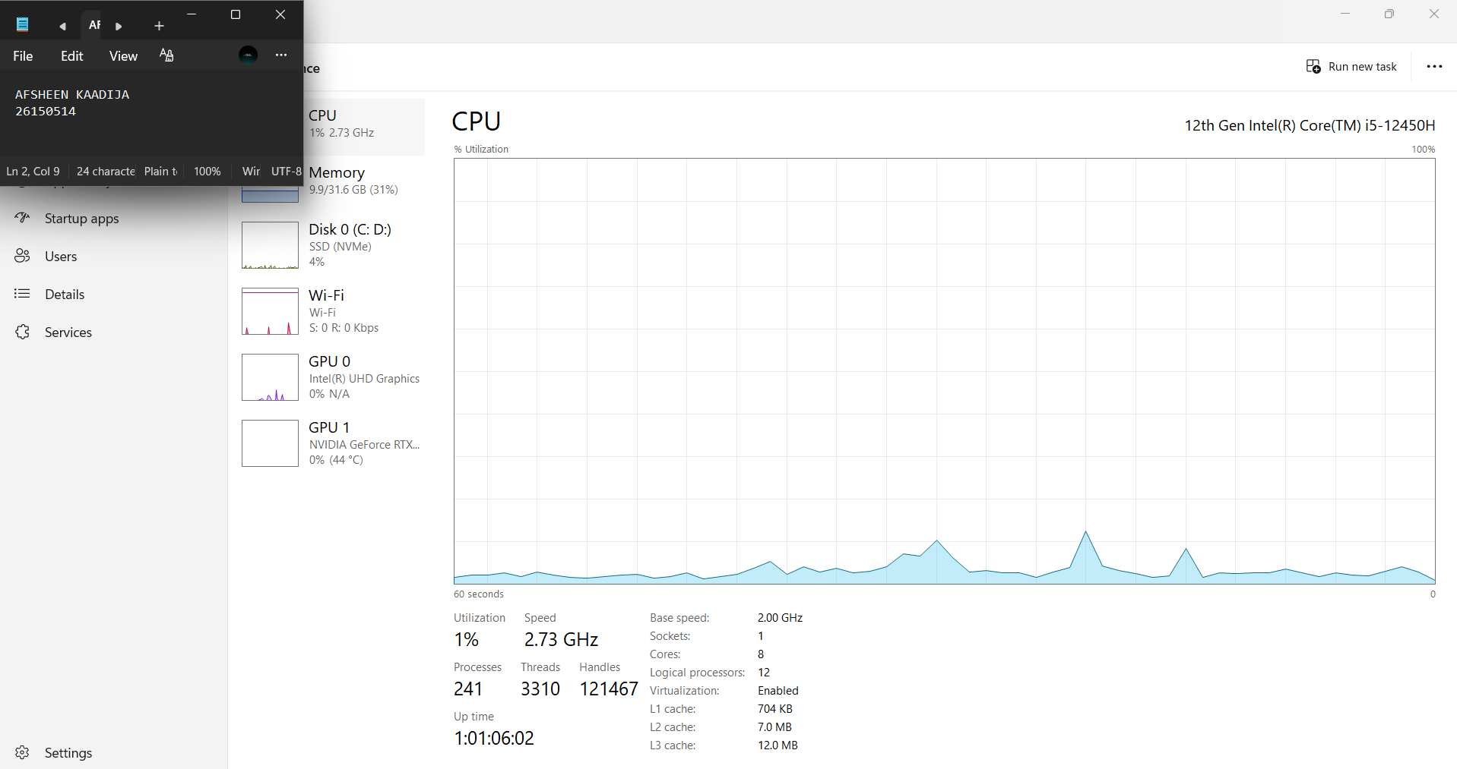
Part B Windows System Information:
• BIOS Version/Date: AMI F.18, 21-08-2024
• OS Name: Microsoft Windows 11 Home Single language
• OS Version: 10.0.26300
• OS Build: Build 26300
• System Manufacturer: HP
• System Model: Victus by HP Gaming Laptop 15-fa 1xxx
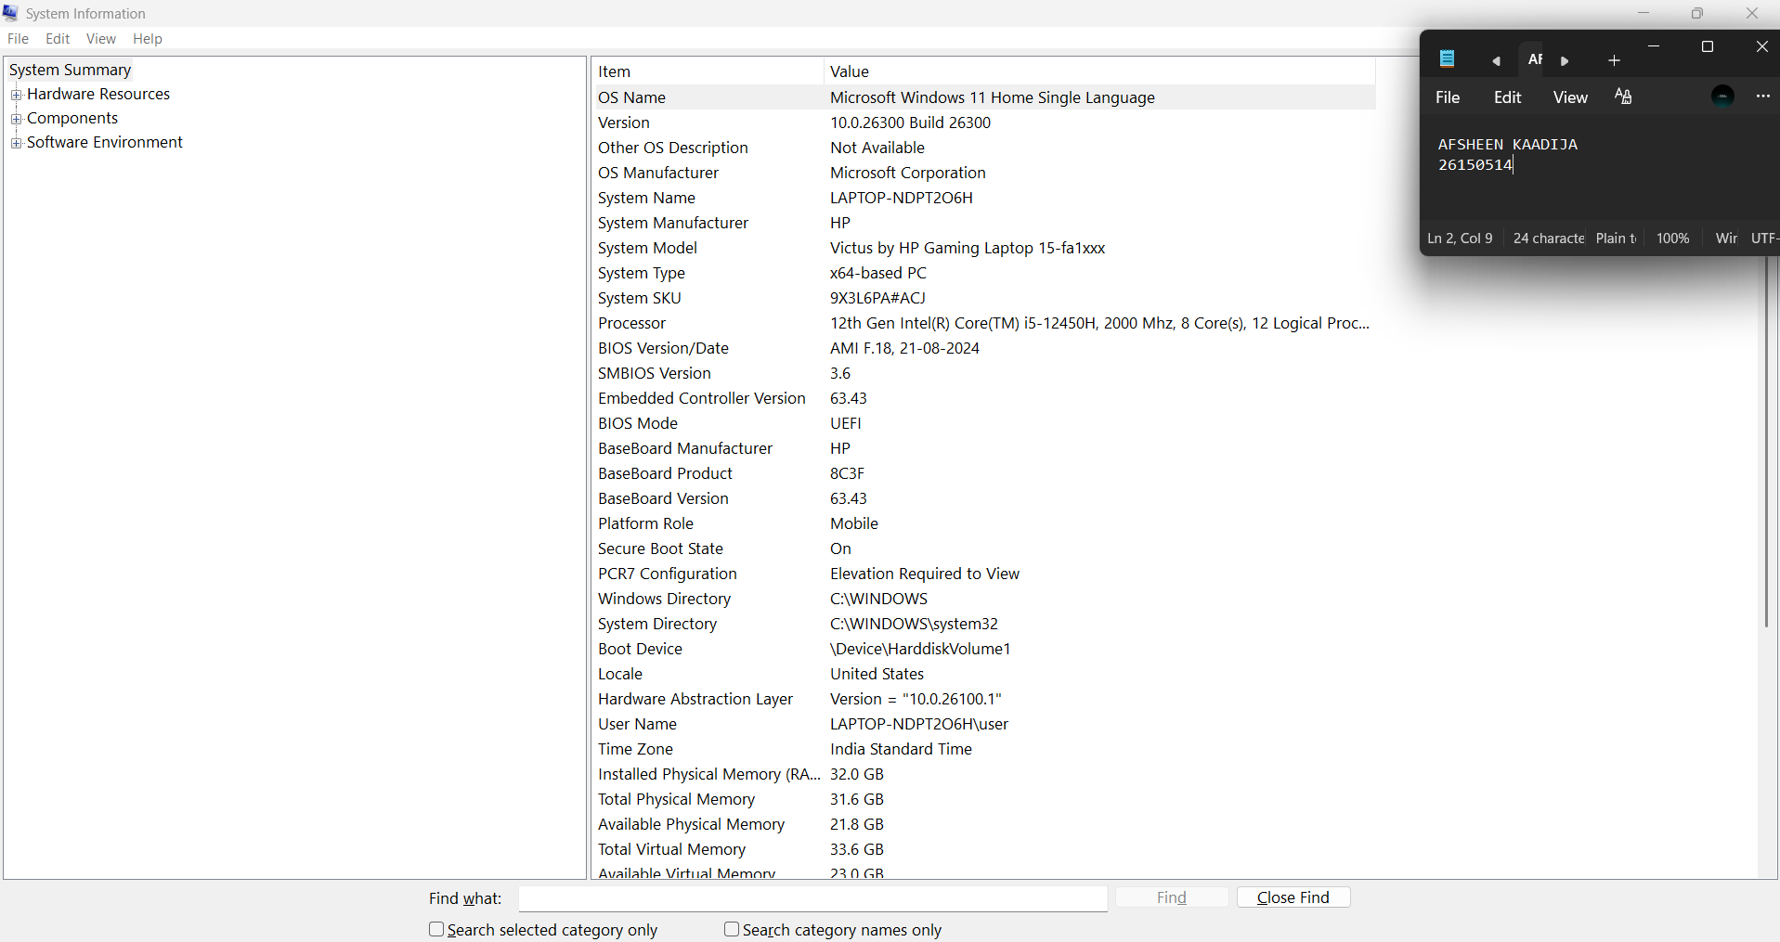

Part C: Windows Command Prompt Commands:
1.whoami
• What it does: Shows your Windows username and domain
• Your output: Laptop-ndpt2o6h\user
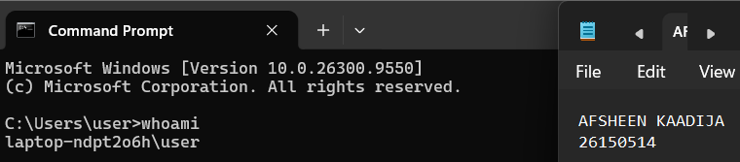 2. Ipconfig
• What it does: Shows your network configuration (IP address,
gateway, DNS)
• Your IP Address: 10.227.233.156
• Your Default Gateway: fe80: :4b1:9bff:fea4:79da%3
10.227.233.169
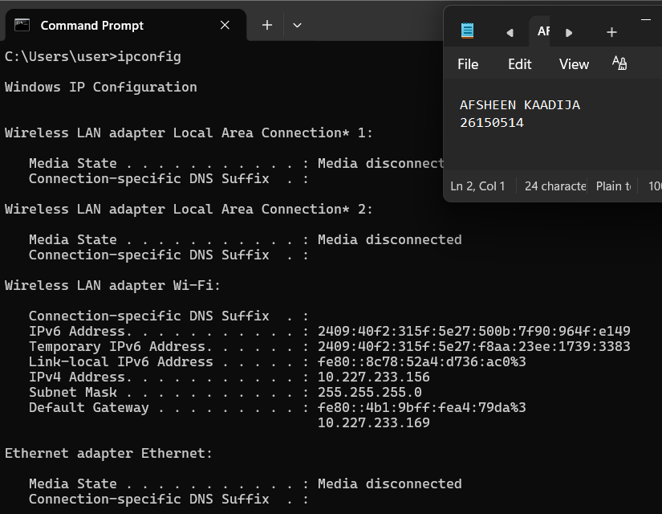
3. dir
• What it does: Lists all files and folders in current directory
• Record 3 folders you see: bca, Desktop, Documents
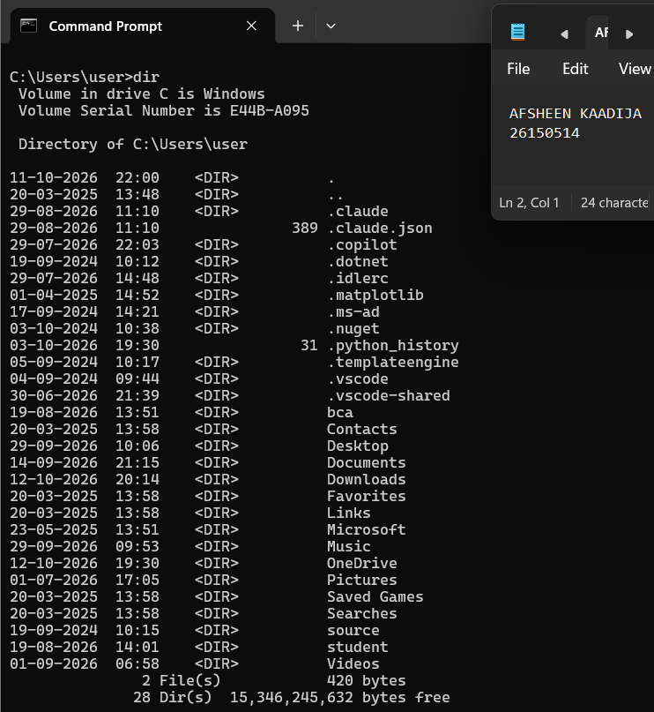
4. mkdir BCA_Test
• What it does: Creates a new folder named "BCA_Test"
• Verify by typing: dir
• Did you see "BCA_Test" folder created? Yes / No: Yes
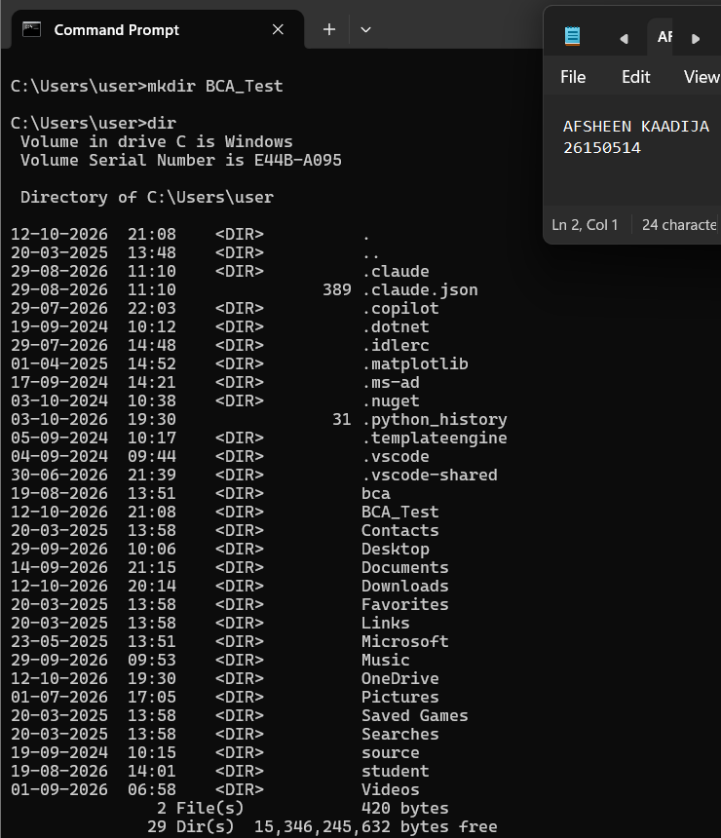
5. tasklist
• What it does: Lists all running programs
• Record 5 running processes: System Idle Process, System, Secure System, Registry, smss.exe.
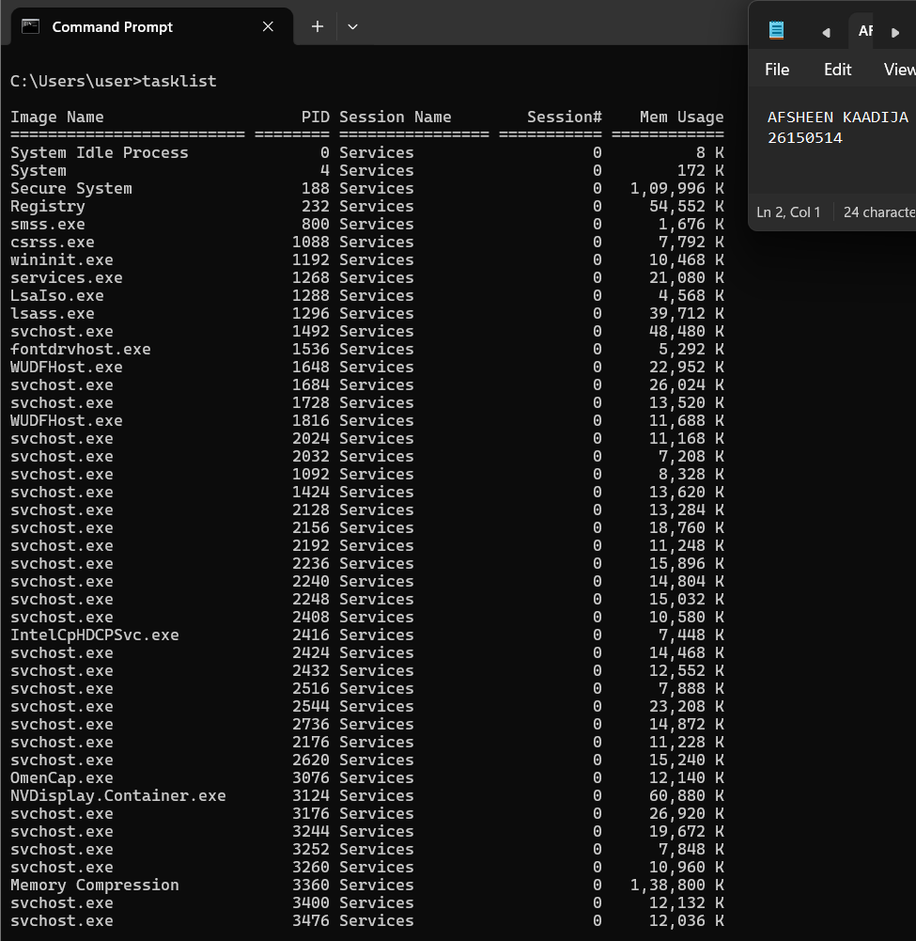
6. systeminfo
• What it does: Shows detailed Windows system information
• Record your Processor: 1 processor(s) Installed.
[01]: Intel64 Family 6 Model 154 Stepping 3 GenuineIntel ~2000 Mhz
• Record your Total Physical Memory: 32,409 MB
