

实 验（实训）报 告

项 目 名 称 | Basic Operations of DBMS and SQL
所 属 课程名称 | Database Theory and Application
项 目 类 型 | Computer Operation
实验(实训)日期
学 院 | Information Technology and Artificial Intelligence
班 级 | 人工智能1班
学 号
姓 名
指导教师

浙江财经大学教务处制

一、实验（实训）概述（目的及要求，基本原理，实施环境、使用的材料、设备、软件等）（可加页）
- Objects
- Study DBMS environment of Microsoft SQL Server.
- Create database.
- Create table.
- Insert data into the database.
- Understand basic SELECT statements.
- Environment and Software
- Personal Computer
- Windows 10 / Windows 11
- Microsoft SQL Server
二、实验（实训）内容（项目内容，方案设计，实验（实训）过程步骤、记录、数据、程序，结果与分析等）（可加页）
- Contents
- Be familiar with operation process and interfaces of Microsoft SQL Server.
- Create Studentdb Database.
- Create all tables of Studentdb database, including Student, Course and SC.
- Insert data into Student, Course and SC.
- Write and test SQL statement according to the query.

- The deadline to submit report
23:59, April 9, 2026

- (Design), process, source code and result
Write and test SQL statement, paste SQL statement and the interface of the running result of SQL statement.

[1] Create Studentdb database.
CREATE DATABASE Studentdb
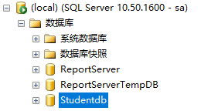

[2] Create Student table in Studentdb.
Attribute | Data type | Null Allowed | Remark
Sno | char(4) | N | Primary key
Sname | varchar(50) | N
Gender | char(2) | Y
Birthday | datetime | Y
Haddress | varchar(100) | Y | Home address
Height | float(2) | Y
CREATE TABLE Student(Sno char(4) Primary Key, Sname varchar(50) NOT NULL, Gender char(2),Birthday datetime, Haddress varchar(100), Height float(2))
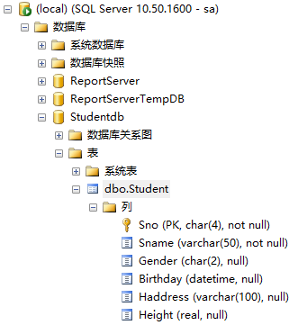

[3] Create Course table in Studentdb.
Attribute | Data type | Null Allowed | Remark
Cno | char(4) | N | Primary key
Cname | varchar(50) | N
Credit | int | Y
CREATE TABLE Course (Cno char(4) Primary Key, Cname varchar(50) NOT NULL, Credit int);
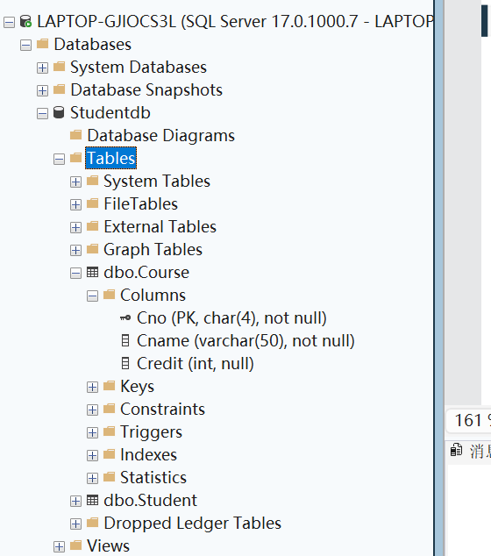

[4] Create SC table in Studentdb.
Attribute | Data type | Null Allowed | Remark
Sno | char(4) | N | Primary key
Cno | char(4) | N | Primary key
Grade | float(1) | Y
CREATE TABLE SC ( Sno char(4), Cno char(4), Grade float(1), PRIMARY KEY (Sno, Cno) );
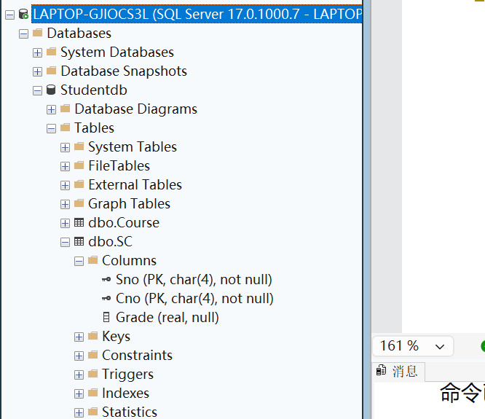

[5] Insert the following data into Student table.
Sno | Sname | Gender | Birthday | Haddress | Height
0001 | Liu Yiping | M | 1990-10-1 | No. 55, Huangchengxi Road, Wenzhou | 1.78
0002 | Zhang Demin | M | 1990-12-2 | No. 22, Xiasha Road， Hangzhou | 1.65
0003 | Ma Dong | M |  | 990-7-4  No. 20, Zhongshanbei Road, Ningbo | 1.71
0004 | Xiao Haiyan | F | 1990-3-15 | No. 43, Yuexiubei Road, Wenzhou | 1.65
0005 | Zhang Minghua | F | 1991-5-13 | No. 7, Genshan Road, Hangzhou | 1.63
INSERT INTO Student VALUES ('0001', 'Liu Yiping','M', '1990-10-1', 'No. 55, Huangchengxi Road, Wenzhou', 1.78);
INSERT INTO Student VALUES ('0002', 'Zhang Demin','M', '1990-12-2', 'No. 22, Xiasha Road，Hangzhou', 1.65);
INSERT INTO Student VALUES ('0003', 'Ma Dong','M', '1990-7-4', 'No. 20, Zhongshanbei Road, Ningbo', 1.71);
INSERT INTO Student VALUES ('0004', 'Xiao Haiyan','F', '1990-3-15', 'No. 43, Yuexiubei Road, Wenzhou', 1.65);
INSERT INTO Student VALUES ('0005', 'Zhang Minghua','F', '1991-5-13', 'No. 7, Genshan Road, Hangzhou', 1.63);

SELECT * FROM Student
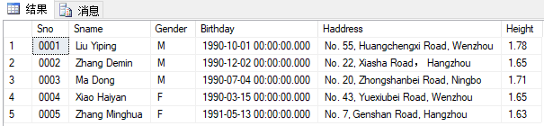

[6] Insert the following data into Course table
Cno | Cname | Credit
0001 | Computer Fundamental | 2
0002 | Management Theory | 3
0003 | Database Theory and Application | 3
0004 | Project Management | 2
0005 | Thesis | 10

INSERT INTO Course (Cno, Cname, Credit) VALUES ('0001', 'Computer Fundamental', 2), ('0002', 'Management Theory', 3), ('0003', 'Database Theory and Application', 3), ('0004', 'Project Management', 2), ('0005', 'Thesis', 10);

SELECT * FROM Course

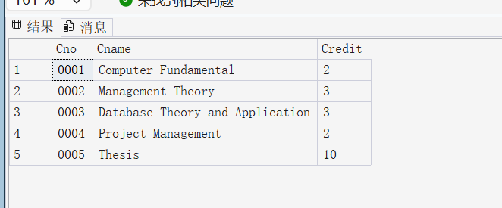

[7] Insert the following data into SC table
Sno | Cno | Grade
0001 | 0001 | 80.0
0001 | 0002 | 90.0
0001 | 0003 | 70.0
0001 | 0004 | 85.0
0001 | 0005 | 92.0
0002 | 0001 | 78.0
0002 | 0002 | NULL
0002 | 0003 | 77.0
0002 | 0004 | 67.0
0003 | 0001 | 66.0
0003 | 0002 | 76.0
0003 | 0003 | NULL
0003 | 0004 | 73.0

INSERT INTO SC (Sno, Cno, Grade) VALUES ('0001', '0001', 80.0), ('0001', '0002', 90.0), ('0001', '0003', 70.0), ('0001', '0004', 85.0), ('0001', '0005', 92.0), ('0002', '0001', 78.0), ('0002', '0002', NULL), ('0002', '0003', 77.0), ('0002', '0004', 67.0), ('0003', '0001', 66.0), ('0003', '0002', 76.0), ('0003', '0003', NULL), ('0003', '0004', 73.0);

SELECT * FROM SC

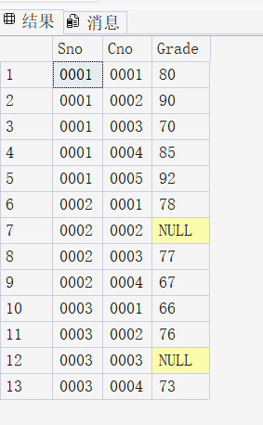
[8] List all information of all students.
SELECT * FROM Student

[9] List the name and address information of all students.
SELECT Sname, Saddr
FROM Student;

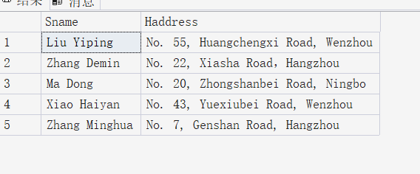
[10] List all information of the students whose last name is ‘Liu’.
SELECT * FROM Student
WHERE Sname LIKE 'Liu%';
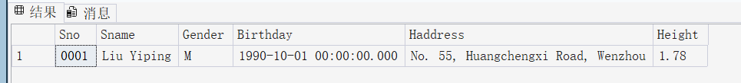
[11] List all information of the students whose name included ‘Min’.
SELECT * FROM Student
WHERE Sname LIKE '%Min%';
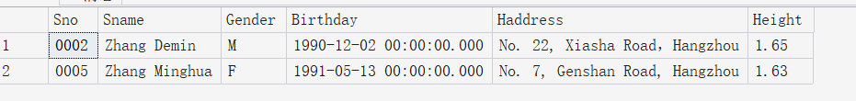
[12] List the Sno and Sname of all male students with height is greater than 1.75
SELECT Sno, Sname
FROM Student
WHERE Gender = 'M' AND Height > 1.75;
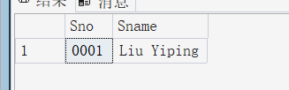
[13] List the name, gender and age of all students from Ningbo city.
* Learn the usage of Getdate() andYear() Function through Baidu
SELECT Sname, Gender, YEAR(GETDATE()) - YEAR(Birthday) AS Age
FROM Student
WHERE Haddress LIKE '%Ningbo%';
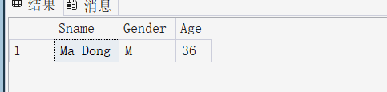
[14] List the Sno and Cno of students who have taken course but have no grade.
* no grade is mean that the value is NULL.
SELECT Sno, Cno
FROM SC
WHERE Grade IS NULL;
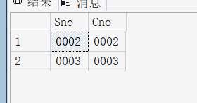

[15] List Cno and Cname of all courses which credit is between 1 and 5.
SELECT Cno, Cname
FROM Course
WHERE Credit BETWEEN 1 AND 5;
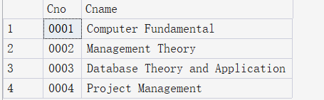
[16] List all information of course named ‘Database Theory and Application’.
SELECT * FROM Course
WHERE Cname = 'Database Theory and Application';
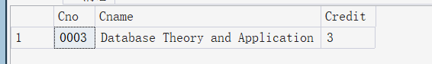
[17] List Sno and Grade of course with ‘0001’, and order by Grade according descend.
SELECT Sno, Grade
FROM SC
WHERE Cno = '0001'
ORDER BY Grade DESC;
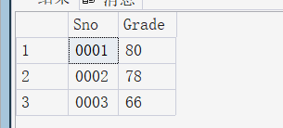
- Conclusion and Analysis

三、Comments and Score
Comments：

Score： Signature of teacher：
Date:

