

实 验（实训）报 告

项 目 名 称 | Operations of Complicated Query
所 属 课程名称 | Database Theory and Application
项 目 类 型 | Computer Operation
实验(实训)日期
学 院 | Information Technology and Artificial Intelligence
班 级 | 1班
学 号
姓 名
指导教师

浙江财经大学教务处制

一、实验（实训）概述（目的及要求，基本原理，实施环境、使用的材料、设备、软件等）（可加页）
- Objects
- Study DBMS environment of Microsoft SQL Server.
- Create database.
- Create table.
- Insert data into the database.
- Practice of complicated query..
- Environment and Software
- Personal Computer
- Windows 10 / Windows 11
- Microsoft SQL Server
二、实验（实训）内容（项目内容，方案设计，实验（实训）过程步骤、记录、数据、程序，结果与分析等）（可加页）
- Contents
- Be familiar with operation process and interfaces of Microsoft SQL Server.
- Create Studentdb Database.
- Create all tables of Studentdb database, including Student, Course and SC.
- Insert data into Student, Course and SC.
- Write and test SQL statement according to the query.

- The deadline to submit report
23:59, April 23, 2026

- (Design), process, source code and result
Write and test SQL statement, paste SQL Statement and the interface of the running result of SQL statement.

[1] List the highest score of ‘0002’ course.
SELECT MAX(Grade) AS highest_score_0002
FROM SC
WHERE Cno = '0002';

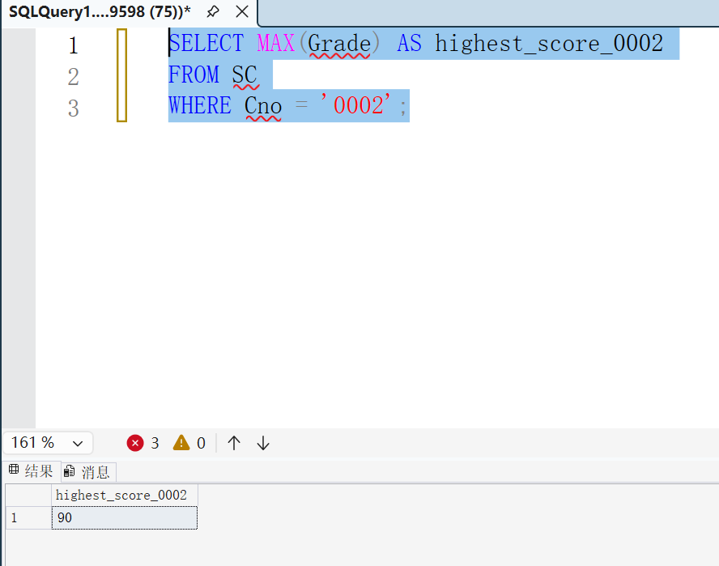

[2] List the number of how many students have taken examination of ‘0001’ course.
SELECT COUNT(DISTINCT Sno) AS student_exam_count_0001
FROM SC
WHERE Cno = '0001' AND Grade IS NOT NULL;

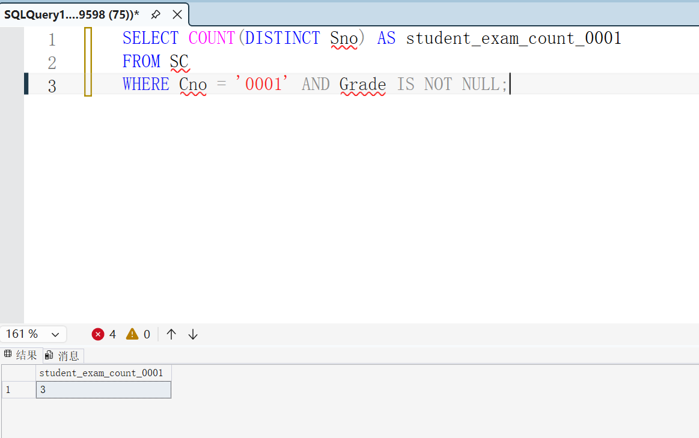
[3] List the average score of ‘0003’ course which student have taken examination.
SELECT AVG(Grade) AS average_score_0003
FROM SC
WHERE Cno = '0003';
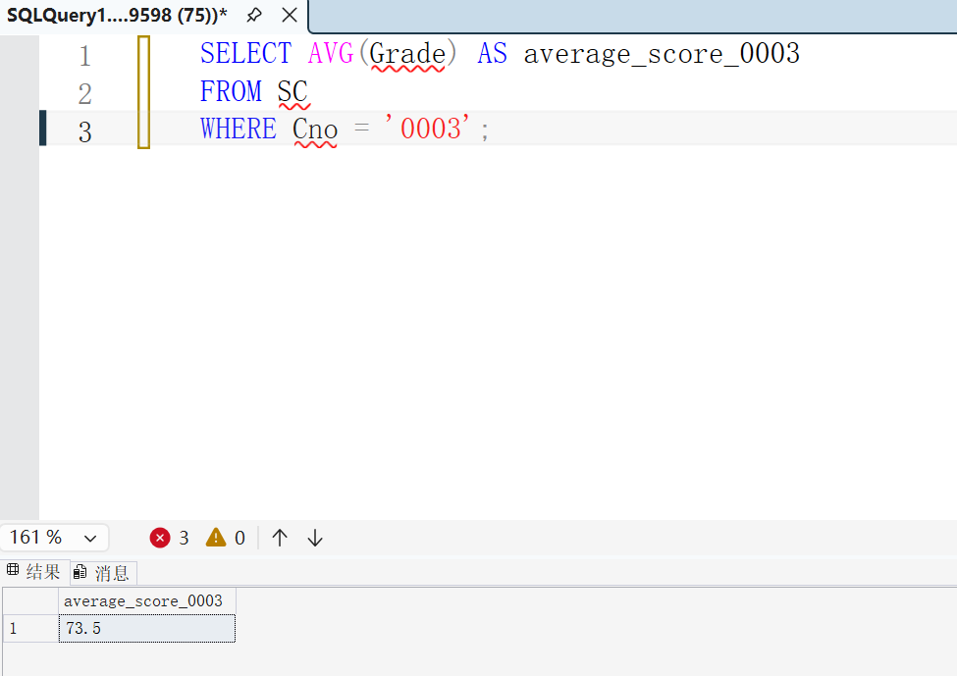
[4] List the name of student who has chosen at least 3 courses.
SELECT S.Sname
FROM Student S
JOIN SC ON S.Sno = SC.Sno
GROUP BY S.Sno, S.Sname
HAVING COUNT(SC.Cno) >= 3;
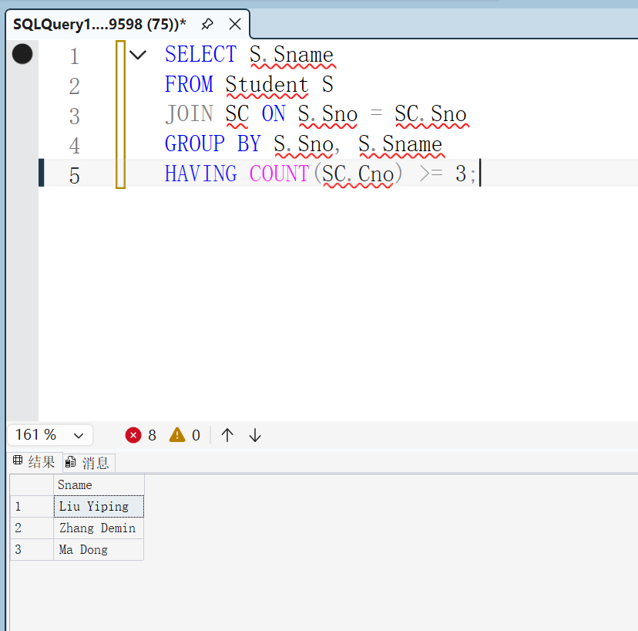
[5] List all Cno and the number of how many students have chosen corresponding course.
SELECT C.Cno, COUNT(SC.Sno) AS student_chosen_count
FROM Course C
LEFT JOIN SC ON C.Cno = SC.Cno
GROUP BY C.Cno;
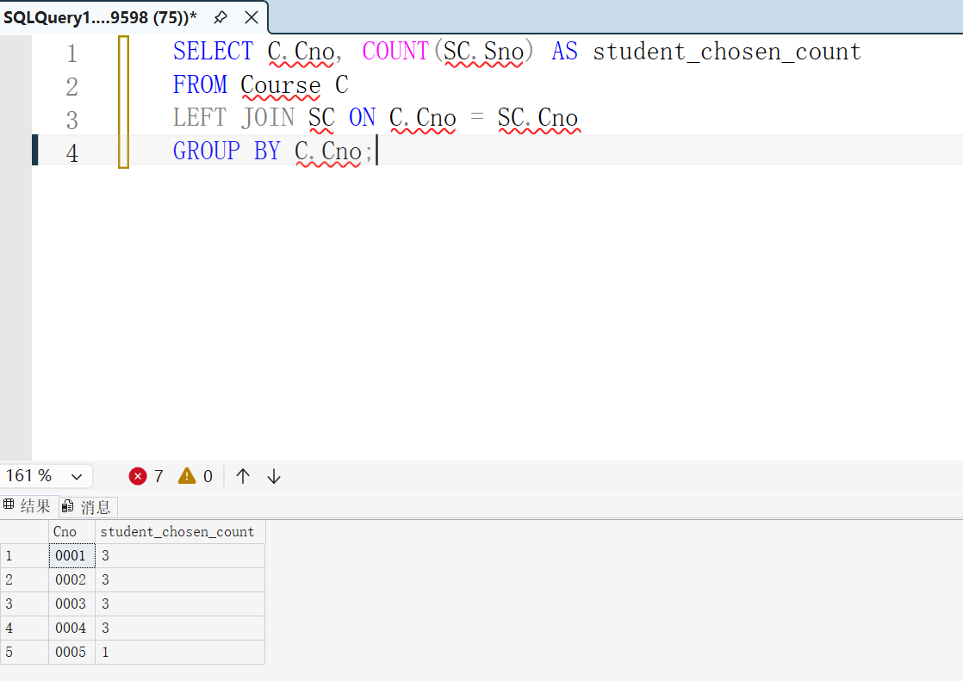
[6] List Sno and Sname of all students who did not take examination.
SELECT S.Sno, S.Sname
FROM Student S
LEFT JOIN SC ON S.Sno = SC.Sno AND SC.Grade IS NOT NULL
WHERE SC.Sno IS NULL;
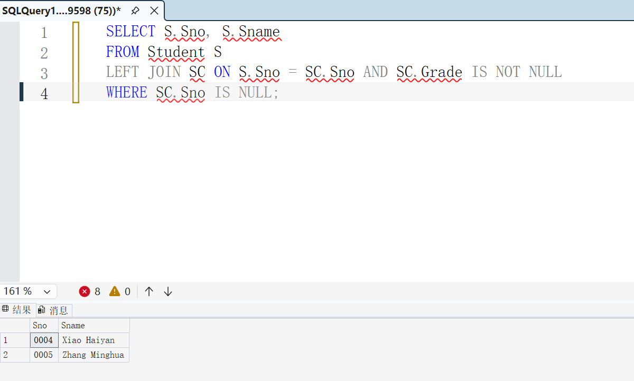 [7] List Cno and Cname of all courses which is chosen by at least 3 students.
SELECT C.Cno, C.Cname
FROM Course C
JOIN SC ON C.Cno = SC.Cno
GROUP BY C.Cno, C.Cname
HAVING COUNT(SC.Sno) >= 3;
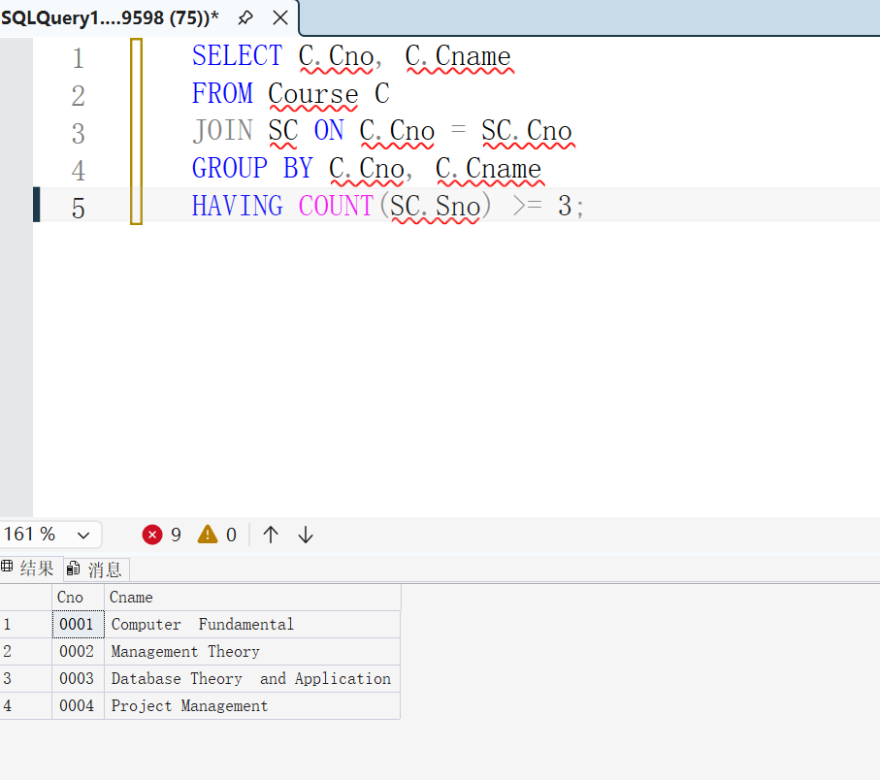 [8] List Sno, Sname, Cname and Grade of all students.

SELECT S.Sno, S.Sname, C.Cname, SC.Grade
FROM Student S
LEFT JOIN SC ON S.Sno = SC.Sno
LEFT JOIN Course C ON SC.Cno = C.Cno;
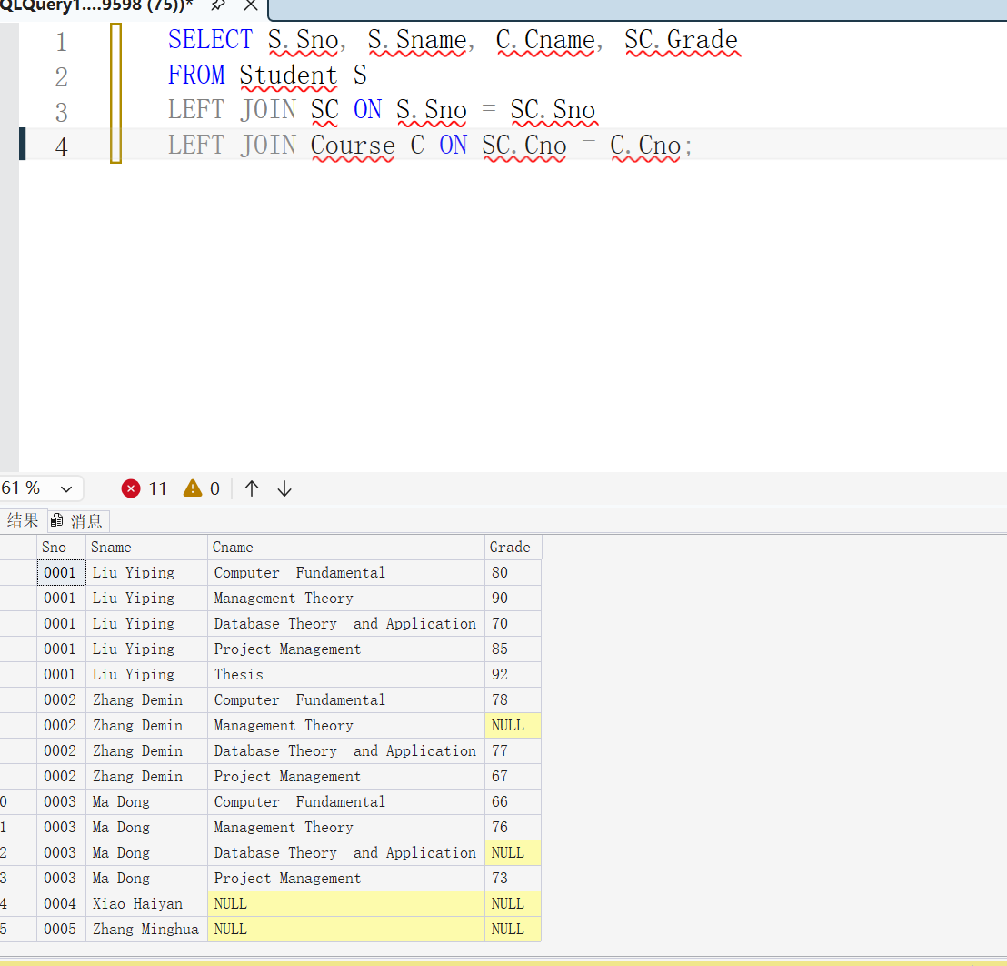
[9] List Sname and Haddress of all students who have chosen ‘0003’ course.
SELECT S.Sno, S.Sname
FROM Student S
JOIN SC ON S.Sno = SC.Sno
GROUP BY S.Sno, S.Sname
HAVING COUNT(SC.Cno) >= 2 AND MIN(SC.Grade) >= 90;

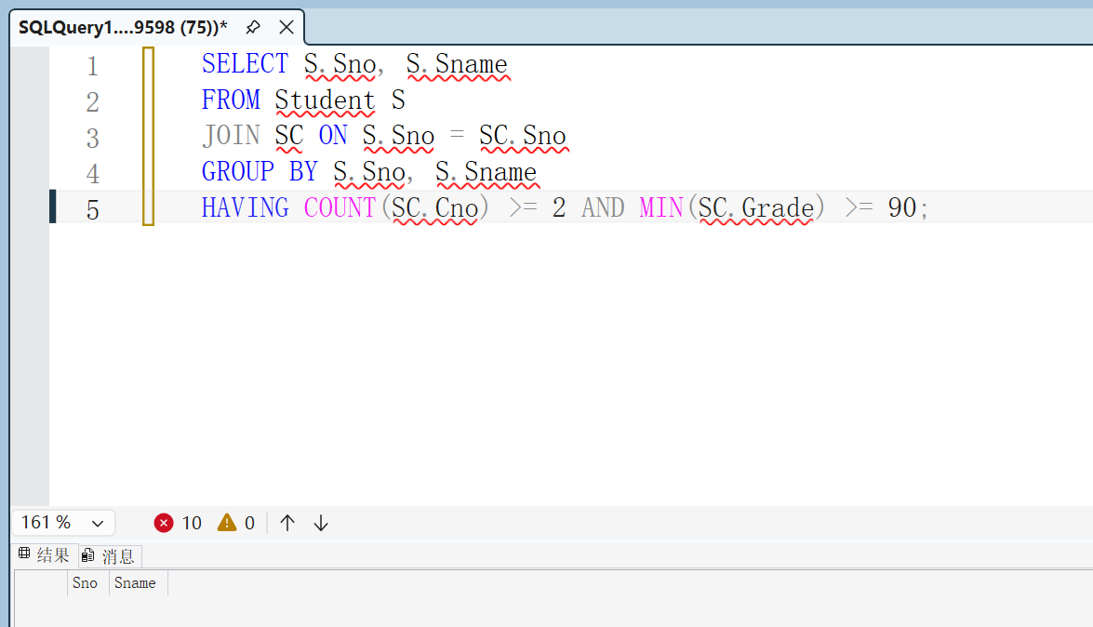

[10] List Sno and Sname of all students who have chosen at least 2 courses, and grade of those courses is equal to 90 or more.
SELECT S.Sno, S.Sname
FROM Student S
JOIN SC ON S.Sno = SC.Sno
GROUP BY S.Sno, S.Sname
HAVING COUNT(SC.Cno) >= 2 AND MIN(SC.Grade) >= 90;
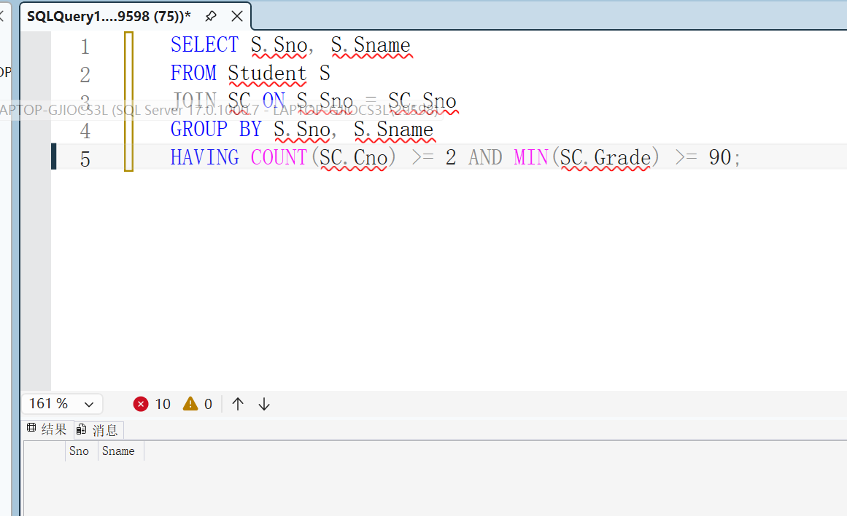
[11] List the information of all other courses with the average grade is higher than the average grade of ‘0003’ course.
SELECT C.*
FROM Course C
JOIN (
SELECT Cno, AVG(Grade) AS avg_score
FROM SC
GROUP BY Cno
) AS CourseAvg ON C.Cno = CourseAvg.Cno
WHERE CourseAvg.avg_score > (SELECT AVG(Grade) FROM SC WHERE Cno = '0003');
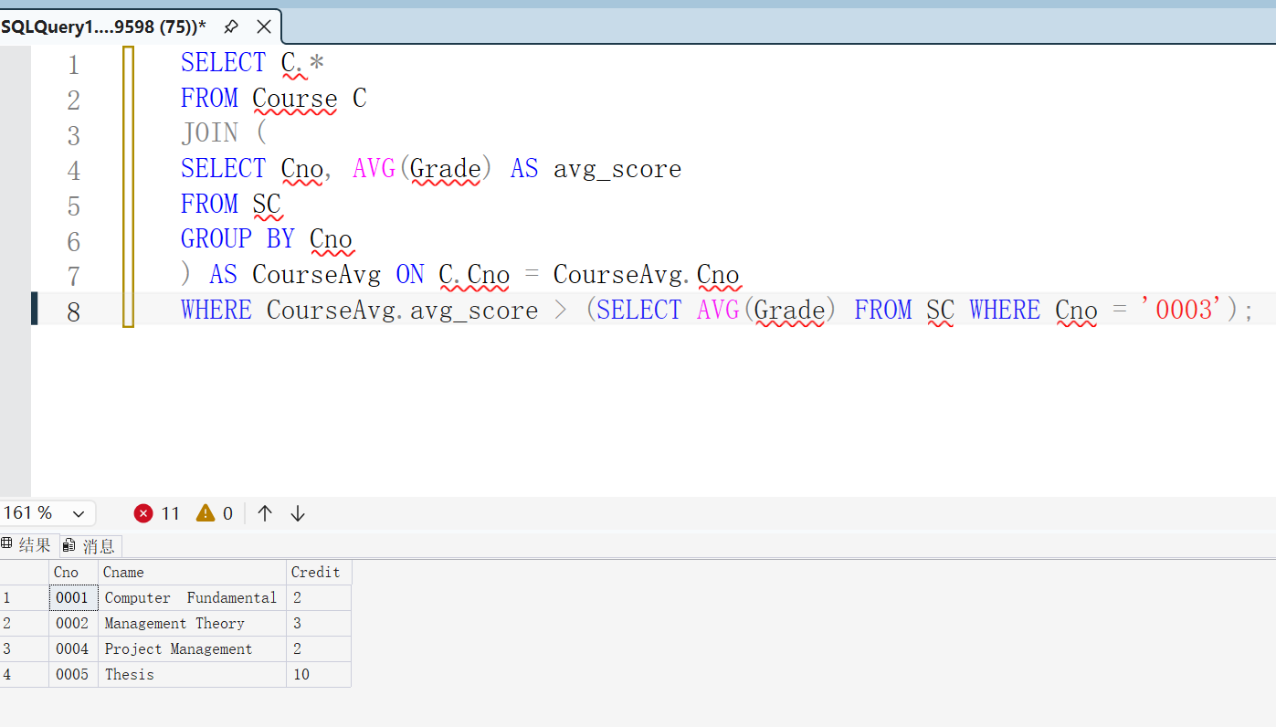
[12] List all information of student and all courses information chose by corresponding student, including the students who have not chosen any course.
SELECT S.*, C.*
FROM Student S
LEFT JOIN SC ON S.Sno = SC.Sno
LEFT JOIN Course C ON SC.Cno = C.Cno;
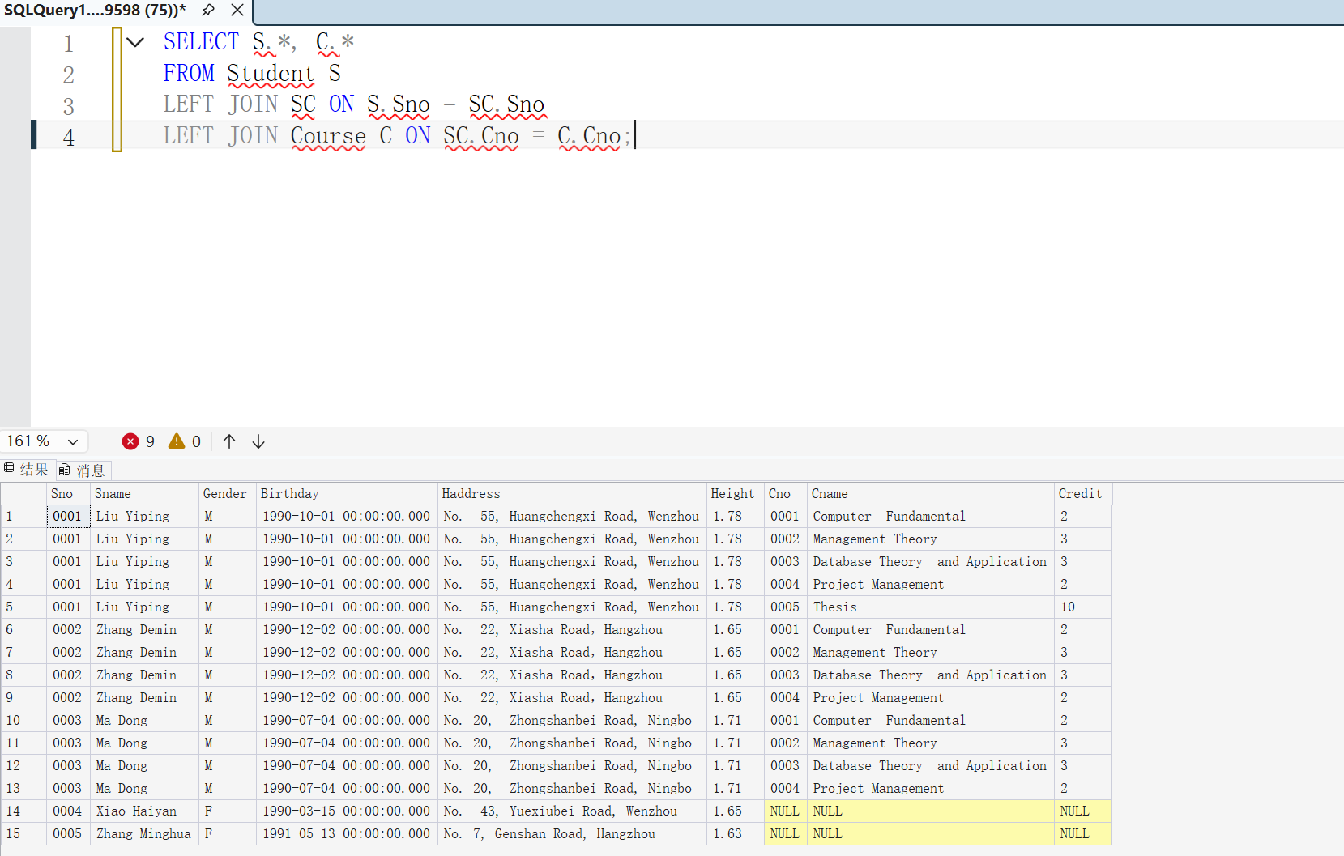
[13] List Sname of all students who have chosen all courses.

SELECT S.Sname
FROM Student S
JOIN SC ON S.Sno = SC.Sno
GROUP BY S.Sno, S.Sname
HAVING COUNT(DISTINCT SC.Cno) = (SELECT COUNT(*) FROM Course);
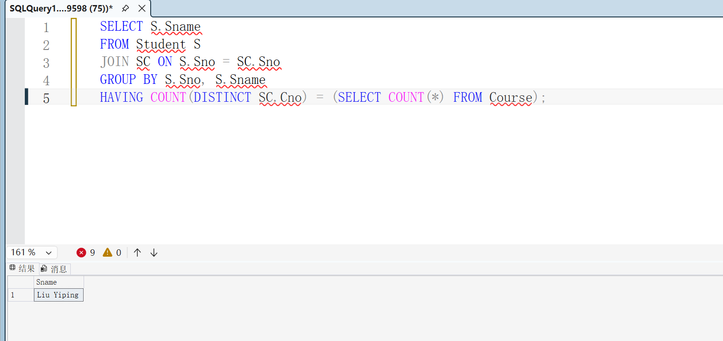
[14] Delete all course-choose information of ‘0002’ course
DELETE FROM SC
WHERE Cno = '0002';
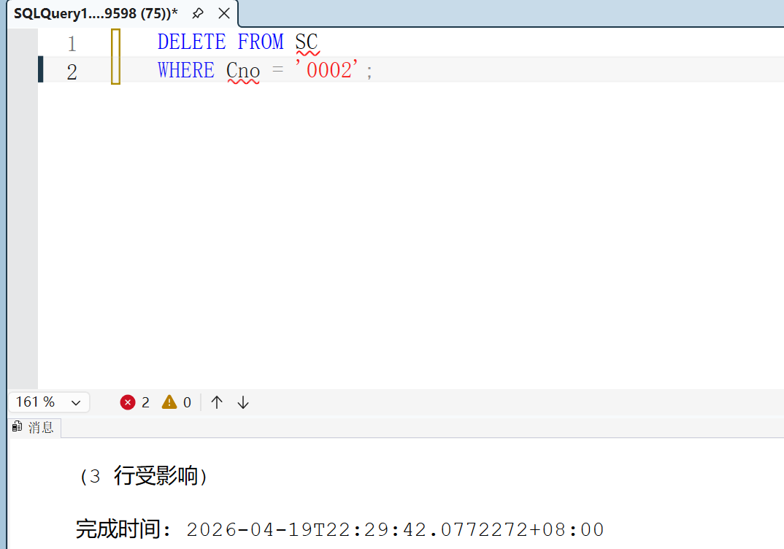
- Conclusion and Analysis

Comments and Score
Comments：

Score： Signature of teacher：
Date:

