

实 验（实训）报 告

项 目 名 称 | Operations of Complicated Query and DML
所 属 课程名称 | Database Theory and Application
项 目 类 型 | Computer Operation
实验(实训)日期
学 院 | Information Technology and Artificial Intelligence
班 级
学 号
姓 名
指导教师

浙江财经大学教务处制

一、实验（实训）概述（目的及要求，基本原理，实施环境、使用的材料、设备、软件等）（可加页）
- Objects
- Study DBMS environment of Microsoft SQL Server.
- Create database.
- Create table.
- Insert data into the database.
- Practice of complicated query..
- Environment and Software
- Personal Computer
- Windows 10 / Windows 11
- Microsoft SQL Server
二、实验（实训）内容（项目内容，方案设计，实验（实训）过程步骤、记录、数据、程序，结果与分析等）（可加页）
- Contents
- Be familiar with operation process and interfaces of Microsoft SQL Server.
- Create Studentdb Database.
- Create all tables of Studentdb database, including Student, Course and SC.
- Insert data into Student, Course and SC.
- Write and test SQL statement according to the query.

- The deadline to submit report
23:59, April 30, 2026

- (Design), process, source code and result
Write and test SQL statement, paste SQL Statement and the interface of the running result of SQL statement.

[1] Remove column named ‘Height’ from student table.
ALTER TABLE Student DROP COLUMN Height;
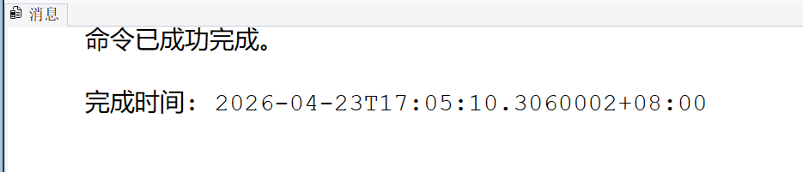
[2] Modify the data type of Sname from ‘varchar(50)’ to ‘varchar(100)’ for student table.
ALTER TABLE Student ALTER COLUMN Sname varchar(100);
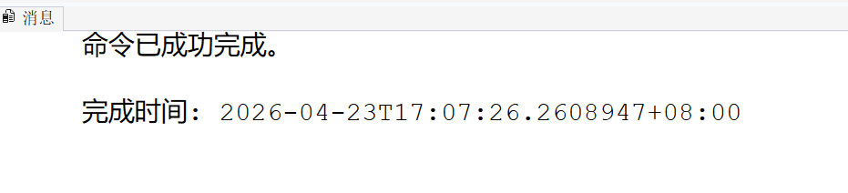

[3] Add a new column ‘Sdept varchar(20)’ for student table, and update the value of Sdept to be ‘Information’ for ‘0001’ and ‘0003’ student, update the value of Sdept to be ‘Mathematics’ for ‘0002’ and ‘0004’ student, update the value of Sdept to be ‘Computer Science’ for ‘0005’ student.
UPDATE Student SET Sdept = 'Information' WHERE Sno IN ('0001', '0003');
UPDATE Student SET Sdept = 'Mathematics' WHERE Sno IN ('0002', '0004');
UPDATE Student SET Sdept = 'Computer Science' WHERE Sno = '0005';
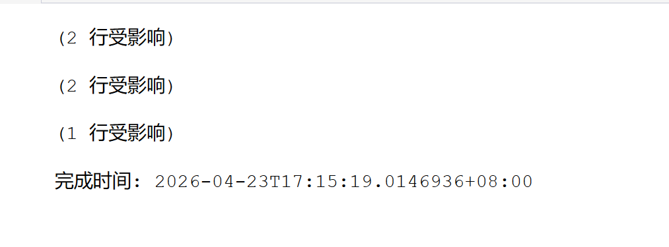
[4] Add a new Constraint named cons_credit for Course table, it requires the value of ‘Credit’ must be between 1 and 10.
ALTER TABLE Course ADD CONSTRAINT cons_credit CHECK (Credit BETWEEN 1 AND 10);

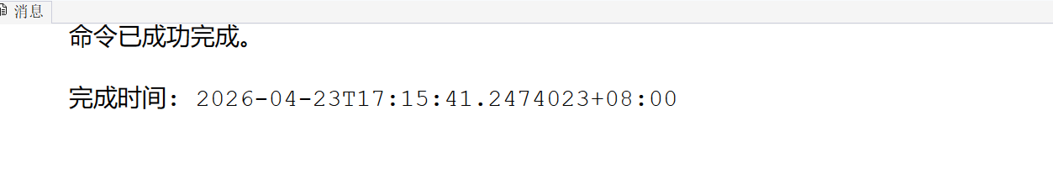
[5] Add a new tuple (‘0009’,‘Big Project’, 12) to test the constraint named cons_credit.
INSERT INTO Course VALUES ('0009', 'Big Project', 12);
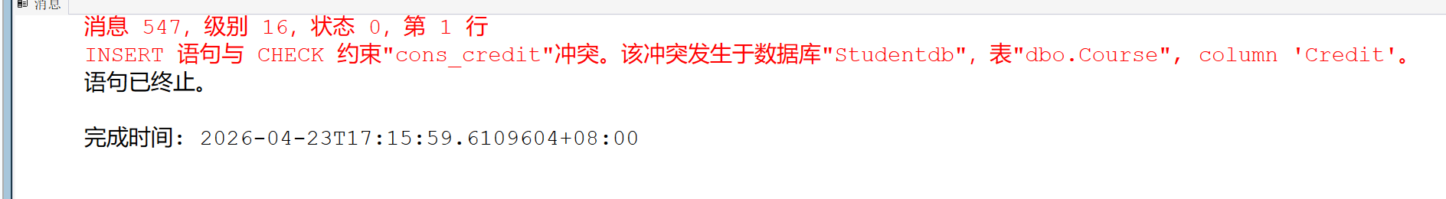
[6] Drop the constraint named cons_credit.
ALTER TABLE Course DROP CONSTRAINT cons_credit;
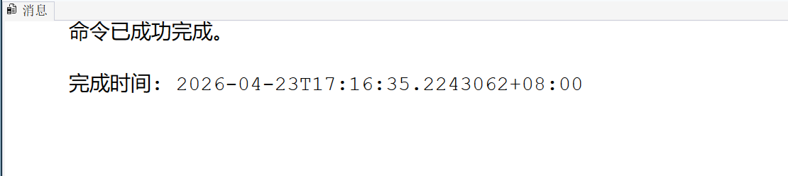
[7] Add a new tuple (‘0009’,‘Big Project’, 12).
INSERT INTO Course VALUES ('0009', 'Big Project', 12);
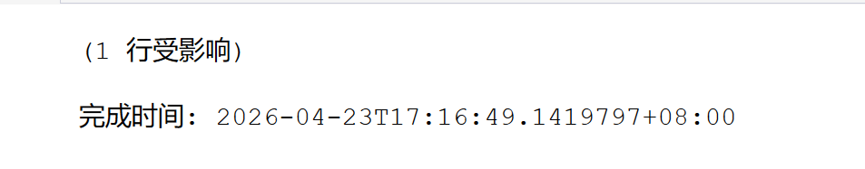
[8] Get Sname of all students who come from the same department of ‘Liu Yiping’.
SELECT Sname FROM Student
WHERE Sdept = (SELECT Sdept FROM Student WHERE Sname = 'Liu Yiping')
AND Sname <> 'Liu Yiping';
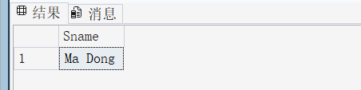
[9] Get Sno, Sname, Sdept of all other departments’ student with the grade of ‘0003’ course is less than all students in ‘Information’ department.
SELECT Sno, Sname, Sdept FROM Student
WHERE Sno IN (SELECT Sno FROM SC WHERE Cno = '0003' AND Grade < ALL (
SELECT Grade FROM SC WHERE Sno IN (SELECT Sno FROM Student WHERE Sdept = 'Information')
)) AND Sdept <> 'Information';
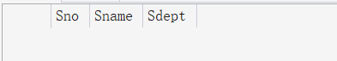
[10] Get Sname and Gender of all other departments’ student with the age is more than all students in ‘Information’ department.
* datetime can be compared directly, e.g. 2023-10-11>2023-09-01.
SELECT Sname, Gender FROM Student
WHERE Birthday < ALL (SELECT Birthday FROM Student WHERE Sdept = 'Information')
AND Sdept <> 'Information';
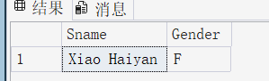
[11] Get Sno of student, come from ‘Information’ department, who have chosen the largest amount of courses . [HARD]
SELECT TOP 1 Sno FROM SC
WHERE Sno IN (SELECT Sno FROM Student WHERE Sdept = 'Information')
GROUP BY Sno ORDER BY COUNT(Cno) DESC;
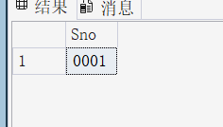
[12] For each course, list the Sno and Sname of all students whose grade is less than the average grade.
SELECT SC.Sno, S.Sname
FROM SC, Student S, (SELECT Cno, AVG(Grade) AS AvgGrade FROM SC GROUP BY Cno) AS T
WHERE SC.Sno = S.Sno AND SC.Cno = T.Cno AND SC.Grade < T.AvgGrade;
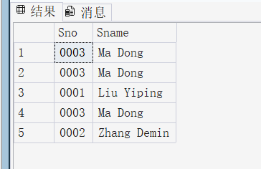
[13] Create a new table Dept_avg_age(Sdept varchar(20) primary key, avg_age float(1) ), and insert the result of statistic into the new table.
CREATE TABLE Dept_avg_age(Sdept varchar(20) PRIMARY KEY, avg_age float);

INSERT INTO Dept_avg_age
SELECT Sdept, AVG(CAST(DATEDIFF(YEAR, Birthday, GETDATE()) AS FLOAT))
FROM Student GROUP BY Sdept;
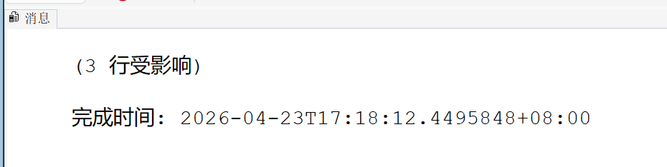
[14] Reduce the grade of all courses by 5 for all students studied in ‘Mathematics’ Department.
UPDATE SC SET Grade = Grade - 5
WHERE Sno IN (SELECT Sno FROM Student WHERE Sdept = 'Mathematics');
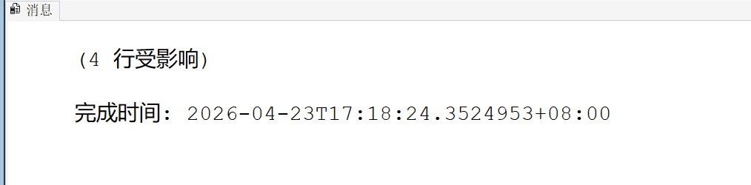
[15] Set the grade to zero of all courses for all students studied in ‘Information’ Department.
UPDATE SC SET Grade = 0
WHERE Sno IN (SELECT Sno FROM Student WHERE Sdept = 'Information');

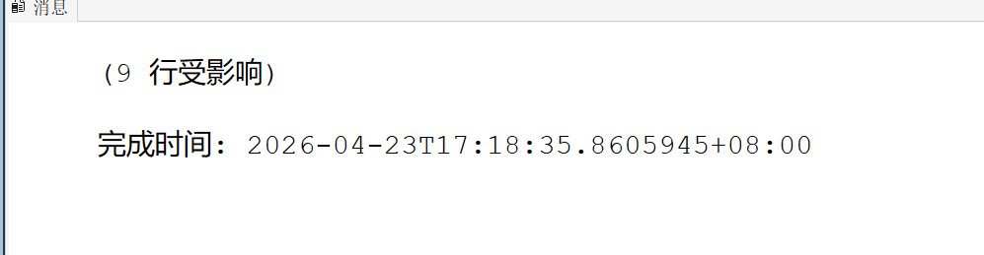
- Conclusion and Analysis

Comments and Score
Comments：

Score： Signature of teacher：
Date:

