

实 验（实训）报 告

项 目 名 称 | Definition, query and update of view
所 属 课程名称 | Database Theory and Application
项 目 类 型 | Computer Operation
实验(实训)日期
学 院 | Information Technology and Artificial Intelligence
班 级
学 号
姓 名
指导教师

浙江财经大学教务处制

一、实验（实训）概述（目的及要求，基本原理，实施环境、使用的材料、设备、软件等）（可加页）
- Objects
- Study the COMMAND of view definition.
- Study the COMMAND of view query.
- Study the COMMAND of view update.
- Understand the role of view.
- Environment and Software
- Personal Computer
- Windows 10 / Windows 11
- Microsoft SQL Server
二、实验（实训）内容（项目内容，方案设计，实验（实训）过程步骤、记录、数据、程序，结果与分析等）（可加页）
- Contents
- Define the view.
- Query the view.
- Update the view.

- The deadline to submit report
23:59, May 7, 2026

- (Design), process, source code and result
Write and test SQL statement, paste SQL Statement and the interface of the running result of SQL statement.

1. Define View.
Finish the following view definitions on Student table, Course table and SC table.

[1] Create a view named V_IS to maintain the information of all students studied in ‘Information’ department.

CREATE VIEW V_IS AS
SELECT * FROM Student
WHERE Sdept = 'Information';
GO
[2] Create a view named V_S_C_G to maintain student’s Sno, Sname, Cno, Cname, and Grade. (Cno, Cname and Grade is related to the courses which the student took)

CREATE VIEW V_S_C_G AS
SELECT Student.Sno,Sname,Course.Cno,Cname,Grade
FROM Student
JOIN SC ON Student.Sno = SC.Sno
JOIN Course ON SC.Cno = Course.Cno;
GO

[3] Create a view named V_NUM_AVG to maintain the Sdept, amount of student, average height for each department.

CREATE VIEW V_NUM_AVG(Sdept,StudentCount,AvgHeight)AS
SELECT Sdept,COUNT(*),AVG(Height)
FROM Student
GROUP BY Sdept;
GO
[4] Create a view named V_YEAR to maintain amount of student in different birth year.
CREATE VIEW V_YEAR(BirthYear, StudentCount) AS
SELECT YEAR(Birthday), COUNT(*)
FROM Student
GROUP BY YEAR(Birthday);
GO

[5] Create a view named V_AVG_S_G to maintain Sno, amount of course, average of grade for each student.
CREATE VIEW V_AVG_S_G(Sno, CourseCount, AvgGrade) AS
SELECT Sno, COUNT(*), AVG(Grade)
FROM SC
GROUP BY Sno;
GO

[6] Create a view named V_AVG_C_G to maintain Cno, amount of student, average of grade for each course.
CREATE VIEW V_AVG_C_G(Cno, StudentCount, AvgGrade) AS
SELECT Cno, COUNT(*), AVG(Grade)
FROM SC
GROUP BY Cno;
GO
[7] Create a view named V_GPA to maintain Sno, Sname, Cname, Credit and GP for each student.
* The calculation expression of grade point is as following.
Grade | Level | Grade Point (GP)
90-100 | A | 4.0
85-89 | A- | 3.7
82-84 | B+ | 3.3
78-81 | B | 3.0
75-77 | B- | 2.7
71-74 | C+ | 2.3
66-70 | C | 2.0
62-65 | C- | 1.7
60-61 | D | 1.3
<60 | F | 0
* Example: use CASE statement.
select student.sno,sname,Cname,credit,(case
when(grade>=90) then 4
when(grade>=85 and grade<90) then 3.7
when(grade>=82 and grade<85) then 3.3
when(grade>=78 and grade<82) then 3.0
when(grade>=75 and grade<78) then 2.7
when(grade>=71 and grade<75) then 2.3
when(grade>=66 and grade<71) then 2.0
when(grade>=62 and grade<66) then 1.7
when(grade>=60 and grade<62) then 1.3
else 0
end) as gpa
from ***
CREATE VIEW V_GPA AS
SELECT
Student.Sno,
Sname,
Cname,
Credit,
CASE
WHEN Grade >= 90 THEN 4.0
WHEN Grade >= 85 THEN 3.7
WHEN Grade >= 82 THEN 3.3
WHEN Grade >= 78 THEN 3.0
WHEN Grade >= 75 THEN 2.7
WHEN Grade >= 71 THEN 2.3
WHEN Grade >= 66 THEN 2.0
WHEN Grade >= 62 THEN 1.7
WHEN Grade >= 60 THEN 1.3
ELSE 0
END AS GP
FROM Student
JOIN SC ON Student.Sno = SC.Sno
JOIN Course ON SC.Cno = Course.Cno;
GO

2. Use View.
[8] List information of all above views.
SELECT * FROM V_IS;
SELECT * FROM V_S_C_G;
SELECT * FROM V_NUM_AVG;
SELECT * FROM V_YEAR;
SELECT * FROM V_AVG_S_G;
SELECT * FROM V_AVG_C_G;
SELECT * FROM V_GPA;
GO
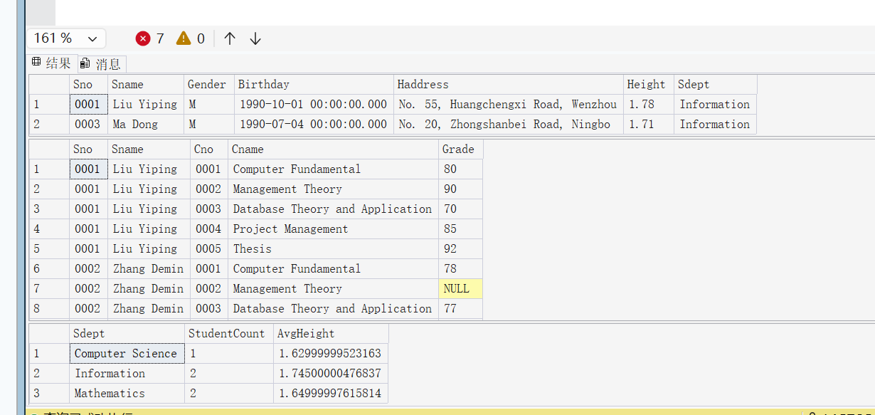
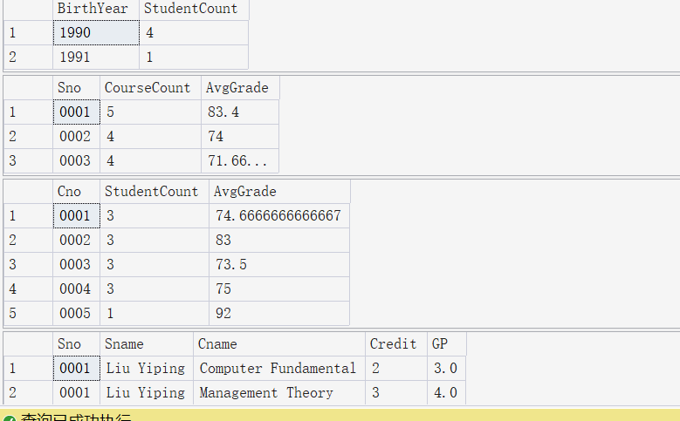
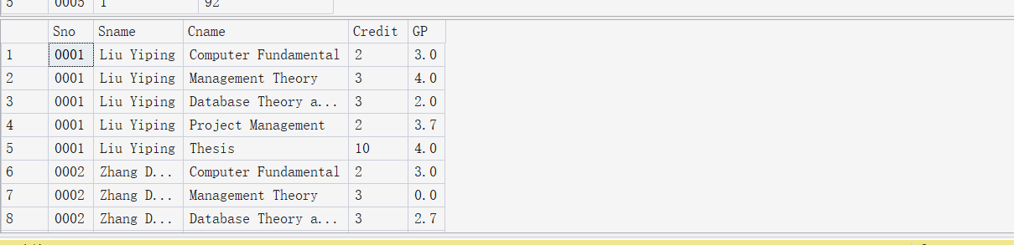
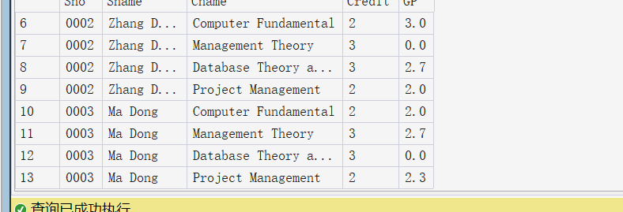
[9] Get Sno, Sname, average of grade for each student whose average grade is equal to or more than 80.
SELECT V_AVG_S_G.Sno,Sname,AvgGrade
FROM V_AVG_S_G
JOIN Student ON V_AVG_S_G.Sno = Student.Sno
WHERE AvgGrade >= 80;
GO
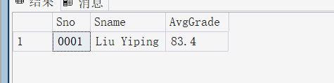
[10] List Sdept and amount of student whose average of grade is equal to or more than 80, and order on the amount of student by descending.
SELECT Sdept,COUNT(*) AS HighScoreCount
FROM Student
JOIN V_AVG_S_G ON Student.Sno = V_AVG_S_G.Sno
WHERE AvgGrade>=80
GROUP BY Sdept
ORDER BY HighScoreCount DESC;
GO
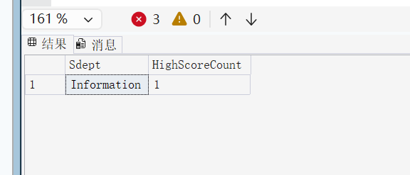
[11] List information of student whose GPA[Grade Point Average] is equal to or more than 3.5, and order on department by ascending.
注：平均绩点GPA是国际通用的学生学习质量评定标准，其计算公式如下：课程学分1*绩点+课程学分2*绩点+......+课程学分n*绩点)/(课程学分1+课程学分2+......+课程学分n)

SELECT
Student.Sno,
Student.Sname,
Student.Sdept,
SUM(V_GPA.GP * V_GPA.Credit) / SUM(V_GPA.Credit) AS GPA
FROM Student
JOIN V_GPA ON Student.Sno = V_GPA.Sno
GROUP BY Student.Sno, Student.Sname, Student.Sdept
HAVING SUM(V_GPA.GP * V_GPA.Credit) / SUM(V_GPA.Credit) >= 3.5
ORDER BY Student.Sdept ASC;
GO
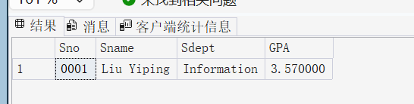
3. Update View.

[12] Update the Sname to ‘Liu Sanping’ for ‘0001’ student through view V_IS, and show the result.
UPDATE V_IS
SET Sname = 'Liu Sanping'
WHERE Sno = '0001';
SELECT * FROM V_IS WHERE Sno = '0001';
GO
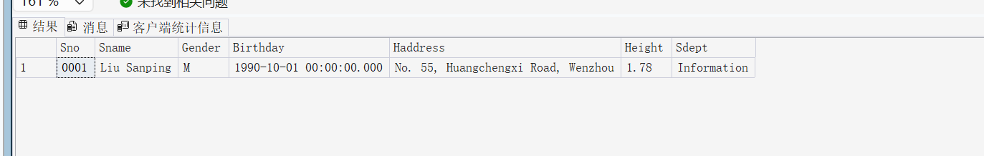

[13] Add a new tuple (‘1001’, ‘Han Lei’,’M’,1992-01-23,’Information’) through V_IS, and show the opresult .
INSERT INTO V_IS (Sno, Sname, Gender, Birthday, Haddress, Height, Sdept)
VALUES ('1001', 'Han Lei', 'M', '1992-01-23', 'Wenzhou', 1.80, 'Information');
SELECT * FROM V_IS WHERE Sno = '1001';
GO
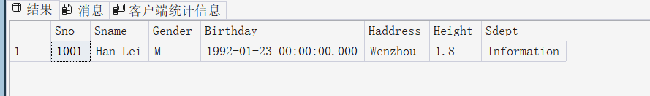
[14] Delete ‘0003’ student through view V_IS, and show the operation result.
DELETE FROM V_IS
WHERE Sno = '0003';
SELECT * FROM V_IS WHERE Sno = '0003';
GO
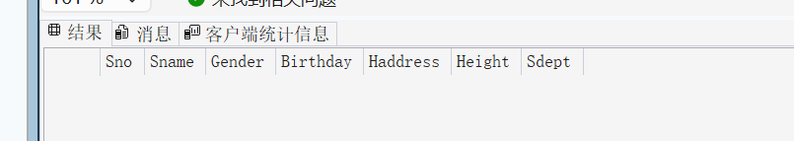
[15] Could you update the average of grade to 90 through view V_AVG_S_G? give the reason.

不能更新，因为包含 AVG 聚合函数和 GROUP BY 分组的视图是只读的，数据库无法将计算后的平均值还原并拆分到原始表的多行数据中。

- Conclusion and Analysis

Comments and Score
Comments：

Score： Signature of teacher：
Date:

