

实 验（实训）报 告

项 目 名 称 | SQL practice for CAP Database
所 属 课程名称 | Database Theory and Application
项 目 类 型 | Computer Operation
实验(实训)日期
学 院 | Information Technology and Artificial Intelligence
班 级
学 号
姓 名
指导教师

浙江财经大学教务处制

一、实验（实训）概述（目的及要求，基本原理，实施环境、使用的材料、设备、软件等）（可加页）
- Objects
- Write the SQL statement for each requirement of CAP database.
- Environment and Software
- Personal Computer
- Windows 10 / Windows 11
- Microsoft SQL Server
二、实验（实训）内容（项目内容，方案设计，实验（实训）过程步骤、记录、数据、程序，结果与分析等）（可加页）
- Contents
- Write the SQL statement for each requirement of CAP database.

- The deadline to submit report
23:59, May 21, 2026

- (Design), process, source code and result
Write and test SQL statement, paste SQL Statement and the interface of the running result of SQL statement.

(1) Find all (ordno, pid) pairs for orders of quantity equal to 1000 or more.
(1) 查询订单中物品数量大于或者等于1000的(ordno, pid)对.
SELECT ordno, pid
FROM Orders
WHERE qty >= 1000;
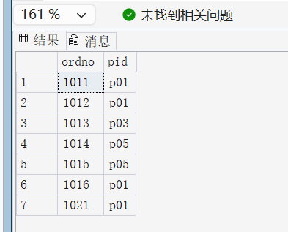

(2) Find all product names of products priced between $0.50 and $1.00, inclusive.
(2) 查询所有价格在$0.50和$1.00之间的商品名称，包括边界价格.
SELECT pname
FROM Products
WHERE price BETWEEN 0.50 AND 1.00;
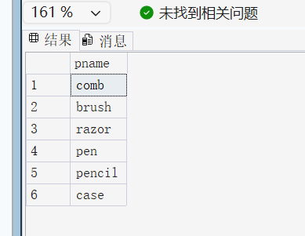
(3) Find all (ordno, cname) pairs for orders of dollar value less than $500.
(3) 查询订单价格低于$500的(ordno, cname)对.
SELECT o.ordno, c.cname
FROM Orders o
JOIN Customers c ON o.cid = c.cid
WHERE o.dollars < 500;
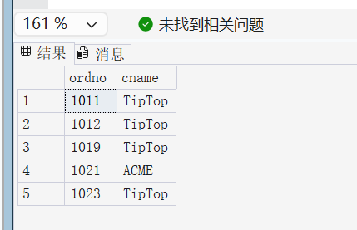
(4) Find all (ordno, aname) pairs for orders in March.
(4) 查询所有三月份接受的订单的(ordno, aname)对.
SELECT o.ordno, a.aname
FROM Orders o
JOIN Agents a ON o.aid = a.aid
WHERE o.month = 'Mar';
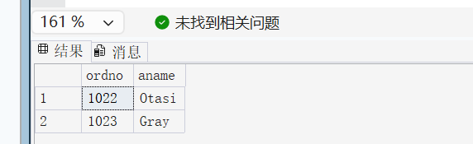 (5) Find all (ordno, cname, aname) triples for orders in March.
(5) 查询所有三月份接受的订单的(ordno, cname, aname)三元组.
SELECT o.ordno, c.cname, a.aname
FROM Orders o
JOIN Customers c ON o.cid = c.cid
JOIN Agents a ON o.aid = a.aid
WHERE o.month = 'Mar';
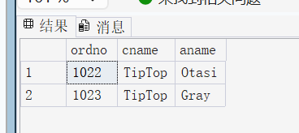
(6) Find all the names of agents in New York who placed orders of individual dollar value less
than $500.
(6) 查询所有位于New York的代理商，并且要求这些代理商所接受的单个订单价格少于$500[只要有一个订单满足即可].
SELECT DISTINCT a.aname
FROM Agents a
JOIN Orders o ON a.aid = o.aid
WHERE a.city = 'New York' AND o.dollars < 500;
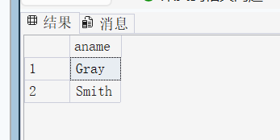
(7) Find all product names of products in Duluth ordered in March.
(7) 查询所有三月份定购的(位于)Duluth的商品的名称.
SELECT DISTINCT p.pname
FROM Orders o
JOIN Products p ON o.pid = p.pid
WHERE o.month = 'Mar' AND p.city = 'Duluth';
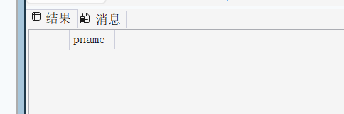 (8) Find all (cid, aid, pid) triples for customer, agent, product combinations that are all in the same city.
(8) 查询所有顾客、代理商和商品都在同一个城市的三元组(cid, aid, pid).
SELECT c.cid, a.aid, p.pid
FROM Customers c, Agents a, Products p
WHERE c.city = a.city AND a.city = p.city;
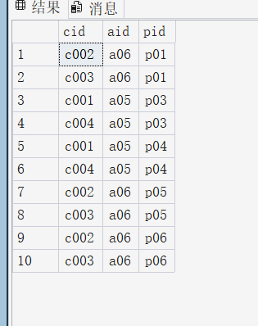
(9) Find all (cid, aid, pid) triples for customer, agent, product combinations that are not all in
the same city (any two maybe).
(9) 查询所有顾客、代理商和商品不都在同一个城市(可能有两个在同一城市)的三元组(cid, aid, pid).
SELECT c.cid, a.aid, p.pid
FROM Customers c, Agents a, Products p
WHERE NOT (c.city = a.city AND a.city = p.city);
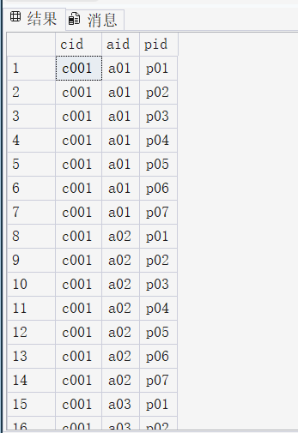
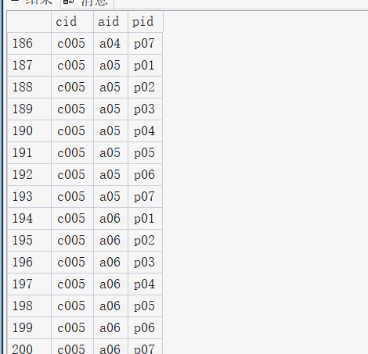
(10) Find all (cid, aid, pid) triples for customer, agent, product combination, no two of which are in the same city.
(10) 查询所有顾客、代理商和商品两两不在同一个城市的三元组(cid, aid, pid).
SELECT c.cid, a.aid, p.pid
FROM Customers c, Agents a, Products p
WHERE c.city <> a.city
AND a.city <> p.city
AND c.city <> p.city;
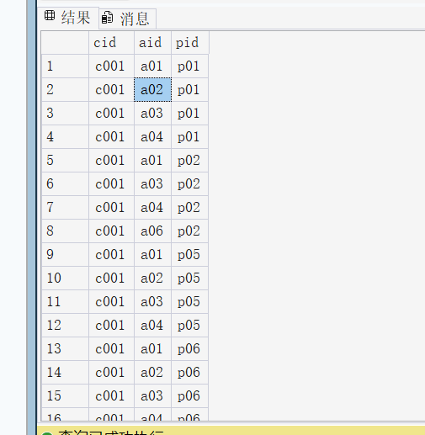
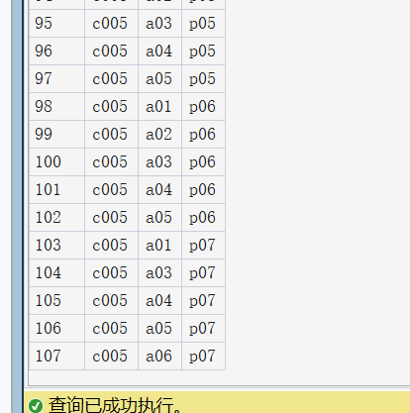
(11) Get cities of agents booking an order from customer c002.
(11) 查询接受顾客c002订单的代理商所在的城市.
SELECT DISTINCT a.city
FROM Agents a
JOIN Orders o ON a.aid = o.aid
WHERE o.cid = 'c002';

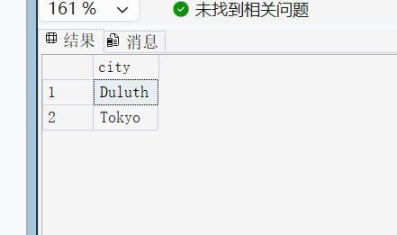
(12) Get product names ordered by at least one customer based in Dallas through an agent
based in Tokyo.
(12) 查询至少被一个在Dallas的顾客通过位于Tokyo的代理商定购的商品的名称.
SELECT DISTINCT p.pname
FROM Orders o
JOIN Customers c ON o.cid = c.cid
JOIN Agents a ON o.aid = a.aid
JOIN Products p ON o.pid = p.pid
WHERE c.city = 'Dallas' AND a.city = 'Tokyo';
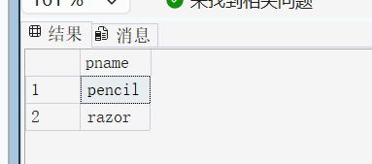
(13) Get pids of products ordered through any agent who makes at least one order for a
customer in Dallas.
(13) 查询曾经收到Dallas的顾客订单的代理商所销售的所有商品的pid值.
SELECT DISTINCT o.pid
FROM Orders o
WHERE o.aid IN (
SELECT DISTINCT aid
FROM Orders
JOIN Customers ON Orders.cid = Customers.cid
WHERE Customers.city = 'Dallas'
);

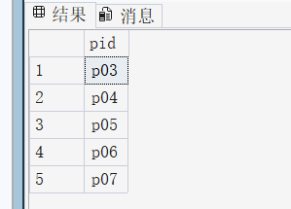
(14) Display all pairs of aids for agents who live in the same city.
(14) 查询所有在同一个城市的代理商的aid对.
SELECT a1.aid, a2.aid
FROM Agents a1
JOIN Agents a2 ON a1.city = a2.city
WHERE a1.aid < a2.aid;
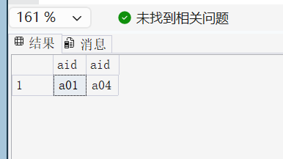
(15) Find cids of customers who did not place an order through agent a03.
(15) 查询没有通过代理商a03定购过商品的顾客的cid值.
SELECT DISTINCT cid
FROM Customers
WHERE cid NOT IN (
SELECT DISTINCT cid
FROM Orders
WHERE aid = 'a03'
);

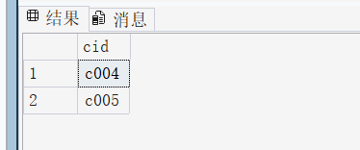
(16) Find cids of customers who have the largest discount.
(16) 查询折扣率最大的顾客的cid值.
SELECT cid
FROM Customers
WHERE discnt = (SELECT MAX(discnt) FROM Customers);

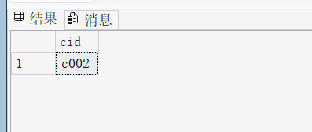
(17) Find cids of customers who order all products.
(17) 查询定购了所有商品的顾客的cid值.
SELECT DISTINCT cid
FROM Orders o1
WHERE NOT EXISTS (
SELECT pid
FROM Products
WHERE pid NOT IN (
SELECT pid
FROM Orders o2
WHERE o2.cid = o1.cid
)
);
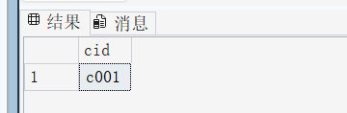
(18) Find pids of products ordered through agent a03 but not through agent a06.
(18) 查询通过代理商a03而不通过代理商a06定购的商品的pid值.
SELECT DISTINCT pid
FROM Orders
WHERE aid = 'a03'
AND pid NOT IN (
SELECT pid
FROM Orders
WHERE aid = 'a06'
);

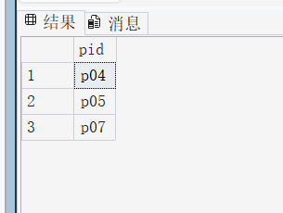
(19) Get pnames and pids of products that are stored in the same city as one of the agents
who sold these products.
(19) 查询商品的pname和pid值，要求这些商品所在的城市和某个销售过该商品的代理商所在的城市相同.
SELECT DISTINCT p.pname, p.pid
FROM Products p
JOIN Orders o ON p.pid = o.pid
JOIN Agents a ON o.aid = a.aid
WHERE p.city = a.city;
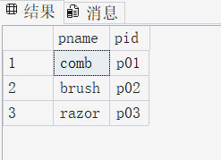
(20) Get aids and anames of agents with aname beginning with the letter “S” who do not
place orders for any product in Duluth.
(20) 查询名字是以S开头的代理商的aid和aname值，并且这些代理没有销售过任何Duluth生产的商品.
SELECT DISTINCT a.aid, a.aname
FROM Agents a
WHERE a.aname LIKE 'S%'
AND a.aid NOT IN (
SELECT DISTINCT o.aid
FROM Orders o
JOIN Products p ON o.pid = p.pid
WHERE p.city = 'Duluth'
);
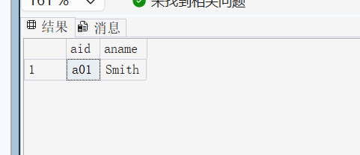 (21) Get cids of customers who order both product p01 and product p07.
(21) 查询同时定购了商品p01和p07的顾客的cid值.
SELECT DISTINCT cid
FROM Orders
WHERE pid = 'p01'
INTERSECT
SELECT DISTINCT cid
FROM Orders
WHERE pid = 'p07';
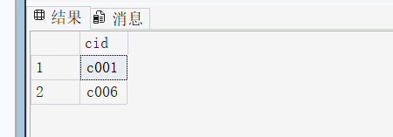
(22) Get names of agents who place orders for all products ordered by customer c002.
(22) 查询销售过所有曾被顾客c002定购过的商品的代理商的名称.
SELECT DISTINCT a.aname
FROM Agents a
WHERE NOT EXISTS (
SELECT pid
FROM Orders
WHERE cid = 'c002'
AND pid NOT IN (
SELECT pid
FROM Orders
WHERE aid = a.aid
)
);
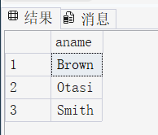
(23) Get names of agents who place orders for all products that are ordered by any customer at
all. (Hint: The phrase “any customer at all” means the same as “some customer.”)
(23) 查询销售过所有曾被某些顾客定购过的商品的代理商的名称.
SELECT DISTINCT a.aname
FROM Agents a
WHERE NOT EXISTS (
SELECT DISTINCT pid
FROM Orders
WHERE pid NOT IN (
SELECT pid
FROM Orders
WHERE aid = a.aid
)
);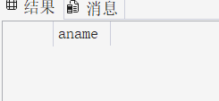
(24) Get (cid, aid, pid) triples for customer, agent, product combination so that at most two
of them are in the same city.
(24) 查询所有的三元组(cid, aid, pid)，要求对应的顾客，代理商和商品中最多有两者是位于同一座城市.
SELECT DISTINCT c.cid, a.aid, p.pid
FROM Customers c, Agents a, Products p
WHERE NOT (c.city = a.city AND a.city = p.city);

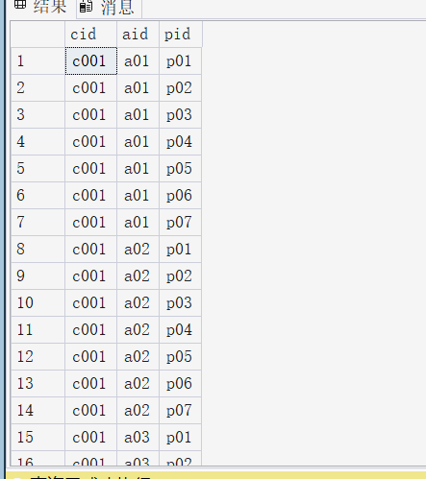
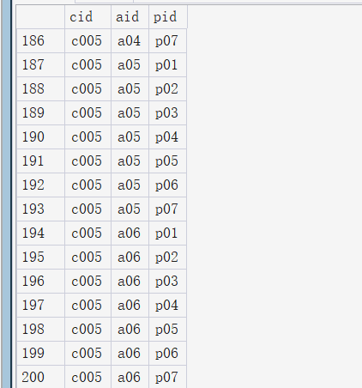
(25) Get pids of products ordered by all customers who place any order through agent a03.
(25) 查询所有曾在代理商a03处定购商品的顾客定购过的商品的pid值.
SELECT DISTINCT pid
FROM Orders o1
WHERE NOT EXISTS (
SELECT DISTINCT cid
FROM Orders
WHERE aid = 'a03'
AND cid NOT IN (
SELECT cid
FROM Orders o2
WHERE o2.pid = o1.pid
)
);

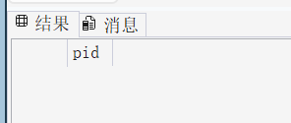
(26) Get aids of agents who place individual orders in dollar value greater than $500 for
customer living in Dallas.
(26) 查询接受过Dallas的顾客一笔总额超过$500的订单的代理商的aid值.
SELECT DISTINCT a.aid
FROM Agents a
JOIN Orders o ON a.aid = o.aid
JOIN Customers c ON o.cid = c.cid
WHERE c.city = 'Dallas' AND o.dollars > 500;
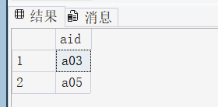
(27) Give all (cname, aname) pairs where the customer places an order through the agent.
(27) 查询所有的(cname, aname)对，要求对应的顾客曾经在对应的代理商处定购过商品.
SELECT DISTINCT c.cname, a.aname
FROM Orders o
JOIN Customers c ON o.cid = c.cid
JOIN Agents a ON o.aid = a.aid;
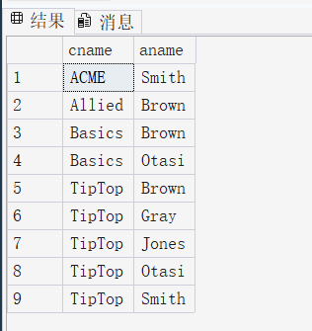
(28) Get cids of customers who order all their products through only one agent.
(28) 查询只从一家代理商定购过商品的顾客的cid值.
SELECT cid
FROM Orders
GROUP BY cid
HAVING COUNT(DISTINCT aid) = 1;
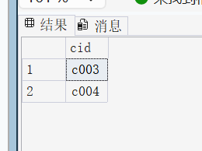 (29) Get aids of agents who do not provide any products produced in Dallas for any customer living in Duluth.
(29) 查询没有为任何住在Duluth的顾客订购任何在Dallas生产的产品的代理商aid值.
SELECT DISTINCT aid
FROM Agents
WHERE aid NOT IN (
SELECT DISTINCT o.aid
FROM Orders o
JOIN Customers c ON o.cid = c.cid
JOIN Products p ON o.pid = p.pid
WHERE c.city = 'Duluth' AND p.city = 'Dallas'
);
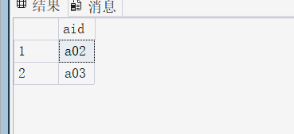
(30) Get aids of agents who provide at least one same product for all customers living in Duluth or customers living in Kyoto.
(30) 查询为住在Duluth或Kyoto的所有顾客订购了至少一种同样产品的代理商的aid值.
SELECT DISTINCT aid
FROM Agents a
WHERE NOT EXISTS (
SELECT cid
FROM Customers
WHERE city IN ('Duluth','Kyoto')
AND cid NOT IN (
SELECT cid
FROM Orders
WHERE aid = a.aid
)
); 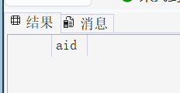
(31) Get cids of customers who order product only from agent a03 or a05.
(31) 查询只通过代理商a03或a05订货的顾客的cid值.
SELECT DISTINCT cid
FROM Orders
GROUP BY cid
HAVING COUNT(DISTINCT aid) = 1
AND MAX(aid) IN ('a03','a05');
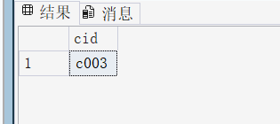
(32) Get pids of products ordered by all customers living in Duluth.
(32) 查询被所有住在Duluth的顾客都订购了的产品的pid值.
SELECT DISTINCT pid
FROM Products p
WHERE NOT EXISTS (
SELECT cid
FROM Customers
WHERE city = 'Duluth'
AND cid NOT IN (
SELECT cid
FROM Orders
WHERE pid = p.pid
)
);
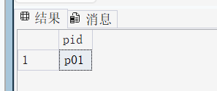
(33) Get aids of agents who have the highest Percent.
(33) 查询拥有最高Percent的代理商的aid值.
SELECT aid
FROM Agents
WHERE percnt = (SELECT MAX(percnt) FROM Agents);
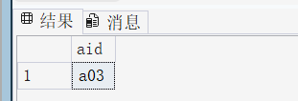

- Conclusion and Analysis

Comments and Score
Comments：

Score： Signature of teacher：
Date:

