

实 验（实训）报 告

项 目 名 称 | Practice of static integrity constraint
所 属 课程名称 | Database Theory and Application
项 目 类 型 | Computer Operation
实验(实训)日期
学 院 | Information Technology and Artificial Intelligence
班 级
学 号
姓 名
指导教师

浙江财经大学教务处制

一、实验（实训）概述（目的及要求，基本原理，实施环境、使用的材料、设备、软件等）（可加页）
- Objects
Study the knowledge of static integrity constraint.
- Environment and Software
- Personal Computer
- Windows 10 / Windows 11
- Microsoft SQL ServerEnvironment and Software
- Personal Computer
- Windows 10 / Windows 11
- Microsoft SQL Server
二、实验（实训）内容（项目内容，方案设计，实验（实训）过程步骤、记录、数据、程序，结果与分析等）（可加页）
- Contents
Be familiar with knowledge of static integrity constraint.
- The deadline to submit report
23:59, May 25, 2026
- (Design), process, source code and result

1. EXECUTE the following SQL statements.
CREATE DATABASE SCT;
GO

USE SCT;
GO

CREATE TABLE Student(Sno char(10) constraint pk_student Primary key, Sname varchar(20), Gender char(2), Age int, Dno char(2),Haddress varchar(100));
CREATE TABLE Dept(Dno char(2) constraint pk_dept Primary key, Dname varchar(20) constraint cst_dept_unique_001 UNIQUE, Dean varchar(20));
CREATE TABLE Course(Cno char(3) constraint pk_course Primary key, Cname varchar(30), Hours int, Credit float(1), Tno char(3));
CREATE TABLE Teacher(Tno char(3) constraint pk_teacher Primary key, Tname varchar(30), Dno char(2), Title varchar(20), Salary float(1), Deduction float(1));
CREATE TABLE SC(Sno char(10), Cno char(3), Score float(1));
GO

INSERT INTO Student VALUES ('2015030101', 'Li Jian','M', 20, '03', 'No. 55, Huangchengxi Road, Wenzhou');
INSERT INTO Student VALUES ('2015030102', 'Zhang Rui','F', 19, '04', 'No. 22, Xiasha Road, Hangzhou');
INSERT INTO Student VALUES ('2015040101', 'Liu Ke','M', 20, '03', 'No. 20, Zhongshanbei Road, Ningbo');

INSERT INTO Dept VALUES('03','Management','Wang Gang');
INSERT INTO Dept VALUES('04','Computer Science','Feng Li');

INSERT INTO Course VALUES ('001','Computer Network',40,2,'001');
INSERT INTO Course VALUES ('002','Software Engineering',60,3,'002');

INSERT INTO Teacher VALUES('001', 'Liu Fei', '03', 'Lecturer', 2800,500);
INSERT INTO Teacher VALUES('002', 'Fu Qiang', '04', 'Professor', 5600,0);

INSERT INTO SC VALUES('2015030101','001', 80.0);
GO

NOTE:
(Sname,Haddress)is the alternate key of student;
Dname is the alternate key of Dept;
Deduction 扣款
Title 职称

2. Write and test SQL statement, paste SQL statement and the interface of the running result of SQL statement. NOTE: if the execution failed, please give the reason.

[1] Insert the tuple of (NULL, '005', 88) into table SC, and there is no such a course with cno=’005’ in Course. Explain why the above tuple can be inserted.
INSERT INTO SC VALUES (NULL, '005', 88);
SELECT * FROM SC;
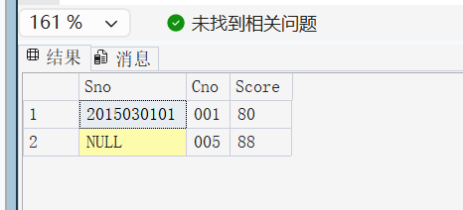
[2] Delete the tuple of (NULL,'005',88), then insert the tuple of ('2015030101','001',80) into table SC, and there is a same tuple already in table SC. Explain why two same tuples can be existed in the table SC.
DELETE FROM SC WHERE Sno IS NULL AND Cno = '005' AND Score = 88;
INSERT INTO SC VALUES ('2015030101', '001', 80);
SELECT * FROM SC;
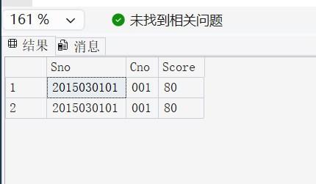
[3] Drop the table SC, and re-create table SC with primary key, set the default value of Score to be 0.
DROP TABLE SC;
CREATE TABLE SC (
Sno char(10),
Cno char(3),
Score float(1) DEFAULT 0,
CONSTRAINT pk_sc PRIMARY KEY (Sno, Cno)
);
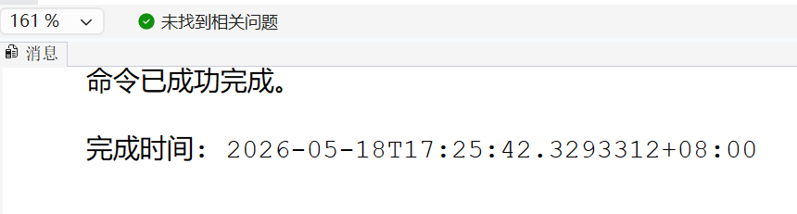
[4] Insert tuple('2015030101','001', 80.0) and tuple ('2015030102','002', 96.0) into table SC.
INSERT INTO SC VALUES ('2015030101', '001', 80.0);
INSERT INTO SC VALUES ('2015030102', '002', 96.0);
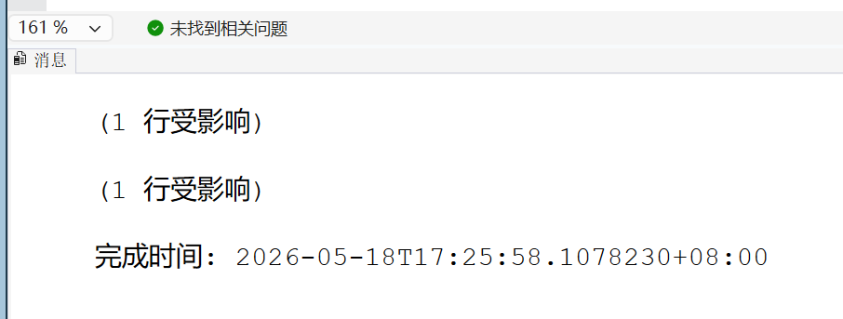
[5] Execute ‘INSERT INTO SC(sno,cno) VALUES('2015040101','001')’, and list all tuples from SC, check the value of score for the above tuple.
INSERT INTO SC(Sno, Cno) VALUES ('2015040101', '001');
SELECT * FROM SC;
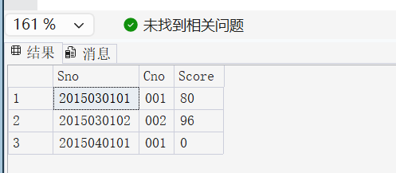
[6] Execute ‘INSERT INTO SC VALUES('2015040101','009', 76)’, and there is no such course with cno = ‘009’ in table course, Explain why the above tuple can be inserted.
INSERT INTO SC VALUES ('2015040101', '009', 76);
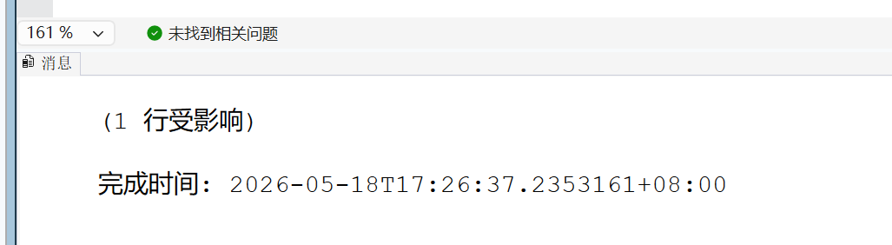
[7] Delete the tuple of ('2015040101','009', 76), and add two foreign key constraints named fk_sc_sno and fk_sc_cno,with DELETE CASCADE and UPDATE CASCADE, in table SC.
DELETE FROM SC WHERE Sno = '2015040101' AND Cno = '009' AND Score = 76;
ALTER TABLE SC ADD CONSTRAINT fk_sc_sno FOREIGN KEY (Sno) REFERENCES Student(Sno)
ON DELETE CASCADE ON UPDATE CASCADE;
ALTER TABLE SC ADD CONSTRAINT fk_sc_cno FOREIGN KEY (Cno) REFERENCES Course(Cno)
ON DELETE CASCADE ON UPDATE CASCADE;
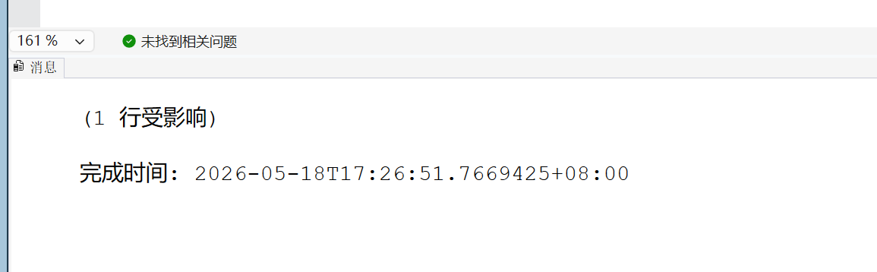
[8] Execute ‘INSERT INTO SC VALUES('2015040101','009', 76)’, and explain the result.
INSERT INTO SC VALUES ('2015040101', '009', 76);
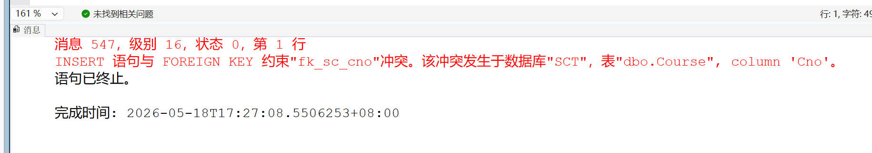
[9] List all information of table SC, then execute ‘UPDATE student SET Sno = '2015030110' WHERE Sno = '2015030101'’, list all information of table SC again. Find the differences, and give the explanation.
SELECT * FROM SC;
UPDATE Student SET Sno = '2015030110' WHERE Sno = '2015030101';
SELECT * FROM SC;
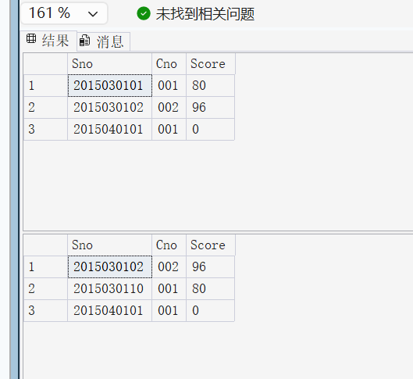
[10] List all information of table SC, then execute ‘DELETE FROM student WHERE Sno = '2015030110'’, list all information of table SC again. Find the differences, and gives the explanation.
SELECT * FROM SC;
DELETE FROM Student WHERE Sno = '2015030110';
SELECT * FROM SC;

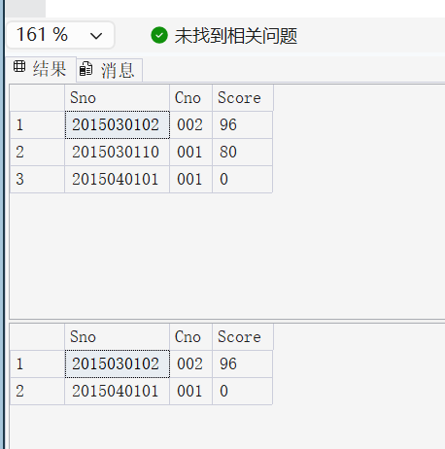
[11] Add a constraint named cst_student_unique_001 for constraint requirement [(Sname is an alternate key] in table Student. Insert a tuple designed by yourself, this new tuple violates the above constraint requirement. Explain the result.
ALTER TABLE Student ADD CONSTRAINT cst_student_unique_001 UNIQUE (Sname);
INSERT INTO Student VALUES ('2015999999', 'Li Jian', 'M', 20, '03', 'Test address'); 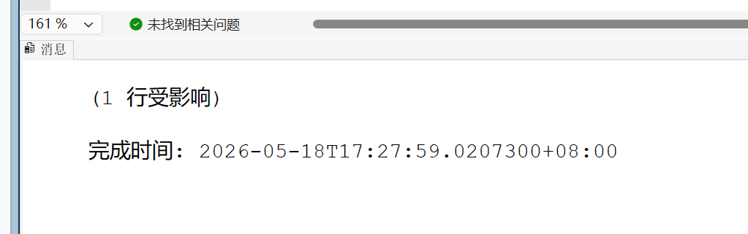
[12] Add a constraint named cst_student_gender for constraint requirement [the value of Gender is ‘F’ or ‘M’] in table Student. Insert a tuple designed by yourself, this new tuple violates the above constraint requirement. Explain the result.
ALTER TABLE Student ADD CONSTRAINT cst_student_gender CHECK (Gender IN ('F', 'M'));
INSERT INTO Student VALUES ('2015888888', 'Test Gender', 'X', 20, '03', 'Test address');
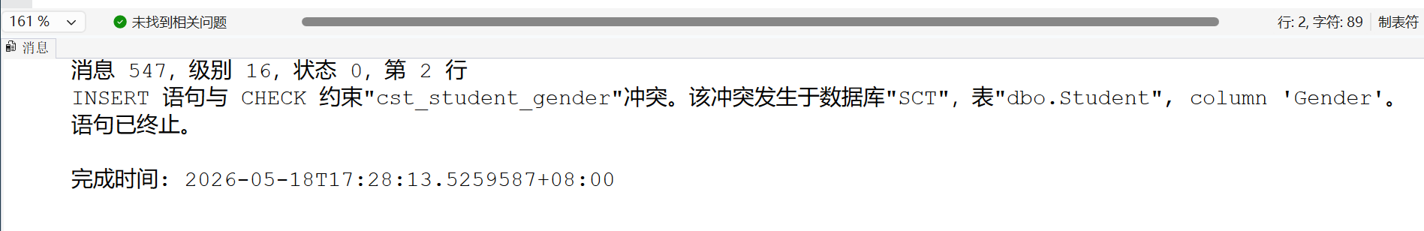
[13] Add a constraint named cst_student_age for constraint requirement [the value of Gender is between 12 and 30] in table Student. Insert a tuple designed by yourself, this new tuple violates the above constraint requirement. Explain the result.
ALTER TABLE Student ADD CONSTRAINT cst_student_age CHECK (Age BETWEEN 12 AND 30);
INSERT INTO Student VALUES ('2015777777', 'Test Age', 'M', 10, '03', 'Test address');
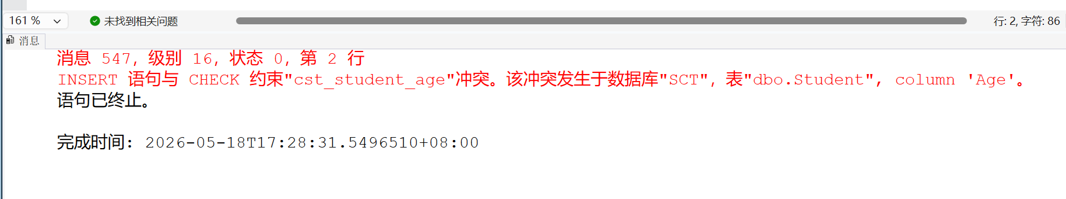
[14] Add a constraint named fk_student_dno for constraint requirement [Dno is a foreign key referenced Dno of Dept, with delete cascade and update cascade] in table Student. Insert a tuple designed by yourself, this new tuple violates the above constraint requirement. Explain the result.
ALTER TABLE Student ADD CONSTRAINT fk_student_dno FOREIGN KEY (Dno) REFERENCES Dept(Dno)
ON DELETE CASCADE ON UPDATE CASCADE;
INSERT INTO Student VALUES ('2015666666', 'Test Dno', 'M', 20, '99', 'Test address');

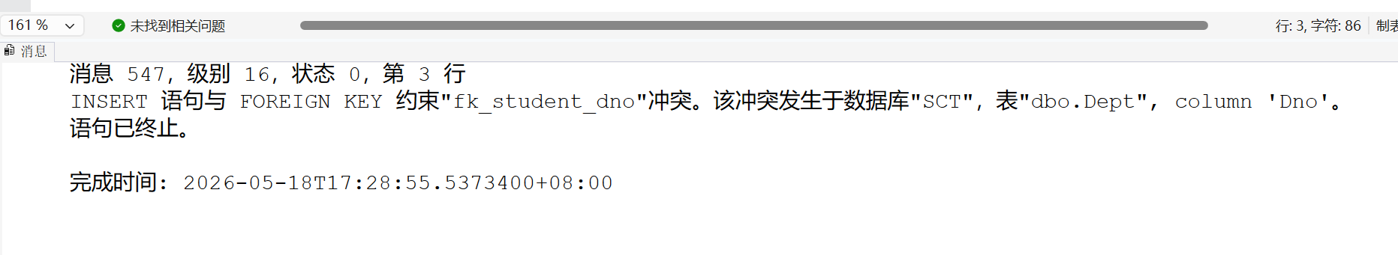
[15] In table Course, there are following constraint requirements.
(1) credit is between 0 and 5; → constraint name is ‘cst_course_credit’
(2) Tno is foreign key references Tno of table Teacher, with delete cascade and
update cascade; →constraint name is ‘fk_course_tno’
(3) Hours/Credit = 20 →constraint name is ‘cst_course_hours_credit’
Write SQL statements to add all above constraint requirements. Insert a tuple designed by yourself, this new tuple violates the 3rd constraint requirement [Hours/Credit=20]. Explain the result.
ALTER TABLE Course ADD CONSTRAINT cst_course_credit CHECK (Credit BETWEEN 0 AND 5);
ALTER TABLE Course ADD CONSTRAINT fk_course_tno FOREIGN KEY (Tno) REFERENCES Teacher(Tno)
ON DELETE CASCADE ON UPDATE CASCADE;
ALTER TABLE Course ADD CONSTRAINT cst_course_hours_credit CHECK (Hours = Credit * 20);
INSERT INTO Course VALUES ('003', 'Test Course', 40, 3, '001');
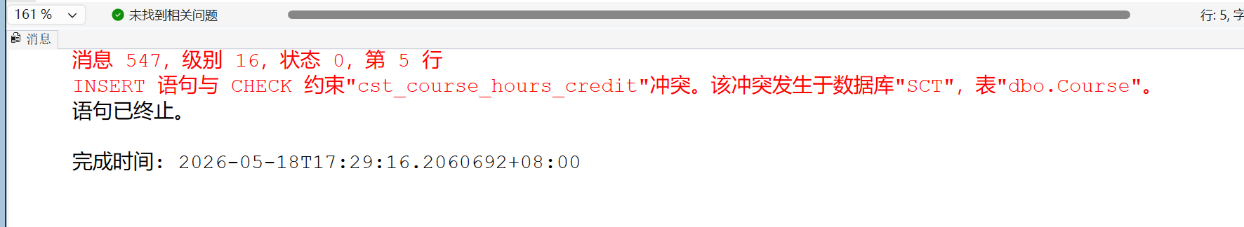
[16] In table Teacher, there are following constraint requirements.
(1) Dno is foreign key references Dno of table Dept, with DELETE NO ACTION and UPDATE NO ACTION; →constraint name is ‘fk_teacher_dno’
(2) Salary-Deduction > 0 →constraint name is ‘cst_teacher_salary_deduction’
Write SQL statements to add all above constraint requirements. Insert a tuple designed by yourself, this new tuple violates the 2nd constraint requirement [Salary-Deduction>0]. Explain the result.
ALTER TABLE Teacher ADD CONSTRAINT fk_teacher_dno FOREIGN KEY (Dno) REFERENCES Dept(Dno)
ON DELETE NO ACTION ON UPDATE NO ACTION;
ALTER TABLE Teacher ADD CONSTRAINT cst_teacher_salary_deduction CHECK (Salary - Deduction >
0);
INSERT INTO Teacher VALUES ('003', 'Test Teacher', '03', 'Lecturer', 500, 500);
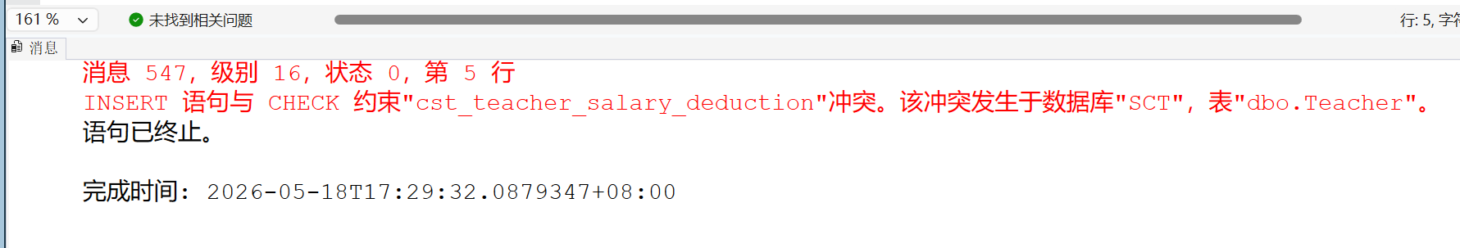

- Conclusion and Analysis

三、Comments and Score
Comments：

Score： Signature of teacher：
Date:

