

实 验（实训）报 告

项 目 名 称 | Practice of Trigger (1)
所 属 课程名称 | Database Theory and Application
项 目 类 型 | Computer Operation
实验(实训)日期
学 院 | Information Technology and Artificial Intelligence
班 级
学 号
姓 名
指导教师

浙江财经大学教务处制

一、实验（实训）概述（目的及要求，基本原理，实施环境、使用的材料、设备、软件等）（可加页）
- Objects
- Study the use of trigger
- Environment and Software
- Personal Computer
- Windows 10 / Windows 11
- Microsoft SQL Server
二、实验（实训）内容（项目内容，方案设计，实验（实训）过程步骤、记录、数据、程序，结果与分析等）（可加页）
- Contents
- Use trigger to complete required operation.

- The deadline to submit report
23:59, May 28, 2026

- (Design), process, source code and result
Write and test SQL statement, paste SQL statement and the interface of the running result of SQL statement.

预备工作：
CREATE DATABASE bankSystem
USE bankSystem
GO

CREATE TABLE bank(cardID varchar(8) primary key, customerName varchar(12), currentMoney money);
CREATE TABLE transInfo(cardID varchar(8) not null, transDate datetime not null, transType varchar(8) constraint cttype check(transType='存入' or transType='支取'), transMoney money, primary key(cardID, transDate));

INSERT INTO bank VALUES ('10010001', '张三',1000);
INSERT INTO bank VALUES ('10010002', '李四',1);

[1] 在银行系统中，当某一储户进行取款操作时，将会向交易信息表(transInfo)插入一条交易信息。试创建触发器tri_insert_transInfo，实现判断取款金额是否超出bank表中该储户的账户余额(至少保留1元)，如果没有超出，则自动更新对应帐户余额，否则撤销相应的取款操作。并进行测试验证。
CREATE TRIGGER tri_insert_transInfo
ON transInfo
AFTER INSERT
AS
BEGIN
DECLARE @cid varchar(8), @type varchar(8), @money money, @cur money;
SELECT @cid=cardID, @type=transType, @money=transMoney FROM inserted;
SELECT @cur=currentMoney FROM bank WHERE cardID=@cid;
IF @type='支取'
BEGIN
IF @cur - @money < 1
BEGIN
RAISERROR('余额不足，至少保留1元',16,1);
ROLLBACK TRANSACTION;
RETURN;
END
UPDATE bank SET currentMoney = currentMoney - @money WHERE cardID=@cid;
END
END
GO
-- test1：取款 500（成功）
INSERT INTO transInfo VALUES('10010001',GETDATE(),'支取',500);
-- result
SELECT * FROM bank;
SELECT * FROM transInfo;
-- test2：取款 999（失败，余额不足）
INSERT INTO transInfo VALUES('10010001',GETDATE(),'支取',999);

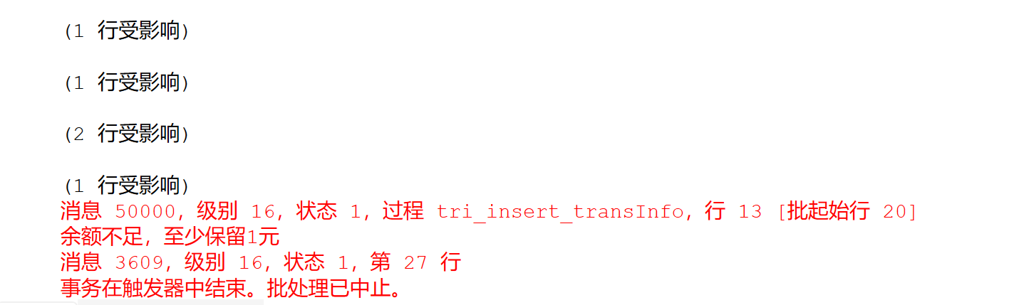
[2] 银行系统中，当某一客户新办一张银行卡时，将会在bank表中新增一个账户。创建触发器tri_insert_cusID,使新插入记录中银行卡的卡号位数保持8位且必须以“10”开头，否则撤销相应操作。并进行测试验证。
*NOTE：LEN()函数

CREATE TRIGGER tri_insert_cusID
ON bank
INSTEAD OF INSERT
AS
BEGIN
DECLARE @cid varchar(8);
SELECT @cid=cardID FROM inserted;
IF LEN(@cid)=8 AND LEFT(@cid,2)='10'
INSERT INTO bank SELECT * FROM inserted;
ELSE
BEGIN
RAISERROR('卡号必须8位且以10开头',16,1);
RETURN;
END
END
GO
-- test1：合法卡号（成功）
INSERT INTO bank VALUES('10123456','测试用户',5000);
-- 查看
SELECT * FROM bank;
-- test2：非法卡号（失败）
INSERT INTO bank VALUES('2012345','错误用户',100);
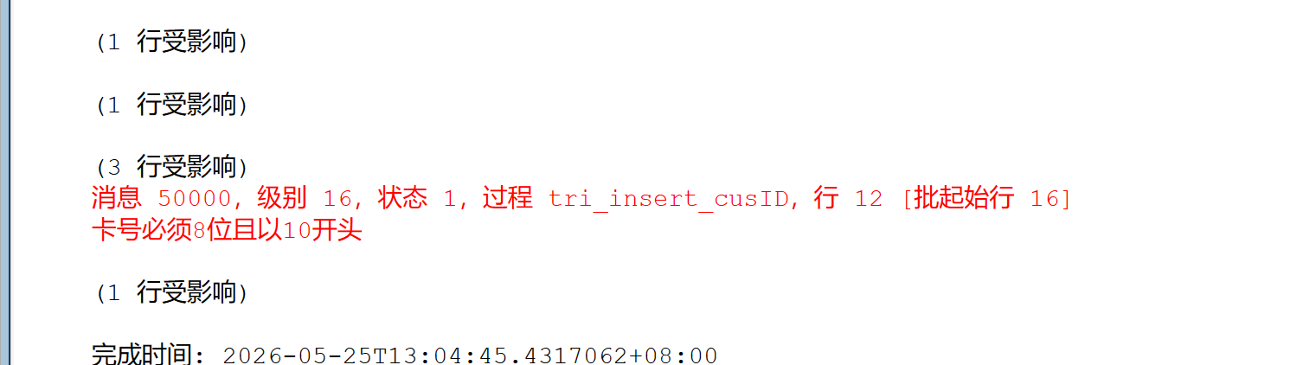
[3] 当用户注销银行卡时，将从bank表中删除该银行卡对应的账户，试创建触发器trig_delete_cusInfo,实现删除该卡号对应的所有交易信息，并且将账户信息和所有交易信息进行备份[backupBank, backupTransinfo]。并进行测试验证。*注意理解以下语句的含义：
IF NOT EXISTS(SELECT * FROM sysobjects WHERE name='backupBank')
SELECT * INTO backupBank FROM deleted

CREATE TRIGGER trig_delete_cusInfo
ON bank
AFTER DELETE
AS
BEGIN
-- 备份账户
IF NOT EXISTS (SELECT * FROM sysobjects WHERE name='backupBank')
SELECT * INTO backupBank FROM deleted;
ELSE
INSERT INTO backupBank SELECT * FROM deleted;
-- 备份交易
IF NOT EXISTS (SELECT * FROM sysobjects WHERE name='backupTransinfo')
SELECT T.* INTO backupTransinfo FROM transInfo T JOIN deleted D ON
T.cardID=D.cardID;
ELSE
INSERT INTO backupTransinfo SELECT T.* FROM transInfo T JOIN deleted D ON
T.cardID=D.cardID;
-- 删除交易
DELETE T FROM transInfo T JOIN deleted D ON T.cardID=D.cardID;
END
GO
-- test：注销卡号 10010002
DELETE FROM bank WHERE cardID='10010002';
-- 查看
SELECT * FROM bank;
SELECT * FROM transInfo;
SELECT * FROM backupBank;
SELECT * FROM backupTransinfo;
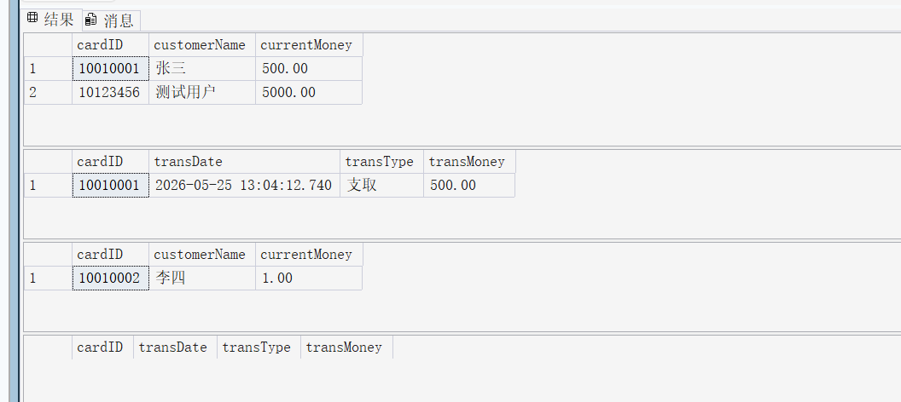 [4] 当银行系统中发生大额现金交易(500万以上)时，相应信息将会被自动采集到中国人民银行反洗钱信息系统做进一步分析调查。试创建触发器trig_ Cashin_check,实现当发生大额现金存入时(操作类型为“存入”)，自动将卡号、姓名、交易时间、交易金额等信息保存到表susTable中。并进行测试验证。注意：* 创建susTbale表的SQL语句参见
SELECT bank.cardID,bank.customerName,inserted.transmoney,
inserted.transdate
INTO sustable
FROM inserted,bank
WHERE bank.cardID = inserted.cardID
IF NOT EXISTS (SELECT * FROM sysobjects WHERE name='susTable')
CREATE TABLE susTable(
cardID varchar(8),
customerName varchar(12),
transMoney money,
transDate datetime
);
GO
CREATE TRIGGER trig_Cashin_check
ON transInfo
AFTER INSERT
AS
BEGIN
INSERT INTO susTable
SELECT B.cardID, B.customerName, I.transMoney, I.transDate
FROM inserted I
JOIN bank B ON I.cardID=B.cardID
WHERE I.transType='存入' AND I.transMoney >= 5000000;
END
GO
-- test：大额存入 600万
INSERT INTO transInfo VALUES('10010001',GETDATE(),'存入',6000000);
-- 查看
SELECT * FROM transInfo;
SELECT * FROM susTable;

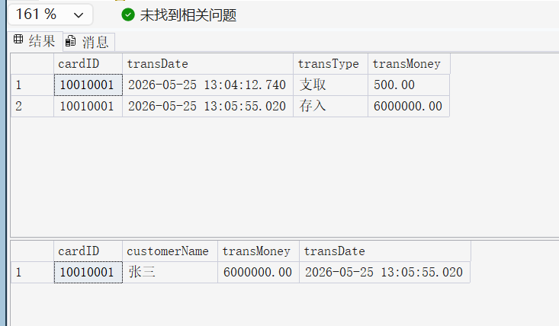

- Conclusion and Analysis

Comments and Score
Comments：

Score： Signature of teacher：
Date:

