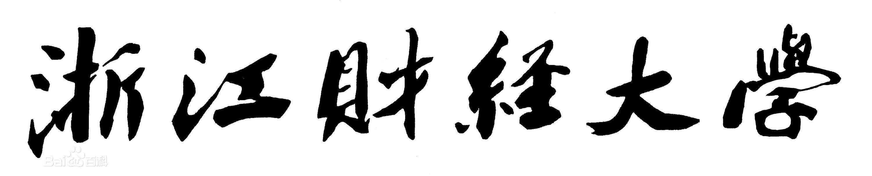

实 验（实训）报 告

项 目 名 称 | Practice of Trigger (2)
所 属 课程名称 | Database Theory and Application
项 目 类 型 | Computer Operation
实验(实训)日期
学 院 | Information Technology and Artificial Intelligence
班 级
学 号
姓 名
指导教师

浙江财经大学教务处制

一、实验（实训）概述（目的及要求，基本原理，实施环境、使用的材料、设备、软件等）（可加页）
- Objects
- Study the use of trigger
- Environment and Software
- Personal Computer
- Windows 10 / Windows 11
- Microsoft SQL Server
二、实验（实训）内容（项目内容，方案设计，实验（实训）过程步骤、记录、数据、程序，结果与分析等）（可加页）
- Contents
- Use trigger to complete required operation.

- The deadline to submit report
23:59, June 1, 2026

- (Design), process, source code and result
Write and test SQL statement, paste SQL statement and the interface of the running result of SQL statement.

预备工作：
CREATE DATABASE Studentdb;
GO

USE Studentdb;
GO

CREATE TABLE Student(Sno char(4) Primary Key, Sname varchar(50) NOT NULL, Gender char(2), Birthday datetime, Haddress varchar(100), Height float(2));
CREATE TABLE Course(Cno char(4) Primary Key, Cname varchar(50) NOT NULL, Credit int);
CREATE TABLE SC(Sno char(4), Cno char(4), Grade float(1) default(NULL), Primary Key(Sno, Cno));
GO

INSERT INTO Student VALUES ('1401', 'Liu Yiping','M', '1990-10-1', 'No. 55, Huangchengxi Road, Wenzhou', 1.78);
INSERT INTO Student VALUES ('1402', 'Zhang Demin','M', '1990-12-2', 'No. 22, Xiasha Road，Hangzhou', 1.65);
INSERT INTO Student VALUES ('1403', 'Ma Dong','M', '1990-7-4', 'No. 20, Zhongshanbei Road, Ningbo', 1.71);
INSERT INTO Student VALUES ('1404', 'Xiao Haiyan','F', '1990-3-15', 'No. 43, Yuexiubei Road, Wenzhou', 1.65);
INSERT INTO Student VALUES ('1405', 'Zhang Minghua','F', '1991-5-13', 'No. 7, Genshan Road, Hangzhou', 1.63);

INSERT INTO Course VALUES ('0001','Computer Fundamental',2);
INSERT INTO Course VALUES ('0002','Management Theory',3);
INSERT INTO Course VALUES ('0003','Database Theory and Application',3);
INSERT INTO Course VALUES ('0004','Project Management',2);
INSERT INTO Course VALUES ('0005','Thesis',10);

INSERT INTO SC VALUES('1401','0001', 80.0);
INSERT INTO SC VALUES('1401','0002', 90.0);
INSERT INTO SC VALUES('1401','0003', 70.0);
INSERT INTO SC VALUES('1401','0004', 85.0);
INSERT INTO SC VALUES('1401','0005', 92.0);
INSERT INTO SC VALUES('1402','0001', 78.0);
INSERT INTO SC VALUES('1402','0002', NULL);
INSERT INTO SC VALUES('1402','0003', 77.0);
INSERT INTO SC VALUES('1402','0004', 67.0);
INSERT INTO SC VALUES('1403','0001', 66.0);
INSERT INTO SC VALUES('1403','0002', 76.0);
INSERT INTO SC VALUES('1403','0003', NULL);
INSERT INTO SC VALUES('1403','0004', 73.0);
GO

[1] 创建一个触发器tri_insert_sno，实现如下功能：使学生表Student中新插入记录中的学号位数保持4位且必须以“14”开头，否则撤销相应操作。并进行测试验证。
IF OBJECT_ID('tri_insert_sno', 'TR') IS NOT NULL
DROP TRIGGER tri_insert_sno;
GO
CREATE TRIGGER tri_insert_sno
ON Student
INSTEAD OF INSERT
AS
BEGIN
DECLARE @invalid_format BIT = 0;
DECLARE @duplicate_key BIT = 0;
-- 检查格式
IF EXISTS (
SELECT 1 FROM inserted
WHERE LEN(Sno) != 4 OR LEFT(Sno, 2) != '14'
)
BEGIN
SET @invalid_format = 1;
END
-- 检查重复
IF EXISTS (
SELECT 1 FROM inserted i
WHERE EXISTS (SELECT 1 FROM Student s WHERE s.Sno = i.Sno)
)
BEGIN
SET @duplicate_key = 1;
END
IF @invalid_format = 1
BEGIN
RAISERROR('学号必须为4位且以14开头', 16, 1);
ROLLBACK;
RETURN;
END
IF @duplicate_key = 1
BEGIN
RAISERROR('学号已存在，不能重复插入', 16, 1);
ROLLBACK;
RETURN;
END
-- 插入
INSERT INTO Student (Sno, Sname, Gender, Birthday, Haddress, Height)
SELECT Sno, Sname, Gender, Birthday, Haddress, Height
FROM inserted;
END;
GO
测试：
-- 第一次插入（成功）
INSERT INTO Student VALUES ('1406', 'Li Hua', 'M', '1992-01-01', 'Hangzhou', 1.75);
-- 重复插入（触发重复键错误）
INSERT INTO Student VALUES ('1406', 'Li Hua', 'M', '1992-01-01', 'Hangzhou', 1.75);
-- 错误格式（触发格式错误）
INSERT INTO Student VALUES ('1506', 'Wang Fang', 'F', '1993-02-01', 'Beijing', 1.68);

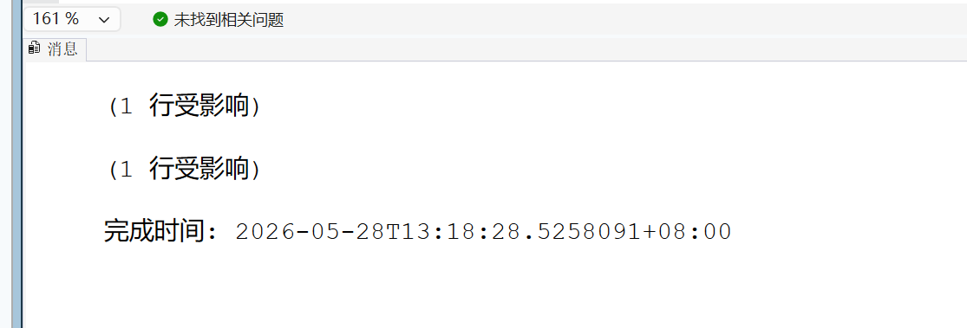
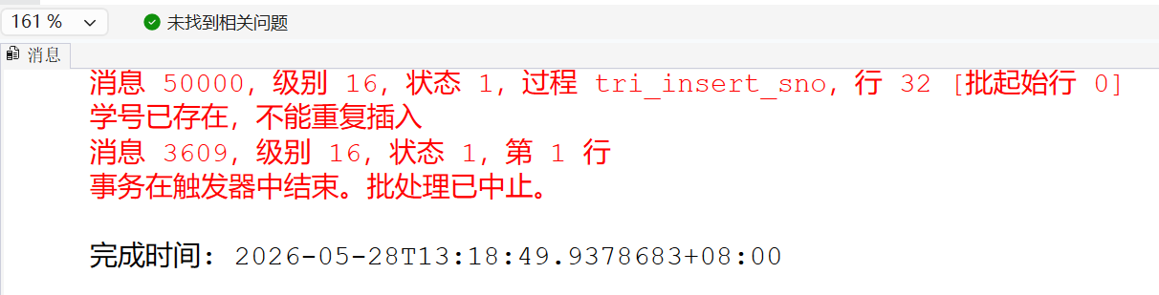
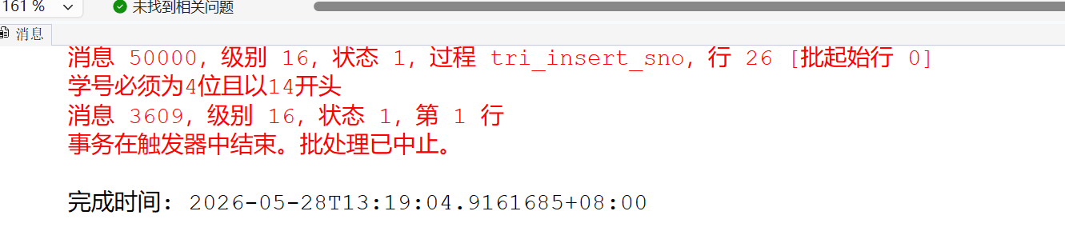
[2] 创建一个触发器tri_update_grade，实现如下功能：防止SC表中的成绩被随意修改(即不能修改成绩)。并进行测试验证。
CREATE TRIGGER tri_update_grade
ON SC
AFTER UPDATE
AS
BEGIN
IF UPDATE(Grade)
BEGIN
RAISERROR('不允许修改成绩！', 16, 1);
ROLLBACK TRANSACTION;
RETURN;
END
END;
GO
测试：
PRINT '========== 测试2：修改成绩（应失败）==========';
UPDATE SC SET Grade = 95.0 WHERE Sno = '1401' AND Cno = '0001';
GO
PRINT '========== 验证成绩未被修改 ==========';
SELECT * FROM SC WHERE Sno = '1401' AND Cno = '0001';
GO
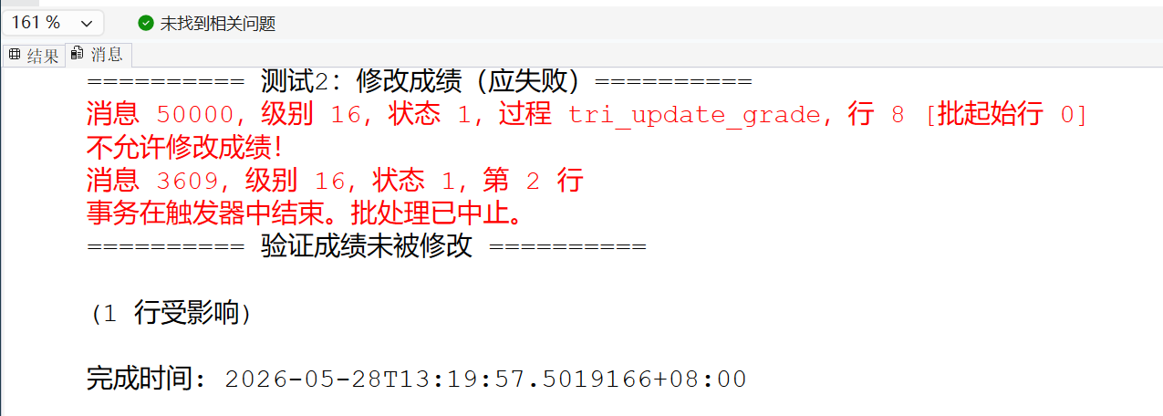
[3] 创建触发器tri_insert_upate_sc，实现如下功能：当向SC表插入或修改一条记录时，分别检查学号及课程号在Student表和Course表中是否分别存在，若不存在则取消插入或修改操作。并进行测试验证。
CREATE TRIGGER tri_insert_update_sc
ON SC
AFTER INSERT, UPDATE
AS
BEGIN
IF EXISTS (
SELECT 1 FROM inserted i
WHERE NOT EXISTS (SELECT 1 FROM Student s WHERE s.Sno = i.Sno)
OR NOT EXISTS (SELECT 1 FROM Course c WHERE c.Cno = i.Cno)
)
BEGIN
RAISERROR('学号或课程号不存在，操作被取消！', 16, 1);
ROLLBACK TRANSACTION;
RETURN;
END
END;
GO
测试：
PRINT '========== 测试3-1：插入不存在的学号（应失败）==========';
INSERT INTO SC VALUES('9999','0001',85.0);
GO
PRINT '========== 测试3-2：插入不存在的课程号（应失败）==========';
INSERT INTO SC VALUES('1401','9999',85.0);
GO
PRINT '========== 测试3-3：插入正确的学号和课程号（应成功）==========';
INSERT INTO SC VALUES('1404','0002',88.0);
GO
PRINT '========== 验证插入结果 ==========';
SELECT * FROM SC WHERE Sno = '1404';
GO
PRINT '========== 测试3-4：修改为不存在的学号（应失败）==========';
UPDATE SC SET Sno = '9999' WHERE Sno = '1401' AND Cno = '0001';
GO
PRINT '========== 验证原数据未被修改 ==========';
SELECT * FROM SC WHERE Sno = '1401' AND Cno = '0001';
GO
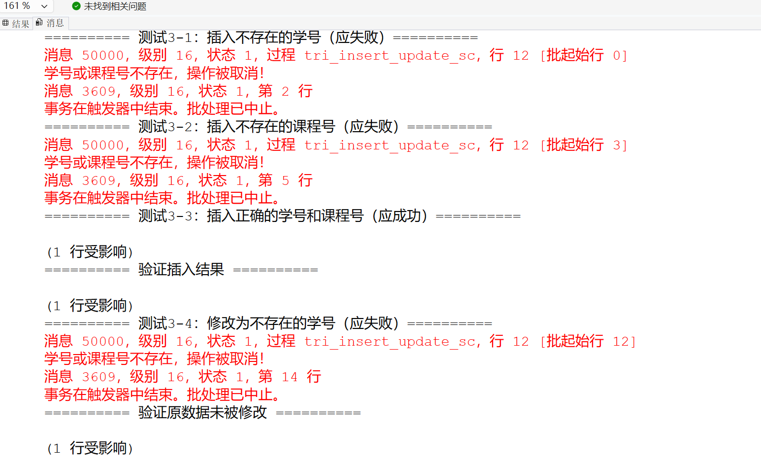
[4] 创建触发器tri_update_course，实现如下功能：若Course表中的课程号发生变化，在SC表中的对应课程号也要进行相应变化，如课程号“0001”变成“1001”，则SC表中相应值也同时变化。并进行测试验证。
CREATE TRIGGER tri_update_course
ON Course
AFTER UPDATE
AS
BEGIN
IF UPDATE(Cno)
BEGIN
UPDATE SC
SET Cno = inserted.Cno
FROM SC
JOIN deleted ON SC.Cno = deleted.Cno
JOIN inserted ON deleted.Cno = inserted.Cno;
END
END
GO
-- 测试
SELECT * FROM SC WHERE Cno='0001';
UPDATE Course SET Cno='1001' WHERE Cno='0001';
SELECT * FROM SC WHERE Cno='1001';
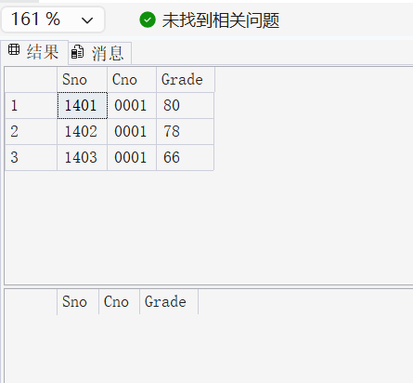
[5] 在学生信息表Student上创建触发器tri_del_student01，当删除学生记录时，判断如果该学生已经有考试成绩，则不允许删除。并进行测试验证。
CREATE TRIGGER tri_del_student01
ON Student
INSTEAD OF DELETE
AS
BEGIN
IF EXISTS(SELECT * FROM deleted WHERE Sno IN(SELECT Sno FROM SC))
BEGIN
RAISERROR('该学生有成绩，不能删除',16,1);
RETURN;
END
DELETE Student WHERE Sno IN(SELECT Sno FROM deleted);
END
GO
-- 测试
DELETE FROM Student WHERE Sno='1401';
SELECT * FROM Student;
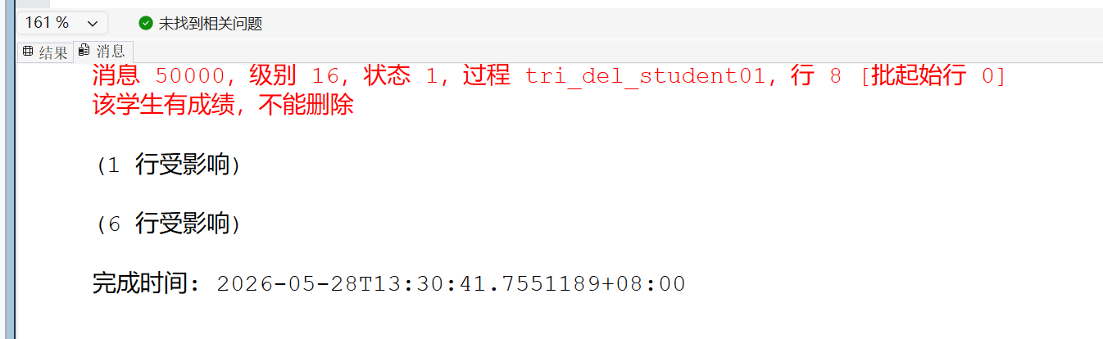

[6] 在学生信息表Student上创建触发器tri_del_student02，当删除学生表中的学生记录时，同步删除选课表中该学生的选课信息。并进行测试验证。
DROP TRIGGER tri_del_student01;
GO
CREATE TRIGGER tri_del_student02
ON Student
AFTER DELETE
AS
BEGIN
DELETE SC WHERE Sno IN(SELECT Sno FROM deleted);
END
GO
-- 测试
SELECT * FROM SC WHERE Sno='1401';
DELETE FROM Student WHERE Sno='1401';
SELECT * FROM SC WHERE Sno='1401';
SELECT * FROM Student;
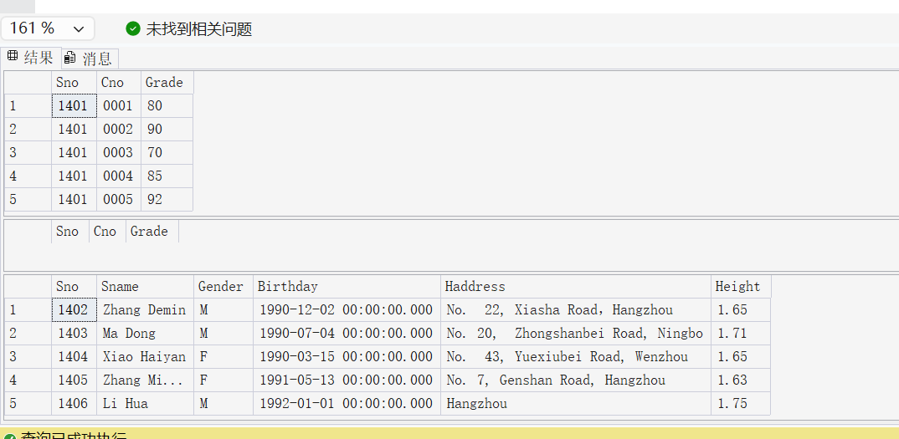
[7] 创建触发器tri_delete_Student03，实现如下功能： 防止用户在删除Student表中记录时进行的误操作(删除记录数大于1)，如：执行了delete from Student (忘了加where限制条件)而删除了全部数据，也就是说删除Student表中记录时，最多只能删除1条记录。并进行测试验证。
DROP TRIGGER tri_del_student02;
GO
CREATE TRIGGER tri_delete_Student03
ON Student
INSTEAD OF DELETE
AS
BEGIN
DECLARE @cnt INT;
SELECT @cnt = COUNT(*) FROM deleted;
IF @cnt > 1
BEGIN
RAISERROR('最多只能删除1条学生记录',16,1);
RETURN;
END
DELETE Student WHERE Sno IN(SELECT Sno FROM deleted);
END
GO
-- 测试1：删1条
DELETE FROM Student WHERE Sno='1402';
SELECT * FROM Student;
-- 测试2：删全部
DELETE FROM Student;
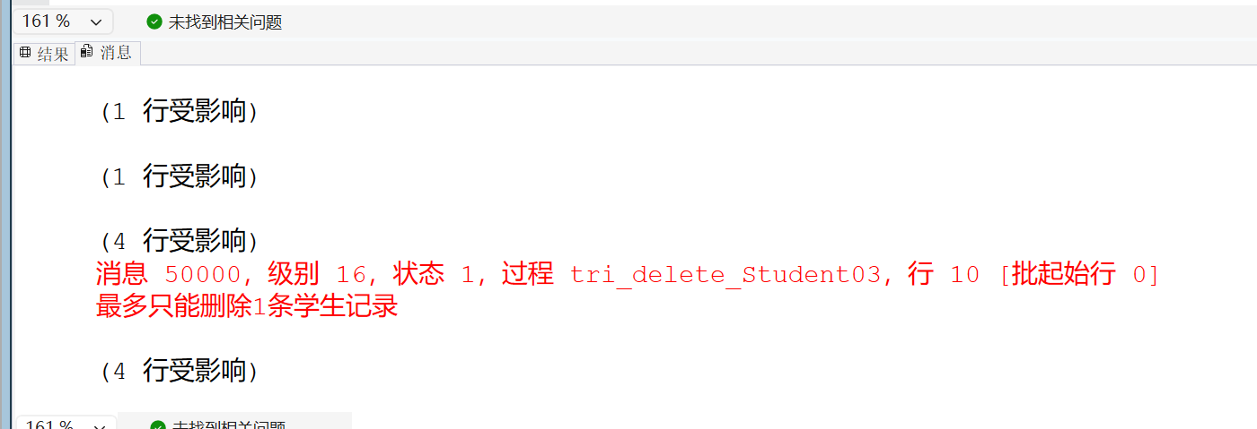

- Conclusion and Analysis

Comments and Score
Comments：

Score： Signature of teacher：
Date:

