電通二乙微處理器實驗 實驗結報

實驗名稱 | 四合一七段顯示器
組別 |  | 組員 | 洪維澤01050852

- 實驗目的
了解七段顯示器之顯示原理:
1.共陰極與共陽極七段顯示器之不同?
2.如何讓七段顯示器顯示0-F?
3.如何控制四合一七段顯示器?
4. 如何讓四合一七段顯示器顯示四位數字?

- 實驗步驟
Arduino接好四合一七段顯示器之電路
四合一七段顯示器每隔0.3秒鐘會跳一個數字,從
000->0059>0100>跳至2359後歸零

- 程式碼
1.
#include "SevSeg.h"
SevSeg sevseg; //Instantiate a seven segment controller object
static unsigned long timer = millis();
static int deciSeconds = 0;
byte a=0;
byte i;
byte b=0;

void setup() {
byte numDigits = 4;
byte digitPins[] = {2, 3, 4, 5};
byte segmentPins[] = { 8, 9, 10, 11, 12, 13,14,15};
bool resistorsOnSegments = false; // 'false' means resistors are on digit pins
byte hardwareConfig = COMMON_CATHODE; // See README.md for options
bool updateWithDelays = false; // Default. Recommended
bool leadingZeros = false; // Use 'true' if you'd like to keep the leading zeros

sevseg.begin(hardwareConfig, numDigits, digitPins, segmentPins, resistorsOnSegments, updateWithDelays, leadingZeros);
sevseg.setBrightness(90);
Serial.begin(9600);

}

void loop() {

if (millis() - timer >= 300) {
timer += 300;
deciSeconds++; // 100 milliSeconds is equal to 1 deciSecond

b=deciSeconds%100;
if (b % 60 == 0)
{
a++;
deciSeconds=0;
Serial.println(a);
for(i=0;i<a;i++)
deciSeconds+=100;
}
if (deciSeconds == 2359) { // Reset to 0 after counting for 1000 seconds.
deciSeconds=0;
}
sevseg.setNumber(deciSeconds);
}

sevseg.refreshDisplay(); // Must run repeatedly
}
於Pin6按鍵,按下後歸零顯示

程式碼
#include "SevSeg.h"
SevSeg sevseg; //Instantiate a seven segment controller object
static unsigned long timer = millis();
static int deciSeconds = 0;
byte a=0;
byte i;
byte b=0;
byte Pin6= digitalRead(6);
void setup() {
byte numDigits = 4;
byte digitPins[] = {2, 3, 4, 5};
byte segmentPins[] = { 8, 9, 10, 11, 12, 13,14,15};
bool resistorsOnSegments = false; // 'false' means resistors are on digit pins
byte hardwareConfig = COMMON_CATHODE; // See README.md for options
bool updateWithDelays = false; // Default. Recommended
bool leadingZeros = false; // Use 'true' if you'd like to keep the leading zeros

sevseg.begin(hardwareConfig, numDigits, digitPins, segmentPins, resistorsOnSegments, updateWithDelays, leadingZeros);
sevseg.setBrightness(90);
Serial.begin(9600);

}

void loop() {

if (millis() - timer >= 100) {
timer += 100;
deciSeconds++; // 100 milliSeconds is equal to 1 deciSecond

b=deciSeconds%100;
if (b % 60 == 0)
{
a++;
deciSeconds=0;
Serial.println(a);
for(i=0;i<a;i++)
deciSeconds+=100;
}
if (deciSeconds == 2359) { // Reset to 0 after counting for 1000 seconds.
deciSeconds=0;
}
sevseg.setNumber(deciSeconds);
}
if(Pin6 == LOW)
{
deciSeconds = 0;
}
sevseg.refreshDisplay(); // Must run repeatedly
}
SevSeg sevseg; //Instantiate a seven segment controller object
static unsigned long timer = millis();
static int deciSeconds = 0;
byte a=0;
byte i;
byte b=0;
byte Pin6= digitalRead(6);
void setup() {
byte numDigits = 4;
byte digitPins[] = {2, 3, 4, 5};
byte segmentPins[] = { 8, 9, 10, 11, 12, 13,14,15};
bool resistorsOnSegments = false; // 'false' means resistors are on digit pins
byte hardwareConfig = COMMON_CATHODE; // See README.md for options
bool updateWithDelays = false; // Default. Recommended
bool leadingZeros = false; // Use 'true' if you'd like to keep the leading zeros

sevseg.begin(hardwareConfig, numDigits, digitPins, segmentPins, resistorsOnSegments, updateWithDelays, leadingZeros);
sevseg.setBrightness(90);
Serial.begin(9600);

}

void loop() {

if (millis() - timer >= 100) {
timer += 100;
deciSeconds++; // 100 milliSeconds is equal to 1 deciSecond

b=deciSeconds%100;
if (b % 60 == 0)
{
a++;
deciSeconds=0;
Serial.println(a);
for(i=0;i<a;i++)
deciSeconds+=100;
}
if (deciSeconds == 2359) { // Reset to 0 after counting for 1000 seconds.
deciSeconds=0;
}
sevseg.setNumber(deciSeconds);
}
if(Pin6 == LOW)
{
deciSeconds = 0;
}
sevseg.refreshDisplay(); // Must run repeatedly
}

實驗步驟3
合併歸零及倒數計時
於Pin6按鍵,按下後歸零顯示
於Pin17接一個按鍵,按下後倒數計時,放開後恢復正常

程式碼
#include "SevSeg.h"
SevSeg sevseg; //Instantiate a seven segment controller object

void setup() {
byte numDigits = 4;
byte digitPins[] = {2, 3, 4, 5};
byte segmentPins[] = {8,9,10,11,12,13,14,15};
bool resistorsOnSegments = false; // 'false' means resistors are on digit pins
byte hardwareConfig = COMMON_CATHODE; // See README.md for options
sevseg.begin(hardwareConfig, numDigits, digitPins, segmentPins, resistorsOnSegments);
sevseg.setBrightness(90);
pinMode(6,INPUT);
pinMode(17,INPUT);
}

void loop()
{

static unsigned long timer = millis();
static int deciSeconds = 0;
boolean val=digitalRead(6);
boolean Pin17=digitalRead(17);
if(val)
{
sevseg.setNumber(0000, 3);
sevseg.refreshDisplay();
if(Pin17==HIGH)
deciSeconds=2400;
else
deciSeconds=0;

}
else if(Pin17==HIGH)
{
sevseg.setNumber(deciSeconds, 3);
if (millis() - timer >= 300)

{
timer += 300;
deciSeconds--;
if (deciSeconds%100 == 59)
{
deciSeconds=deciSeconds-59;
}
else
{
deciSeconds=deciSeconds-1;
}
}
if (deciSeconds == 0)
deciSeconds =2400 ;

sevseg.refreshDisplay(); // Must run repeatedly
}
else
{
sevseg.setNumber(deciSeconds, 3);
if (millis() - timer >= 300)
{
timer += 300;
deciSeconds++;
if (deciSeconds%100 == 59)
{
deciSeconds=deciSeconds+41;
}
else
{
deciSeconds=deciSeconds+1;
}
if (deciSeconds == 2400)
deciSeconds =0 ;
}

sevseg.refreshDisplay(); // Must run repeatedly
}
}

- 實驗結果及分析
由於沒有開關的關西所以使用高低電壓來分別PIN17&6
過程中有些許的不懂，還好隔壁有熱心的同學，當我不會時可以問他。
還有USB十分不穩上傳完一次就要重拔一次。
- 修正電路圖
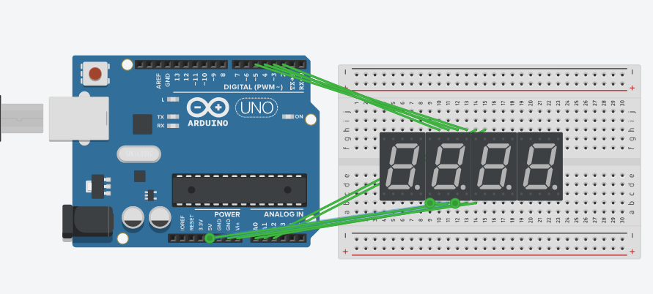

- 修正程式碼

