電通二乙微處理器實驗 實驗結報

實驗名稱 | Lab 12 –溫氏度感測
組別 |  | 組員 | 洪維澤

- 實驗目的
DHT-11 可以一直量測溫度
整合timer與dht-11測量溫濕度
使用Timer 每隔10 秒將溫度度上傳至 MCS Cloud

- 實驗步驟

- 程式碼
Check1
#include "DHT.h"

#define DHTPIN 2 // Digital pin connected to the DHT sensor
// Feather HUZZAH ESP8266 note: use pins 3, 4, 5, 12, 13 or 14 --
// Pin 15 can work but DHT must be disconnected during program upload.

// Uncomment whatever type you're using!
//#define DHTTYPE DHT11 // DHT 11
#define DHTTYPE DHT22 // DHT 22 (AM2302), AM2321
//#define DHTTYPE DHT21 // DHT 21 (AM2301)

// Connect pin 1 (on the left) of the sensor to +5V
// NOTE: If using a board with 3.3V logic like an Arduino Due connect pin 1
// to 3.3V instead of 5V!
// Connect pin 2 of the sensor to whatever your DHTPIN is
// Connect pin 4 (on the right) of the sensor to GROUND
// Connect a 10K resistor from pin 2 (data) to pin 1 (power) of the sensor

// Initialize DHT sensor.
// Note that older versions of this library took an optional third parameter to
// tweak the timings for faster processors. This parameter is no longer needed
// as the current DHT reading algorithm adjusts itself to work on faster procs.
DHT dht(DHTPIN, DHTTYPE);

void setup() {
Serial.begin(9600);
Serial.println(F("DHTxx test!"));

dht.begin();
}

void loop() {
// Wait a few seconds between measurements.
delay(2000);

// Reading temperature or humidity takes about 250 milliseconds!
// Sensor readings may also be up to 2 seconds 'old' (its a very slow sensor)
float h = dht.readHumidity();
// Read temperature as Celsius (the default)
float t = dht.readTemperature();
// Read temperature as Fahrenheit (isFahrenheit = true)
float f = dht.readTemperature(true);

// Check if any reads failed and exit early (to try again).
if (isnan(h) || isnan(t) || isnan(f)) {
Serial.println(F("Failed to read from DHT sensor!"));
return;
}

// Compute heat index in Fahrenheit (the default)
float hif = dht.computeHeatIndex(f, h);
// Compute heat index in Celsius (isFahreheit = false)
float hic = dht.computeHeatIndex(t, h, false);

Serial.print(F("Humidity: "));
Serial.print(h);
Serial.print(F("% Temperature: "));
Serial.print(t);
Serial.print(F("°C "));
Serial.print(f);
Serial.print(F("°F Heat index: "));
Serial.print(hic);
Serial.print(F("°C "));
Serial.print(hif);
Serial.println(F("°F"));
}
=============================================================
=============================================================
Check2
#include "Arduino.h”
#include "LTimer.h”
int led0 = 7;
int led1 = 6;
int val0 = 0;
int val1 = 0;
// instantiation
LTimer timer0(LTIMER_0);
LTimer timer1(LTIMER_1);
// callback function for timer0
void _callback0(void *usr_data)
{ val0 = !val0;
digitalWrite(led0, val0);
}
// callback function for timer1
void _callback1(void *usr_data)
{ val1 = !val1;
digitalWrite(led1, val1);
}
void setup()
{ pinMode(led0, OUTPUT);
pinMode(led1, OUTPUT);
Serial.begin(115200);
// initialization
timer0.begin();
timer1.begin();
// start the execution
timer0.start(500, LTIMER_REPEAT_MODE, _callback0, NULL);
timer1.start(250, LTIMER_REPEAT_MODE, _callback1, NULL);
}
void loop() { }

=============================================================
Check3
#include <LWiFi.h>
#include "MCS.h"
#include "DHT.h"

#define DHTPIN 2
#define DHTTYPE DHT11

DHT dht(DHTPIN, DHTTYPE);
char _lwifi_ssid[] = "HTC Portable Hotspot EA38";
char _lwifi_pass[] = "41265557887d";
MCSDevice mcs("DNNmkKvO", "WQ9doEEdKyIJzvrr");

MCSDisplayFloat Temperature("Humidity");
MCSDisplayFloat Humidity("Temperature");
void setup()
{
dht.begin();
Serial.begin(9600);
Serial.println("Connect to Wifi");
while (WiFi.begin(_lwifi_ssid, _lwifi_pass) != WL_CONNECTED) {
Serial.println("Wifi Reconnecting..");
delay(1000);
}

Serial.println("Connect to MCS...");
while (!mcs.connected()) {
Serial.println("MCS Reconnecting..");
mcs.connect();
}
Serial.println("MCS Connected!");
Serial.println("Humidity and temperature\n\n");
mcs.addChannel(Temperature);
mcs.addChannel(Humidity);
}

void loop()
{
while (!mcs.connected()) {
mcs.connect();
if (mcs.connected()) {
Serial.println("MCS Reconnect");
}
}
mcs.process(1000);
float h = dht.readHumidity();
float t = dht.readTemperature();
if (isnan(h) || isnan(t)) {
Serial.println("Failed to read from DHT sensor!");
return;
}
Serial.print("Humidity: ");
Serial.print(h);
Serial.print(" %\t");
Serial.print("Temperature: ");
Serial.print(t);
Serial.print(" *C ");
Humidity.set(h);
Temperature.set(t);
Serial.println("Add sensor value.");
delay(200);
}

實驗結果及分析
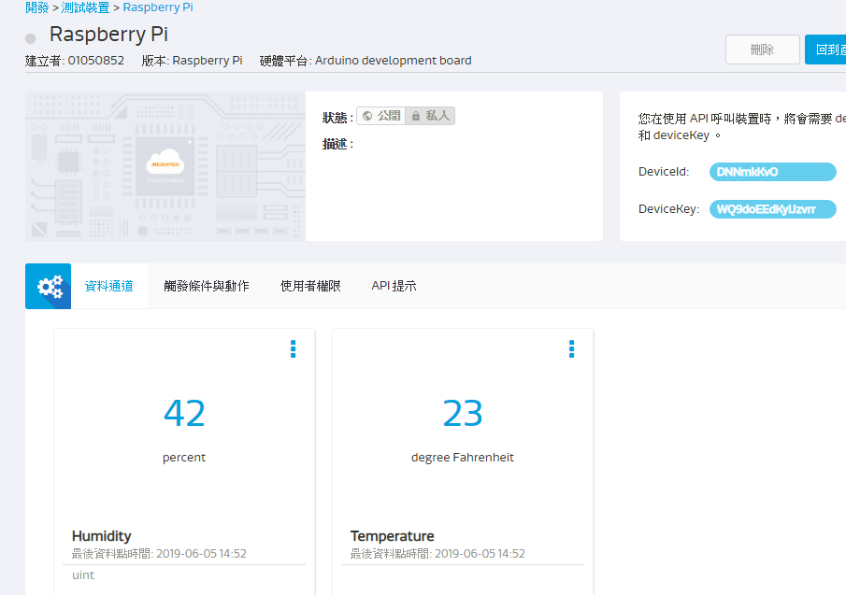

- 心得討論

MCS很不熟悉的系統，剛開始不知道要怎麼弄。後來請同學教我
。

