# Section 2: 3D Coaching

## Game Plan

**Observe**

1. Log in to your online account and complete the following units in Modules 2-3:

2.1: Just Another Program?

2.2: The 3Dimensions of Coaching

2.3: Foundation and Framework

2.4: The Power of Why

2.5: Results of the 3D Process

2.6: Wrap Up

3.1: Learning

3.2: It’s Time

3.3: The Path to Mastery

3.4: The Basis for Care

3.5: The Power of the Leader

3.6: Wrap Up

**Reflect**

1. Complete Section 2 of this Companion Workbook. You may do this electronically, print out this Section and use pen or pencil, or make notes within the online system. Come to your Team Meeting having completed all the questions in Section 2.

**Discuss**

1. Attend and participate in your Team meeting.   
   **Time:** __________ **Place:** __________________________

## 3D Coaching Points

To NEGLECT any aspect of our being is to NOT be the best we can be. This is true of ourselves, and those whom we coach.

Understanding is the basis for care.

## Material Mastery

3D is a _____________ for coaching, built on a ___________________ of purpose.

|  |  |
| --- | --- |
| **The ____ Dimension**  The value system required to reach your goals and fulfill your purpose. |  |
| **The ____ Dimension**  The mindset required to govern your performance and relationships. |  |
| **The ____ Dimension**  The fundamentals skills required to successfully complete your tasks with excellence. |  |

The Greeks had two words for time: **Chronos** and **Kairos**.

____________ time is linear and is measured in minutes, months, and millennia.

____________ time is measured by moments which often-become significant markers in our lives.

Kairos moments, whether positive or negative, can cause us to step off the Chronos timeline and into a process of rethinking, reforming, and re-engaging on a new trajectory. When this happens, these moments achieve their potential of moving us up and forward on the **Path to Mastery**.

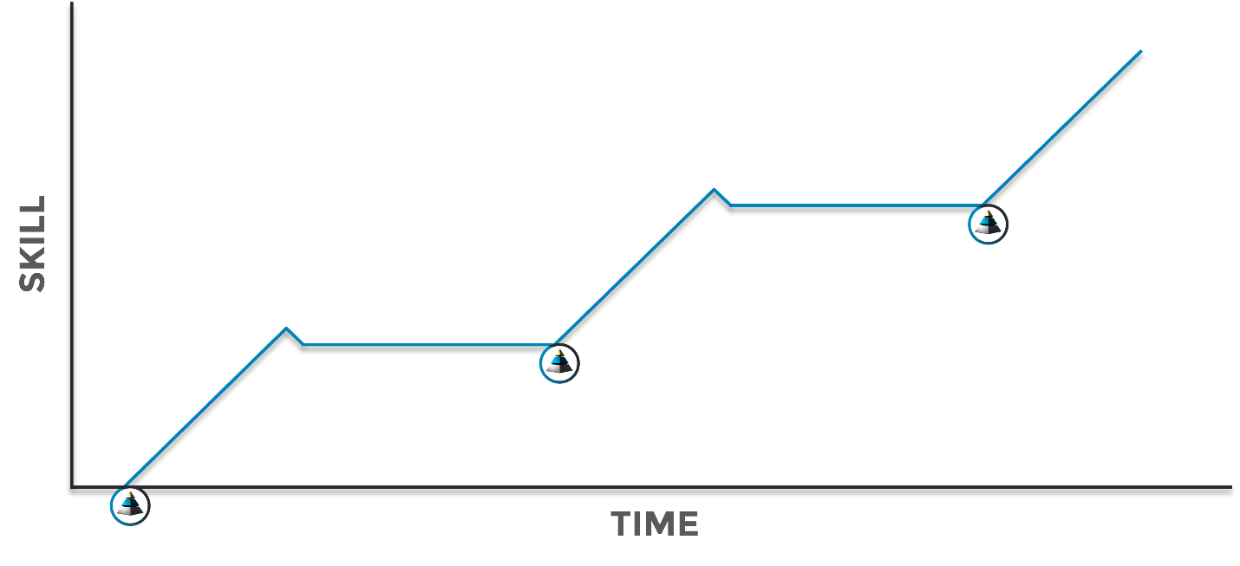

Remember, __________________ is the basis for care. As leaders, we must understand:

1. the purpose of work itself
2. the power we possess as leaders

*“Work is the production of value by the actions of our thoughts and bodily efforts upon available resources.”* – **Dallas Willard**

The essence of work is **Productive** __________________ .

Two of the most powerful words in the English language are "Coach says." Great POWER requires great __________________ for it to be a blessing and not a curse.

## Reflection

What would you say is the “foundation of purpose” for where you are at in this phase of your life? How can you keep yourself reminded of it?

How can the 3D Framework help you clarify and/or fulfill your intended purpose more effectively?

What was a significant Kairos moment you’ve experienced in life? How did that experience change your trajectory moving forward?

How can you bring more creativity and meaning to the work you’re engaged in?

How would your team members answer this question: *How does it* ***feel*** *to be coached by you as their leader?*

## Discussion

What are the 3Dimensions contained in the 3D Framework? In your own words, describe what each Dimension is all about.

As you coach others in your various leadership roles (boss, manager, team leader, parent, teacher, coach, etc.), which Dimension do you believe you are most proficient at coaching/leading currently? Why?

Which Dimension do you feel least equipped to coach/lead right now? Why?

Think of a time where you were coached in the 2nd and/or 3rd Dimensions. What impact did this experience have on you personally? What impact did it have on your performance?

*Kairos time* refers to the moments that often-become significant markers in our lives. Briefly share one of these moments (positive or negative) from your life journey and something you learned through that experience that “changed your trajectory.”

In Module 3, the leadership skill of “Zooming In” and “Zooming Out” was introduced. How can this concept empower a wise decision-making process? Can you think of a specific example where this would be helpful?

## Action

Use the 3D Framework as a diagnostic tool to evaluate your organization’s professional development plan. First, list all of training initiatives that have taken place in your organization over the past 12 months. Then, identify which Dimension(s) were the primary focal point of each of these trainings. This exercise will also help you discern which Dimension(s) need more intentional focus so you can look for resources to fill the gap.

Find ways to memorialize your Kairos moments so they don’t become part of the forgotten past. Write about them in a journal. Hang meaningful art on the wall that reminds you of these experiences. Start a blog. Use meaningful imagery or messaging on your screensavers and backgrounds. Engrave jewelry. Cut out vinyl graphics. Share these stories with your children and grandchildren. Do what you need to do to stay reminded of these transformational moments of your life.

Contemplate the areas of your life where you have some sort of positional power over other people. This could be a role at work, as a volunteer, or even as a parent or guardian. What is one practical thing you can do to serve them as their leader? Now, go do it.

First, engage in more activities that cultivate creativity in your life. Then, look for opportunities to boldly express that creativity in the business environment once the inspiration comes. Schedule a regular time to reflect more and keep the appointment. Spend more time outside in nature. Go to a local art gallery to be inspired by the beauty. Paint your own picture. Read more good books. Consume more good music. Watch the sunrise or sunset more often. Schedule more time to look over water or sit by a fire. Or both. Be more intentional to find the truth, goodness, and beauty that is found all around us if we will slow down to look.

## Notes