# Section 3: The 1st Dimension

## Game Plan

**Observe**

1. Log in to your online account and complete the following units in Module 4:

4.1: Defining Business

4.2: First Things First

4.3: Business Strategy

4.4: Business Execution

4.5: Diagnosing Problems

4.6: Wrap Up

**Reflect**

1. Complete Section 3 of this Companion Workbook. You may do this electronically, print out this Section and use pen or pencil, or make notes within the online system. Come to your Team Meeting having completed all the questions in Section 3.

**Discuss**

1. Attend and participate in your Team meeting.   
   **Time:** __________ **Place:** __________________________

## 3D Coaching Points

When we keep first things first, second things aren’t diminished, they’re enhanced. But when second things become first things, we usually lose them both.

You can’t fix 2nd and 3rd Dimension issues in the 1st Dimension.

## Material Mastery



The F _ _ _ t Dimension encompasses the fundamental

skills required to complete a task.  
  
**Examples include:**

|  |  |  |
| --- | --- | --- |
| * Time Management * Planning & Strategy * Risk Assessment | * Budgeting * Product Knowledge * Reporting | * Sales Methodology * Communication |

“When f _ _ _ t things are put first, s _ _ _ _ d things aren’t suppressed, but they’re actually increased.” **– C.S. Lewis**

Without a clear answer to “why,” the answer in business will almost always be m _ _ e.

Applying the H _ d _ _ _ _ g Concept will help us to stay focused on the primary thing that we do well as an organization. It is based on an ancient Greek parable that states, "The fox knows many things, but the hedgehog knows one big thing."

To successfully execute our business strategy with structure and clarity, we must have a great 1st Dimension strategy for c _ _ _ _ _ _ _ _ _ _ _ n.

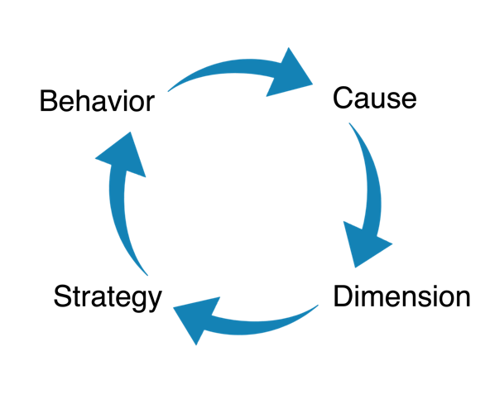  
Success in communication is not based on the sending,   
but on the r _ _ _ _ _ _ _ g.

The **3D Decision-Making Cycle** (right) helps to  
diagnose issues before we prescribe solutions.

## Reflection

As you think about the priorities of your life, what are the “first things” that need to be kept first?

What are some practical ways that you keep first things first in your life?

What would you describe as your personal “Hedgehog” (the primary thing you do well) in your organization? What 1st Dimension skill are you most confident in or do you get the most attention for in your organization?

In what aspects of the 1st Dimension do you most want to improve as a leader?

How effective are you with your 1st Dimension communication skills? How do you know? What can you do to improve?

As a leader, how have you tried to fix 2nd and 3rd Dimension problems with 1st Dimension solutions? Was it effective? How can the 3D Decision-Making Cycle help you be more effective?

## Discussion

When it comes to the 1st Dimension role you play in your organization, what is your personal Hedgehog? (Your main strength)

In your organization, what aspects of the 1st Dimension need the most improvement? Why?

What skill(s) or action(s) do you fear most because you don’t have the skillset to execute it with confidence and competence?  How can you change this?  Who can help you get better at 1st Dimension aspect of your role?

Who do you admire most in your organization for their 1st Dimension skills? What are some practical ways you can learn from their expertise?

Great 1st Dimension communication skills are critical to success. Which aspects of your present role are you most unclear about? How can you seek clarity?

Can you recite your organization’s vision, mission, or immediate priorities? Why or why not?

When issues surface, the 3D Decision-Making Cycle helps leaders diagnose which dimension the issue falls in before making a prescription for a strategy or solution. Do you think this is important? Why or why not? Share examples.

## Action

Effective communication is a primary key to success in the 1st Dimension. Unclear expectations lead to unmet expectations. After tasks are assigned in the 1st Dimension, take time as a leader to check for understanding. Ask questions like:

1. What did you hear me say?
2. What do you understand your task to be?

*\*Remember, for this to be effective there must be a sense of “psychological safety” felt by our teammates.*

Reflect on the “First Things” in your life that need to be prioritized over everything else. Find ways to represent these priorities in your calendar by literally scheduling time for them. Then, keep your appointments!

Ask your family/friends to weigh in on your list of “First Things.” What do they think needs to be changed or added? (Psychological safety required)

Regularly revisit your organization’s mission, vision, and values with your team. Challenge the team members to measure their current initiatives against the established mission, vision, and values.

Before you analyze or correct a behavior with a team member, take time to imagine all the 1st, 2nd, and 3rd dimension root cause that could be present. This helps lead to understanding and empathy to find out “where they are.”

Think of specific issues or behaviors that you would like to “coach up” in your organization. Use the 3D Decision-Making Cycle to determine the cause and dimension before rolling out a solution.

## Notes