|  |  |
| --- | --- |
| **F:\3dcoaching_pc_v3\3D Curriculum\3 Dimensional Coaching logo.png** | ***“Coaching the heart***  ***behind the jersey.”*** |

**Date Issued**  May 19, 2014

**Between** 3Dimensional Coaching

**and**

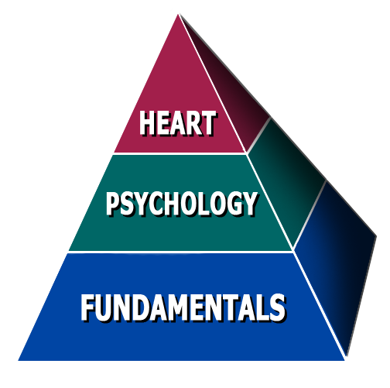**Sponsor**  Neal Hook

Central HS (SJSD)

2602 Edmond St

St. Joseph, MO 64501

**Presenter** Wes Simmons

**Date of appearance**  Thursday, May 22, 2014

**Location** Central High School

**Start Time** 1:00 p.m.

**Length** 2 hours

**Fee** $500

**Payment Terms:**

Please make check payable to 3Dimensional Coaching (**EIN# 44-0610626).**

Mail to 3Dimensional Coaching, P.O. Box 8966, St. Joseph, MO 64508

Payment should be mailed to arrive 5-7 days before the presentation. Payment can also be given to the presenter on the day of the event.

THIS CONTRACT SERVES AS AN INVOICE. YOU WILL NOT RECEIVE ANOTHER INVOICE UNLESS YOU REQUEST IT.

**Other Terms:**

Sponsor is also responsible for providing projector and sound system compatible with a laptop.

I have read and understand all the information contained herein:

**Signature Date**

**3Dimensional Coaching  
P.O. Box 8966****, Saint Joseph, MO 64508**

**www.3dinstitute.com**