**Full Name:**

Erick Garcia

 First Name Last Name

egarcia@floridarushsoccer.com

**E-mail:**

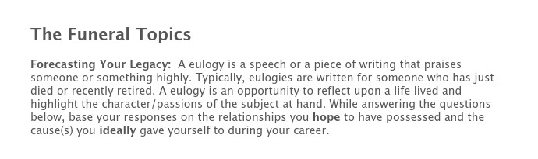

**If you could write 3 sentences that were to be read at your funeral, what would they be?**

Coach Erick was know for his time he spent with the players outside the game. He enjoyed getting to know eachone of them and treated them as his family. His heart and love for his family showed in his players.

**In 3 sentences or less, what are the types of things that you hope your family and friends will say about you at your funeral?**

**He was a loving father and loving husband. He was always there for me when we needed him and he treated everyone the fairly. He has always a joy to be around with his outlook on life.**

**In 3 sentences or less, what are the types of things that you hope your former players will say about you at your funeral?**

**He was like a father to me and helps me when I couldn’t talk to my parents. He always challenges me to make to correct decision on and off the fields. He always encourages me to always appreciate what my parents have done for me.**

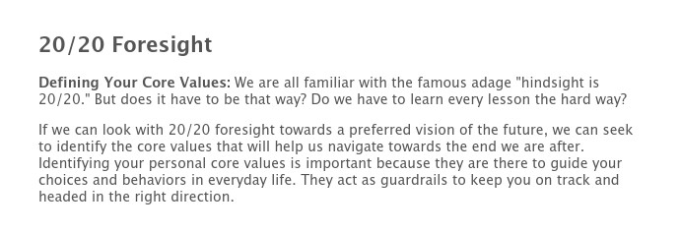

**Research indicates that if you truly want to impact behavior, no more than three or four core values should be emphasized. Look at the abbreviated list below and put a checkmark next to the core values that will best help you leave the legacy you desire.**

|  |  |  |  |
| --- | --- | --- | --- |
| Authenticity | Balance | Beauty | Commitment |
| Community | Compassion | Concern | Courage |
| Creativity | Dedicated | Determined | Durable |
| Empathy | Enthusiasm | Excellence | Faith |
| Family **X** | Fairness | Freedom | Friendship |
| Generosity | Genuineness | Grace | Happiness |
| Harmony | Health | Honesty | Hope |
| Humor | Integrity **X** | Innovation | Joyfulness |
| Journey | Justice | Kindness | Knowledge |
| Leadership | Learning | Love | Loyalty |
| Merciful | Neighborly | Noble | Non-conforming |
| Nurturing | Objective | Openness | Optimistic |
| Organization | Original | Peace | Performance |
| Perseverance | Respectfulness | Relationships | Responsibility |
| Security | Serenity | Serving | Spirituality |
| Stability | Success | Teamwork **X** | Togetherness |
| Trust | Truth | Understanding | Unity **X** |
| Victory | Virtuous | Wholeness | Wisdom |

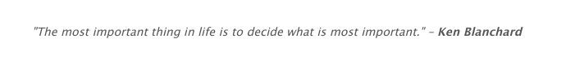

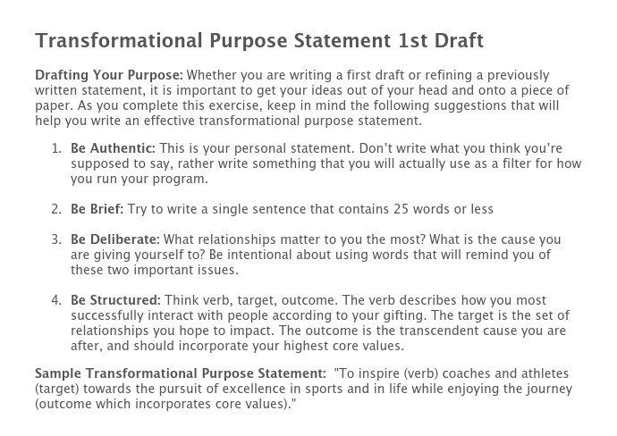

**Identifying Your Gifting: What verbs listed below best describe how you most successfully interact with people? Use these verbs to craft your “Transformational Purpose Statement.”**

|  |  |  |  |
| --- | --- | --- | --- |
| Act | Coach | Construct | Create |
| Demonstrate | Develop | Educate | Empower |
| Encourage | Help | Identify | Initiate |
| Inspire | Lead | Love | Manage |
| Mentor | Model | Motivate | Manage |
| Prepare | Produce | Recognize | Relate |
| Stimulate | Study | Teach | Tell |

**My Transformational Purpose in coaching is:**

**I want to teach players and coaches to encourage our young people of today. Through inspiration and love of the game and experience of life.**

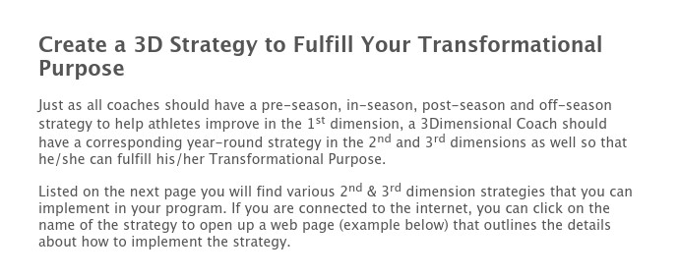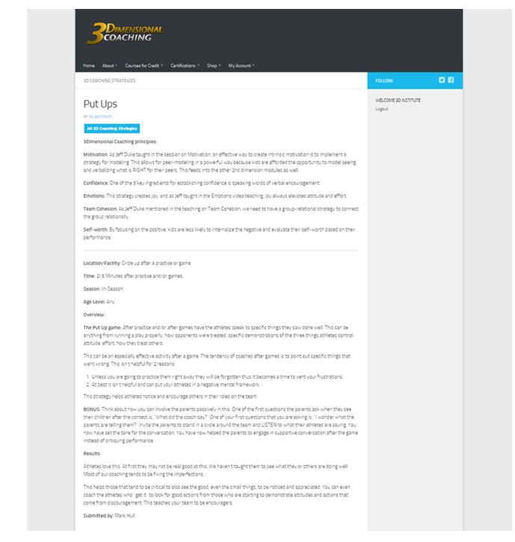

**Select at least one strategy for each season. Which strategies do you plan to implement and when?**

Not Implementing Pre-Season In-Season Post-Season Off-Season

3D Parenting Presentation **Note writing - Captains/Leaders - Food Kitchen – Lunch Room – home visits**

A Question to Ask Every Parent

An "Extra Practice" - Clean Your Room

Banquet Letters to Parents Canoe Trip

Captains/Leaders Training

Cell Phone Ban (Used Strategically)

Codes of Conduct

Contemplation Exercises

Cross the Line

FCA Camp

FCA Huddles

Follow the Leader

Food Kitchen

Helmet Awards

Home Visits

Honor Calls

Journaling

Lesson Plans/Theme of the Week

Lunch Room

Masculinity/Femininity Issues

Mission Trips

Note Writing

Nursing Home Outreach

Put Ups

Slip N Slide

Spotlight Drill

Spring Clean Up

Sticky Notes

Tag, You're It!

Upside Down

**If you have other strategies you plan to use that are not outlined above, chronicle those strategies below:**



[Powered by TCPDF (www.tcpdf.org)](http://www.tcpdf.org/)