**Full Name: Roger Crowe**

**E-mail:** [**coachrogercrowe@gmail.com**](mailto:coachrogercrowe@gmail.com)



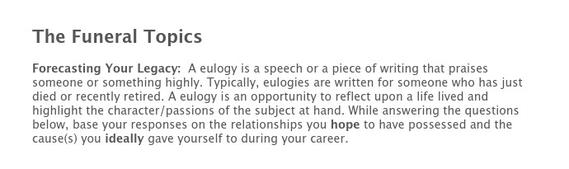

**If you could write 3 sentences that were to be read at your funeral, what would they be?**

Roger was a giant among men. His heart was as big as he was. He loved people and he loved Jesus.

**In 3 sentences or less, what are the types of things that you hope your family and friends will say about you at your funeral?**

I know he loved me. He told me and showed me every day that he loved me. He loved the Lord and sought Him every day.

**In 3 sentences or less, what are the types of things that you hope your former players will say about you at your funeral?**

I loved Coach Crowe. He was a great coach and a better man. He was always there for me and pushed me to be my best. He cared more about me the person than about my athletic ability.

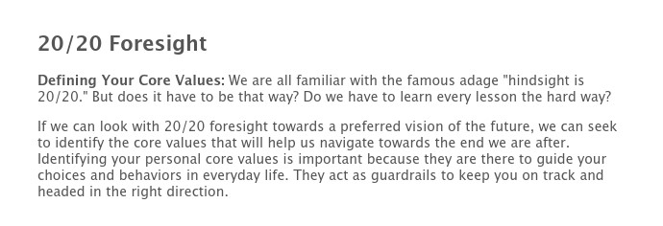

**Research indicates that if you truly want to impact behavior, no more than three or four core values should be emphasized. Look at the abbreviated list below and put a checkmark next to the core values that will best help you leave the legacy you desire.**

|  |  |  |  |
| --- | --- | --- | --- |
| **Authenticity** | Balance | Beauty | Commitment |
| Community | Compassion | Concern | Courage |
| Creativity | Dedicated | Determined | Durable |
| Empathy | Enthusiasm | Excellence | Faith |
| Family | Fairness | Freedom | Friendship |
| Generosity | Genuineness | Grace | Happiness |
| Harmony | Health | Honesty | Hope |
| Humor | **Integrity** | Innovation | Joyfulness |
| Journey | Justice | Kindness | Knowledge |
| Leadership | Learning | **Love** | Loyalty |
| Merciful | Neighborly | Noble | Non-conforming |
| Nurturing | Objective | Openness | Optimistic |
| Organization | Original | Peace | Performance |
| Perseverance | Respectfulness | Relationships | Responsibility |
| Security | Serenity | Serving | Spirituality |
| Stability | Success | Teamwork | Togetherness |
| Trust | Truth | Understanding | Unity |
| Victory | Virtuous | Wholeness | **Wisdom** |



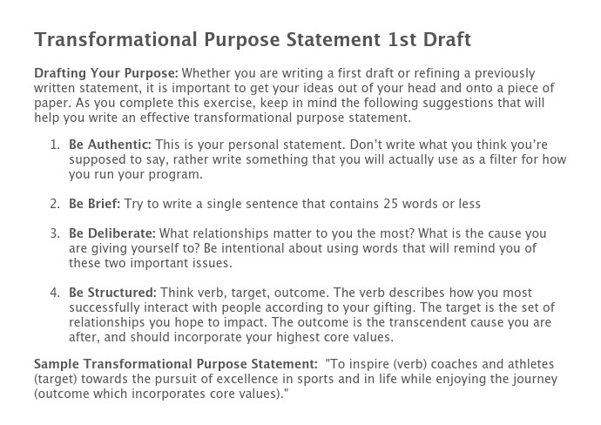

**Identifying Your Gifting: What verbs listed below best describe how you most successfully interact with people? Use these verbs to craft your “Transformational Purpose Statement.”**

|  |  |  |  |
| --- | --- | --- | --- |
| Act | Coach | Construct | Create |
| Demonstrate | Develop | Educate | Empower |
| Encourage | Help | Identify | Initiate |
| Inspire | Lead | Love | Manage |
| Mentor | Model | Motivate | Manage |
| Prepare | Produce | Recognize | Relate |
| Stimulate | Study | Teach | Tell |
|  |  |  |  |

My Transformational Purpose in coaching is to engage with everyone I meet with the intent to let them know that they are uniquely gifted and that with hard work, commitment, and a love for others the world is a better place for all of us.

|  |  |  |  |  |  |
| --- | --- | --- | --- | --- | --- |
| **Select at least one strategy for each season. Which strategies do you plan to implement and when?** | | | | | |
|  | Not Implementing | Pre-Season | In-Season | Post-Season | Off-Season |
| 3D Parenting Presentation |  |  |  |  |  |
| A Question to Ask Every Parent |  |  |  |  |  |
| An "Extra Practice" - Clean Your Room |  |  |  |  |  |
| Banquet Letters to Parents |  |  |  |  |  |
| Canoe Trip |  |  |  |  |  |
| Cross the Line |  |  |  |  |  |
| Captains/Leaders Training |  |  |  |  |  |
| Cell Phone Ban (Used Strategically) |  |  |  |  |  |
| Codes of Conduct |  |  |  |  |  |
| Contemplation Exercises |  |  |  |  |  |
| FCA Camp |  |  |  |  |  |
| FCA Huddles |  |  |  |  |  |
| Follow the Leader |  |  |  |  |  |
| Food Kitchen |  |  |  |  |  |
| Helmet Awards |  |  | **\*** |  |  |
| Home Visits |  |  |  |  |  |
| Honor Calls |  |  |  |  |  |
| Journaling |  |  |  |  |  |
| Lesson Plans/Theme of the Week |  |  |  |  |  |
| Lunch Room |  |  |  |  |  |
| Masculinity/Femininity Issues |  |  |  |  |  |
| Mission Trips |  |  |  |  |  |
| Note Writing |  | **\*** |  |  |  |
| Nursing Home Outreach |  |  |  |  |  |
| Put Ups |  |  |  |  |  |
| Slip N Slide |  |  |  |  |  |
| Spotlight Drill |  |  |  |  | **\*** |
| Spring Clean Up |  |  |  |  |  |
| Sticky Notes |  |  |  |  |  |
| Tag, You're It! |  |  |  | **\*** |  |
| Upside Down |  |  |  |  |  |

**If you have other strategies you plan to use that are not outlined above, chronicle those strategies below:**