**Full Name:**

Jim Kessler

jckessler@grace.edu

**E-mail:**

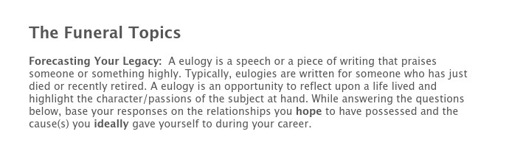

**If you could write 3 sentences that were to be read at your funeral, what would they be?**

A servant of Christ

**In 3 sentences or less, what are the types of things that you hope your family and friends will say about you at your funeral?**

**He loved his Lord, loved his family, loved is church and church family, he loved his community, and love the men and women to which he dedicated his life’s work of teaching and coaching.**

**In 3 sentences or less, what are the types of things that you hope your former players will say about you at your funeral?**

**He cared more about me as a person than as a player.**

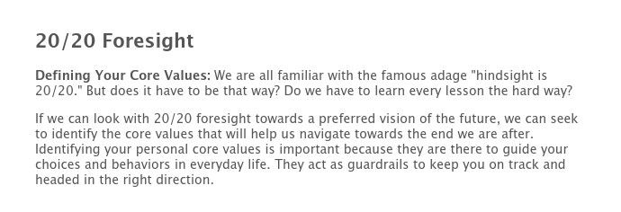

**Research indicates that if you truly want to impact behavior, no more than three or four core values should be emphasized. Look at the abbreviated list below and put a checkmark next to the core values that will best help you leave the legacy you desire.**

|  |  |  |  |
| --- | --- | --- | --- |
| Authenticity | Balance | Beauty | Commitment |
| Community | Compassion | Concern | Courage |
| Creativity | Dedicated | Determined | Durable |
| Empathy | Enthusiasm | Excellence | Faith |
| Family | Fairness | Freedom | Friendship |
| Generosity | Genuineness | Grace | Happiness |
| Harmony | Health | Honesty | Hope |
| Humor | Integrity | Innovation | Joyfulness |
| Journey | Justice | Kindness | Knowledge |
| Leadership | Learning | Love | Loyalty |
| Merciful | Neighborly | Noble | Non-conforming |
| Nurturing | Objective | Openness | Optimistic |
| Organization | Original | Peace | Performance |
| Perseverance | Respectfulness | Relationships | Responsibility |
| Security | Serenity | Serving | Spirituality |
| Stability | Success | Teamwork | Togetherness |
| Trust | Truth | Understanding | Unity |
| Victory | Virtuous | Wholeness | Wisdom |



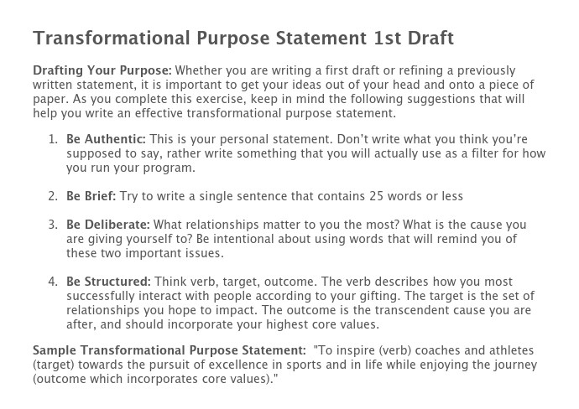

**Identifying Your Gifting: What verbs listed below best describe how you most successfully interact with people? Use these verbs to craft your “Transformational Purpose Statement.”**

|  |  |  |  |
| --- | --- | --- | --- |
| Act | Coach | Construct | Create |
| Demonstrate | Develop | Educate | Empower |
| Encourage | Help | Identify | Initiate |
| Inspire | Lead | Love | Manage |
| Mentor | Model | Motivate | Manage |
| Prepare | Produce | Recognize | Relate |
| Stimulate | Study | Teach | Tell |

**My Transformational Purpose in coaching is:**

My Philosophy of Purpose for Coaching by Jim Kessler

Playing basketball at Grace is about more than winning…it is intended to be an experience that encourages maturation and growth athletically, educationally, and spiritually. It is my intention to challenge players to achieve excellence both on and off the court with respect to their God given ability. It is a goal that lessons learned as a member of the team, will be applicable to the development of clear Christian character, professional competence and a lifetime of service to God and others.

My conviction is that the ultimate measure of winning is assessed by what life is about, which is living in a way that brings honor to Jesus Christ and serving my fellowman in such a way as to direct them to do the same. Once we concede to His sovereignty, the only two components of achievement over which we have ultimate control and responsibility are our *attitude* in response to circumstance and degree of *effort* we are willing to dedicate to the challenge.

Coaching at Grace is about ministry to people--students, faculty, and constituency. Their best interest--spiritually, mentally and physically--must be at the core of my life and vocation. This servant heart attitude must dominate my motives and direct my actions and clearly must remain the focus of my tenure. To lose sight of this fact is to lose sight of my mission and purpose. The passage "Pressing on to take hold of that for which he took hold of me," (Philippians 3:7-21) teaches that the success of my life and ministry is not based on the simple task of winning basketball games, but upon my reporting for duty, ready and willing to do my best as He directs.

I want to leave a legacy of love that outlast my time and leaves my players better men, closer to the Savior, faithful and responsible husbands and fathers and able to pass this legacy on to others. If I am to lead, then I must first commit to serve my Savior and fellow man.

5 Core

Be Honest-with self and others

Be Responsible- for and to God, self, and others

Be Teachable- have a teachable spirit.

Be a joyful warrior- Trials give opportunities to mature.

Be a lover-of God and man

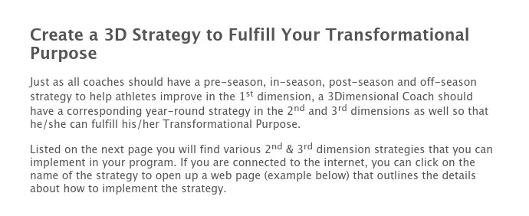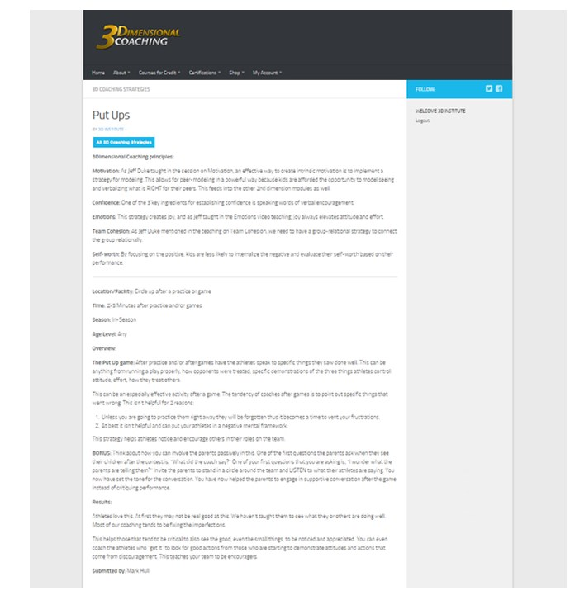

**Select at least one strategy for each season. Which strategies do you plan to implement and when?**

Not Implementing Pre-Season In-Season Post-Season Off-Season

3D Parenting Presentation

A Question to Ask Every Parent

An "Extra Practice" - Clean Your Room

Banquet Letters to Parents Canoe Trip

Captains/Leaders Training

Cell Phone Ban (Used Strategically)

Codes of Conduct

Contemplation Exercises

Cross the Line

FCA Camp

FCA Huddles

Follow the Leader

Food Kitchen

Helmet Awards

Home Visits

Honor Calls

Journaling

Lesson Plans/Theme of the Week

Lunch Room

Masculinity/Femininity Issues

Mission Trips

Note Writing

Nursing Home Outreach

Put Ups

Slip N Slide

Spotlight Drill

Spring Clean Up

Sticky Notes

Tag, You're It!

Upside Down

**If you have other strategies you plan to use that are not outlined above, chronicle those strategies below:**

[Powered by TCPDF (www.tcpdf.org)](http://www.tcpdf.org)