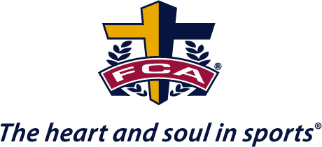

***“One coach will impact more people in a season***

***than the normal person does in a lifetime!”***

**Billy Graham**

***We at South Coastal FCA see this true statement at work every day in Beaufort County Schools***. For many young people their coach may be almost as important in their lives as parents. In some cases, even more important! Through the influence of coaches, athletes and teams can be transformed, and then entire schools impacted. Our FCA Coaches Ministry comes along side coaches to encourage, assist, and equip them to be the best they can be and to help coaches model the ***FCA values of Integrity, Serving, Teamwork, and Excellence.*** We do this through Coaches Conferences, Coaches Breakfasts, Coaches Family Camps/Retreats, Marriage Conferences, Team Chaplains, Bible Studies, 3D Coaching, and one on one ministry.

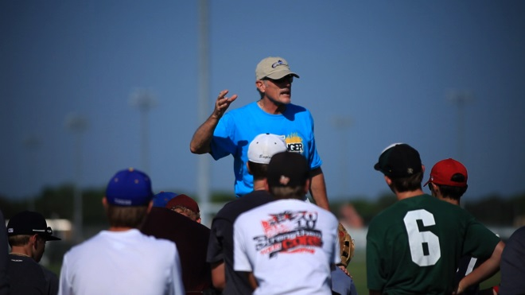

***FCA Ministry - To and Through Coaches***

***Please allow our South Coastal FCA Team to help you in any way we can. We love and respect coaches and understand the challenges and rewards of the job you all have. We are here for you and your athletes!***

**Chuck Workman Paul Cifaldi Aaron Bush Lisa Richardson**

**Area Representative Area Director Area Representative Area Representative**

[**cworkman@fca.org**](mailto:cworkman@fca.org)[**pcifaldi@fca.org**](mailto:pcifaldi@fca.org)[**abush@fca.org**](mailto:abush@fca.org) **lisarichardson@fca.org**

**843-415-3898 843-301-6640 843-709-3912 843-263-7226**