|  |  |
| --- | --- |
| **F:\3dcoaching_pc_v3\3D Curriculum\3 Dimensional Coaching logo.png**  ***TM*** | ***“Coaching the heart***  ***behind the jersey.”*** |

**Date Issued**  9/23/15

**Between** 3D Institute, INC

**and**

**Sponsor**  Smithville HS

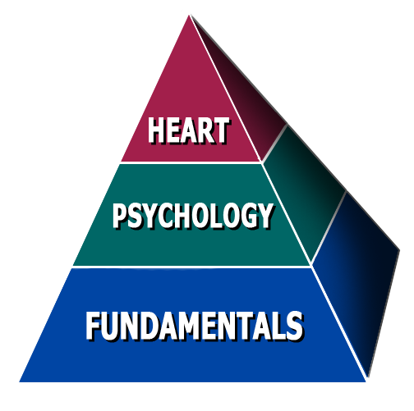 645 South Commercial Ave.

Smithville, MO 64489

**Certified Presenter** Wes Simmons

**Date of appearance**  Tuesday, November 17, 2015

**Location** Smithville High School

**Start Time** 8:30 AM

**Length** 3 Hours

**Speaking Fee** $500.00

**Travel Fee** $80.00

**Resources** (50 booklets) $50.00

**Total: $630.00**

**Payment Terms:**

Please make check payable to 3D Institute (**EIN# 47-2053869).**

Mail to 7325 Forestwood Court, Orlando, FL 32835

Payment should be mailed to arrive 5-7 days before the presentation. Payment can also be given to the presenter on the day of the event.

THIS CONTRACT SERVES AS AN INVOICE. YOU WILL NOT RECEIVE ANOTHER INVOICE UNLESS YOU REQUEST IT.

**Other Terms:**

Sponsor is also responsible for providing projector and sound system compatible with a laptop.

I have read and understand all the information contained herein:

**Signature Date**

