|  |  |
| --- | --- |
| **F:\3dcoaching_pc_v3\3D Curriculum\3 Dimensional Coaching logo.png**  ***TM*** | ***“Coaching the heart***  ***behind the jersey.”*** |

**Date Issued**  9/2/15

**Between** 3D Institute, INC

**and**

**Sponsor**  ESU 11

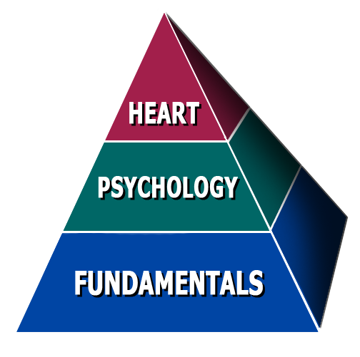 600 12 Ave  
 Holdrege, NE 68949

**Certified Presenter** Wes Simmons

**Date of appearance**  Monday 10/5/15

**Location** Holdredge HS

**Start Time** 10:30 AM

**Length** 2 Hours

**Speaking Fee** $500.00

**Travel** (602 miles @ $0.575) $346.15

**Resources** (50 booklets) $50.00

**Total: $846.15**

**Payment Terms:**

Please make check payable to 3Dimensional Coaching (**EIN# 44-0610626).**

Mail to 3Dimensional Coaching, P.O. Box 8966, St. Joseph, MO 64508

Payment should be mailed to arrive 5-7 days before the presentation. Payment can also be given to the presenter on the day of the event.

THIS CONTRACT SERVES AS AN INVOICE. YOU WILL NOT RECEIVE ANOTHER INVOICE UNLESS YOU REQUEST IT.

**Other Terms:**

Sponsor is also responsible for providing projector and sound system compatible with a laptop.

I have read and understand all the information contained herein:

**Signature Date**

